ｽﾍﾟｸﾄﾙﾗﾍﾞﾙ: ｽﾍﾟｸﾄﾙ 1

ﾗｲﾌﾞﾀｲﾑ 120.0 s

収集ｼﾞｵﾒﾄﾘ[度] :

試料傾斜角 = 0.0

方位角 = 0.0

ｴﾚﾍﾞｰｼｮﾝ = 30.0

加速電圧 = 10.00 kV

ｽﾍﾟｸﾄﾙ全ｶｳﾝﾄ数 = 103224

|  |  |  |  |
| --- | --- | --- | --- |
| ｻﾝﾌﾟﾙﾃﾞｰﾀ : | ｴﾈﾙｷﾞｰ[eV] | 分解能[eV] | ｶｳﾝﾄ数 |
| ｽﾄﾛｰﾌﾞ : | 3.8 | 51.62 | 1223548 |
|  |  |  |  |

定量最適化がおこなわれていません

ｽﾍﾟｸﾄﾙ処理 :

省略されたﾋﾟｰｸはありません

処理ｵﾌﾟｼｮﾝ : 酸素 ｽﾄｲｷｵﾒﾄﾘ (ﾉｰﾏﾗｲｽﾞ)

繰り返し回数 = 1

ｽﾀﾝﾀﾞｰﾄﾞ :

Na Albite 1999/06/01

Mg MgO 1999/06/01

Al Al2O3 1999/06/01

Si SiO2 1999/06/01

P GaP 1999/06/01

S FeS2 1999/06/01

K MAD-10 Feldspar 1999/06/01

Ca Wollastonite 1999/06/01

Cr Cr 1999/06/01

Mn Mn 1999/06/01

Fe Fe 1999/06/01

Ni Ni 1999/06/01

|  |  |  |  |  |  |
| --- | --- | --- | --- | --- | --- |
| 元素 | 質量濃度 | 原子数 | 化合物 | 化学式 |  |
|  | [%] | 濃度[%] | 濃度[%] |  |  |
| Na K | 42.96 | 50.37 | 57.91 | Na2O |  |
| Mg K | -2.04 | -2.26 | -3.38 | MgO |  |
| Al K | -1.38 | -1.38 | -2.61 | Al2O3 |  |
| Si K | -0.57 | -0.54 | -1.21 | SiO2 |  |
| P K | -0.69 | -0.60 | -1.58 | P2O5 |  |
| S K | -0.87 | -0.73 | -2.18 | SO3 |  |
| K K | -0.05 | -0.03 | -0.06 | K2O |  |
| Ca K | -1.42 | -0.96 | -1.99 | CaO |  |
| Cr K | 7.12 | 3.69 | 10.40 | Cr2O3 |  |
| Mn K | 1.34 | 0.66 | 1.73 | MnO |  |
| Fe K | -13.17 | -6.36 | -16.94 | FeO |  |
| Ni K | 47.09 | 21.62 | 59.92 | NiO |  |
| O | 21.69 | 36.54 |  |  |  |
| ﾄｰﾀﾙ | 100.00 |  |  |  |  |

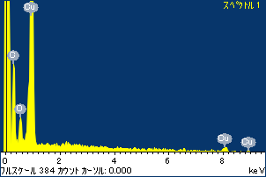

ﾌﾟﾛｼﾞｪｸﾄ : ﾌﾟﾛｼﾞｪｸﾄ 1

ｵｰﾅｰ : Administrator

領域 分析領域 15

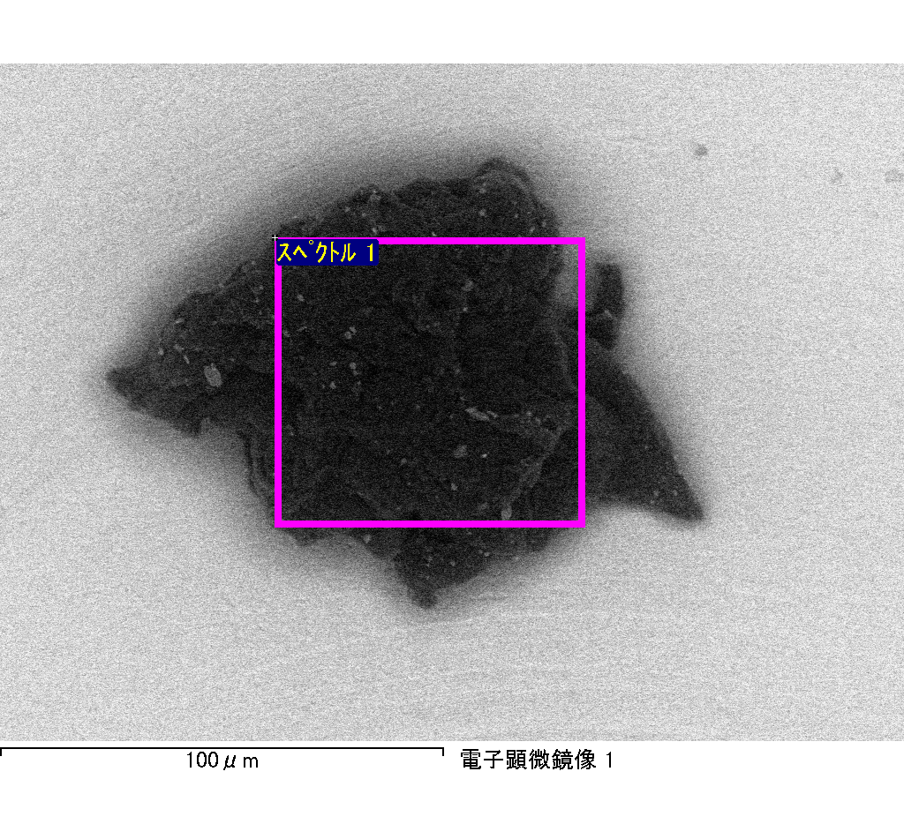

ｽﾍﾟｸﾄﾙﾗﾍﾞﾙ: ｽﾍﾟｸﾄﾙ 1

ﾗｲﾌﾞﾀｲﾑ 120.0 s

収集ｼﾞｵﾒﾄﾘ[度] :

試料傾斜角 = 0.0

方位角 = 0.0

ｴﾚﾍﾞｰｼｮﾝ = 30.0

加速電圧 = 10.00 kV

ｽﾍﾟｸﾄﾙ全ｶｳﾝﾄ数 = 106862

|  |  |  |  |
| --- | --- | --- | --- |
| ｻﾝﾌﾟﾙﾃﾞｰﾀ : | ｴﾈﾙｷﾞｰ[eV] | 分解能[eV] | ｶｳﾝﾄ数 |
| ｽﾄﾛｰﾌﾞ : | 3.8 | 51.73 | 1203436 |
|  |  |  |  |

定量最適化がおこなわれていません

ｽﾍﾟｸﾄﾙ処理 :

省略されたﾋﾟｰｸはありません

処理ｵﾌﾟｼｮﾝ : 酸素 ｽﾄｲｷｵﾒﾄﾘ (ﾉｰﾏﾗｲｽﾞ)

繰り返し回数 = 2

ｽﾀﾝﾀﾞｰﾄﾞ :

Na Albite 1999/06/01

Mg MgO 1999/06/01

Al Al2O3 1999/06/01

Si SiO2 1999/06/01

P GaP 1999/06/01

S FeS2 1999/06/01

K MAD-10 Feldspar 1999/06/01

Ca Wollastonite 1999/06/01

Cr Cr 1999/06/01

Mn Mn 1999/06/01

Fe Fe 1999/06/01

Ni Ni 1999/06/01

|  |  |  |  |  |  |
| --- | --- | --- | --- | --- | --- |
| 元素 | 質量濃度 | 原子数 | 化合物 | 化学式 |  |
|  | [%] | 濃度[%] | 濃度[%] |  |  |
| Na K | -13.39 | -14.56 | -18.06 | Na2O |  |
| Mg K | 0.65 | 0.66 | 1.07 | MgO |  |
| Al K | 0.06 | 0.06 | 0.11 | Al2O3 |  |
| Si K | 0.47 | 0.42 | 1.01 | SiO2 |  |
| P K | -0.35 | -0.28 | -0.80 | P2O5 |  |
| S K | 28.17 | 21.95 | 70.34 | SO3 |  |
| K K | -0.14 | -0.09 | -0.17 | K2O |  |
| Ca K | 0.62 | 0.39 | 0.87 | CaO |  |
| Cr K | -2.19 | -1.05 | -3.20 | Cr2O3 |  |
| Mn K | -0.23 | -0.11 | -0.30 | MnO |  |
| Fe K | 47.65 | 21.32 | 61.30 | FeO |  |
| Ni K | -9.58 | -4.08 | -12.19 | NiO |  |
| O | 48.26 | 75.36 |  |  |  |
| ﾄｰﾀﾙ | 100.00 |  |  |  |  |

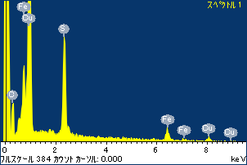

ﾌﾟﾛｼﾞｪｸﾄ : ﾌﾟﾛｼﾞｪｸﾄ 1

ｵｰﾅｰ : Administrator

領域 分析領域 17

