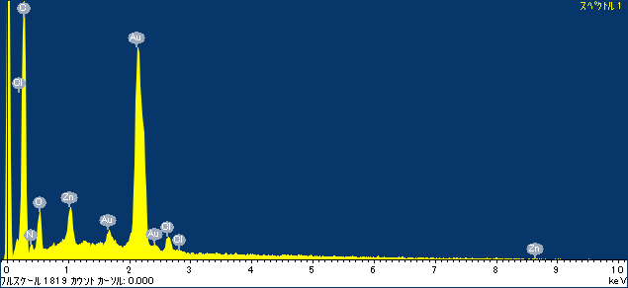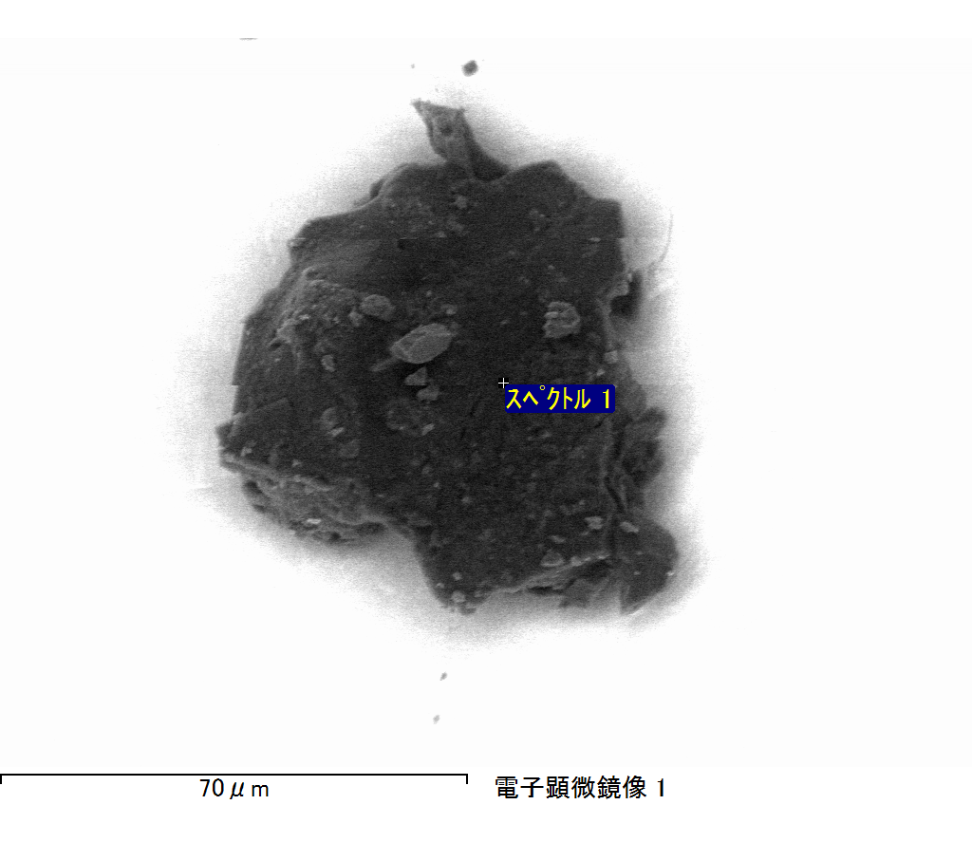

ｺﾒﾝﾄ :

2017/12/14 11:05:07

ﾌﾟﾛｼﾞｪｸﾄ 1

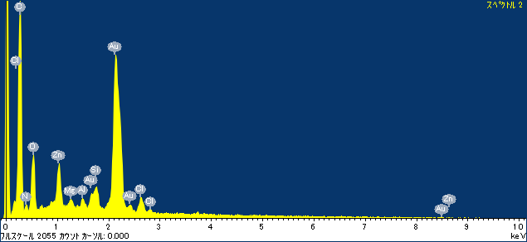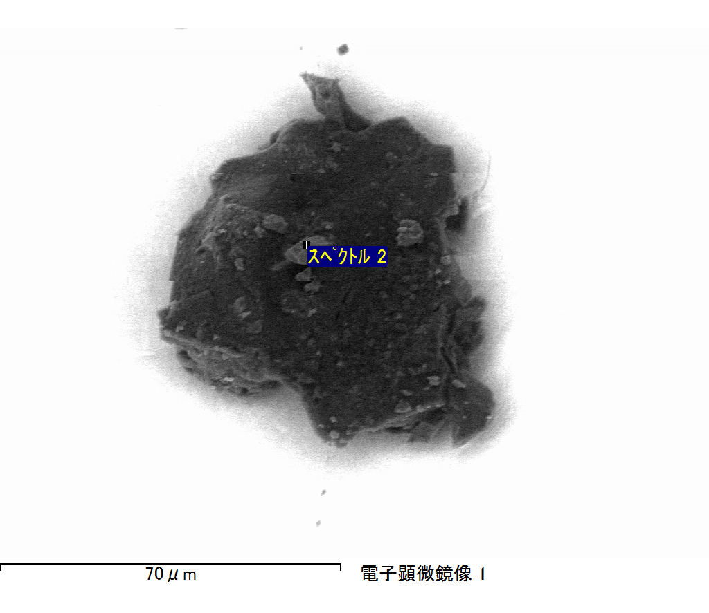

ｺﾒﾝﾄ :

2017/12/14 11:05:36

ﾌﾟﾛｼﾞｪｸﾄ 1

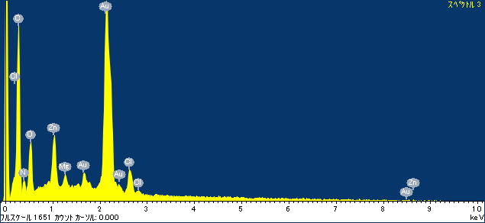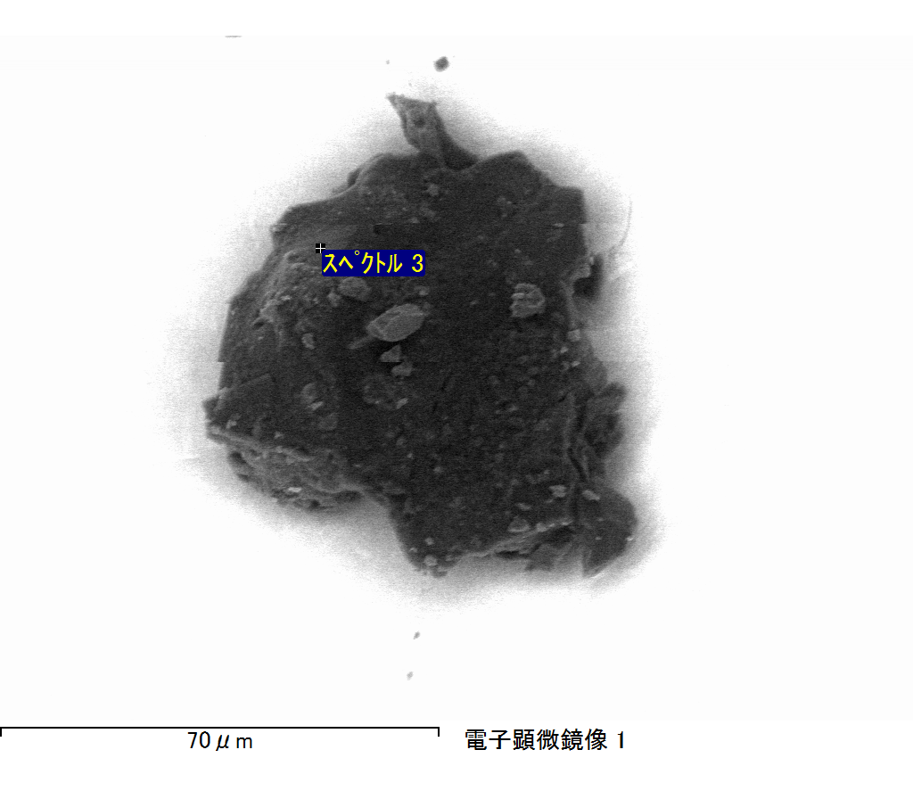

ｺﾒﾝﾄ :

2017/12/14 11:05:39

ﾌﾟﾛｼﾞｪｸﾄ 1

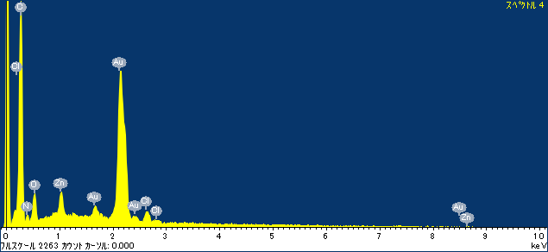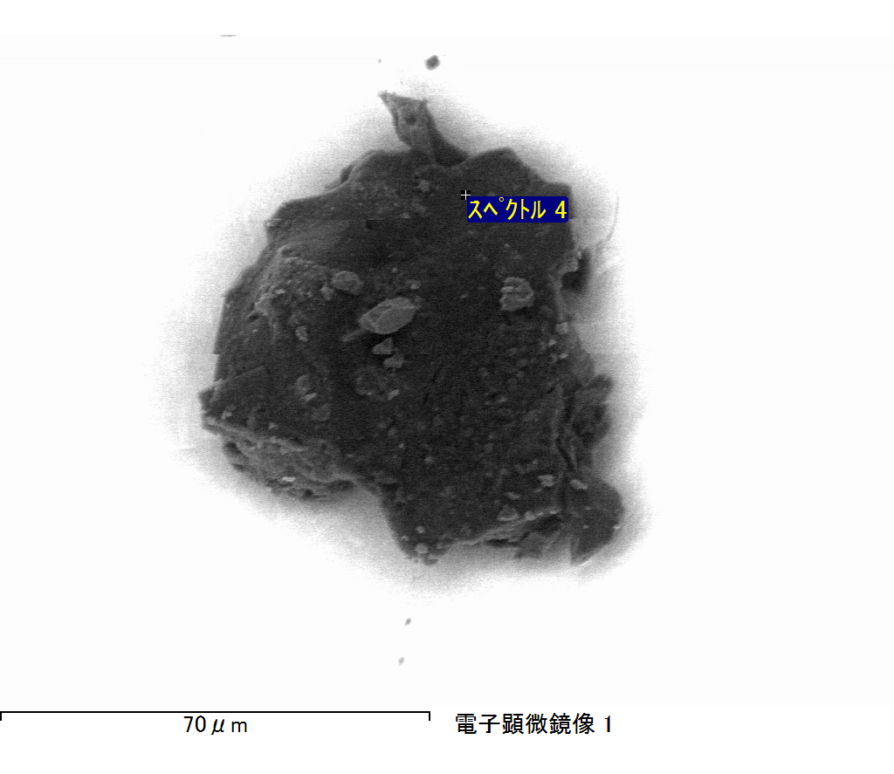

ｺﾒﾝﾄ :

2017/12/14 11:05:45

ﾌﾟﾛｼﾞｪｸﾄ 1

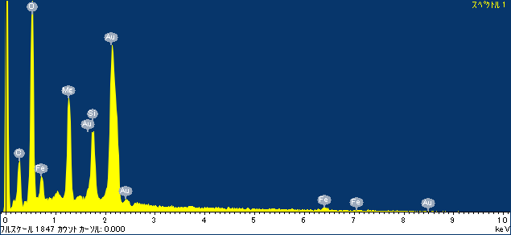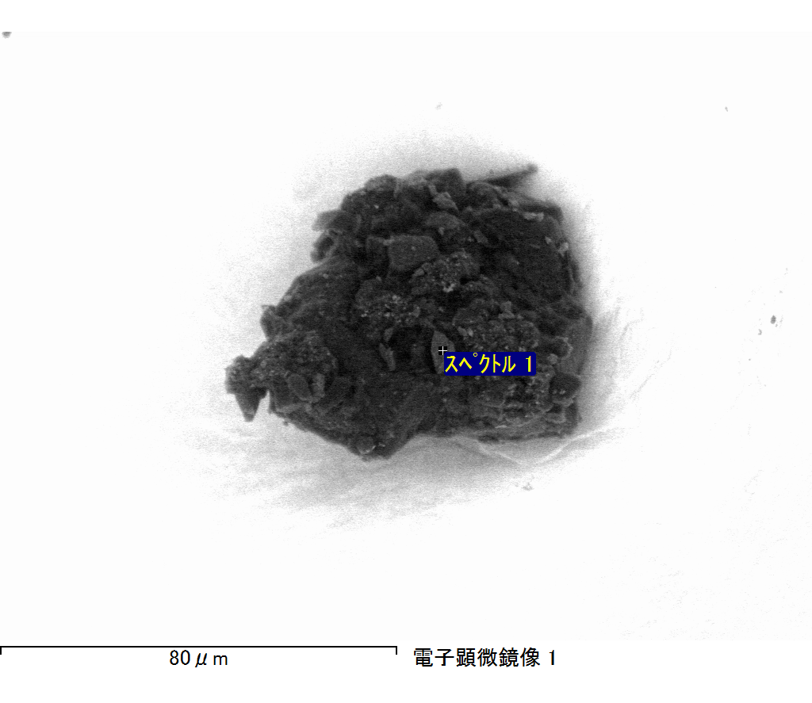

ｺﾒﾝﾄ :

2017/12/14 11:08:49

ﾌﾟﾛｼﾞｪｸﾄ 1

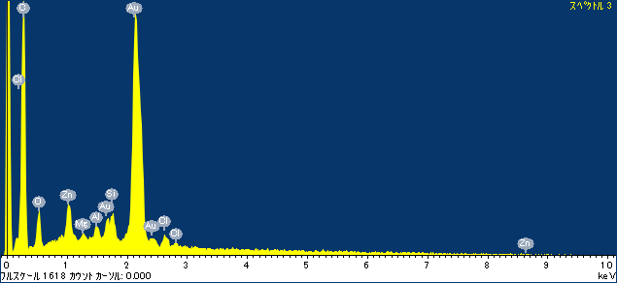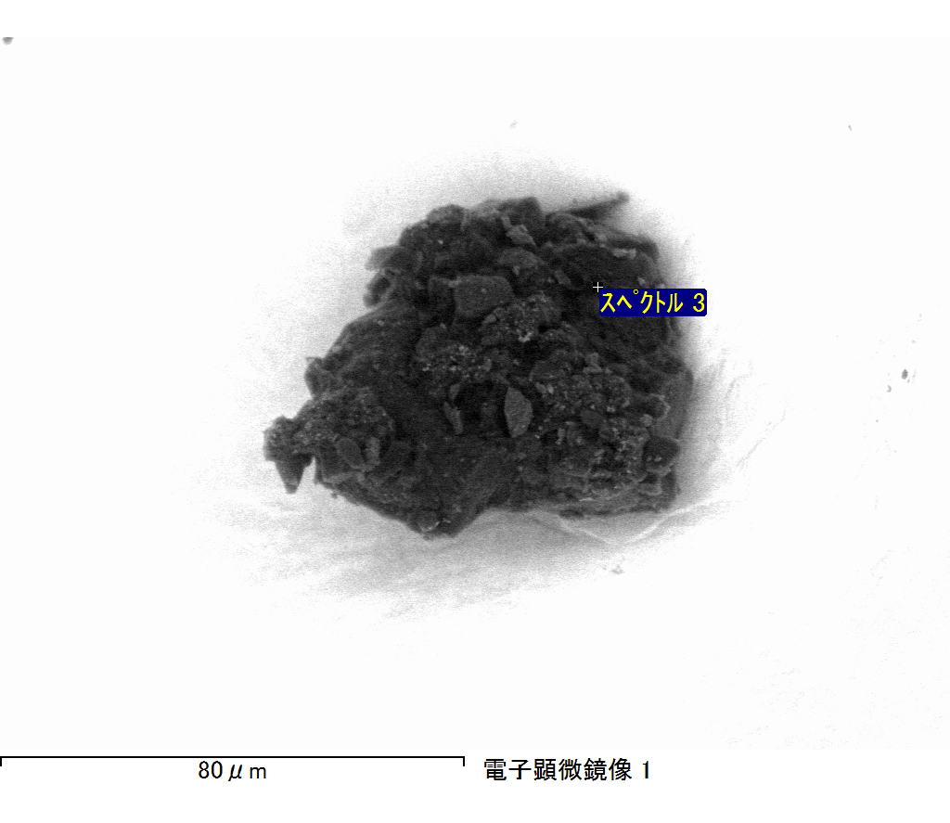

ｺﾒﾝﾄ :

2017/12/14 11:08:53

ﾌﾟﾛｼﾞｪｸﾄ 1