ｽﾍﾟｸﾄﾙﾗﾍﾞﾙ: ｽﾍﾟｸﾄﾙ 1

ﾗｲﾌﾞﾀｲﾑ 120.0 s

収集ｼﾞｵﾒﾄﾘ[度] :

試料傾斜角 = 0.0

方位角 = 0.0

ｴﾚﾍﾞｰｼｮﾝ = 30.0

加速電圧 = 10.00 kV

ｽﾍﾟｸﾄﾙ全ｶｳﾝﾄ数 = 123189

|  |  |  |  |
| --- | --- | --- | --- |
| ｻﾝﾌﾟﾙﾃﾞｰﾀ : | ｴﾈﾙｷﾞｰ[eV] | 分解能[eV] | ｶｳﾝﾄ数 |
| ｽﾄﾛｰﾌﾞ : | 3.8 | 52.06 | 1201696 |
|  |  |  |  |

定量最適化がおこなわれていません

ｽﾍﾟｸﾄﾙ処理 :

省略されたﾋﾟｰｸはありません

処理ｵﾌﾟｼｮﾝ : 酸素 ｽﾄｲｷｵﾒﾄﾘ (ﾉｰﾏﾗｲｽﾞ)

繰り返し回数 = 2

ｽﾀﾝﾀﾞｰﾄﾞ :

Na Albite 1999/06/01

Mg MgO 1999/06/01

Al Al2O3 1999/06/01

Si SiO2 1999/06/01

P GaP 1999/06/01

S FeS2 1999/06/01

K MAD-10 Feldspar 1999/06/01

Ca Wollastonite 1999/06/01

Cr Cr 1999/06/01

Mn Mn 1999/06/01

Fe Fe 1999/06/01

Ni Ni 1999/06/01

|  |  |  |  |  |  |
| --- | --- | --- | --- | --- | --- |
| 元素 | 質量濃度 | 原子数 | 化合物 | 化学式 |  |
|  | [%] | 濃度[%] | 濃度[%] |  |  |
| Na K | -1.22 | -1.11 | -1.65 | Na2O |  |
| Mg K | 0.35 | 0.30 | 0.58 | MgO |  |
| Al K | -0.03 | -0.02 | -0.06 | Al2O3 |  |
| Si K | -21.79 | -16.29 | -46.61 | SiO2 |  |
| P K | 31.57 | 21.40 | 72.33 | P2O5 |  |
| S K | 26.85 | 17.58 | 67.03 | SO3 |  |
| K K | 1.10 | 0.59 | 1.32 | K2O |  |
| Ca K | -0.58 | -0.31 | -0.82 | CaO |  |
| Cr K | 1.27 | 0.51 | 1.85 | Cr2O3 |  |
| Mn K | -0.06 | -0.02 | -0.08 | MnO |  |
| Fe K | -5.52 | -2.07 | -7.10 | FeO |  |
| Ni K | 10.36 | 3.70 | 13.18 | NiO |  |
| O | 57.71 | 75.74 |  |  |  |
| ﾄｰﾀﾙ | 100.00 |  |  |  |  |

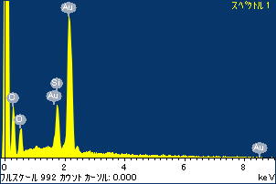

ﾌﾟﾛｼﾞｪｸﾄ : 20120130_Au10SEM

ｵｰﾅｰ : Administrator

領域 分析領域 1

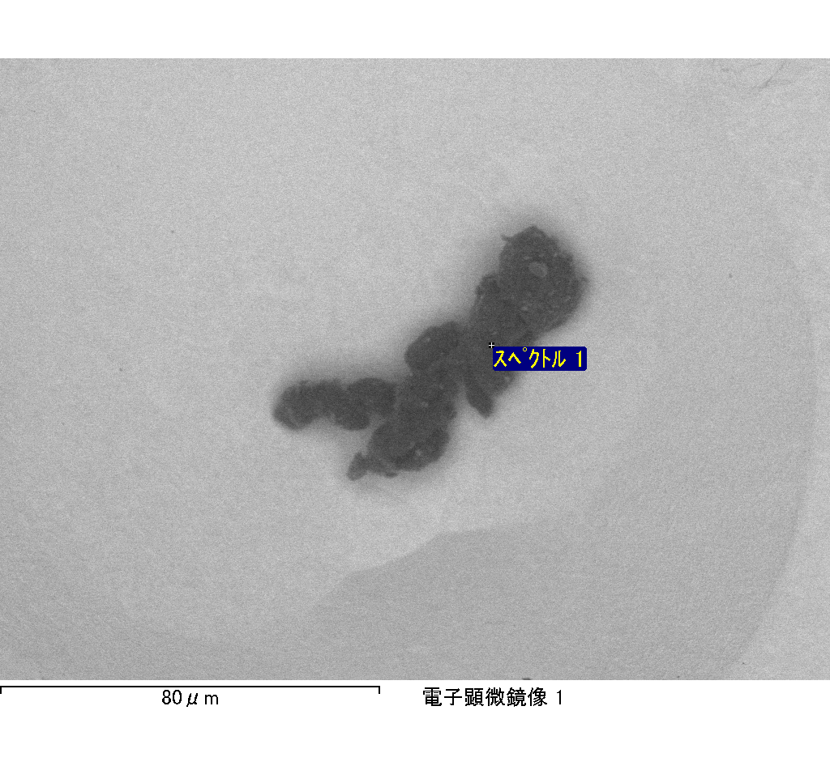

ｽﾍﾟｸﾄﾙﾗﾍﾞﾙ: ｽﾍﾟｸﾄﾙ 3

ﾗｲﾌﾞﾀｲﾑ 19.1 s

収集ｼﾞｵﾒﾄﾘ[度] :

試料傾斜角 = 0.0

方位角 = 0.0

ｴﾚﾍﾞｰｼｮﾝ = 30.0

加速電圧 = 10.00 kV

ｽﾍﾟｸﾄﾙ全ｶｳﾝﾄ数 = 19734

|  |  |  |  |
| --- | --- | --- | --- |
| ｻﾝﾌﾟﾙﾃﾞｰﾀ : | ｴﾈﾙｷﾞｰ[eV] | 分解能[eV] | ｶｳﾝﾄ数 |
| ｽﾄﾛｰﾌﾞ : | 3.8 | 52.07 | 191721 |
|  |  |  |  |

定量最適化がおこなわれていません

ｽﾍﾟｸﾄﾙ処理 :

省略されたﾋﾟｰｸはありません

処理ｵﾌﾟｼｮﾝ : 酸素 ｽﾄｲｷｵﾒﾄﾘ (ﾉｰﾏﾗｲｽﾞ)

繰り返し回数 = 1

ｽﾀﾝﾀﾞｰﾄﾞ :

Na Albite 1999/06/01

Mg MgO 1999/06/01

Al Al2O3 1999/06/01

Si SiO2 1999/06/01

P GaP 1999/06/01

S FeS2 1999/06/01

K MAD-10 Feldspar 1999/06/01

Ca Wollastonite 1999/06/01

Cr Cr 1999/06/01

Mn Mn 1999/06/01

Fe Fe 1999/06/01

Ni Ni 1999/06/01

|  |  |  |  |  |  |
| --- | --- | --- | --- | --- | --- |
| 元素 | 質量濃度 | 原子数 | 化合物 | 化学式 |  |
|  | [%] | 濃度[%] | 濃度[%] |  |  |
| Na K | -1.05 | -0.98 | -1.42 | Na2O |  |
| Mg K | -0.20 | -0.18 | -0.33 | MgO |  |
| Al K | -1.08 | -0.86 | -2.04 | Al2O3 |  |
| Si K | 0.33 | 0.25 | 0.70 | SiO2 |  |
| P K | 22.54 | 15.66 | 51.65 | P2O5 |  |
| S K | 15.54 | 10.43 | 38.80 | SO3 |  |
| K K | -1.73 | -0.95 | -2.09 | K2O |  |
| Ca K | -0.30 | -0.16 | -0.42 | CaO |  |
| Cr K | -3.28 | -1.36 | -4.79 | Cr2O3 |  |
| Mn K | 4.54 | 1.78 | 5.86 | MnO |  |
| Fe K | 5.62 | 2.17 | 7.23 | FeO |  |
| Ni K | 5.38 | 1.97 | 6.85 | NiO |  |
| O | 53.70 | 72.23 |  |  |  |
| ﾄｰﾀﾙ | 100.00 |  |  |  |  |

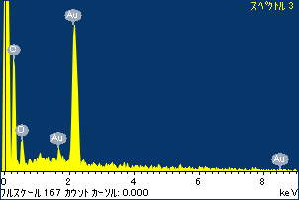

ﾌﾟﾛｼﾞｪｸﾄ : 20120130_Au10SEM

ｵｰﾅｰ : Administrator

領域 分析領域 1

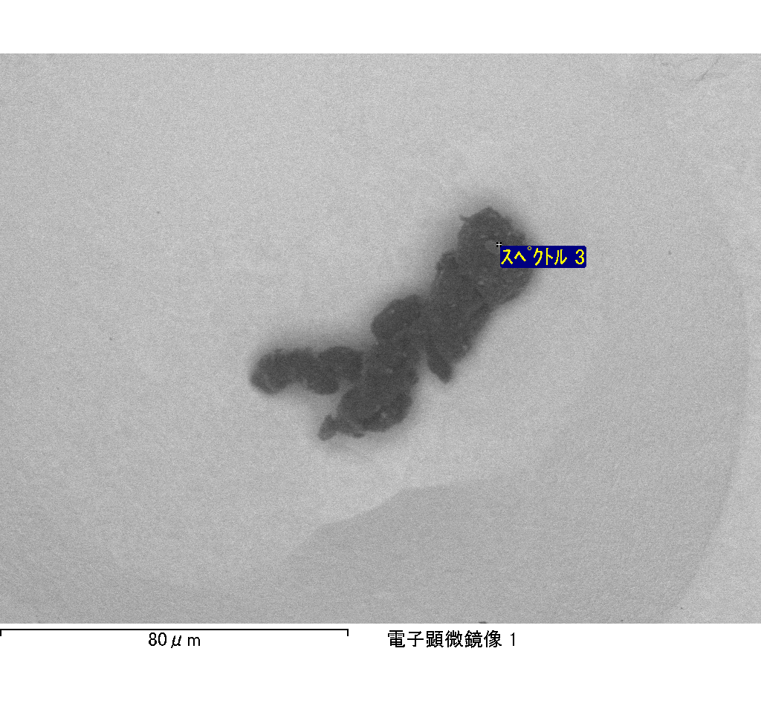

ｽﾍﾟｸﾄﾙﾗﾍﾞﾙ: ｽﾍﾟｸﾄﾙ 6

ﾗｲﾌﾞﾀｲﾑ 28.3 s

収集ｼﾞｵﾒﾄﾘ[度] :

試料傾斜角 = 0.0

方位角 = 0.0

ｴﾚﾍﾞｰｼｮﾝ = 30.0

加速電圧 = 10.00 kV

ｽﾍﾟｸﾄﾙ全ｶｳﾝﾄ数 = 27747

|  |  |  |  |
| --- | --- | --- | --- |
| ｻﾝﾌﾟﾙﾃﾞｰﾀ : | ｴﾈﾙｷﾞｰ[eV] | 分解能[eV] | ｶｳﾝﾄ数 |
| ｽﾄﾛｰﾌﾞ : | 3.8 | 52.04 | 284952 |
|  |  |  |  |

定量最適化がおこなわれていません

ｽﾍﾟｸﾄﾙ処理 :

省略されたﾋﾟｰｸはありません

処理ｵﾌﾟｼｮﾝ : 酸素 ｽﾄｲｷｵﾒﾄﾘ (ﾉｰﾏﾗｲｽﾞ)

繰り返し回数 = 1

ｽﾀﾝﾀﾞｰﾄﾞ :

Na Albite 1999/06/01

Mg MgO 1999/06/01

Al Al2O3 1999/06/01

Si SiO2 1999/06/01

P GaP 1999/06/01

S FeS2 1999/06/01

K MAD-10 Feldspar 1999/06/01

Ca Wollastonite 1999/06/01

Cr Cr 1999/06/01

Mn Mn 1999/06/01

Fe Fe 1999/06/01

Ni Ni 1999/06/01

|  |  |  |  |  |  |
| --- | --- | --- | --- | --- | --- |
| 元素 | 質量濃度 | 原子数 | 化合物 | 化学式 |  |
|  | [%] | 濃度[%] | 濃度[%] |  |  |
| Na K | 0.34 | 0.34 | 0.46 | Na2O |  |
| Mg K | -0.06 | -0.05 | -0.09 | MgO |  |
| Al K | -0.02 | -0.02 | -0.04 | Al2O3 |  |
| Si K | -0.48 | -0.39 | -1.02 | SiO2 |  |
| P K | 19.50 | 14.37 | 44.68 | P2O5 |  |
| S K | 12.80 | 9.11 | 31.96 | SO3 |  |
| K K | -0.60 | -0.35 | -0.72 | K2O |  |
| Ca K | -1.26 | -0.72 | -1.77 | CaO |  |
| Cr K | -0.75 | -0.33 | -1.10 | Cr2O3 |  |
| Mn K | 1.05 | 0.44 | 1.35 | MnO |  |
| Fe K | -3.41 | -1.40 | -4.39 | FeO |  |
| Ni K | 24.10 | 9.37 | 30.67 | NiO |  |
| O | 48.79 | 69.62 |  |  |  |
| ﾄｰﾀﾙ | 100.00 |  |  |  |  |

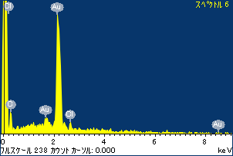

ﾌﾟﾛｼﾞｪｸﾄ : 20120130_Au10SEM

ｵｰﾅｰ : Administrator

領域 分析領域 1

