ｽﾍﾟｸﾄﾙﾗﾍﾞﾙ: ｽﾍﾟｸﾄﾙ 1

ﾗｲﾌﾞﾀｲﾑ 120.0 s

収集ｼﾞｵﾒﾄﾘ[度] :

試料傾斜角 = 0.0

方位角 = 0.0

ｴﾚﾍﾞｰｼｮﾝ = 30.0

加速電圧 = 10.00 kV

ｽﾍﾟｸﾄﾙ全ｶｳﾝﾄ数 = 182093

|  |  |  |  |
| --- | --- | --- | --- |
| ｻﾝﾌﾟﾙﾃﾞｰﾀ : | ｴﾈﾙｷﾞｰ[eV] | 分解能[eV] | ｶｳﾝﾄ数 |
| ｽﾄﾛｰﾌﾞ : | 3.8 | 52.10 | 1194802 |
|  |  |  |  |

定量最適化がおこなわれていません

ｽﾍﾟｸﾄﾙ処理 :

省略されたﾋﾟｰｸはありません

処理ｵﾌﾟｼｮﾝ : 酸素 ｽﾄｲｷｵﾒﾄﾘ (ﾉｰﾏﾗｲｽﾞ)

繰り返し回数 = 2

ｽﾀﾝﾀﾞｰﾄﾞ :

Na Albite 1999/06/01

Mg MgO 1999/06/01

Al Al2O3 1999/06/01

Si SiO2 1999/06/01

P GaP 1999/06/01

S FeS2 1999/06/01

K MAD-10 Feldspar 1999/06/01

Ca Wollastonite 1999/06/01

Cr Cr 1999/06/01

Mn Mn 1999/06/01

Fe Fe 1999/06/01

Ni Ni 1999/06/01

|  |  |  |  |  |  |
| --- | --- | --- | --- | --- | --- |
| 元素 | 質量濃度 | 原子数 | 化合物 | 化学式 |  |
|  | [%] | 濃度[%] | 濃度[%] |  |  |
| Na K | -12.09 | -2.88 | -16.30 | Na2O |  |
| Mg K | -29.31 | -6.61 | -48.60 | MgO |  |
| Al K | -61.85 | -12.57 | -116.87 | Al2O3 |  |
| Si K | -65.47 | -12.78 | -140.06 | SiO2 |  |
| P K | 277.54 | 49.12 | 635.93 | P2O5 |  |
| S K | 218.08 | 37.28 | 544.53 | SO3 |  |
| K K | 7.19 | 1.01 | 8.67 | K2O |  |
| Ca K | 6.58 | 0.90 | 9.20 | CaO |  |
| Cr K | -433.75 | -45.73 | -633.95 | Cr2O3 |  |
| Mn K | 4.38 | 0.44 | 5.66 | MnO |  |
| Fe K | -248.53 | -24.39 | -319.73 | FeO |  |
| Ni K | 134.79 | 12.58 | 171.52 | NiO |  |
| O | 302.45 | 103.63 |  |  |  |
| ﾄｰﾀﾙ | 100.00 |  |  |  |  |

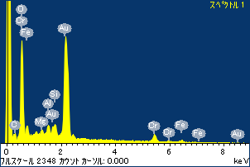

ﾌﾟﾛｼﾞｪｸﾄ : ﾌﾟﾛｼﾞｪｸﾄ 1

ｵｰﾅｰ : Administrator

領域 分析領域 5

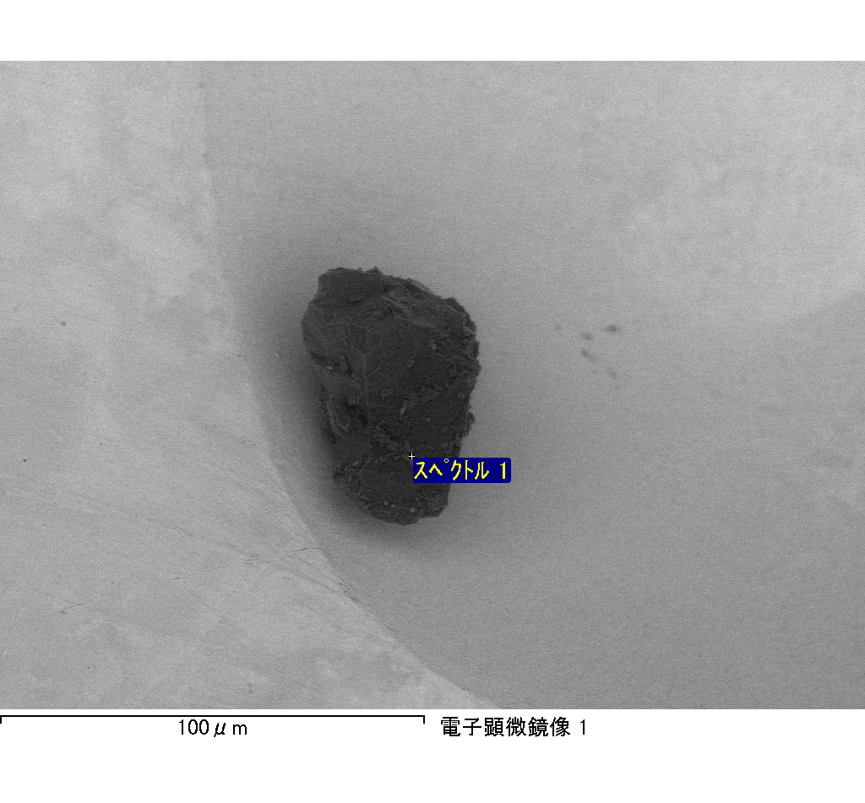

ｽﾍﾟｸﾄﾙﾗﾍﾞﾙ: ｽﾍﾟｸﾄﾙ 2

ﾗｲﾌﾞﾀｲﾑ 120.0 s

収集ｼﾞｵﾒﾄﾘ[度] :

試料傾斜角 = 0.0

方位角 = 0.0

ｴﾚﾍﾞｰｼｮﾝ = 30.0

加速電圧 = 10.00 kV

ｽﾍﾟｸﾄﾙ全ｶｳﾝﾄ数 = 179870

|  |  |  |  |
| --- | --- | --- | --- |
| ｻﾝﾌﾟﾙﾃﾞｰﾀ : | ｴﾈﾙｷﾞｰ[eV] | 分解能[eV] | ｶｳﾝﾄ数 |
| ｽﾄﾛｰﾌﾞ : | 3.8 | 52.12 | 1196452 |
|  |  |  |  |

定量最適化がおこなわれていません

ｽﾍﾟｸﾄﾙ処理 :

定量計算に使用されていないﾋﾟｰｸ : 2.800 keV

処理ｵﾌﾟｼｮﾝ : 酸素 ｽﾄｲｷｵﾒﾄﾘ (ﾉｰﾏﾗｲｽﾞ)

繰り返し回数 = 2

ｽﾀﾝﾀﾞｰﾄﾞ :

Na Albite 1999/06/01

Mg MgO 1999/06/01

Al Al2O3 1999/06/01

Si SiO2 1999/06/01

P GaP 1999/06/01

S FeS2 1999/06/01

K MAD-10 Feldspar 1999/06/01

Ca Wollastonite 1999/06/01

Cr Cr 1999/06/01

Mn Mn 1999/06/01

Fe Fe 1999/06/01

Ni Ni 1999/06/01

|  |  |  |  |  |  |
| --- | --- | --- | --- | --- | --- |
| 元素 | 質量濃度 | 原子数 | 化合物 | 化学式 |  |
|  | [%] | 濃度[%] | 濃度[%] |  |  |
| Na K | 9.16 | 14.75 | 12.35 | Na2O |  |
| Mg K | 50.45 | 76.79 | 83.64 | MgO |  |
| Al K | 11.72 | 16.08 | 22.14 | Al2O3 |  |
| Si K | 146.27 | 192.74 | 312.91 | SiO2 |  |
| P K | -107.16 | -128.04 | -245.53 | P2O5 |  |
| S K | -87.20 | -100.65 | -217.72 | SO3 |  |
| K K | -1.44 | -1.36 | -1.73 | K2O |  |
| Ca K | 57.03 | 52.66 | 79.79 | CaO |  |
| Cr K | -7.60 | -5.41 | -11.11 | Cr2O3 |  |
| Mn K | 9.74 | 6.56 | 12.58 | MnO |  |
| Fe K | 30.05 | 19.92 | 38.67 | FeO |  |
| Ni K | 11.02 | 6.94 | 14.02 | NiO |  |
| O | -22.04 | -50.98 |  |  |  |
| ﾄｰﾀﾙ | 100.00 |  |  |  |  |

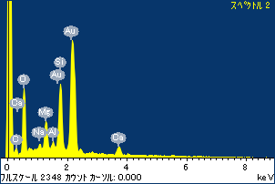

ﾌﾟﾛｼﾞｪｸﾄ : ﾌﾟﾛｼﾞｪｸﾄ 1

ｵｰﾅｰ : Administrator

領域 分析領域 5

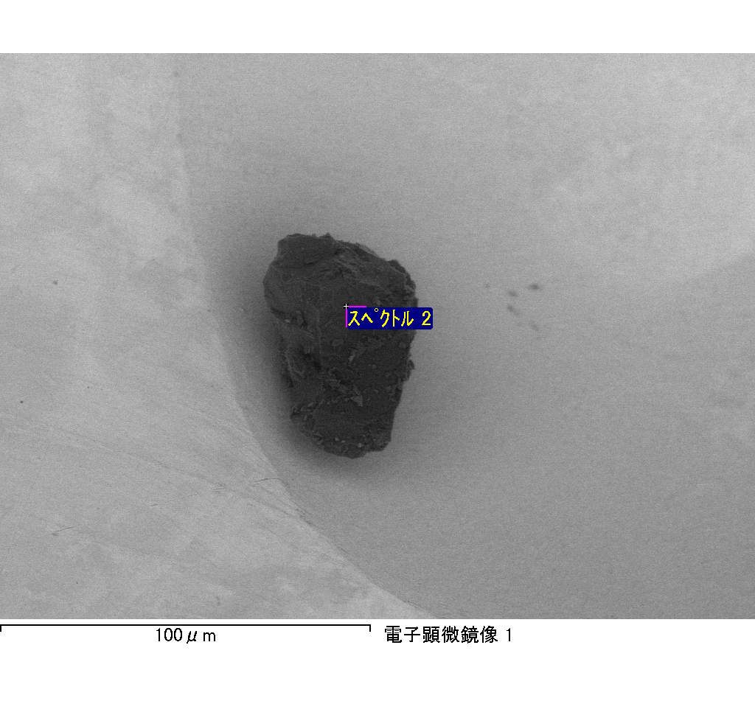

ｽﾍﾟｸﾄﾙﾗﾍﾞﾙ: ｽﾍﾟｸﾄﾙ 3

ﾗｲﾌﾞﾀｲﾑ 120.0 s

収集ｼﾞｵﾒﾄﾘ[度] :

試料傾斜角 = 0.0

方位角 = 0.0

ｴﾚﾍﾞｰｼｮﾝ = 30.0

加速電圧 = 10.00 kV

ｽﾍﾟｸﾄﾙ全ｶｳﾝﾄ数 = 172288

|  |  |  |  |
| --- | --- | --- | --- |
| ｻﾝﾌﾟﾙﾃﾞｰﾀ : | ｴﾈﾙｷﾞｰ[eV] | 分解能[eV] | ｶｳﾝﾄ数 |
| ｽﾄﾛｰﾌﾞ : | 3.8 | 52.14 | 1196957 |
|  |  |  |  |

定量最適化がおこなわれていません

ｽﾍﾟｸﾄﾙ処理 :

省略されたﾋﾟｰｸはありません

処理ｵﾌﾟｼｮﾝ : 酸素 ｽﾄｲｷｵﾒﾄﾘ (ﾉｰﾏﾗｲｽﾞ)

繰り返し回数 = 2

ｽﾀﾝﾀﾞｰﾄﾞ :

Na Albite 1999/06/01

Mg MgO 1999/06/01

Al Al2O3 1999/06/01

Si SiO2 1999/06/01

P GaP 1999/06/01

S FeS2 1999/06/01

K MAD-10 Feldspar 1999/06/01

Ca Wollastonite 1999/06/01

Cr Cr 1999/06/01

Mn Mn 1999/06/01

Fe Fe 1999/06/01

Ni Ni 1999/06/01

|  |  |  |  |  |  |
| --- | --- | --- | --- | --- | --- |
| 元素 | 質量濃度 | 原子数 | 化合物 | 化学式 |  |
|  | [%] | 濃度[%] | 濃度[%] |  |  |
| Na K | -1.35 | -1.10 | -1.82 | Na2O |  |
| Mg K | -11.88 | -9.15 | -19.70 | MgO |  |
| Al K | -2.29 | -1.59 | -4.33 | Al2O3 |  |
| Si K | -51.10 | -34.08 | -109.33 | SiO2 |  |
| P K | 62.89 | 38.03 | 144.09 | P2O5 |  |
| S K | 51.50 | 30.09 | 128.59 | SO3 |  |
| K K | 0.56 | 0.27 | 0.67 | K2O |  |
| Ca K | -37.66 | -17.60 | -52.70 | CaO |  |
| Cr K | 2.27 | 0.82 | 3.32 | Cr2O3 |  |
| Mn K | 4.27 | 1.46 | 5.51 | MnO |  |
| Fe K | -10.64 | -3.57 | -13.68 | FeO |  |
| Ni K | 15.22 | 4.86 | 19.37 | NiO |  |
| O | 78.22 | 91.58 |  |  |  |
| ﾄｰﾀﾙ | 100.00 |  |  |  |  |

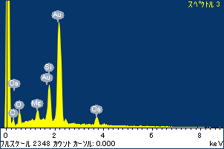

ﾌﾟﾛｼﾞｪｸﾄ : ﾌﾟﾛｼﾞｪｸﾄ 1

ｵｰﾅｰ : Administrator

領域 分析領域 5

