ｽﾍﾟｸﾄﾙﾗﾍﾞﾙ: ｽﾍﾟｸﾄﾙ 1

ﾗｲﾌﾞﾀｲﾑ 120.0 s

収集ｼﾞｵﾒﾄﾘ[度] :

試料傾斜角 = 0.0

方位角 = 0.0

ｴﾚﾍﾞｰｼｮﾝ = 30.0

加速電圧 = 10.00 kV

ｽﾍﾟｸﾄﾙ全ｶｳﾝﾄ数 = 212222

|  |  |  |  |
| --- | --- | --- | --- |
| ｻﾝﾌﾟﾙﾃﾞｰﾀ : | ｴﾈﾙｷﾞｰ[eV] | 分解能[eV] | ｶｳﾝﾄ数 |
| ｽﾄﾛｰﾌﾞ : | 3.8 | 51.88 | 1195362 |
|  |  |  |  |

定量最適化がおこなわれていません

ｽﾍﾟｸﾄﾙ処理 :

定量計算に使用されていないﾋﾟｰｸ : 2.820 keV

処理ｵﾌﾟｼｮﾝ : 酸素 ｽﾄｲｷｵﾒﾄﾘ (ﾉｰﾏﾗｲｽﾞ)

繰り返し回数 = 2

ｽﾀﾝﾀﾞｰﾄﾞ :

Na Albite 1999/06/01

Mg MgO 1999/06/01

Al Al2O3 1999/06/01

Si SiO2 1999/06/01

P GaP 1999/06/01

S FeS2 1999/06/01

K MAD-10 Feldspar 1999/06/01

Ca Wollastonite 1999/06/01

Cr Cr 1999/06/01

Mn Mn 1999/06/01

Fe Fe 1999/06/01

Ni Ni 1999/06/01

|  |  |  |  |  |  |
| --- | --- | --- | --- | --- | --- |
| 元素 | 質量濃度 | 原子数 | 化合物 | 化学式 |  |
|  | [%] | 濃度[%] | 濃度[%] |  |  |
| Na K | 0.32 | 0.41 | 0.43 | Na2O |  |
| Mg K | 113.36 | 138.64 | 187.96 | MgO |  |
| Al K | 2.19 | 2.42 | 4.14 | Al2O3 |  |
| Si K | 178.05 | 188.50 | 380.90 | SiO2 |  |
| P K | -129.83 | -124.63 | -297.48 | P2O5 |  |
| S K | -101.76 | -94.37 | -254.09 | SO3 |  |
| K K | -1.93 | -1.47 | -2.32 | K2O |  |
| Ca K | 1.04 | 0.77 | 1.46 | CaO |  |
| Cr K | -4.61 | -2.63 | -6.73 | Cr2O3 |  |
| Mn K | -2.55 | -1.38 | -3.29 | MnO |  |
| Fe K | 82.79 | 44.08 | 106.51 | FeO |  |
| Ni K | -13.74 | -6.96 | -17.48 | NiO |  |
| O | -23.34 | -43.38 |  |  |  |
| ﾄｰﾀﾙ | 100.00 |  |  |  |  |

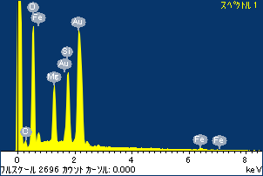

ﾌﾟﾛｼﾞｪｸﾄ : ﾌﾟﾛｼﾞｪｸﾄ20110509Au05

ｵｰﾅｰ : Administrator

領域 分析領域 1

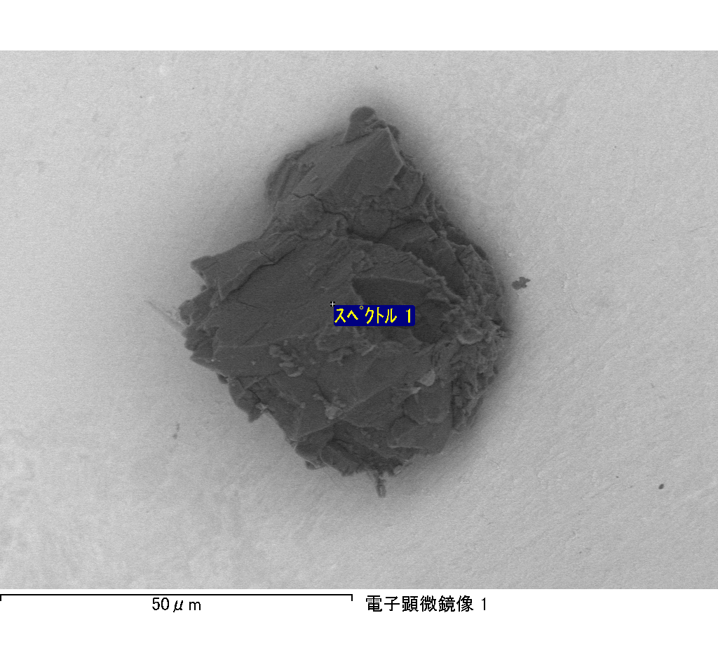

ｽﾍﾟｸﾄﾙ処理 :

定量計算に使用されていないﾋﾟｰｸ : 2.790 keV

処理ｵﾌﾟｼｮﾝ : 酸素 ｽﾄｲｷｵﾒﾄﾘ (ﾉｰﾏﾗｲｽﾞ)

繰り返し回数 = 2

ｽﾀﾝﾀﾞｰﾄﾞ :

Na Albite 1999/06/01

Mg MgO 1999/06/01

Al Al2O3 1999/06/01

Si SiO2 1999/06/01

P GaP 1999/06/01

S FeS2 1999/06/01

K MAD-10 Feldspar 1999/06/01

Ca Wollastonite 1999/06/01

Cr Cr 1999/06/01

Mn Mn 1999/06/01

Fe Fe 1999/06/01

Ni Ni 1999/06/01

|  |  |  |  |  |  |
| --- | --- | --- | --- | --- | --- |
| 元素 | 質量濃度 | 原子数 | 化合物 | 化学式 |  |
|  | [%] | 濃度[%] | 濃度[%] |  |  |
| Na K | 0.55 | 0.70 | 0.74 | Na2O |  |
| Mg K | 806.88 | 977.43 | 1337.86 | MgO |  |
| Al K | 2.72 | 2.97 | 5.14 | Al2O3 |  |
| Si K | 1238.93 | 1299.14 | 2650.42 | SiO2 |  |
| P K | -998.37 | -949.28 | -2287.59 | P2O5 |  |
| S K | -691.96 | -635.57 | -1727.77 | SO3 |  |
| K K | 4.64 | 3.49 | 5.59 | K2O |  |
| Ca K | 11.07 | 8.14 | 15.49 | CaO |  |
| Cr K | -46.66 | -26.43 | -68.20 | Cr2O3 |  |
| Mn K | 50.19 | 26.91 | 64.81 | MnO |  |
| Fe K | 325.31 | 171.55 | 418.51 | FeO |  |
| Ni K | -247.53 | -124.17 | -314.98 | NiO |  |
| O | -355.76 | -654.88 |  |  |  |
| ﾄｰﾀﾙ | 100.00 |  |  |  |  |

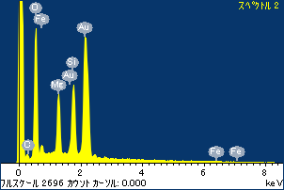

ﾌﾟﾛｼﾞｪｸﾄ : ﾌﾟﾛｼﾞｪｸﾄ20110509Au05

ｵｰﾅｰ : Administrator

領域 分析領域 1

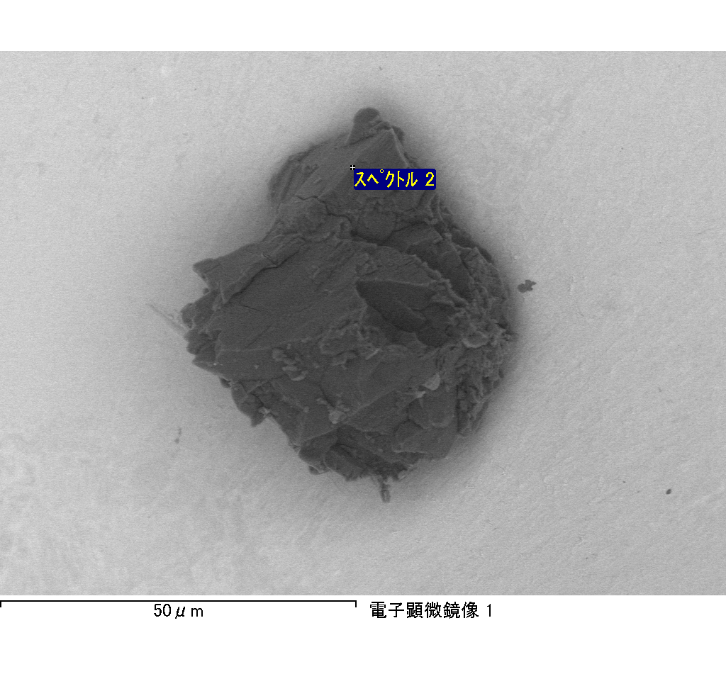

ｽﾍﾟｸﾄﾙﾗﾍﾞﾙ: ｽﾍﾟｸﾄﾙ 2

ﾗｲﾌﾞﾀｲﾑ 120.0 s

収集ｼﾞｵﾒﾄﾘ[度] :

試料傾斜角 = 0.0

方位角 = 0.0

ｴﾚﾍﾞｰｼｮﾝ = 30.0

加速電圧 = 10.00 kV

ｽﾍﾟｸﾄﾙ全ｶｳﾝﾄ数 = 208838

|  |  |  |  |
| --- | --- | --- | --- |
| ｻﾝﾌﾟﾙﾃﾞｰﾀ : | ｴﾈﾙｷﾞｰ[eV] | 分解能[eV] | ｶｳﾝﾄ数 |
| ｽﾄﾛｰﾌﾞ : | 3.8 | 51.83 | 1195713 |
|  |  |  |  |

定量最適化がおこなわれていません

ｽﾍﾟｸﾄﾙﾗﾍﾞﾙ: ｽﾍﾟｸﾄﾙ 1

ﾗｲﾌﾞﾀｲﾑ 120.0 s

収集ｼﾞｵﾒﾄﾘ[度] :

試料傾斜角 = 0.0

方位角 = 0.0

ｴﾚﾍﾞｰｼｮﾝ = 30.0

加速電圧 = 10.00 kV

ｽﾍﾟｸﾄﾙ全ｶｳﾝﾄ数 = 194068

|  |  |  |  |
| --- | --- | --- | --- |
| ｻﾝﾌﾟﾙﾃﾞｰﾀ : | ｴﾈﾙｷﾞｰ[eV] | 分解能[eV] | ｶｳﾝﾄ数 |
| ｽﾄﾛｰﾌﾞ : | 3.8 | 51.91 | 1196331 |
|  |  |  |  |

定量最適化がおこなわれていません

ｽﾍﾟｸﾄﾙ処理 :

省略されたﾋﾟｰｸはありません

処理ｵﾌﾟｼｮﾝ : 酸素 ｽﾄｲｷｵﾒﾄﾘ (ﾉｰﾏﾗｲｽﾞ)

繰り返し回数 = 2

ｽﾀﾝﾀﾞｰﾄﾞ :

Na Albite 1999/06/01

Mg MgO 1999/06/01

Al Al2O3 1999/06/01

Si SiO2 1999/06/01

P GaP 1999/06/01

S FeS2 1999/06/01

K MAD-10 Feldspar 1999/06/01

Ca Wollastonite 1999/06/01

Cr Cr 1999/06/01

Mn Mn 1999/06/01

Fe Fe 1999/06/01

Ni Ni 1999/06/01

|  |  |  |  |  |  |
| --- | --- | --- | --- | --- | --- |
| 元素 | 質量濃度 | 原子数 | 化合物 | 化学式 |  |
|  | [%] | 濃度[%] | 濃度[%] |  |  |
| Na K | 0.77 | 1.18 | 1.03 | Na2O |  |
| Mg K | 84.89 | 123.33 | 140.75 | MgO |  |
| Al K | 0.42 | 0.55 | 0.80 | Al2O3 |  |
| Si K | 139.04 | 174.87 | 297.46 | SiO2 |  |
| P K | -102.85 | -117.29 | -235.66 | P2O5 |  |
| S K | -82.71 | -91.12 | -206.53 | SO3 |  |
| K K | 1.31 | 1.19 | 1.58 | K2O |  |
| Ca K | 3.67 | 3.24 | 5.14 | CaO |  |
| Cr K | -2.72 | -1.85 | -3.97 | Cr2O3 |  |
| Mn K | 3.62 | 2.33 | 4.67 | MnO |  |
| Fe K | 55.57 | 35.14 | 71.48 | FeO |  |
| Ni K | 18.27 | 10.99 | 23.25 | NiO |  |
| O | -19.28 | -42.56 |  |  |  |
| ﾄｰﾀﾙ | 100.00 |  |  |  |  |

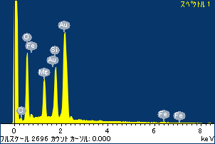

ﾌﾟﾛｼﾞｪｸﾄ : ﾌﾟﾛｼﾞｪｸﾄ20110509Au05

ｵｰﾅｰ : Administrator

領域 分析領域 2

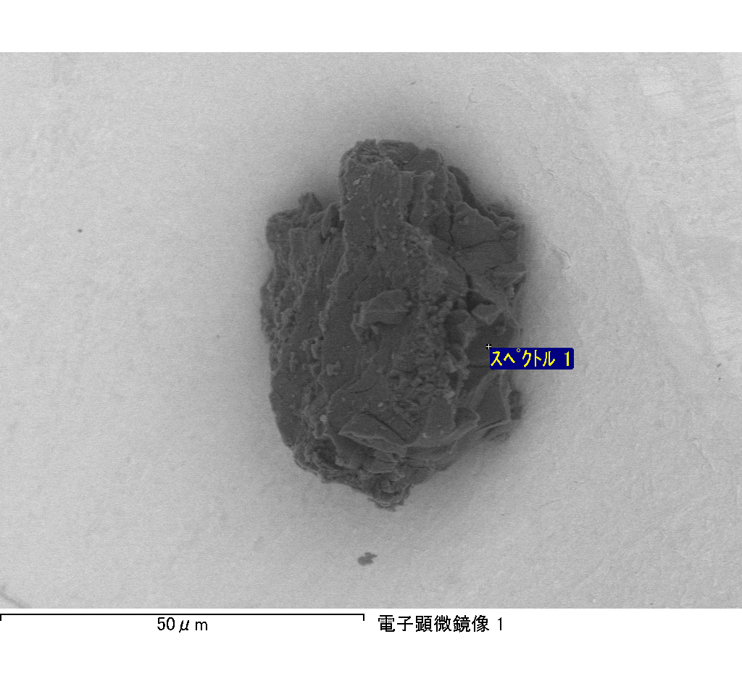

ｽﾍﾟｸﾄﾙ処理 :

省略されたﾋﾟｰｸはありません

処理ｵﾌﾟｼｮﾝ : 酸素 ｽﾄｲｷｵﾒﾄﾘ (ﾉｰﾏﾗｲｽﾞ)

繰り返し回数 = 2

ｽﾀﾝﾀﾞｰﾄﾞ :

Na Albite 1999/06/01

Mg MgO 1999/06/01

Al Al2O3 1999/06/01

Si SiO2 1999/06/01

P GaP 1999/06/01

S FeS2 1999/06/01

K MAD-10 Feldspar 1999/06/01

Ca Wollastonite 1999/06/01

Cr Cr 1999/06/01

Mn Mn 1999/06/01

Fe Fe 1999/06/01

Ni Ni 1999/06/01

|  |  |  |  |  |  |
| --- | --- | --- | --- | --- | --- |
| 元素 | 質量濃度 | 原子数 | 化合物 | 化学式 |  |
|  | [%] | 濃度[%] | 濃度[%] |  |  |
| Na K | -0.10 | -4.95 | -0.14 | Na2O |  |
| Mg K | 17.06 | 770.99 | 28.28 | MgO |  |
| Al K | 1.83 | 74.43 | 3.45 | Al2O3 |  |
| Si K | 18.61 | 728.09 | 39.81 | SiO2 |  |
| P K | -65.93 | -2339.19 | -151.07 | P2O5 |  |
| S K | -17.89 | -613.31 | -44.68 | SO3 |  |
| K K | -1.62 | -45.66 | -1.96 | K2O |  |
| Ca K | -1.36 | -37.30 | -1.90 | CaO |  |
| Cr K | -2.08 | -44.03 | -3.04 | Cr2O3 |  |
| Mn K | -2.88 | -57.60 | -3.72 | MnO |  |
| Fe K | 193.08 | 3799.33 | 248.39 | FeO |  |
| Ni K | -10.55 | -197.39 | -13.42 | NiO |  |
| O | -28.15 | -1933.40 |  |  |  |
| ﾄｰﾀﾙ | 100.00 |  |  |  |  |

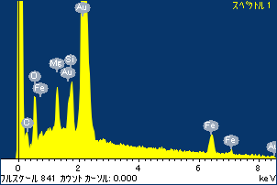

ﾌﾟﾛｼﾞｪｸﾄ : ﾌﾟﾛｼﾞｪｸﾄ20110509Au05

ｵｰﾅｰ : Administrator

領域 分析領域 3

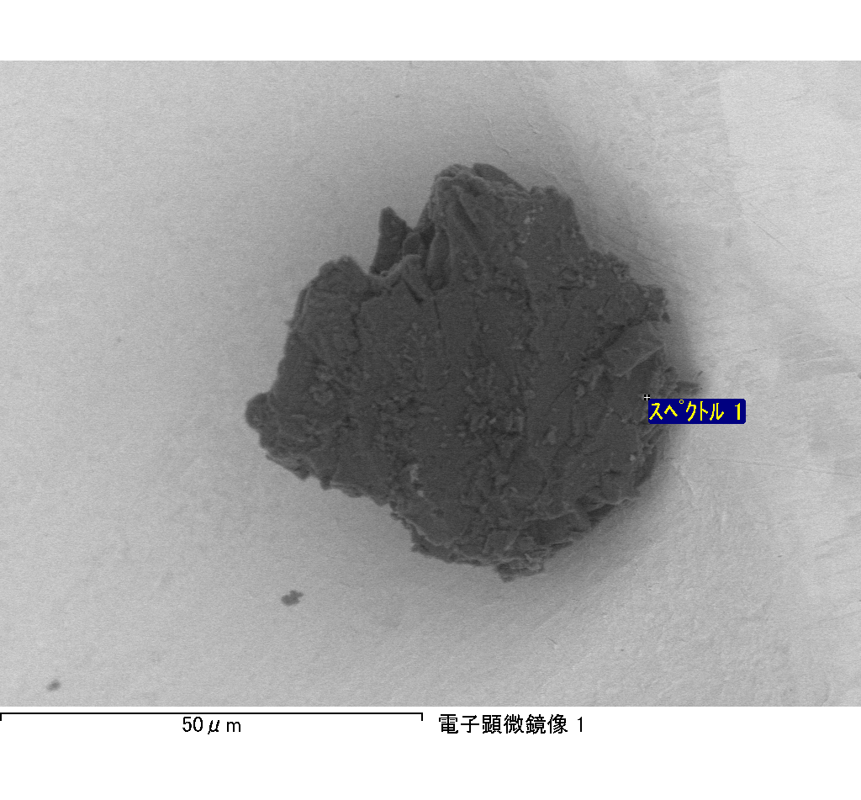

ｽﾍﾟｸﾄﾙﾗﾍﾞﾙ: ｽﾍﾟｸﾄﾙ 1

ﾗｲﾌﾞﾀｲﾑ 120.0 s

収集ｼﾞｵﾒﾄﾘ[度] :

試料傾斜角 = 0.0

方位角 = 0.0

ｴﾚﾍﾞｰｼｮﾝ = 30.0

加速電圧 = 10.00 kV

ｽﾍﾟｸﾄﾙ全ｶｳﾝﾄ数 = 183585

|  |  |  |  |
| --- | --- | --- | --- |
| ｻﾝﾌﾟﾙﾃﾞｰﾀ : | ｴﾈﾙｷﾞｰ[eV] | 分解能[eV] | ｶｳﾝﾄ数 |
| ｽﾄﾛｰﾌﾞ : | 3.8 | 51.88 | 1197227 |
|  |  |  |  |

定量最適化がおこなわれていません