ｽﾍﾟｸﾄﾙﾗﾍﾞﾙ: ｽﾍﾟｸﾄﾙ 1

ﾗｲﾌﾞﾀｲﾑ 120.0 s

収集ｼﾞｵﾒﾄﾘ[度] :

試料傾斜角 = 0.0

方位角 = 0.0

ｴﾚﾍﾞｰｼｮﾝ = 30.0

加速電圧 = 10.00 kV

ｽﾍﾟｸﾄﾙ全ｶｳﾝﾄ数 = 215522

|  |  |  |  |
| --- | --- | --- | --- |
| ｻﾝﾌﾟﾙﾃﾞｰﾀ : | ｴﾈﾙｷﾞｰ[eV] | 分解能[eV] | ｶｳﾝﾄ数 |
| ｽﾄﾛｰﾌﾞ : | 3.8 | 51.88 | 1193300 |
|  |  |  |  |

定量最適化がおこなわれていません

ｽﾍﾟｸﾄﾙ処理 :

省略されたﾋﾟｰｸはありません

処理ｵﾌﾟｼｮﾝ : 酸素 ｽﾄｲｷｵﾒﾄﾘ (ﾉｰﾏﾗｲｽﾞ)

繰り返し回数 = 2

ｽﾀﾝﾀﾞｰﾄﾞ :

Na Albite 1999/06/01

Mg MgO 1999/06/01

Al Al2O3 1999/06/01

Si SiO2 1999/06/01

P GaP 1999/06/01

S FeS2 1999/06/01

K MAD-10 Feldspar 1999/06/01

Ca Wollastonite 1999/06/01

Cr Cr 1999/06/01

Mn Mn 1999/06/01

Fe Fe 1999/06/01

Ni Ni 1999/06/01

|  |  |  |  |  |  |
| --- | --- | --- | --- | --- | --- |
| 元素 | 質量濃度 | 原子数 | 化合物 | 化学式 |  |
|  | [%] | 濃度[%] | 濃度[%] |  |  |
| Na K | 6.08 | -15.02 | 8.20 | Na2O |  |
| Mg K | 267.43 | -624.86 | 443.42 | MgO |  |
| Al K | 8.50 | -17.90 | 16.07 | Al2O3 |  |
| Si K | 243.62 | -492.73 | 521.17 | SiO2 |  |
| P K | -276.37 | 506.85 | -633.25 | P2O5 |  |
| S K | -227.09 | 402.32 | -567.02 | SO3 |  |
| K K | -0.12 | 0.18 | -0.15 | K2O |  |
| Ca K | 1.61 | -2.28 | 2.26 | CaO |  |
| Cr K | 0.47 | -0.51 | 0.69 | Cr2O3 |  |
| Mn K | 19.56 | -20.22 | 25.25 | MnO |  |
| Fe K | 142.24 | -144.68 | 182.99 | FeO |  |
| Ni K | 78.88 | -76.33 | 100.38 | NiO |  |
| O | -164.82 | 585.20 |  |  |  |
| ﾄｰﾀﾙ | 100.00 |  |  |  |  |

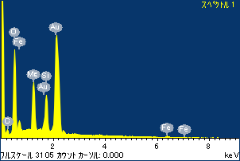

ﾌﾟﾛｼﾞｪｸﾄ : ﾌﾟﾛｼﾞｪｸﾄ 120110516

ｵｰﾅｰ : Administrator

領域 分析領域 1

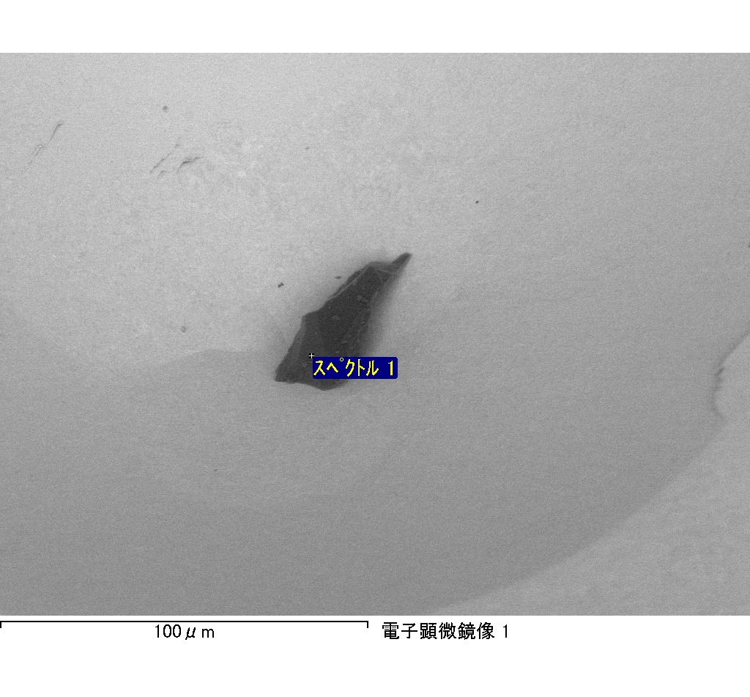

ｽﾍﾟｸﾄﾙﾗﾍﾞﾙ: ｽﾍﾟｸﾄﾙ 2

ﾗｲﾌﾞﾀｲﾑ 120.0 s

収集ｼﾞｵﾒﾄﾘ[度] :

試料傾斜角 = 0.0

方位角 = 0.0

ｴﾚﾍﾞｰｼｮﾝ = 30.0

加速電圧 = 10.00 kV

ｽﾍﾟｸﾄﾙ全ｶｳﾝﾄ数 = 219769

|  |  |  |  |
| --- | --- | --- | --- |
| ｻﾝﾌﾟﾙﾃﾞｰﾀ : | ｴﾈﾙｷﾞｰ[eV] | 分解能[eV] | ｶｳﾝﾄ数 |
| ｽﾄﾛｰﾌﾞ : | 3.8 | 51.82 | 1194025 |
|  |  |  |  |

定量最適化がおこなわれていません

ｽﾍﾟｸﾄﾙ処理 :

定量計算に使用されていないﾋﾟｰｸ : 2.775 keV

処理ｵﾌﾟｼｮﾝ : 酸素 ｽﾄｲｷｵﾒﾄﾘ (ﾉｰﾏﾗｲｽﾞ)

繰り返し回数 = 2

ｽﾀﾝﾀﾞｰﾄﾞ :

Na Albite 1999/06/01

Mg MgO 1999/06/01

Al Al2O3 1999/06/01

Si SiO2 1999/06/01

P GaP 1999/06/01

S FeS2 1999/06/01

K MAD-10 Feldspar 1999/06/01

Ca Wollastonite 1999/06/01

Cr Cr 1999/06/01

Mn Mn 1999/06/01

Fe Fe 1999/06/01

Ni Ni 1999/06/01

|  |  |  |  |  |  |
| --- | --- | --- | --- | --- | --- |
| 元素 | 質量濃度 | 原子数 | 化合物 | 化学式 |  |
|  | [%] | 濃度[%] | 濃度[%] |  |  |
| Na K | 47.60 | 50.59 | 64.16 | Na2O |  |
| Mg K | 4.54 | 4.56 | 7.53 | MgO |  |
| Al K | 77.09 | 69.81 | 145.66 | Al2O3 |  |
| Si K | 219.76 | 191.19 | 470.13 | SiO2 |  |
| P K | -148.96 | -117.51 | -341.31 | P2O5 |  |
| S K | -115.54 | -88.04 | -288.48 | SO3 |  |
| K K | 5.40 | 3.37 | 6.50 | K2O |  |
| Ca K | 5.68 | 3.47 | 7.95 | CaO |  |
| Cr K | -0.37 | -0.17 | -0.54 | Cr2O3 |  |
| Mn K | -1.94 | -0.86 | -2.51 | MnO |  |
| Fe K | 9.19 | 4.02 | 11.82 | FeO |  |
| Ni K | 15.01 | 6.25 | 19.09 | NiO |  |
| O | -17.46 | -26.66 |  |  |  |
| ﾄｰﾀﾙ | 100.00 |  |  |  |  |

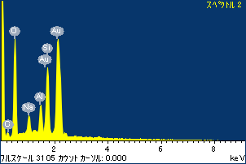

ﾌﾟﾛｼﾞｪｸﾄ : ﾌﾟﾛｼﾞｪｸﾄ 120110516

ｵｰﾅｰ : Administrator

領域 分析領域 1

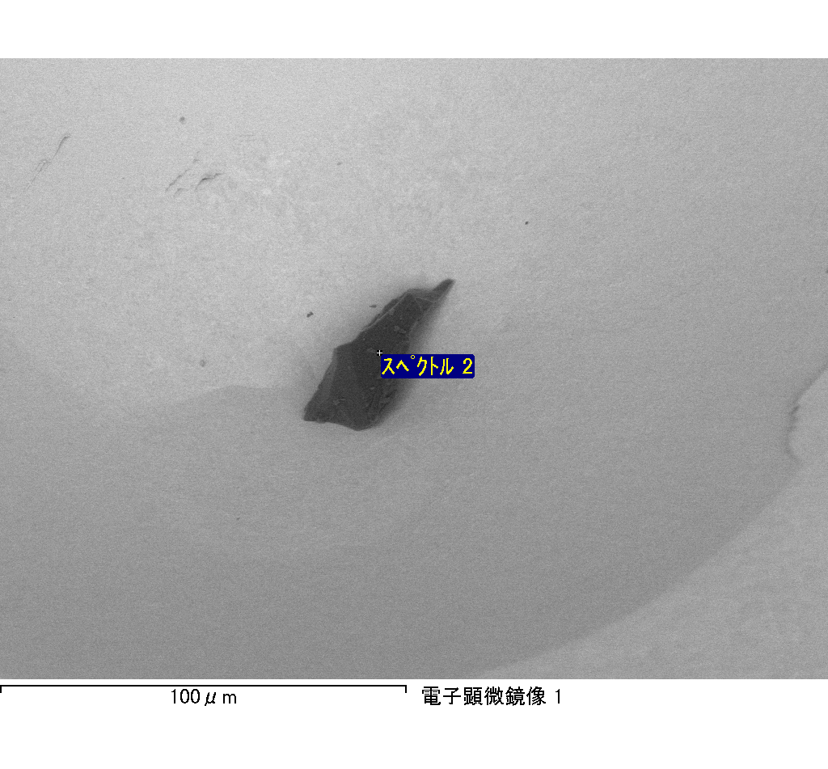

ｽﾍﾟｸﾄﾙﾗﾍﾞﾙ: ｽﾍﾟｸﾄﾙ 3

ﾗｲﾌﾞﾀｲﾑ 120.0 s

収集ｼﾞｵﾒﾄﾘ[度] :

試料傾斜角 = 0.0

方位角 = 0.0

ｴﾚﾍﾞｰｼｮﾝ = 30.0

加速電圧 = 10.00 kV

ｽﾍﾟｸﾄﾙ全ｶｳﾝﾄ数 = 231641

|  |  |  |  |
| --- | --- | --- | --- |
| ｻﾝﾌﾟﾙﾃﾞｰﾀ : | ｴﾈﾙｷﾞｰ[eV] | 分解能[eV] | ｶｳﾝﾄ数 |
| ｽﾄﾛｰﾌﾞ : | 3.8 | 51.85 | 1194045 |
|  |  |  |  |

定量最適化がおこなわれていません

ｽﾍﾟｸﾄﾙ処理 :

省略されたﾋﾟｰｸはありません

処理ｵﾌﾟｼｮﾝ : 酸素 ｽﾄｲｷｵﾒﾄﾘ (ﾉｰﾏﾗｲｽﾞ)

繰り返し回数 = 2

ｽﾀﾝﾀﾞｰﾄﾞ :

Na Albite 1999/06/01

Mg MgO 1999/06/01

Al Al2O3 1999/06/01

Si SiO2 1999/06/01

P GaP 1999/06/01

S FeS2 1999/06/01

K MAD-10 Feldspar 1999/06/01

Ca Wollastonite 1999/06/01

Cr Cr 1999/06/01

Mn Mn 1999/06/01

Fe Fe 1999/06/01

Ni Ni 1999/06/01

|  |  |  |  |  |  |
| --- | --- | --- | --- | --- | --- |
| 元素 | 質量濃度 | 原子数 | 化合物 | 化学式 |  |
|  | [%] | 濃度[%] | 濃度[%] |  |  |
| Na K | -1.20 | -0.66 | -1.62 | Na2O |  |
| Mg K | -167.12 | -87.08 | -277.09 | MgO |  |
| Al K | -6.84 | -3.21 | -12.93 | Al2O3 |  |
| Si K | -145.45 | -65.60 | -311.15 | SiO2 |  |
| P K | 195.03 | 79.76 | 446.87 | P2O5 |  |
| S K | 159.23 | 62.91 | 397.58 | SO3 |  |
| K K | -1.45 | -0.47 | -1.74 | K2O |  |
| Ca K | -1.61 | -0.51 | -2.26 | CaO |  |
| Cr K | -0.48 | -0.12 | -0.70 | Cr2O3 |  |
| Mn K | 4.05 | 0.93 | 5.23 | MnO |  |
| Fe K | -141.09 | -32.00 | -181.50 | FeO |  |
| Ni K | 30.90 | 6.67 | 39.32 | NiO |  |
| O | 176.03 | 139.38 |  |  |  |
| ﾄｰﾀﾙ | 100.00 |  |  |  |  |

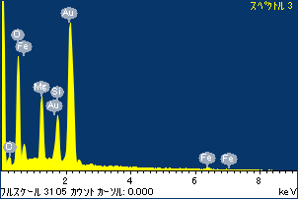

ﾌﾟﾛｼﾞｪｸﾄ : ﾌﾟﾛｼﾞｪｸﾄ 120110516

ｵｰﾅｰ : Administrator

領域 分析領域 1

