ｽﾍﾟｸﾄﾙ処理 :

省略されたﾋﾟｰｸはありません

処理ｵﾌﾟｼｮﾝ : 酸素 ｽﾄｲｷｵﾒﾄﾘ (ﾉｰﾏﾗｲｽﾞ)

繰り返し回数 = 2

ｽﾀﾝﾀﾞｰﾄﾞ :

Na Albite 1999/06/01

Mg MgO 1999/06/01

Al Al2O3 1999/06/01

Si SiO2 1999/06/01

P GaP 1999/06/01

S FeS2 1999/06/01

K MAD-10 Feldspar 1999/06/01

Ca Wollastonite 1999/06/01

Cr Cr 1999/06/01

Mn Mn 1999/06/01

Fe Fe 1999/06/01

Ni Ni 1999/06/01

|  |  |  |  |  |  |
| --- | --- | --- | --- | --- | --- |
| 元素 | 質量濃度 | 原子数 | 化合物 | 化学式 |  |
|  | [%] | 濃度[%] | 濃度[%] |  |  |
| Na K | 23.61 | -5.45 | 31.82 | Na2O |  |
| Mg K | 992.31 | -216.69 | 1645.32 | MgO |  |
| Al K | -2.01 | 0.39 | -3.79 | Al2O3 |  |
| Si K | 769.21 | -145.40 | 1645.57 | SiO2 |  |
| P K | -1014.32 | 173.85 | -2324.14 | P2O5 |  |
| S K | -802.73 | 132.91 | -2004.36 | SO3 |  |
| K K | 3.44 | -0.47 | 4.15 | K2O |  |
| Ca K | 31.13 | -4.12 | 43.56 | CaO |  |
| Cr K | -19.18 | 1.96 | -28.04 | Cr2O3 |  |
| Mn K | 17.54 | -1.70 | 22.65 | MnO |  |
| Fe K | 582.55 | -55.38 | 749.44 | FeO |  |
| Ni K | 249.76 | -22.58 | 317.82 | NiO |  |
| O | -731.31 | 242.67 |  |  |  |
| ﾄｰﾀﾙ | 100.00 |  |  |  |  |

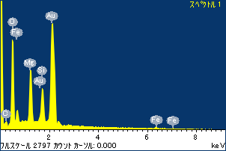

ﾌﾟﾛｼﾞｪｸﾄ : ﾌﾟﾛｼﾞｪｸﾄ20110519

ｵｰﾅｰ : Administrator

領域 分析領域 14

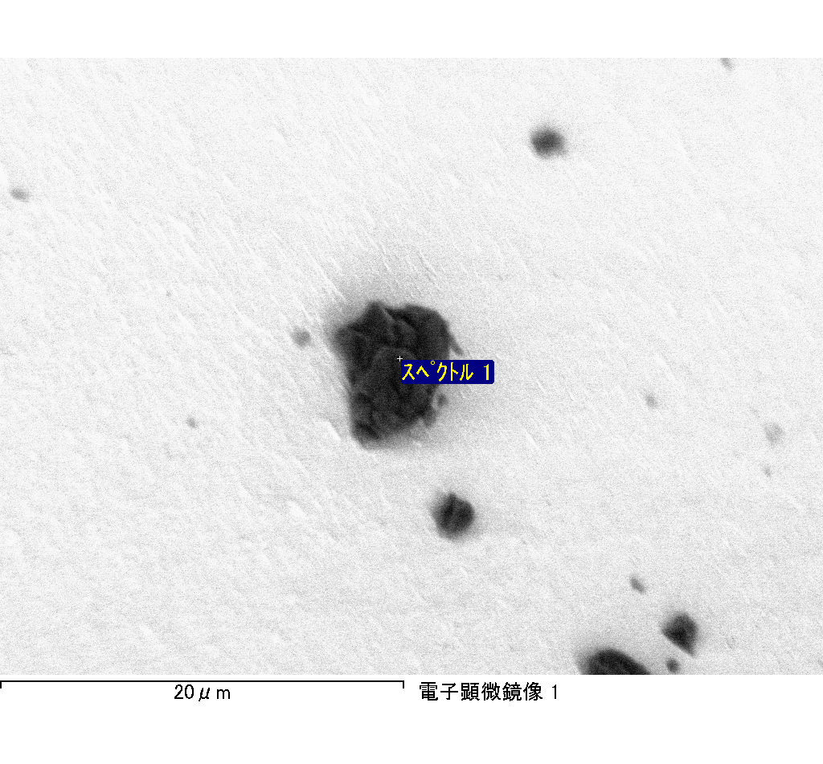

ｽﾍﾟｸﾄﾙﾗﾍﾞﾙ: ｽﾍﾟｸﾄﾙ 1

ﾗｲﾌﾞﾀｲﾑ 120.0 s

収集ｼﾞｵﾒﾄﾘ[度] :

試料傾斜角 = 0.0

方位角 = 0.0

ｴﾚﾍﾞｰｼｮﾝ = 30.0

加速電圧 = 10.00 kV

ｽﾍﾟｸﾄﾙ全ｶｳﾝﾄ数 = 213676

|  |  |  |  |
| --- | --- | --- | --- |
| ｻﾝﾌﾟﾙﾃﾞｰﾀ : | ｴﾈﾙｷﾞｰ[eV] | 分解能[eV] | ｶｳﾝﾄ数 |
| ｽﾄﾛｰﾌﾞ : | 3.8 | 51.75 | 1195865 |
|  |  |  |  |

定量最適化がおこなわれていません

ｽﾍﾟｸﾄﾙﾗﾍﾞﾙ: ｽﾍﾟｸﾄﾙ 1

ﾗｲﾌﾞﾀｲﾑ 120.0 s

収集ｼﾞｵﾒﾄﾘ[度] :

試料傾斜角 = 0.0

方位角 = 0.0

ｴﾚﾍﾞｰｼｮﾝ = 30.0

加速電圧 = 10.00 kV

ｽﾍﾟｸﾄﾙ全ｶｳﾝﾄ数 = 213125

|  |  |  |  |
| --- | --- | --- | --- |
| ｻﾝﾌﾟﾙﾃﾞｰﾀ : | ｴﾈﾙｷﾞｰ[eV] | 分解能[eV] | ｶｳﾝﾄ数 |
| ｽﾄﾛｰﾌﾞ : | 3.8 | 51.76 | 1195031 |
|  |  |  |  |

定量最適化がおこなわれていません

ｽﾍﾟｸﾄﾙ処理 :

省略されたﾋﾟｰｸはありません

処理ｵﾌﾟｼｮﾝ : 酸素 ｽﾄｲｷｵﾒﾄﾘ (ﾉｰﾏﾗｲｽﾞ)

繰り返し回数 = 2

ｽﾀﾝﾀﾞｰﾄﾞ :

Na Albite 1999/06/01

Mg MgO 1999/06/01

Al Al2O3 1999/06/01

Si SiO2 1999/06/01

P GaP 1999/06/01

S FeS2 1999/06/01

K MAD-10 Feldspar 1999/06/01

Ca Wollastonite 1999/06/01

Cr Cr 1999/06/01

Mn Mn 1999/06/01

Fe Fe 1999/06/01

Ni Ni 1999/06/01

|  |  |  |  |  |  |
| --- | --- | --- | --- | --- | --- |
| 元素 | 質量濃度 | 原子数 | 化合物 | 化学式 |  |
|  | [%] | 濃度[%] | 濃度[%] |  |  |
| Na K | 0.06 | 0.13 | 0.08 | Na2O |  |
| Mg K | 3.02 | 5.98 | 5.01 | MgO |  |
| Al K | 1.66 | 2.95 | 3.13 | Al2O3 |  |
| Si K | 3.50 | 6.00 | 7.49 | SiO2 |  |
| P K | -39.61 | -61.52 | -90.75 | P2O5 |  |
| S K | 16.09 | 24.14 | 40.17 | SO3 |  |
| K K | -0.03 | -0.04 | -0.04 | K2O |  |
| Ca K | -0.11 | -0.13 | -0.15 | CaO |  |
| Cr K | 1.81 | 1.68 | 2.65 | Cr2O3 |  |
| Mn K | -1.22 | -1.06 | -1.57 | MnO |  |
| Fe K | 104.95 | 90.41 | 135.02 | FeO |  |
| Ni K | -0.82 | -0.67 | -1.04 | NiO |  |
| O | 10.69 | 32.13 |  |  |  |
| ﾄｰﾀﾙ | 100.00 |  |  |  |  |

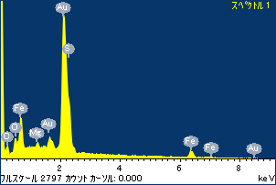

ﾌﾟﾛｼﾞｪｸﾄ : ﾌﾟﾛｼﾞｪｸﾄ20110519

ｵｰﾅｰ : Administrator

領域 分析領域 15

