ｽﾍﾟｸﾄﾙﾗﾍﾞﾙ: ｽﾍﾟｸﾄﾙ 1

ﾗｲﾌﾞﾀｲﾑ 120.0 s

収集ｼﾞｵﾒﾄﾘ[度] :

試料傾斜角 = 0.0

方位角 = 0.0

ｴﾚﾍﾞｰｼｮﾝ = 30.0

加速電圧 = 10.00 kV

ｽﾍﾟｸﾄﾙ全ｶｳﾝﾄ数 = 199595

|  |  |  |  |
| --- | --- | --- | --- |
| ｻﾝﾌﾟﾙﾃﾞｰﾀ : | ｴﾈﾙｷﾞｰ[eV] | 分解能[eV] | ｶｳﾝﾄ数 |
| ｽﾄﾛｰﾌﾞ : | 3.8 | 51.71 | 1195171 |
|  |  |  |  |

定量最適化がおこなわれていません

ｽﾍﾟｸﾄﾙ処理 :

省略されたﾋﾟｰｸはありません

処理ｵﾌﾟｼｮﾝ : 酸素 ｽﾄｲｷｵﾒﾄﾘ (ﾉｰﾏﾗｲｽﾞ)

繰り返し回数 = 2

ｽﾀﾝﾀﾞｰﾄﾞ :

Na Albite 1999/06/01

Mg MgO 1999/06/01

Al Al2O3 1999/06/01

Si SiO2 1999/06/01

P GaP 1999/06/01

S FeS2 1999/06/01

K MAD-10 Feldspar 1999/06/01

Ca Wollastonite 1999/06/01

Cr Cr 1999/06/01

Mn Mn 1999/06/01

Fe Fe 1999/06/01

Ni Ni 1999/06/01

|  |  |  |  |  |  |
| --- | --- | --- | --- | --- | --- |
| 元素 | 質量濃度 | 原子数 | 化合物 | 化学式 |  |
|  | [%] | 濃度[%] | 濃度[%] |  |  |
| Na K | 5.16 | -9.61 | 6.96 | Na2O |  |
| Mg K | 433.51 | -763.07 | 718.79 | MgO |  |
| Al K | 1.53 | -2.43 | 2.90 | Al2O3 |  |
| Si K | 358.67 | -546.51 | 767.30 | SiO2 |  |
| P K | -413.33 | 571.07 | -947.08 | P2O5 |  |
| S K | -318.41 | 424.97 | -795.04 | SO3 |  |
| K K | 0.55 | -0.60 | 0.66 | K2O |  |
| Ca K | 5.85 | -6.24 | 8.18 | CaO |  |
| Cr K | 8.12 | -6.68 | 11.86 | Cr2O3 |  |
| Mn K | -36.30 | 28.27 | -46.87 | MnO |  |
| Fe K | 210.65 | -161.41 | 270.99 | FeO |  |
| Ni K | 79.65 | -58.06 | 101.35 | NiO |  |
| O | -235.64 | 630.30 |  |  |  |
| ﾄｰﾀﾙ | 100.00 |  |  |  |  |

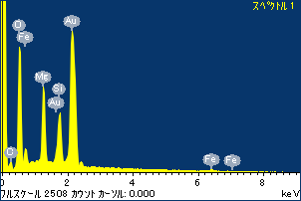

ﾌﾟﾛｼﾞｪｸﾄ : ﾌﾟﾛｼﾞｪｸﾄ20110520

ｵｰﾅｰ : Administrator

領域 分析領域 6

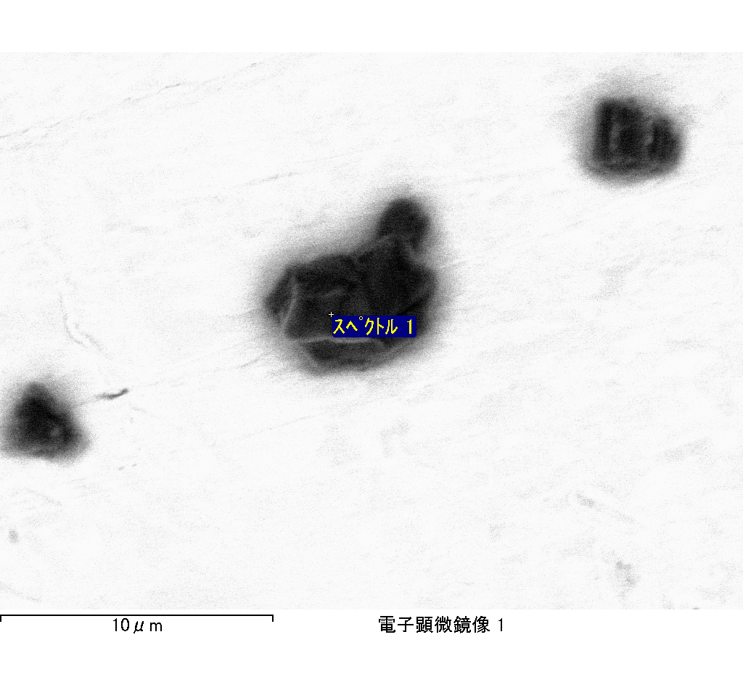

ｽﾍﾟｸﾄﾙﾗﾍﾞﾙ: ｽﾍﾟｸﾄﾙ 2

ﾗｲﾌﾞﾀｲﾑ 120.0 s

収集ｼﾞｵﾒﾄﾘ[度] :

試料傾斜角 = 0.0

方位角 = 0.0

ｴﾚﾍﾞｰｼｮﾝ = 30.0

加速電圧 = 10.00 kV

ｽﾍﾟｸﾄﾙ全ｶｳﾝﾄ数 = 202470

|  |  |  |  |
| --- | --- | --- | --- |
| ｻﾝﾌﾟﾙﾃﾞｰﾀ : | ｴﾈﾙｷﾞｰ[eV] | 分解能[eV] | ｶｳﾝﾄ数 |
| ｽﾄﾛｰﾌﾞ : | 3.8 | 51.67 | 1195273 |
|  |  |  |  |

定量最適化がおこなわれていません

ｽﾍﾟｸﾄﾙ処理 :

省略されたﾋﾟｰｸはありません

処理ｵﾌﾟｼｮﾝ : 酸素 ｽﾄｲｷｵﾒﾄﾘ (ﾉｰﾏﾗｲｽﾞ)

繰り返し回数 = 2

ｽﾀﾝﾀﾞｰﾄﾞ :

Na Albite 1999/06/01

Mg MgO 1999/06/01

Al Al2O3 1999/06/01

Si SiO2 1999/06/01

P GaP 1999/06/01

S FeS2 1999/06/01

K MAD-10 Feldspar 1999/06/01

Ca Wollastonite 1999/06/01

Cr Cr 1999/06/01

Mn Mn 1999/06/01

Fe Fe 1999/06/01

Ni Ni 1999/06/01

|  |  |  |  |  |  |
| --- | --- | --- | --- | --- | --- |
| 元素 | 質量濃度 | 原子数 | 化合物 | 化学式 |  |
|  | [%] | 濃度[%] | 濃度[%] |  |  |
| Na K | 51.12 | 58.68 | 68.91 | Na2O |  |
| Mg K | 1.61 | 1.75 | 2.67 | MgO |  |
| Al K | 75.50 | 73.85 | 142.65 | Al2O3 |  |
| Si K | 222.29 | 208.88 | 475.55 | SiO2 |  |
| P K | -154.47 | -131.61 | -353.94 | P2O5 |  |
| S K | -118.35 | -97.41 | -295.50 | SO3 |  |
| K K | 8.55 | 5.77 | 10.30 | K2O |  |
| Ca K | 9.52 | 6.27 | 13.32 | CaO |  |
| Cr K | 3.26 | 1.65 | 4.76 | Cr2O3 |  |
| Mn K | -6.42 | -3.09 | -8.29 | MnO |  |
| Fe K | 10.97 | 5.19 | 14.12 | FeO |  |
| Ni K | 20.02 | 9.00 | 25.47 | NiO |  |
| O | -23.59 | -38.92 |  |  |  |
| ﾄｰﾀﾙ | 100.00 |  |  |  |  |

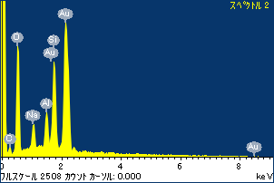

ﾌﾟﾛｼﾞｪｸﾄ : ﾌﾟﾛｼﾞｪｸﾄ20110520

ｵｰﾅｰ : Administrator

領域 分析領域 6

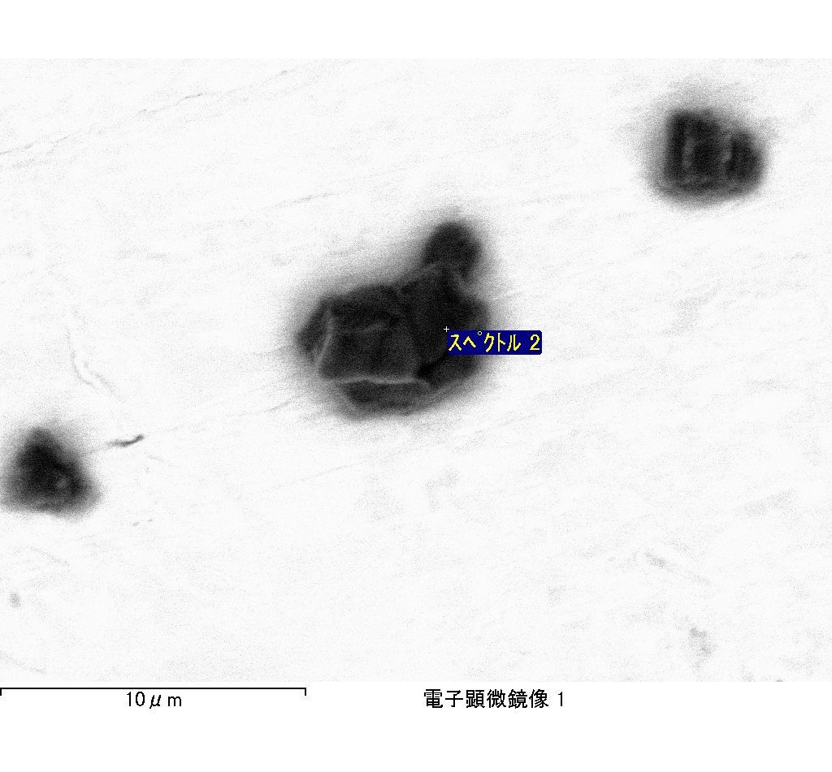

ｽﾍﾟｸﾄﾙﾗﾍﾞﾙ: ｽﾍﾟｸﾄﾙ 3

ﾗｲﾌﾞﾀｲﾑ 120.0 s

収集ｼﾞｵﾒﾄﾘ[度] :

試料傾斜角 = 0.0

方位角 = 0.0

ｴﾚﾍﾞｰｼｮﾝ = 30.0

加速電圧 = 10.00 kV

ｽﾍﾟｸﾄﾙ全ｶｳﾝﾄ数 = 209270

|  |  |  |  |
| --- | --- | --- | --- |
| ｻﾝﾌﾟﾙﾃﾞｰﾀ : | ｴﾈﾙｷﾞｰ[eV] | 分解能[eV] | ｶｳﾝﾄ数 |
| ｽﾄﾛｰﾌﾞ : | 3.8 | 51.72 | 1194702 |
|  |  |  |  |

定量最適化がおこなわれていません

ｽﾍﾟｸﾄﾙ処理 :

省略されたﾋﾟｰｸはありません

処理ｵﾌﾟｼｮﾝ : 酸素 ｽﾄｲｷｵﾒﾄﾘ (ﾉｰﾏﾗｲｽﾞ)

繰り返し回数 = 2

ｽﾀﾝﾀﾞｰﾄﾞ :

Na Albite 1999/06/01

Mg MgO 1999/06/01

Al Al2O3 1999/06/01

Si SiO2 1999/06/01

P GaP 1999/06/01

S FeS2 1999/06/01

K MAD-10 Feldspar 1999/06/01

Ca Wollastonite 1999/06/01

Cr Cr 1999/06/01

Mn Mn 1999/06/01

Fe Fe 1999/06/01

Ni Ni 1999/06/01

|  |  |  |  |  |  |
| --- | --- | --- | --- | --- | --- |
| 元素 | 質量濃度 | 原子数 | 化合物 | 化学式 |  |
|  | [%] | 濃度[%] | 濃度[%] |  |  |
| Na K | 64.08 | 61.58 | 86.37 | Na2O |  |
| Mg K | -1.17 | -1.06 | -1.94 | MgO |  |
| Al K | 85.79 | 70.25 | 162.10 | Al2O3 |  |
| Si K | 240.31 | 189.05 | 514.08 | SiO2 |  |
| P K | -164.75 | -117.52 | -377.49 | P2O5 |  |
| S K | -122.33 | -84.30 | -305.46 | SO3 |  |
| K K | 3.91 | 2.21 | 4.71 | K2O |  |
| Ca K | 11.65 | 6.42 | 16.30 | CaO |  |
| Cr K | -10.46 | -4.44 | -15.29 | Cr2O3 |  |
| Mn K | 5.45 | 2.19 | 7.03 | MnO |  |
| Fe K | 13.55 | 5.36 | 17.43 | FeO |  |
| Ni K | -6.16 | -2.32 | -7.84 | NiO |  |
| O | -19.85 | -27.41 |  |  |  |
| ﾄｰﾀﾙ | 100.00 |  |  |  |  |

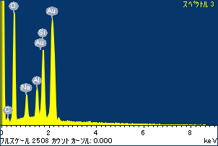

ﾌﾟﾛｼﾞｪｸﾄ : ﾌﾟﾛｼﾞｪｸﾄ20110520

ｵｰﾅｰ : Administrator

領域 分析領域 6

