ｽﾍﾟｸﾄﾙﾗﾍﾞﾙ: ｽﾍﾟｸﾄﾙ 1

ﾗｲﾌﾞﾀｲﾑ 120.0 s

収集ｼﾞｵﾒﾄﾘ[度] :

試料傾斜角 = 0.0

方位角 = 0.0

ｴﾚﾍﾞｰｼｮﾝ = 30.0

加速電圧 = 10.00 kV

ｽﾍﾟｸﾄﾙ全ｶｳﾝﾄ数 = 189944

|  |  |  |  |
| --- | --- | --- | --- |
| ｻﾝﾌﾟﾙﾃﾞｰﾀ : | ｴﾈﾙｷﾞｰ[eV] | 分解能[eV] | ｶｳﾝﾄ数 |
| ｽﾄﾛｰﾌﾞ : | 3.8 | 51.77 | 1195280 |
|  |  |  |  |

定量最適化がおこなわれていません

ｽﾍﾟｸﾄﾙ処理 :

省略されたﾋﾟｰｸはありません

処理ｵﾌﾟｼｮﾝ : 酸素 ｽﾄｲｷｵﾒﾄﾘ (ﾉｰﾏﾗｲｽﾞ)

繰り返し回数 = 2

ｽﾀﾝﾀﾞｰﾄﾞ :

Na Albite 1999/06/01

Mg MgO 1999/06/01

Al Al2O3 1999/06/01

Si SiO2 1999/06/01

P GaP 1999/06/01

S FeS2 1999/06/01

K MAD-10 Feldspar 1999/06/01

Ca Wollastonite 1999/06/01

Cr Cr 1999/06/01

Mn Mn 1999/06/01

Fe Fe 1999/06/01

Ni Ni 1999/06/01

|  |  |  |  |  |  |
| --- | --- | --- | --- | --- | --- |
| 元素 | 質量濃度 | 原子数 | 化合物 | 化学式 |  |
|  | [%] | 濃度[%] | 濃度[%] |  |  |
| Na K | 0.23 | 4.48 | 0.31 | Na2O |  |
| Mg K | 13.58 | 249.99 | 22.52 | MgO |  |
| Al K | 1.41 | 23.35 | 2.66 | Al2O3 |  |
| Si K | 11.09 | 176.67 | 23.72 | SiO2 |  |
| P K | -58.39 | -843.61 | -133.78 | P2O5 |  |
| S K | -14.00 | -195.41 | -34.96 | SO3 |  |
| K K | 1.73 | 19.81 | 2.09 | K2O |  |
| Ca K | -0.37 | -4.16 | -0.52 | CaO |  |
| Cr K | 4.40 | 37.87 | 6.43 | Cr2O3 |  |
| Mn K | -7.27 | -59.23 | -9.39 | MnO |  |
| Fe K | 154.15 | 1235.34 | 198.31 | FeO |  |
| Ni K | 17.77 | 135.45 | 22.61 | NiO |  |
| O | -24.33 | -680.55 |  |  |  |
| ﾄｰﾀﾙ | 100.00 |  |  |  |  |

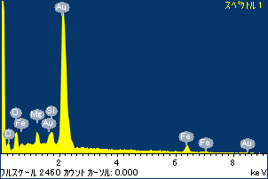

ﾌﾟﾛｼﾞｪｸﾄ : ﾌﾟﾛｼﾞｪｸﾄ20110519

ｵｰﾅｰ : Administrator

領域 分析領域 1

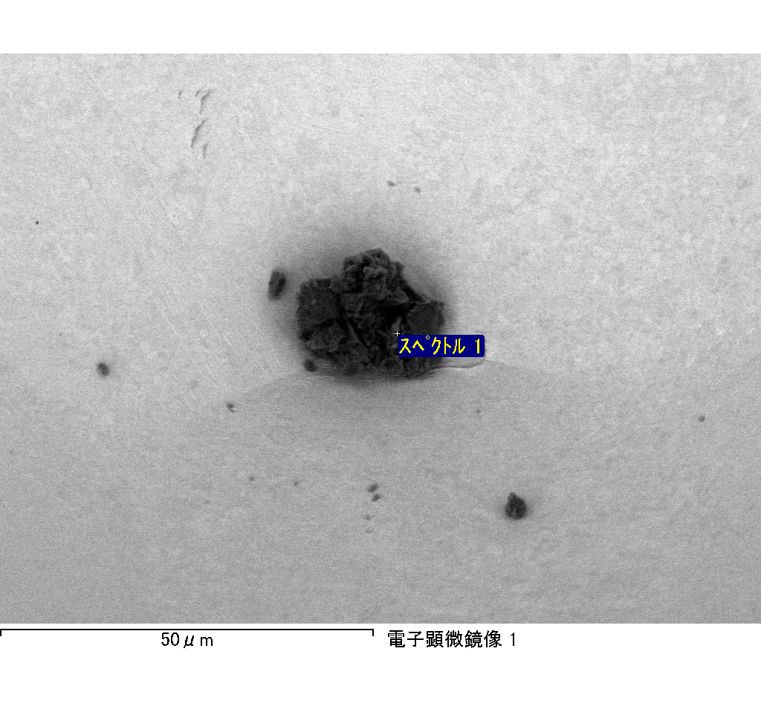

ｽﾍﾟｸﾄﾙﾗﾍﾞﾙ: ｽﾍﾟｸﾄﾙ 1

ﾗｲﾌﾞﾀｲﾑ 120.0 s

収集ｼﾞｵﾒﾄﾘ[度] :

試料傾斜角 = 0.0

方位角 = 0.0

ｴﾚﾍﾞｰｼｮﾝ = 30.0

加速電圧 = 10.00 kV

ｽﾍﾟｸﾄﾙ全ｶｳﾝﾄ数 = 216901

|  |  |  |  |
| --- | --- | --- | --- |
| ｻﾝﾌﾟﾙﾃﾞｰﾀ : | ｴﾈﾙｷﾞｰ[eV] | 分解能[eV] | ｶｳﾝﾄ数 |
| ｽﾄﾛｰﾌﾞ : | 3.8 | 51.81 | 1194975 |
|  |  |  |  |

定量最適化がおこなわれていません

ｽﾍﾟｸﾄﾙ処理 :

省略されたﾋﾟｰｸはありません

処理ｵﾌﾟｼｮﾝ : 酸素 ｽﾄｲｷｵﾒﾄﾘ (ﾉｰﾏﾗｲｽﾞ)

繰り返し回数 = 2

ｽﾀﾝﾀﾞｰﾄﾞ :

Na Albite 1999/06/01

Mg MgO 1999/06/01

Al Al2O3 1999/06/01

Si SiO2 1999/06/01

P GaP 1999/06/01

S FeS2 1999/06/01

K MAD-10 Feldspar 1999/06/01

Ca Wollastonite 1999/06/01

Cr Cr 1999/06/01

Mn Mn 1999/06/01

Fe Fe 1999/06/01

Ni Ni 1999/06/01

|  |  |  |  |  |  |
| --- | --- | --- | --- | --- | --- |
| 元素 | 質量濃度 | 原子数 | 化合物 | 化学式 |  |
|  | [%] | 濃度[%] | 濃度[%] |  |  |
| Na K | -1.75 | -1.42 | -2.37 | Na2O |  |
| Mg K | -107.11 | -82.25 | -177.60 | MgO |  |
| Al K | -0.12 | -0.08 | -0.22 | Al2O3 |  |
| Si K | -92.33 | -61.37 | -197.51 | SiO2 |  |
| P K | 115.63 | 69.70 | 264.96 | P2O5 |  |
| S K | 94.15 | 54.82 | 235.08 | SO3 |  |
| K K | -1.91 | -0.91 | -2.30 | K2O |  |
| Ca K | 2.42 | 1.13 | 3.39 | CaO |  |
| Cr K | 5.37 | 1.93 | 7.85 | Cr2O3 |  |
| Mn K | 3.40 | 1.15 | 4.38 | MnO |  |
| Fe K | -95.51 | -31.93 | -122.87 | FeO |  |
| Ni K | 68.54 | 21.79 | 87.22 | NiO |  |
| O | 109.22 | 127.45 |  |  |  |
| ﾄｰﾀﾙ | 100.00 |  |  |  |  |

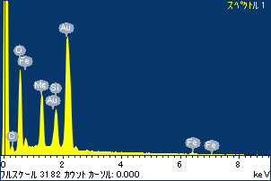

ﾌﾟﾛｼﾞｪｸﾄ : ﾌﾟﾛｼﾞｪｸﾄ20110519

ｵｰﾅｰ : Administrator

領域 分析領域 2

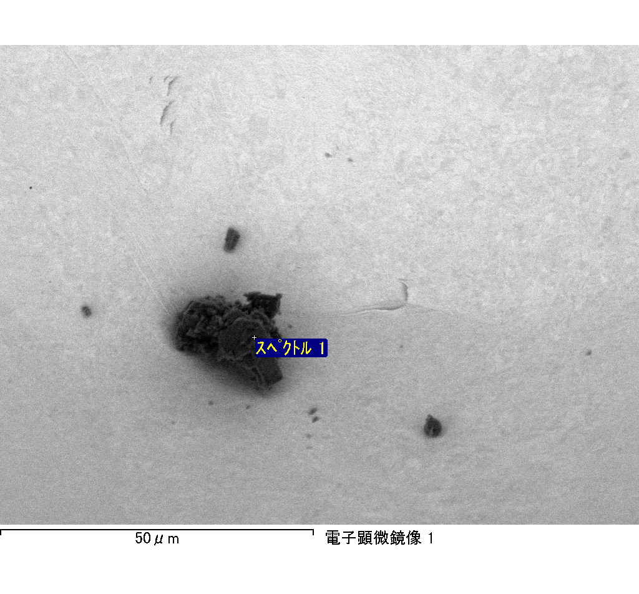

ｽﾍﾟｸﾄﾙ処理 :

省略されたﾋﾟｰｸはありません

処理ｵﾌﾟｼｮﾝ : 酸素 ｽﾄｲｷｵﾒﾄﾘ (ﾉｰﾏﾗｲｽﾞ)

繰り返し回数 = 2

ｽﾀﾝﾀﾞｰﾄﾞ :

Na Albite 1999/06/01

Mg MgO 1999/06/01

Al Al2O3 1999/06/01

Si SiO2 1999/06/01

P GaP 1999/06/01

S FeS2 1999/06/01

K MAD-10 Feldspar 1999/06/01

Ca Wollastonite 1999/06/01

Cr Cr 1999/06/01

Mn Mn 1999/06/01

Fe Fe 1999/06/01

Ni Ni 1999/06/01

|  |  |  |  |  |  |
| --- | --- | --- | --- | --- | --- |
| 元素 | 質量濃度 | 原子数 | 化合物 | 化学式 |  |
|  | [%] | 濃度[%] | 濃度[%] |  |  |
| Na K | 3.59 | -156.40 | 4.84 | Na2O |  |
| Mg K | 156.46 | -6440.07 | 259.42 | MgO |  |
| Al K | 3.40 | -126.04 | 6.42 | Al2O3 |  |
| Si K | 126.63 | -4511.79 | 270.89 | SiO2 |  |
| P K | -159.76 | 5161.61 | -366.06 | P2O5 |  |
| S K | -122.55 | 3824.83 | -306.00 | SO3 |  |
| K K | 3.36 | -86.10 | 4.05 | K2O |  |
| Ca K | -2.71 | 67.56 | -3.79 | CaO |  |
| Cr K | -1.89 | 36.32 | -2.76 | Cr2O3 |  |
| Mn K | -4.04 | 73.60 | -5.22 | MnO |  |
| Fe K | 118.30 | -2119.81 | 152.19 | FeO |  |
| Ni K | 67.59 | -1152.06 | 86.01 | NiO |  |
| O | -88.38 | 5528.34 |  |  |  |
| ﾄｰﾀﾙ | 100.00 |  |  |  |  |

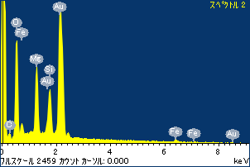

ﾌﾟﾛｼﾞｪｸﾄ : ﾌﾟﾛｼﾞｪｸﾄ20110519

ｵｰﾅｰ : Administrator

領域 分析領域 2

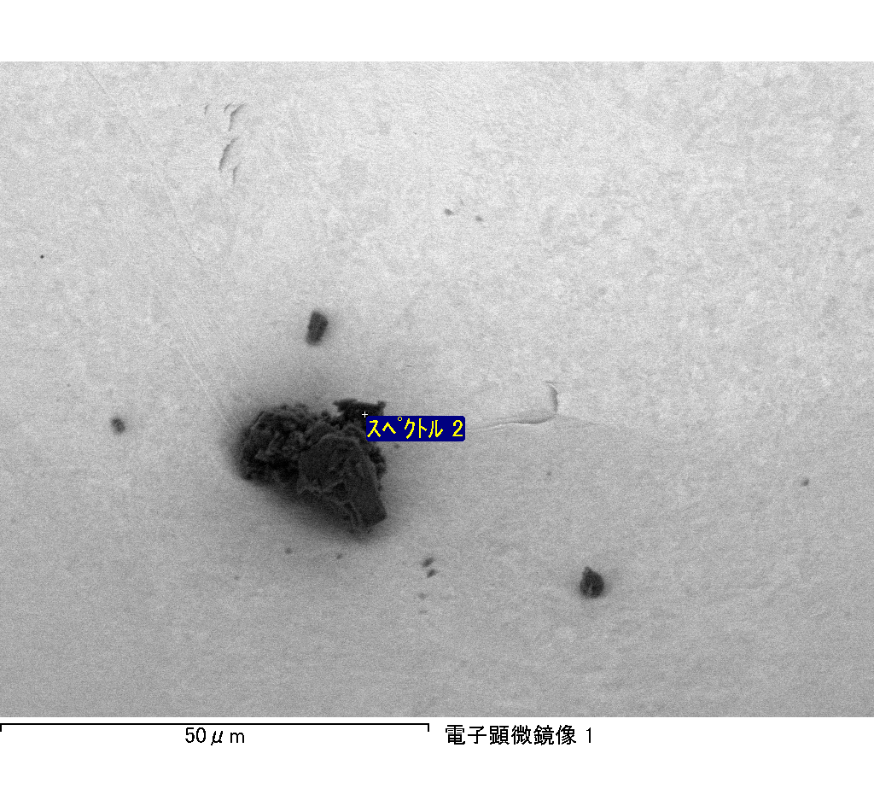

ｽﾍﾟｸﾄﾙﾗﾍﾞﾙ: ｽﾍﾟｸﾄﾙ 2

ﾗｲﾌﾞﾀｲﾑ 120.0 s

収集ｼﾞｵﾒﾄﾘ[度] :

試料傾斜角 = 0.0

方位角 = 0.0

ｴﾚﾍﾞｰｼｮﾝ = 30.0

加速電圧 = 10.00 kV

ｽﾍﾟｸﾄﾙ全ｶｳﾝﾄ数 = 214869

|  |  |  |  |
| --- | --- | --- | --- |
| ｻﾝﾌﾟﾙﾃﾞｰﾀ : | ｴﾈﾙｷﾞｰ[eV] | 分解能[eV] | ｶｳﾝﾄ数 |
| ｽﾄﾛｰﾌﾞ : | 3.8 | 51.80 | 1194827 |
|  |  |  |  |

定量最適化がおこなわれていません