ｽﾍﾟｸﾄﾙﾗﾍﾞﾙ: ｽﾍﾟｸﾄﾙ 1

ﾗｲﾌﾞﾀｲﾑ 120.0 s

収集ｼﾞｵﾒﾄﾘ[度] :

試料傾斜角 = 0.0

方位角 = 0.0

ｴﾚﾍﾞｰｼｮﾝ = 30.0

加速電圧 = 10.00 kV

ｽﾍﾟｸﾄﾙ全ｶｳﾝﾄ数 = 221409

|  |  |  |  |
| --- | --- | --- | --- |
| ｻﾝﾌﾟﾙﾃﾞｰﾀ : | ｴﾈﾙｷﾞｰ[eV] | 分解能[eV] | ｶｳﾝﾄ数 |
| ｽﾄﾛｰﾌﾞ : | 3.8 | 51.86 | 1195012 |
|  |  |  |  |

定量最適化がおこなわれていません

ｽﾍﾟｸﾄﾙ処理 :

省略されたﾋﾟｰｸはありません

処理ｵﾌﾟｼｮﾝ : 酸素 ｽﾄｲｷｵﾒﾄﾘ (ﾉｰﾏﾗｲｽﾞ)

繰り返し回数 = 2

ｽﾀﾝﾀﾞｰﾄﾞ :

Na Albite 1999/06/01

Mg MgO 1999/06/01

Al Al2O3 1999/06/01

Si SiO2 1999/06/01

P GaP 1999/06/01

S FeS2 1999/06/01

K MAD-10 Feldspar 1999/06/01

Ca Wollastonite 1999/06/01

Cr Cr 1999/06/01

Mn Mn 1999/06/01

Fe Fe 1999/06/01

Ni Ni 1999/06/01

|  |  |  |  |  |  |
| --- | --- | --- | --- | --- | --- |
| 元素 | 質量濃度 | 原子数 | 化合物 | 化学式 |  |
|  | [%] | 濃度[%] | 濃度[%] |  |  |
| Na K | -0.77 | -1.02 | -1.04 | Na2O |  |
| Mg K | 106.60 | 134.47 | 176.76 | MgO |  |
| Al K | 1.85 | 2.10 | 3.50 | Al2O3 |  |
| Si K | 90.24 | 98.53 | 193.05 | SiO2 |  |
| P K | -83.78 | -82.94 | -191.96 | P2O5 |  |
| S K | -65.58 | -62.72 | -163.75 | SO3 |  |
| K K | 1.17 | 0.92 | 1.41 | K2O |  |
| Ca K | -0.13 | -0.10 | -0.18 | CaO |  |
| Cr K | 5.06 | 2.99 | 7.40 | Cr2O3 |  |
| Mn K | 0.91 | 0.51 | 1.17 | MnO |  |
| Fe K | 67.19 | 36.89 | 86.44 | FeO |  |
| Ni K | -10.07 | -5.26 | -12.81 | NiO |  |
| O | -12.71 | -24.36 |  |  |  |
| ﾄｰﾀﾙ | 100.00 |  |  |  |  |

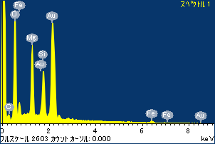

ﾌﾟﾛｼﾞｪｸﾄ : ﾌﾟﾛｼﾞｪｸﾄ 1

ｵｰﾅｰ : Administrator

領域 分析領域 1

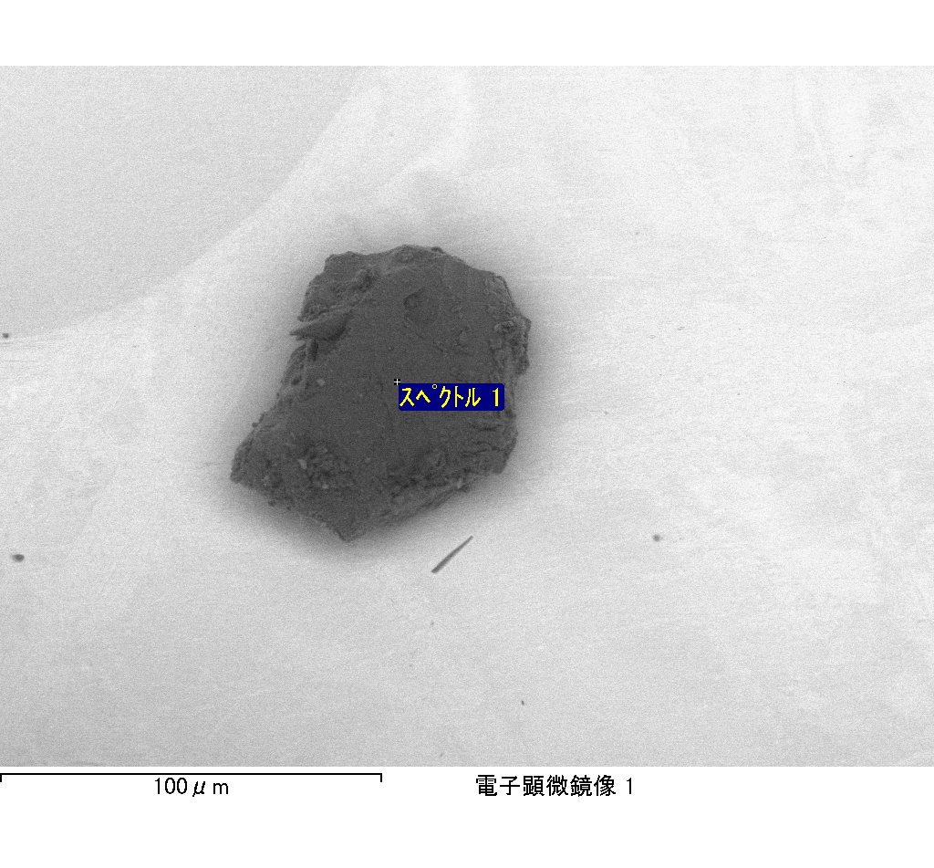

ｽﾍﾟｸﾄﾙﾗﾍﾞﾙ: ｽﾍﾟｸﾄﾙ 2

ﾗｲﾌﾞﾀｲﾑ 120.0 s

収集ｼﾞｵﾒﾄﾘ[度] :

試料傾斜角 = 0.0

方位角 = 0.0

ｴﾚﾍﾞｰｼｮﾝ = 30.0

加速電圧 = 10.00 kV

ｽﾍﾟｸﾄﾙ全ｶｳﾝﾄ数 = 214968

|  |  |  |  |
| --- | --- | --- | --- |
| ｻﾝﾌﾟﾙﾃﾞｰﾀ : | ｴﾈﾙｷﾞｰ[eV] | 分解能[eV] | ｶｳﾝﾄ数 |
| ｽﾄﾛｰﾌﾞ : | 3.8 | 51.84 | 1194785 |
|  |  |  |  |

定量最適化がおこなわれていません

ｽﾍﾟｸﾄﾙ処理 :

省略されたﾋﾟｰｸはありません

処理ｵﾌﾟｼｮﾝ : 酸素 ｽﾄｲｷｵﾒﾄﾘ (ﾉｰﾏﾗｲｽﾞ)

繰り返し回数 = 2

ｽﾀﾝﾀﾞｰﾄﾞ :

Na Albite 1999/06/01

Mg MgO 1999/06/01

Al Al2O3 1999/06/01

Si SiO2 1999/06/01

P GaP 1999/06/01

S FeS2 1999/06/01

K MAD-10 Feldspar 1999/06/01

Ca Wollastonite 1999/06/01

Cr Cr 1999/06/01

Mn Mn 1999/06/01

Fe Fe 1999/06/01

Ni Ni 1999/06/01

|  |  |  |  |  |  |
| --- | --- | --- | --- | --- | --- |
| 元素 | 質量濃度 | 原子数 | 化合物 | 化学式 |  |
|  | [%] | 濃度[%] | 濃度[%] |  |  |
| Na K | 24.04 | 32.14 | 32.41 | Na2O |  |
| Mg K | 29.69 | 37.53 | 49.22 | MgO |  |
| Al K | 37.95 | 43.23 | 71.71 | Al2O3 |  |
| Si K | 137.93 | 150.93 | 295.08 | SiO2 |  |
| P K | -116.47 | -115.56 | -266.88 | P2O5 |  |
| S K | -66.04 | -63.30 | -164.90 | SO3 |  |
| K K | 1.45 | 1.14 | 1.75 | K2O |  |
| Ca K | 6.65 | 5.10 | 9.31 | CaO |  |
| Cr K | -1.71 | -1.01 | -2.50 | Cr2O3 |  |
| Mn K | -3.01 | -1.68 | -3.89 | MnO |  |
| Fe K | 66.28 | 36.47 | 85.27 | FeO |  |
| Ni K | -5.17 | -2.70 | -6.57 | NiO |  |
| O | -11.59 | -22.27 |  |  |  |
| ﾄｰﾀﾙ | 100.00 |  |  |  |  |

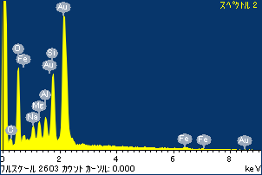

ﾌﾟﾛｼﾞｪｸﾄ : ﾌﾟﾛｼﾞｪｸﾄ 1

ｵｰﾅｰ : Administrator

領域 分析領域 1

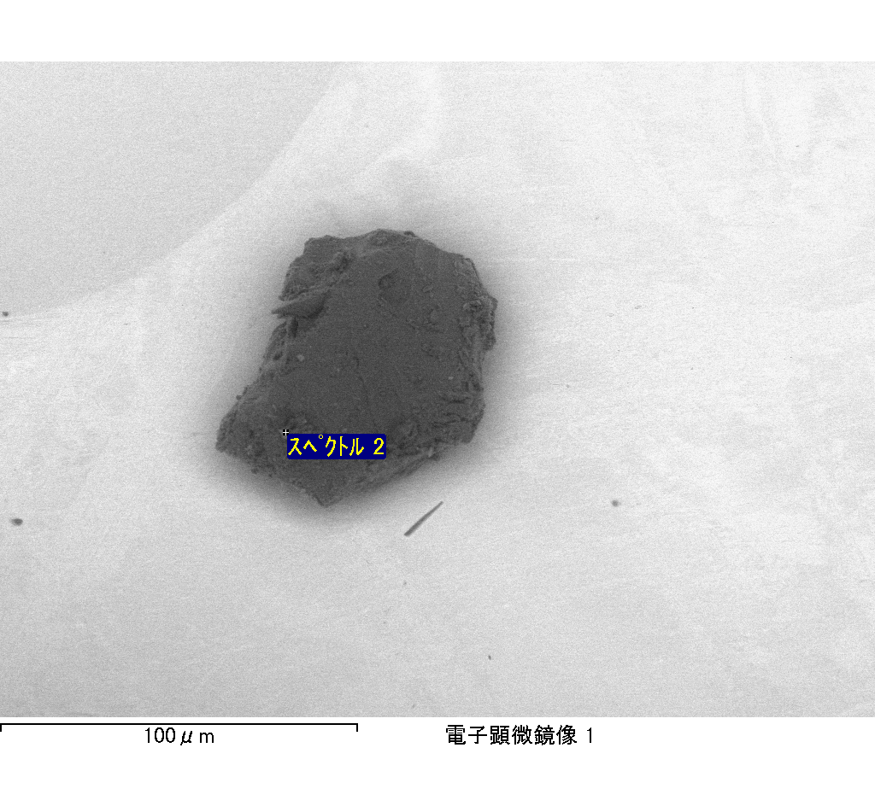

ｽﾍﾟｸﾄﾙﾗﾍﾞﾙ: ｽﾍﾟｸﾄﾙ 3

ﾗｲﾌﾞﾀｲﾑ 120.0 s

収集ｼﾞｵﾒﾄﾘ[度] :

試料傾斜角 = 0.0

方位角 = 0.0

ｴﾚﾍﾞｰｼｮﾝ = 30.0

加速電圧 = 10.00 kV

ｽﾍﾟｸﾄﾙ全ｶｳﾝﾄ数 = 196025

|  |  |  |  |
| --- | --- | --- | --- |
| ｻﾝﾌﾟﾙﾃﾞｰﾀ : | ｴﾈﾙｷﾞｰ[eV] | 分解能[eV] | ｶｳﾝﾄ数 |
| ｽﾄﾛｰﾌﾞ : | 3.8 | 51.86 | 1196742 |
|  |  |  |  |

定量最適化がおこなわれていません

ｽﾍﾟｸﾄﾙ処理 :

省略されたﾋﾟｰｸはありません

処理ｵﾌﾟｼｮﾝ : 酸素 ｽﾄｲｷｵﾒﾄﾘ (ﾉｰﾏﾗｲｽﾞ)

繰り返し回数 = 2

ｽﾀﾝﾀﾞｰﾄﾞ :

Na Albite 1999/06/01

Mg MgO 1999/06/01

Al Al2O3 1999/06/01

Si SiO2 1999/06/01

P GaP 1999/06/01

S FeS2 1999/06/01

K MAD-10 Feldspar 1999/06/01

Ca Wollastonite 1999/06/01

Cr Cr 1999/06/01

Mn Mn 1999/06/01

Fe Fe 1999/06/01

Ni Ni 1999/06/01

|  |  |  |  |  |  |
| --- | --- | --- | --- | --- | --- |
| 元素 | 質量濃度 | 原子数 | 化合物 | 化学式 |  |
|  | [%] | 濃度[%] | 濃度[%] |  |  |
| Na K | -15.34 | -7.78 | -20.68 | Na2O |  |
| Mg K | -66.44 | -31.84 | -110.16 | MgO |  |
| Al K | -28.49 | -12.30 | -53.83 | Al2O3 |  |
| Si K | -163.30 | -67.75 | -349.34 | SiO2 |  |
| P K | 180.60 | 67.95 | 413.82 | P2O5 |  |
| S K | 155.90 | 56.66 | 389.26 | SO3 |  |
| K K | -2.69 | -0.80 | -3.23 | K2O |  |
| Ca K | -7.06 | -2.05 | -9.87 | CaO |  |
| Cr K | 4.48 | 1.00 | 6.55 | Cr2O3 |  |
| Mn K | 11.92 | 2.53 | 15.39 | MnO |  |
| Fe K | -114.45 | -23.88 | -147.24 | FeO |  |
| Ni K | -24.09 | -4.78 | -30.65 | NiO |  |
| O | 168.96 | 123.06 |  |  |  |
| ﾄｰﾀﾙ | 100.00 |  |  |  |  |

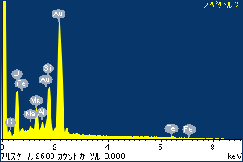

ﾌﾟﾛｼﾞｪｸﾄ : ﾌﾟﾛｼﾞｪｸﾄ 1

ｵｰﾅｰ : Administrator

領域 分析領域 1

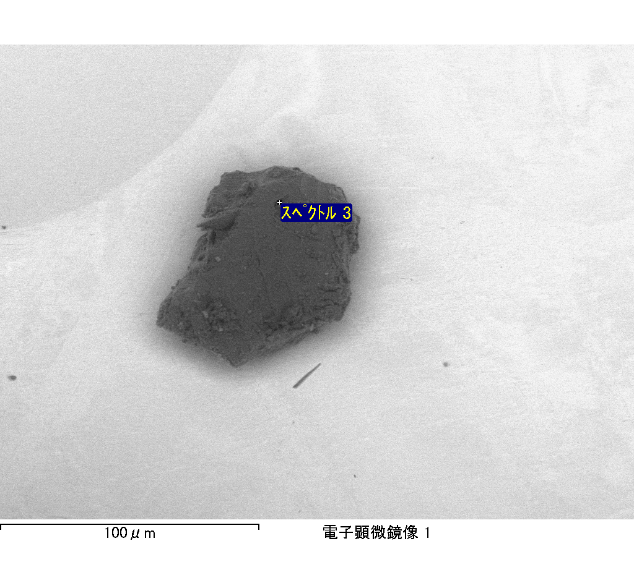

ｽﾍﾟｸﾄﾙﾗﾍﾞﾙ: ｽﾍﾟｸﾄﾙ 4

ﾗｲﾌﾞﾀｲﾑ 120.0 s

収集ｼﾞｵﾒﾄﾘ[度] :

試料傾斜角 = 0.0

方位角 = 0.0

ｴﾚﾍﾞｰｼｮﾝ = 30.0

加速電圧 = 10.00 kV

ｽﾍﾟｸﾄﾙ全ｶｳﾝﾄ数 = 218728

|  |  |  |  |
| --- | --- | --- | --- |
| ｻﾝﾌﾟﾙﾃﾞｰﾀ : | ｴﾈﾙｷﾞｰ[eV] | 分解能[eV] | ｶｳﾝﾄ数 |
| ｽﾄﾛｰﾌﾞ : | 3.8 | 51.81 | 1194461 |
|  |  |  |  |

定量最適化がおこなわれていません

ｽﾍﾟｸﾄﾙ処理 :

省略されたﾋﾟｰｸはありません

処理ｵﾌﾟｼｮﾝ : 酸素 ｽﾄｲｷｵﾒﾄﾘ (ﾉｰﾏﾗｲｽﾞ)

繰り返し回数 = 2

ｽﾀﾝﾀﾞｰﾄﾞ :

Na Albite 1999/06/01

Mg MgO 1999/06/01

Al Al2O3 1999/06/01

Si SiO2 1999/06/01

P GaP 1999/06/01

S FeS2 1999/06/01

K MAD-10 Feldspar 1999/06/01

Ca Wollastonite 1999/06/01

Cr Cr 1999/06/01

Mn Mn 1999/06/01

Fe Fe 1999/06/01

Ni Ni 1999/06/01

|  |  |  |  |  |  |
| --- | --- | --- | --- | --- | --- |
| 元素 | 質量濃度 | 原子数 | 化合物 | 化学式 |  |
|  | [%] | 濃度[%] | 濃度[%] |  |  |
| Na K | 0.79 | 1.18 | 1.06 | Na2O |  |
| Mg K | 65.04 | 92.11 | 107.84 | MgO |  |
| Al K | 0.54 | 0.69 | 1.02 | Al2O3 |  |
| Si K | 55.34 | 67.85 | 118.39 | SiO2 |  |
| P K | -52.94 | -58.85 | -121.31 | P2O5 |  |
| S K | -41.79 | -44.88 | -104.34 | SO3 |  |
| K K | -0.30 | -0.26 | -0.36 | K2O |  |
| Ca K | 0.28 | 0.24 | 0.40 | CaO |  |
| Cr K | 3.94 | 2.61 | 5.76 | Cr2O3 |  |
| Mn K | -0.03 | -0.02 | -0.03 | MnO |  |
| Fe K | 68.52 | 42.25 | 88.15 | FeO |  |
| Ni K | 2.69 | 1.58 | 3.42 | NiO |  |
| O | -2.09 | -4.50 |  |  |  |
| ﾄｰﾀﾙ | 100.00 |  |  |  |  |

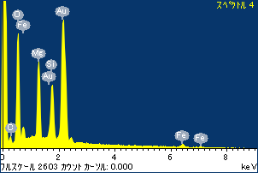

ﾌﾟﾛｼﾞｪｸﾄ : ﾌﾟﾛｼﾞｪｸﾄ 1

ｵｰﾅｰ : Administrator

領域 分析領域 1

