ｽﾍﾟｸﾄﾙﾗﾍﾞﾙ: ｽﾍﾟｸﾄﾙ 1

ﾗｲﾌﾞﾀｲﾑ 120.0 s

収集ｼﾞｵﾒﾄﾘ[度] :

試料傾斜角 = 0.0

方位角 = 0.0

ｴﾚﾍﾞｰｼｮﾝ = 30.0

加速電圧 = 10.00 kV

ｽﾍﾟｸﾄﾙ全ｶｳﾝﾄ数 = 194867

|  |  |  |  |
| --- | --- | --- | --- |
| ｻﾝﾌﾟﾙﾃﾞｰﾀ : | ｴﾈﾙｷﾞｰ[eV] | 分解能[eV] | ｶｳﾝﾄ数 |
| ｽﾄﾛｰﾌﾞ : | 3.8 | 51.78 | 1196402 |
|  |  |  |  |

定量最適化がおこなわれていません

ｽﾍﾟｸﾄﾙ処理 :

省略されたﾋﾟｰｸはありません

処理ｵﾌﾟｼｮﾝ : 酸素 ｽﾄｲｷｵﾒﾄﾘ (ﾉｰﾏﾗｲｽﾞ)

繰り返し回数 = 2

ｽﾀﾝﾀﾞｰﾄﾞ :

Na Albite 1999/06/01

Mg MgO 1999/06/01

Al Al2O3 1999/06/01

Si SiO2 1999/06/01

P GaP 1999/06/01

S FeS2 1999/06/01

K MAD-10 Feldspar 1999/06/01

Ca Wollastonite 1999/06/01

Cr Cr 1999/06/01

Mn Mn 1999/06/01

Fe Fe 1999/06/01

Ni Ni 1999/06/01

|  |  |  |  |  |  |
| --- | --- | --- | --- | --- | --- |
| 元素 | 質量濃度 | 原子数 | 化合物 | 化学式 |  |
|  | [%] | 濃度[%] | 濃度[%] |  |  |
| Na K | -11.56 | -5.91 | -15.59 | Na2O |  |
| Mg K | -216.68 | -104.76 | -359.26 | MgO |  |
| Al K | -18.16 | -7.91 | -34.30 | Al2O3 |  |
| Si K | -354.57 | -148.40 | -758.53 | SiO2 |  |
| P K | 339.65 | 128.90 | 778.25 | P2O5 |  |
| S K | 265.73 | 97.42 | 663.51 | SO3 |  |
| K K | 1.96 | 0.59 | 2.36 | K2O |  |
| Ca K | -13.28 | -3.90 | -18.58 | CaO |  |
| Cr K | 12.30 | 2.78 | 17.97 | Cr2O3 |  |
| Mn K | -13.74 | -2.94 | -17.74 | MnO |  |
| Fe K | -116.46 | -24.51 | -149.83 | FeO |  |
| Ni K | -6.49 | -1.30 | -8.25 | NiO |  |
| O | 231.30 | 169.94 |  |  |  |
| ﾄｰﾀﾙ | 100.00 |  |  |  |  |

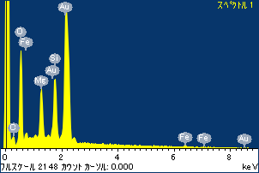

ﾌﾟﾛｼﾞｪｸﾄ : ﾌﾟﾛｼﾞｪｸﾄ 1

ｵｰﾅｰ : Administrator

領域 分析領域 1

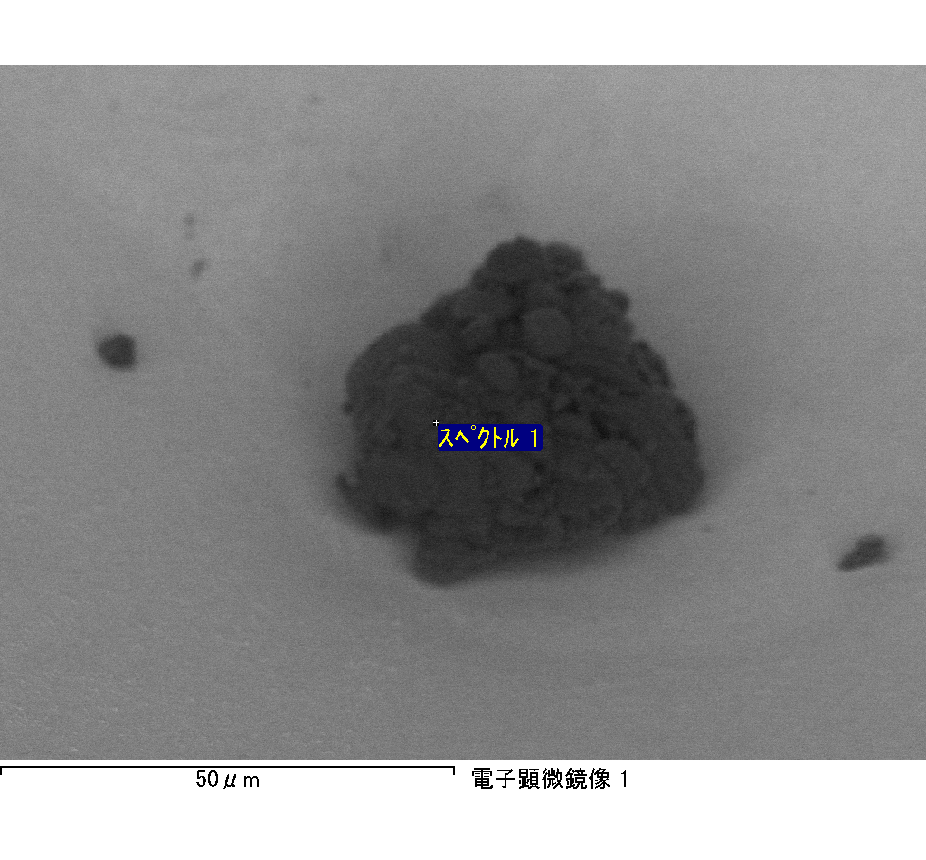

ｽﾍﾟｸﾄﾙﾗﾍﾞﾙ: ｽﾍﾟｸﾄﾙ 2

ﾗｲﾌﾞﾀｲﾑ 120.0 s

収集ｼﾞｵﾒﾄﾘ[度] :

試料傾斜角 = 0.0

方位角 = 0.0

ｴﾚﾍﾞｰｼｮﾝ = 30.0

加速電圧 = 10.00 kV

ｽﾍﾟｸﾄﾙ全ｶｳﾝﾄ数 = 196449

|  |  |  |  |
| --- | --- | --- | --- |
| ｻﾝﾌﾟﾙﾃﾞｰﾀ : | ｴﾈﾙｷﾞｰ[eV] | 分解能[eV] | ｶｳﾝﾄ数 |
| ｽﾄﾛｰﾌﾞ : | 3.8 | 51.81 | 1195710 |
|  |  |  |  |

定量最適化がおこなわれていません

ｽﾍﾟｸﾄﾙ処理 :

省略されたﾋﾟｰｸはありません

処理ｵﾌﾟｼｮﾝ : 酸素 ｽﾄｲｷｵﾒﾄﾘ (ﾉｰﾏﾗｲｽﾞ)

繰り返し回数 = 2

ｽﾀﾝﾀﾞｰﾄﾞ :

Na Albite 1999/06/01

Mg MgO 1999/06/01

Al Al2O3 1999/06/01

Si SiO2 1999/06/01

P GaP 1999/06/01

S FeS2 1999/06/01

K MAD-10 Feldspar 1999/06/01

Ca Wollastonite 1999/06/01

Cr Cr 1999/06/01

Mn Mn 1999/06/01

Fe Fe 1999/06/01

Ni Ni 1999/06/01

|  |  |  |  |  |  |
| --- | --- | --- | --- | --- | --- |
| 元素 | 質量濃度 | 原子数 | 化合物 | 化学式 |  |
|  | [%] | 濃度[%] | 濃度[%] |  |  |
| Na K | -2.94 | -1.30 | -3.96 | Na2O |  |
| Mg K | -171.36 | -71.64 | -284.13 | MgO |  |
| Al K | -6.32 | -2.38 | -11.94 | Al2O3 |  |
| Si K | -268.34 | -97.11 | -574.05 | SiO2 |  |
| P K | 278.35 | 91.34 | 637.79 | P2O5 |  |
| S K | 229.11 | 72.62 | 572.06 | SO3 |  |
| K K | -4.23 | -1.10 | -5.09 | K2O |  |
| Ca K | -6.31 | -1.60 | -8.83 | CaO |  |
| Cr K | -9.66 | -1.89 | -14.12 | Cr2O3 |  |
| Mn K | 3.98 | 0.74 | 5.14 | MnO |  |
| Fe K | -119.43 | -21.74 | -153.65 | FeO |  |
| Ni K | -46.55 | -8.06 | -59.23 | NiO |  |
| O | 223.69 | 142.11 |  |  |  |
| ﾄｰﾀﾙ | 100.00 |  |  |  |  |

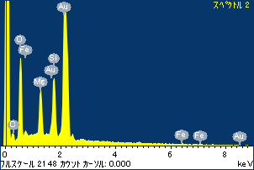

ﾌﾟﾛｼﾞｪｸﾄ : ﾌﾟﾛｼﾞｪｸﾄ 1

ｵｰﾅｰ : Administrator

領域 分析領域 1

