ｽﾍﾟｸﾄﾙﾗﾍﾞﾙ: ｽﾍﾟｸﾄﾙ 1

ﾗｲﾌﾞﾀｲﾑ 120.0 s

収集ｼﾞｵﾒﾄﾘ[度] :

試料傾斜角 = 0.0

方位角 = 0.0

ｴﾚﾍﾞｰｼｮﾝ = 30.0

加速電圧 = 10.00 kV

ｽﾍﾟｸﾄﾙ全ｶｳﾝﾄ数 = 180491

|  |  |  |  |
| --- | --- | --- | --- |
| ｻﾝﾌﾟﾙﾃﾞｰﾀ : | ｴﾈﾙｷﾞｰ[eV] | 分解能[eV] | ｶｳﾝﾄ数 |
| ｽﾄﾛｰﾌﾞ : | 3.8 | 51.85 | 1195531 |
|  |  |  |  |

定量最適化がおこなわれていません

ｽﾍﾟｸﾄﾙ処理 :

省略されたﾋﾟｰｸはありません

処理ｵﾌﾟｼｮﾝ : 酸素 ｽﾄｲｷｵﾒﾄﾘ (ﾉｰﾏﾗｲｽﾞ)

繰り返し回数 = 2

ｽﾀﾝﾀﾞｰﾄﾞ :

Na Albite 1999/06/01

Mg MgO 1999/06/01

Al Al2O3 1999/06/01

Si SiO2 1999/06/01

P GaP 1999/06/01

S FeS2 1999/06/01

K MAD-10 Feldspar 1999/06/01

Ca Wollastonite 1999/06/01

Cr Cr 1999/06/01

Mn Mn 1999/06/01

Fe Fe 1999/06/01

Ni Ni 1999/06/01

|  |  |  |  |  |  |
| --- | --- | --- | --- | --- | --- |
| 元素 | 質量濃度 | 原子数 | 化合物 | 化学式 |  |
|  | [%] | 濃度[%] | 濃度[%] |  |  |
| Na K | -0.09 | -0.07 | -0.12 | Na2O |  |
| Mg K | -25.02 | -17.58 | -41.49 | MgO |  |
| Al K | -1.43 | -0.90 | -2.70 | Al2O3 |  |
| Si K | -33.86 | -20.59 | -72.43 | SiO2 |  |
| P K | 60.42 | 33.32 | 138.44 | P2O5 |  |
| S K | 48.74 | 25.96 | 121.70 | SO3 |  |
| K K | 1.83 | 0.80 | 2.20 | K2O |  |
| Ca K | -3.51 | -1.50 | -4.91 | CaO |  |
| Cr K | -1.18 | -0.39 | -1.73 | Cr2O3 |  |
| Mn K | 3.71 | 1.15 | 4.79 | MnO |  |
| Fe K | -30.56 | -9.35 | -39.31 | FeO |  |
| Ni K | -3.49 | -1.02 | -4.45 | NiO |  |
| O | 84.44 | 90.15 |  |  |  |
| ﾄｰﾀﾙ | 100.00 |  |  |  |  |

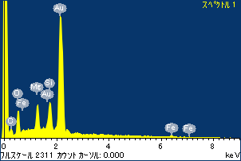

ﾌﾟﾛｼﾞｪｸﾄ : ﾌﾟﾛｼﾞｪｸﾄ 1

ｵｰﾅｰ : Administrator

領域 分析領域 1

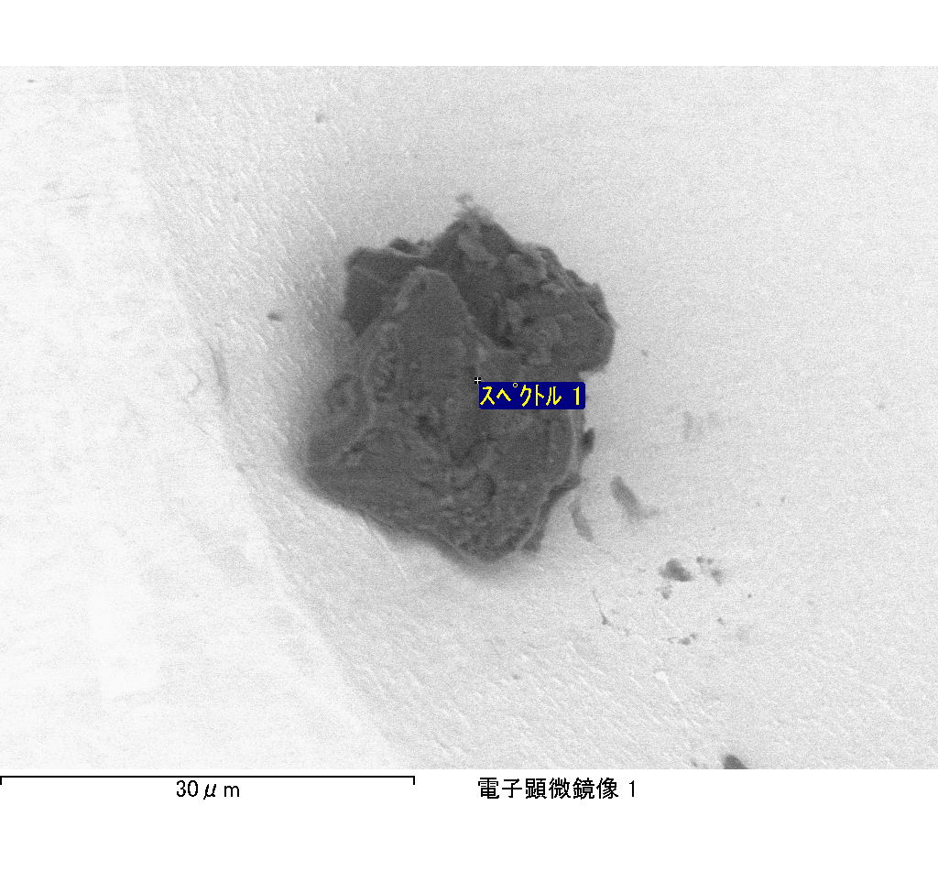

ｽﾍﾟｸﾄﾙﾗﾍﾞﾙ: ｽﾍﾟｸﾄﾙ 2

ﾗｲﾌﾞﾀｲﾑ 120.0 s

収集ｼﾞｵﾒﾄﾘ[度] :

試料傾斜角 = 0.0

方位角 = 0.0

ｴﾚﾍﾞｰｼｮﾝ = 30.0

加速電圧 = 10.00 kV

ｽﾍﾟｸﾄﾙ全ｶｳﾝﾄ数 = 203169

|  |  |  |  |
| --- | --- | --- | --- |
| ｻﾝﾌﾟﾙﾃﾞｰﾀ : | ｴﾈﾙｷﾞｰ[eV] | 分解能[eV] | ｶｳﾝﾄ数 |
| ｽﾄﾛｰﾌﾞ : | 3.8 | 51.85 | 1193651 |
|  |  |  |  |

定量最適化がおこなわれていません

ｽﾍﾟｸﾄﾙ処理 :

省略されたﾋﾟｰｸはありません

処理ｵﾌﾟｼｮﾝ : 酸素 ｽﾄｲｷｵﾒﾄﾘ (ﾉｰﾏﾗｲｽﾞ)

繰り返し回数 = 2

ｽﾀﾝﾀﾞｰﾄﾞ :

Na Albite 1999/06/01

Mg MgO 1999/06/01

Al Al2O3 1999/06/01

Si SiO2 1999/06/01

P GaP 1999/06/01

S FeS2 1999/06/01

K MAD-10 Feldspar 1999/06/01

Ca Wollastonite 1999/06/01

Cr Cr 1999/06/01

Mn Mn 1999/06/01

Fe Fe 1999/06/01

Ni Ni 1999/06/01

|  |  |  |  |  |  |
| --- | --- | --- | --- | --- | --- |
| 元素 | 質量濃度 | 原子数 | 化合物 | 化学式 |  |
|  | [%] | 濃度[%] | 濃度[%] |  |  |
| Na K | -0.35 | -0.36 | -0.47 | Na2O |  |
| Mg K | 9.57 | 9.20 | 15.88 | MgO |  |
| Al K | 135.43 | 117.29 | 255.89 | Al2O3 |  |
| Si K | 13.98 | 11.63 | 29.91 | SiO2 |  |
| P K | -51.20 | -38.63 | -117.32 | P2O5 |  |
| S K | -44.19 | -32.21 | -110.35 | SO3 |  |
| K K | -0.57 | -0.34 | -0.69 | K2O |  |
| Ca K | 4.11 | 2.40 | 5.76 | CaO |  |
| Cr K | 0.70 | 0.31 | 1.02 | Cr2O3 |  |
| Mn K | 1.81 | 0.77 | 2.34 | MnO |  |
| Fe K | 4.54 | 1.90 | 5.84 | FeO |  |
| Ni K | 9.59 | 3.82 | 12.21 | NiO |  |
| O | 16.58 | 24.21 |  |  |  |
| ﾄｰﾀﾙ | 100.00 |  |  |  |  |

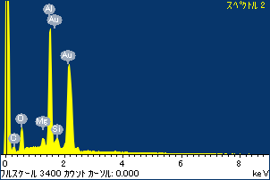

ﾌﾟﾛｼﾞｪｸﾄ : ﾌﾟﾛｼﾞｪｸﾄ 1

ｵｰﾅｰ : Administrator

領域 分析領域 1

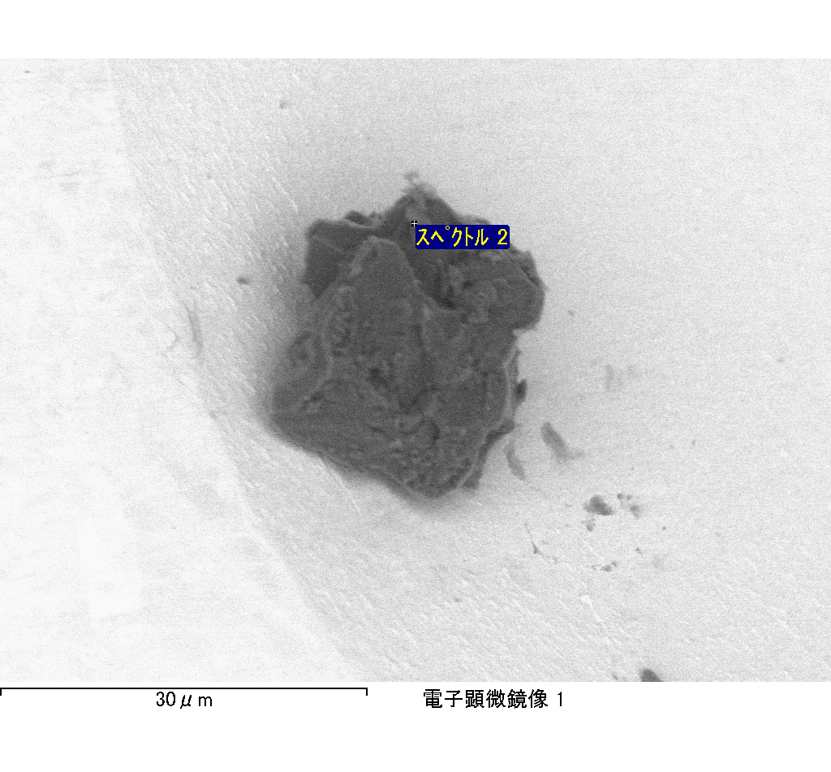

ｽﾍﾟｸﾄﾙﾗﾍﾞﾙ: ｽﾍﾟｸﾄﾙ 4

ﾗｲﾌﾞﾀｲﾑ 120.0 s

収集ｼﾞｵﾒﾄﾘ[度] :

試料傾斜角 = 0.0

方位角 = 0.0

ｴﾚﾍﾞｰｼｮﾝ = 30.0

加速電圧 = 10.00 kV

ｽﾍﾟｸﾄﾙ全ｶｳﾝﾄ数 = 189827

|  |  |  |  |
| --- | --- | --- | --- |
| ｻﾝﾌﾟﾙﾃﾞｰﾀ : | ｴﾈﾙｷﾞｰ[eV] | 分解能[eV] | ｶｳﾝﾄ数 |
| ｽﾄﾛｰﾌﾞ : | 3.8 | 51.74 | 1196583 |
|  |  |  |  |

定量最適化がおこなわれていません

ｽﾍﾟｸﾄﾙ処理 :

省略されたﾋﾟｰｸはありません

処理ｵﾌﾟｼｮﾝ : 酸素 ｽﾄｲｷｵﾒﾄﾘ (ﾉｰﾏﾗｲｽﾞ)

繰り返し回数 = 2

ｽﾀﾝﾀﾞｰﾄﾞ :

Na Albite 1999/06/01

Mg MgO 1999/06/01

Al Al2O3 1999/06/01

Si SiO2 1999/06/01

P GaP 1999/06/01

S FeS2 1999/06/01

K MAD-10 Feldspar 1999/06/01

Ca Wollastonite 1999/06/01

Cr Cr 1999/06/01

Mn Mn 1999/06/01

Fe Fe 1999/06/01

Ni Ni 1999/06/01

|  |  |  |  |  |  |
| --- | --- | --- | --- | --- | --- |
| 元素 | 質量濃度 | 原子数 | 化合物 | 化学式 |  |
|  | [%] | 濃度[%] | 濃度[%] |  |  |
| Na K | -0.24 | -0.16 | -0.33 | Na2O |  |
| Mg K | -91.98 | -58.38 | -152.52 | MgO |  |
| Al K | -0.96 | -0.55 | -1.82 | Al2O3 |  |
| Si K | -73.51 | -40.39 | -157.26 | SiO2 |  |
| P K | 109.17 | 54.39 | 250.14 | P2O5 |  |
| S K | 93.93 | 45.20 | 234.54 | SO3 |  |
| K K | -0.68 | -0.27 | -0.82 | K2O |  |
| Ca K | -4.47 | -1.72 | -6.25 | CaO |  |
| Cr K | 6.12 | 1.82 | 8.94 | Cr2O3 |  |
| Mn K | -8.68 | -2.44 | -11.21 | MnO |  |
| Fe K | -58.57 | -16.18 | -75.35 | FeO |  |
| Ni K | 9.38 | 2.47 | 11.94 | NiO |  |
| O | 120.50 | 116.22 |  |  |  |
| ﾄｰﾀﾙ | 100.00 |  |  |  |  |

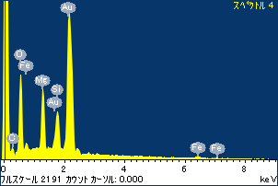

ﾌﾟﾛｼﾞｪｸﾄ : ﾌﾟﾛｼﾞｪｸﾄ 1

ｵｰﾅｰ : Administrator

領域 分析領域 1

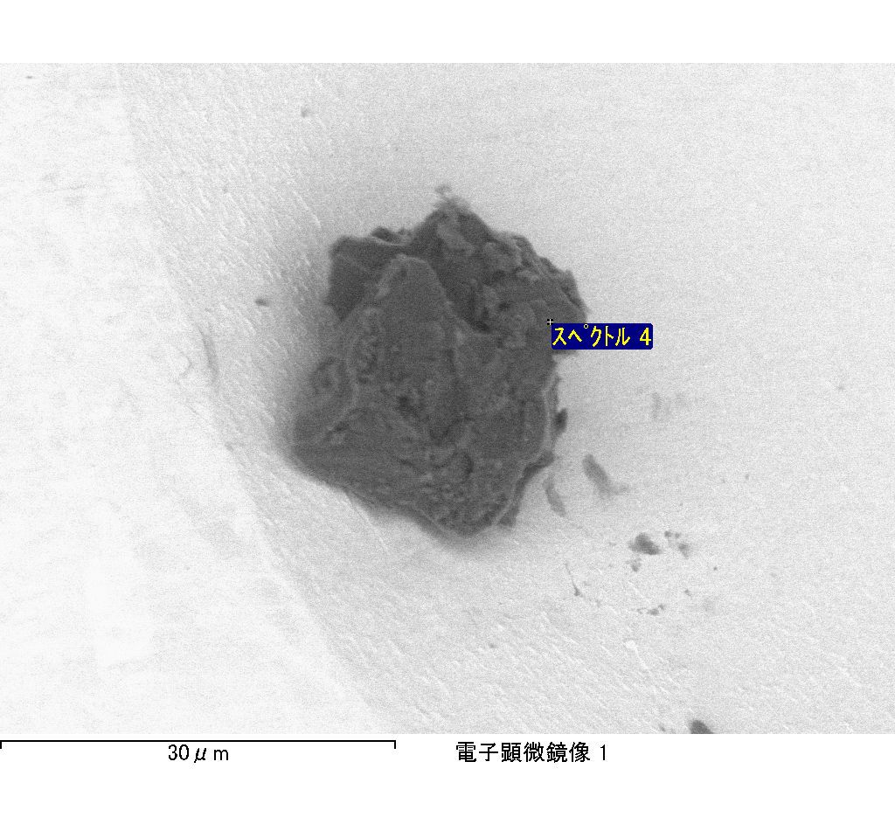

ｽﾍﾟｸﾄﾙﾗﾍﾞﾙ: ｽﾍﾟｸﾄﾙ 5

ﾗｲﾌﾞﾀｲﾑ 120.0 s

収集ｼﾞｵﾒﾄﾘ[度] :

試料傾斜角 = 0.0

方位角 = 0.0

ｴﾚﾍﾞｰｼｮﾝ = 30.0

加速電圧 = 10.00 kV

ｽﾍﾟｸﾄﾙ全ｶｳﾝﾄ数 = 179102

|  |  |  |  |
| --- | --- | --- | --- |
| ｻﾝﾌﾟﾙﾃﾞｰﾀ : | ｴﾈﾙｷﾞｰ[eV] | 分解能[eV] | ｶｳﾝﾄ数 |
| ｽﾄﾛｰﾌﾞ : | 3.8 | 51.87 | 1195412 |
|  |  |  |  |

定量最適化がおこなわれていません

ｽﾍﾟｸﾄﾙ処理 :

省略されたﾋﾟｰｸはありません

処理ｵﾌﾟｼｮﾝ : 酸素 ｽﾄｲｷｵﾒﾄﾘ (ﾉｰﾏﾗｲｽﾞ)

繰り返し回数 = 2

ｽﾀﾝﾀﾞｰﾄﾞ :

Na Albite 1999/06/01

Mg MgO 1999/06/01

Al Al2O3 1999/06/01

Si SiO2 1999/06/01

P GaP 1999/06/01

S FeS2 1999/06/01

K MAD-10 Feldspar 1999/06/01

Ca Wollastonite 1999/06/01

Cr Cr 1999/06/01

Mn Mn 1999/06/01

Fe Fe 1999/06/01

Ni Ni 1999/06/01

|  |  |  |  |  |  |
| --- | --- | --- | --- | --- | --- |
| 元素 | 質量濃度 | 原子数 | 化合物 | 化学式 |  |
|  | [%] | 濃度[%] | 濃度[%] |  |  |
| Na K | -0.31 | -0.21 | -0.41 | Na2O |  |
| Mg K | -25.29 | -16.26 | -41.93 | MgO |  |
| Al K | -1.88 | -1.09 | -3.54 | Al2O3 |  |
| Si K | -64.82 | -36.08 | -138.67 | SiO2 |  |
| P K | 88.02 | 44.42 | 201.69 | P2O5 |  |
| S K | 69.79 | 34.02 | 174.27 | SO3 |  |
| K K | -0.50 | -0.20 | -0.60 | K2O |  |
| Ca K | -43.68 | -17.04 | -61.12 | CaO |  |
| Cr K | -1.96 | -0.59 | -2.87 | Cr2O3 |  |
| Mn K | -5.46 | -1.55 | -7.04 | MnO |  |
| Fe K | -26.77 | -7.49 | -34.44 | FeO |  |
| Ni K | 11.53 | 3.07 | 14.67 | NiO |  |
| O | 101.32 | 98.99 |  |  |  |
| ﾄｰﾀﾙ | 100.00 |  |  |  |  |

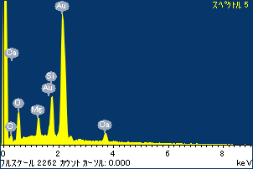

ﾌﾟﾛｼﾞｪｸﾄ : ﾌﾟﾛｼﾞｪｸﾄ 1

ｵｰﾅｰ : Administrator

領域 分析領域 1

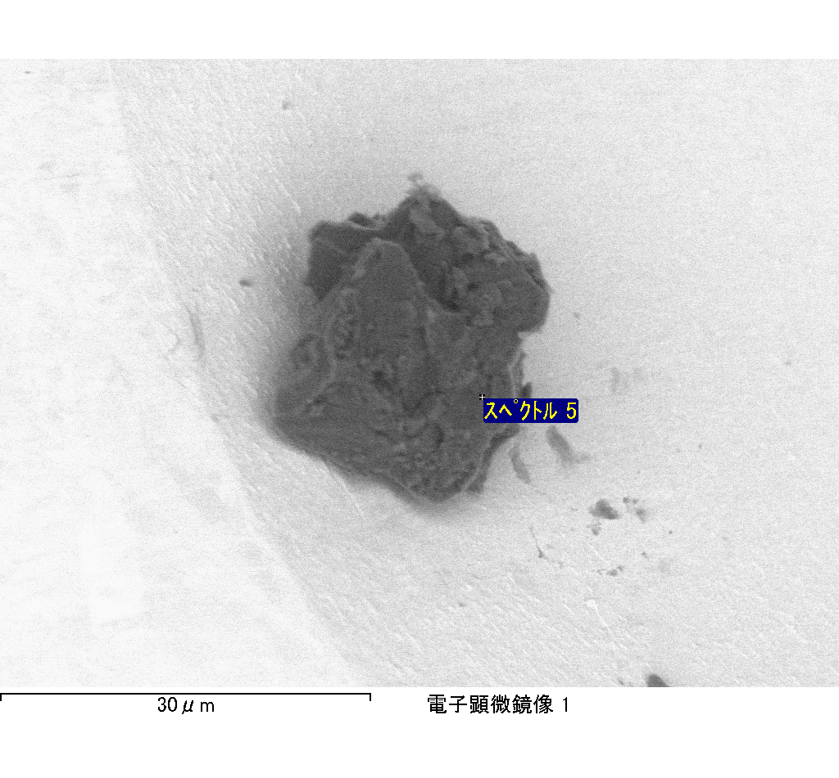

ｽﾍﾟｸﾄﾙﾗﾍﾞﾙ: ｽﾍﾟｸﾄﾙ 6

ﾗｲﾌﾞﾀｲﾑ 48.6 s

収集ｼﾞｵﾒﾄﾘ[度] :

試料傾斜角 = 0.0

方位角 = 0.0

ｴﾚﾍﾞｰｼｮﾝ = 30.0

加速電圧 = 10.00 kV

ｽﾍﾟｸﾄﾙ全ｶｳﾝﾄ数 = 78060

|  |  |  |  |
| --- | --- | --- | --- |
| ｻﾝﾌﾟﾙﾃﾞｰﾀ : | ｴﾈﾙｷﾞｰ[eV] | 分解能[eV] | ｶｳﾝﾄ数 |
| ｽﾄﾛｰﾌﾞ : | 3.8 | 51.83 | 485436 |
|  |  |  |  |

定量最適化がおこなわれていません

ｽﾍﾟｸﾄﾙ処理 :

省略されたﾋﾟｰｸはありません

処理ｵﾌﾟｼｮﾝ : 酸素 ｽﾄｲｷｵﾒﾄﾘ (ﾉｰﾏﾗｲｽﾞ)

繰り返し回数 = 2

ｽﾀﾝﾀﾞｰﾄﾞ :

Na Albite 1999/06/01

Mg MgO 1999/06/01

Al Al2O3 1999/06/01

Si SiO2 1999/06/01

P GaP 1999/06/01

S FeS2 1999/06/01

K MAD-10 Feldspar 1999/06/01

Ca Wollastonite 1999/06/01

Cr Cr 1999/06/01

Mn Mn 1999/06/01

Fe Fe 1999/06/01

Ni Ni 1999/06/01

|  |  |  |  |  |  |
| --- | --- | --- | --- | --- | --- |
| 元素 | 質量濃度 | 原子数 | 化合物 | 化学式 |  |
|  | [%] | 濃度[%] | 濃度[%] |  |  |
| Na K | -4.46 | -3.39 | -6.01 | Na2O |  |
| Mg K | -60.47 | -43.39 | -100.26 | MgO |  |
| Al K | -13.13 | -8.49 | -24.80 | Al2O3 |  |
| Si K | -164.09 | -101.92 | -351.03 | SiO2 |  |
| P K | 159.12 | 89.62 | 364.60 | P2O5 |  |
| S K | 126.08 | 68.60 | 314.82 | SO3 |  |
| K K | 2.34 | 1.04 | 2.82 | K2O |  |
| Ca K | -101.46 | -44.16 | -141.95 | CaO |  |
| Cr K | -11.30 | -3.79 | -16.51 | Cr2O3 |  |
| Mn K | 6.19 | 1.96 | 7.99 | MnO |  |
| Fe K | -18.66 | -5.83 | -24.00 | FeO |  |
| Ni K | 58.42 | 17.36 | 74.34 | NiO |  |
| O | 121.40 | 132.37 |  |  |  |
| ﾄｰﾀﾙ | 100.00 |  |  |  |  |

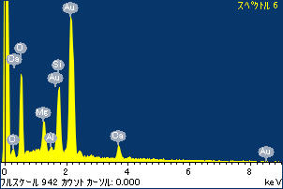

ﾌﾟﾛｼﾞｪｸﾄ : ﾌﾟﾛｼﾞｪｸﾄ 1

ｵｰﾅｰ : Administrator

領域 分析領域 1

