ｽﾍﾟｸﾄﾙﾗﾍﾞﾙ: ｽﾍﾟｸﾄﾙ 1

ﾗｲﾌﾞﾀｲﾑ 120.0 s

収集ｼﾞｵﾒﾄﾘ[度] :

試料傾斜角 = 0.0

方位角 = 0.0

ｴﾚﾍﾞｰｼｮﾝ = 30.0

加速電圧 = 10.00 kV

ｽﾍﾟｸﾄﾙ全ｶｳﾝﾄ数 = 200657

|  |  |  |  |
| --- | --- | --- | --- |
| ｻﾝﾌﾟﾙﾃﾞｰﾀ : | ｴﾈﾙｷﾞｰ[eV] | 分解能[eV] | ｶｳﾝﾄ数 |
| ｽﾄﾛｰﾌﾞ : | 3.8 | 51.91 | 1194790 |
|  |  |  |  |

定量最適化がおこなわれていません

ｽﾍﾟｸﾄﾙ処理 :

省略されたﾋﾟｰｸはありません

処理ｵﾌﾟｼｮﾝ : 酸素 ｽﾄｲｷｵﾒﾄﾘ (ﾉｰﾏﾗｲｽﾞ)

繰り返し回数 = 2

ｽﾀﾝﾀﾞｰﾄﾞ :

Na Albite 1999/06/01

Mg MgO 1999/06/01

Al Al2O3 1999/06/01

Si SiO2 1999/06/01

P GaP 1999/06/01

S FeS2 1999/06/01

K MAD-10 Feldspar 1999/06/01

Ca Wollastonite 1999/06/01

Cr Cr 1999/06/01

Mn Mn 1999/06/01

Fe Fe 1999/06/01

Ni Ni 1999/06/01

|  |  |  |  |  |  |
| --- | --- | --- | --- | --- | --- |
| 元素 | 質量濃度 | 原子数 | 化合物 | 化学式 |  |
|  | [%] | 濃度[%] | 濃度[%] |  |  |
| Na K | -0.62 | -0.41 | -0.84 | Na2O |  |
| Mg K | -63.03 | -39.02 | -104.51 | MgO |  |
| Al K | -0.74 | -0.42 | -1.41 | Al2O3 |  |
| Si K | -65.65 | -35.18 | -140.45 | SiO2 |  |
| P K | 97.41 | 47.33 | 223.19 | P2O5 |  |
| S K | 80.25 | 37.67 | 200.37 | SO3 |  |
| K K | -0.49 | -0.19 | -0.59 | K2O |  |
| Ca K | 2.14 | 0.80 | 3.00 | CaO |  |
| Cr K | 4.35 | 1.26 | 6.35 | Cr2O3 |  |
| Mn K | -0.75 | -0.20 | -0.96 | MnO |  |
| Fe K | -60.36 | -16.27 | -77.66 | FeO |  |
| Ni K | -5.10 | -1.31 | -6.49 | NiO |  |
| O | 112.61 | 105.93 |  |  |  |
| ﾄｰﾀﾙ | 100.00 |  |  |  |  |

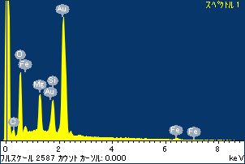

ﾌﾟﾛｼﾞｪｸﾄ : ﾌﾟﾛｼﾞｪｸﾄ 1

ｵｰﾅｰ : Administrator

領域 分析領域 1

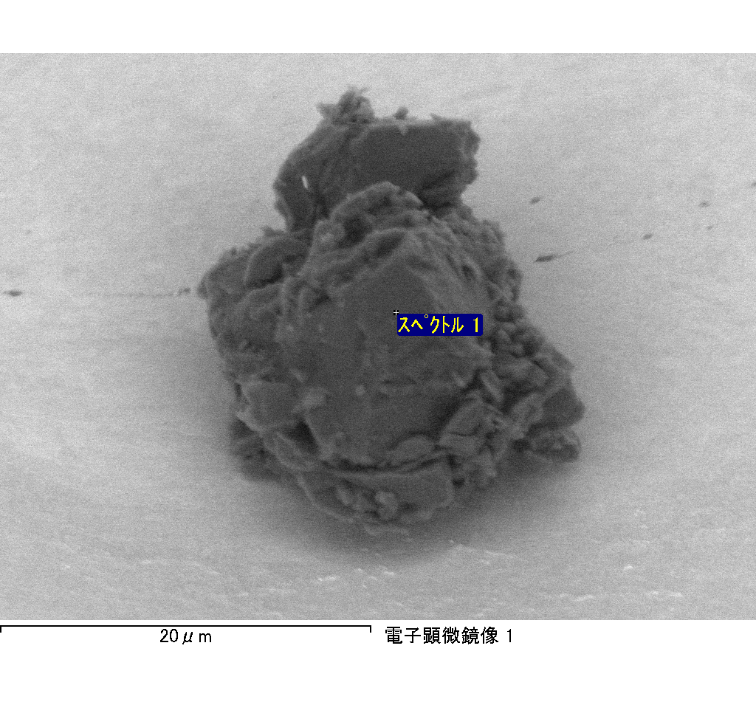

ｽﾍﾟｸﾄﾙﾗﾍﾞﾙ: ｽﾍﾟｸﾄﾙ 2

ﾗｲﾌﾞﾀｲﾑ 120.0 s

収集ｼﾞｵﾒﾄﾘ[度] :

試料傾斜角 = 0.0

方位角 = 0.0

ｴﾚﾍﾞｰｼｮﾝ = 30.0

加速電圧 = 10.00 kV

ｽﾍﾟｸﾄﾙ全ｶｳﾝﾄ数 = 191748

|  |  |  |  |
| --- | --- | --- | --- |
| ｻﾝﾌﾟﾙﾃﾞｰﾀ : | ｴﾈﾙｷﾞｰ[eV] | 分解能[eV] | ｶｳﾝﾄ数 |
| ｽﾄﾛｰﾌﾞ : | 3.8 | 51.80 | 1195334 |
|  |  |  |  |

定量最適化がおこなわれていません

ｽﾍﾟｸﾄﾙ処理 :

省略されたﾋﾟｰｸはありません

処理ｵﾌﾟｼｮﾝ : 酸素 ｽﾄｲｷｵﾒﾄﾘ (ﾉｰﾏﾗｲｽﾞ)

繰り返し回数 = 2

ｽﾀﾝﾀﾞｰﾄﾞ :

Na Albite 1999/06/01

Mg MgO 1999/06/01

Al Al2O3 1999/06/01

Si SiO2 1999/06/01

P GaP 1999/06/01

S FeS2 1999/06/01

K MAD-10 Feldspar 1999/06/01

Ca Wollastonite 1999/06/01

Cr Cr 1999/06/01

Mn Mn 1999/06/01

Fe Fe 1999/06/01

Ni Ni 1999/06/01

|  |  |  |  |  |  |
| --- | --- | --- | --- | --- | --- |
| 元素 | 質量濃度 | 原子数 | 化合物 | 化学式 |  |
|  | [%] | 濃度[%] | 濃度[%] |  |  |
| Na K | 0.91 | 0.48 | 1.22 | Na2O |  |
| Mg K | -84.30 | -42.03 | -139.78 | MgO |  |
| Al K | -5.23 | -2.35 | -9.88 | Al2O3 |  |
| Si K | -73.49 | -31.72 | -157.22 | SiO2 |  |
| P K | 125.19 | 48.99 | 286.84 | P2O5 |  |
| S K | 109.71 | 41.47 | 273.94 | SO3 |  |
| K K | 1.06 | 0.33 | 1.28 | K2O |  |
| Ca K | -12.60 | -3.81 | -17.63 | CaO |  |
| Cr K | 5.93 | 1.38 | 8.67 | Cr2O3 |  |
| Mn K | -7.50 | -1.66 | -9.69 | MnO |  |
| Fe K | -78.65 | -17.07 | -101.18 | FeO |  |
| Ni K | -28.74 | -5.93 | -36.57 | NiO |  |
| O | 147.72 | 111.91 |  |  |  |
| ﾄｰﾀﾙ | 100.00 |  |  |  |  |

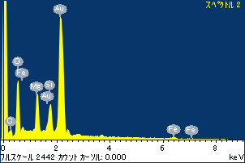

ﾌﾟﾛｼﾞｪｸﾄ : ﾌﾟﾛｼﾞｪｸﾄ 1

ｵｰﾅｰ : Administrator

領域 分析領域 1

