ｽﾍﾟｸﾄﾙﾗﾍﾞﾙ: ｽﾍﾟｸﾄﾙ 1

ﾗｲﾌﾞﾀｲﾑ 120.0 s

収集ｼﾞｵﾒﾄﾘ[度] :

試料傾斜角 = 0.0

方位角 = 0.0

ｴﾚﾍﾞｰｼｮﾝ = 30.0

加速電圧 = 10.00 kV

ｽﾍﾟｸﾄﾙ全ｶｳﾝﾄ数 = 191178

|  |  |  |  |
| --- | --- | --- | --- |
| ｻﾝﾌﾟﾙﾃﾞｰﾀ : | ｴﾈﾙｷﾞｰ[eV] | 分解能[eV] | ｶｳﾝﾄ数 |
| ｽﾄﾛｰﾌﾞ : | 3.8 | 51.80 | 1195609 |
|  |  |  |  |

定量最適化がおこなわれていません

ｽﾍﾟｸﾄﾙ処理 :

省略されたﾋﾟｰｸはありません

処理ｵﾌﾟｼｮﾝ : 酸素 ｽﾄｲｷｵﾒﾄﾘ (ﾉｰﾏﾗｲｽﾞ)

繰り返し回数 = 2

ｽﾀﾝﾀﾞｰﾄﾞ :

Na Albite 1999/06/01

Mg MgO 1999/06/01

Al Al2O3 1999/06/01

Si SiO2 1999/06/01

P GaP 1999/06/01

S FeS2 1999/06/01

K MAD-10 Feldspar 1999/06/01

Ca Wollastonite 1999/06/01

Cr Cr 1999/06/01

Mn Mn 1999/06/01

Fe Fe 1999/06/01

Ni Ni 1999/06/01

|  |  |  |  |  |  |
| --- | --- | --- | --- | --- | --- |
| 元素 | 質量濃度 | 原子数 | 化合物 | 化学式 |  |
|  | [%] | 濃度[%] | 濃度[%] |  |  |
| Na K | -1.80 | -0.65 | -2.43 | Na2O |  |
| Mg K | -512.47 | -174.59 | -849.72 | MgO |  |
| Al K | -2.93 | -0.90 | -5.53 | Al2O3 |  |
| Si K | -437.10 | -128.90 | -935.08 | SiO2 |  |
| P K | 519.04 | 138.79 | 1189.28 | P2O5 |  |
| S K | 425.13 | 109.82 | 1061.51 | SO3 |  |
| K K | -8.34 | -1.77 | -10.04 | K2O |  |
| Ca K | -21.86 | -4.52 | -30.59 | CaO |  |
| Cr K | 3.55 | 0.57 | 5.19 | Cr2O3 |  |
| Mn K | 45.61 | 6.88 | 58.89 | MnO |  |
| Fe K | -425.37 | -63.09 | -547.23 | FeO |  |
| Ni K | 130.26 | 18.38 | 165.76 | NiO |  |
| O | 386.29 | 199.98 |  |  |  |
| ﾄｰﾀﾙ | 100.00 |  |  |  |  |

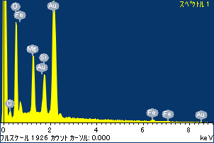

ﾌﾟﾛｼﾞｪｸﾄ : ﾌﾟﾛｼﾞｪｸﾄ 1

ｵｰﾅｰ : Administrator

領域 分析領域 7

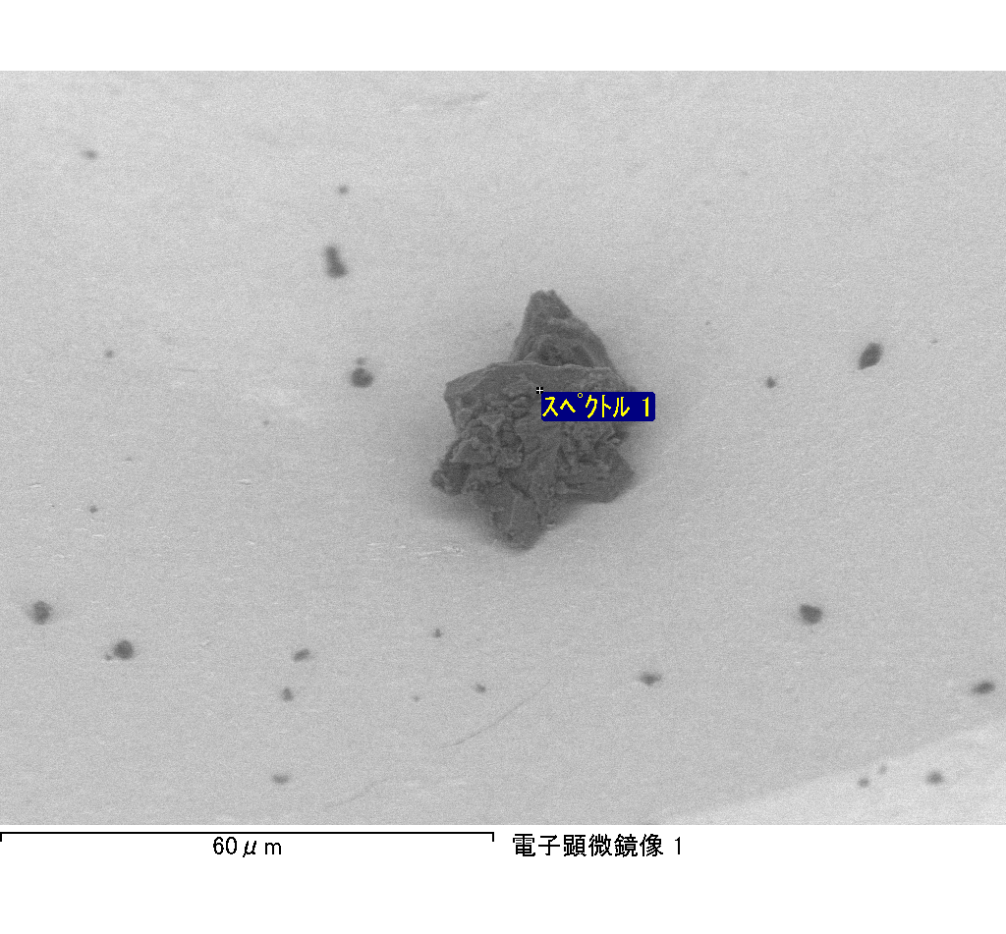

ｽﾍﾟｸﾄﾙﾗﾍﾞﾙ: ｽﾍﾟｸﾄﾙ 2

ﾗｲﾌﾞﾀｲﾑ 120.0 s

収集ｼﾞｵﾒﾄﾘ[度] :

試料傾斜角 = 0.0

方位角 = 0.0

ｴﾚﾍﾞｰｼｮﾝ = 30.0

加速電圧 = 10.00 kV

ｽﾍﾟｸﾄﾙ全ｶｳﾝﾄ数 = 191479

|  |  |  |  |
| --- | --- | --- | --- |
| ｻﾝﾌﾟﾙﾃﾞｰﾀ : | ｴﾈﾙｷﾞｰ[eV] | 分解能[eV] | ｶｳﾝﾄ数 |
| ｽﾄﾛｰﾌﾞ : | 3.8 | 51.82 | 1195868 |
|  |  |  |  |

定量最適化がおこなわれていません

ｽﾍﾟｸﾄﾙ処理 :

省略されたﾋﾟｰｸはありません

処理ｵﾌﾟｼｮﾝ : 酸素 ｽﾄｲｷｵﾒﾄﾘ (ﾉｰﾏﾗｲｽﾞ)

繰り返し回数 = 2

ｽﾀﾝﾀﾞｰﾄﾞ :

Na Albite 1999/06/01

Mg MgO 1999/06/01

Al Al2O3 1999/06/01

Si SiO2 1999/06/01

P GaP 1999/06/01

S FeS2 1999/06/01

K MAD-10 Feldspar 1999/06/01

Ca Wollastonite 1999/06/01

Cr Cr 1999/06/01

Mn Mn 1999/06/01

Fe Fe 1999/06/01

Ni Ni 1999/06/01

|  |  |  |  |  |  |
| --- | --- | --- | --- | --- | --- |
| 元素 | 質量濃度 | 原子数 | 化合物 | 化学式 |  |
|  | [%] | 濃度[%] | 濃度[%] |  |  |
| Na K | -1.20 | -1.10 | -1.61 | Na2O |  |
| Mg K | -27.94 | -24.39 | -46.32 | MgO |  |
| Al K | -2.67 | -2.10 | -5.04 | Al2O3 |  |
| Si K | -68.32 | -51.63 | -146.16 | SiO2 |  |
| P K | 71.66 | 49.11 | 164.19 | P2O5 |  |
| S K | 58.32 | 38.61 | 145.63 | SO3 |  |
| K K | 0.81 | 0.44 | 0.97 | K2O |  |
| Ca K | -33.67 | -17.83 | -47.10 | CaO |  |
| Cr K | -3.61 | -1.47 | -5.28 | Cr2O3 |  |
| Mn K | 7.25 | 2.80 | 9.36 | MnO |  |
| Fe K | -15.84 | -6.02 | -20.37 | FeO |  |
| Ni K | 40.65 | 14.70 | 51.73 | NiO |  |
| O | 74.54 | 98.90 |  |  |  |
| ﾄｰﾀﾙ | 100.00 |  |  |  |  |

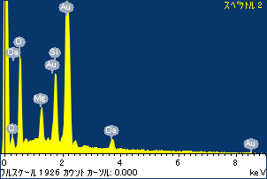

ﾌﾟﾛｼﾞｪｸﾄ : ﾌﾟﾛｼﾞｪｸﾄ 1

ｵｰﾅｰ : Administrator

領域 分析領域 7

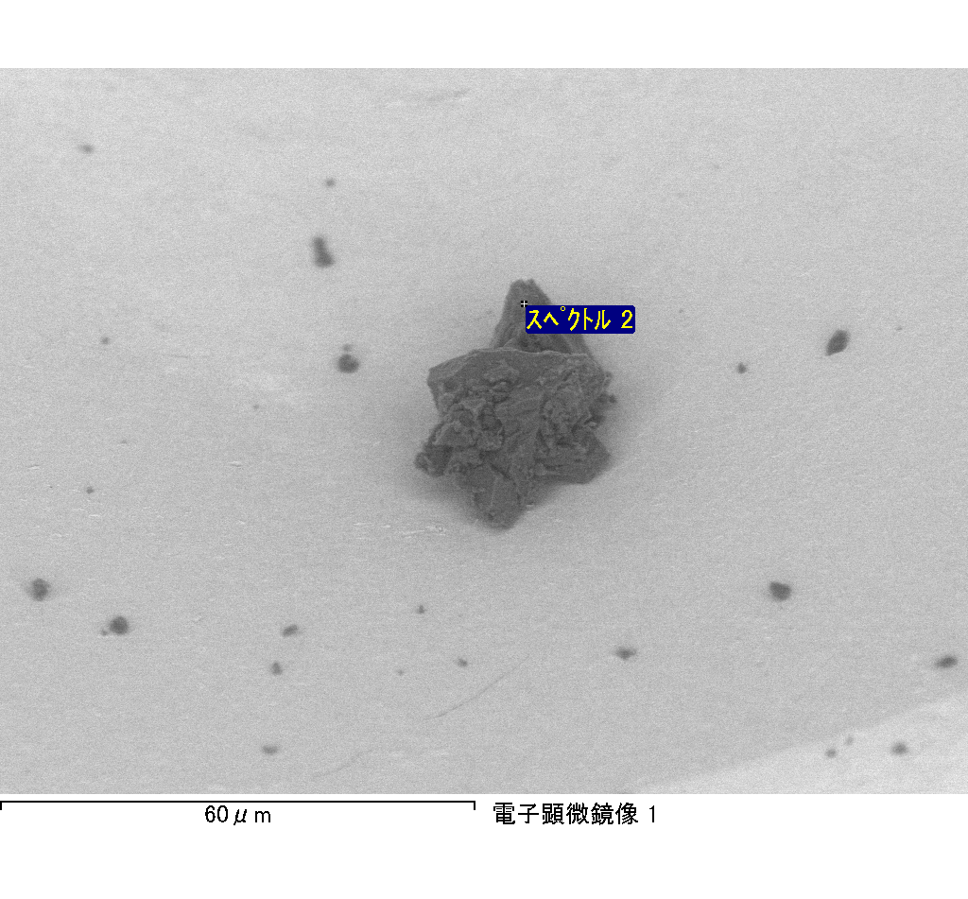

ｽﾍﾟｸﾄﾙ処理 :

省略されたﾋﾟｰｸはありません

処理ｵﾌﾟｼｮﾝ : 酸素 ｽﾄｲｷｵﾒﾄﾘ (ﾉｰﾏﾗｲｽﾞ)

繰り返し回数 = 2

ｽﾀﾝﾀﾞｰﾄﾞ :

Na Albite 1999/06/01

Mg MgO 1999/06/01

Al Al2O3 1999/06/01

Si SiO2 1999/06/01

P GaP 1999/06/01

S FeS2 1999/06/01

K MAD-10 Feldspar 1999/06/01

Ca Wollastonite 1999/06/01

Cr Cr 1999/06/01

Mn Mn 1999/06/01

Fe Fe 1999/06/01

Ni Ni 1999/06/01

|  |  |  |  |  |  |
| --- | --- | --- | --- | --- | --- |
| 元素 | 質量濃度 | 原子数 | 化合物 | 化学式 |  |
|  | [%] | 濃度[%] | 濃度[%] |  |  |
| Na K | 24.61 | -2.91 | 33.17 | Na2O |  |
| Mg K | 2809.68 | -314.21 | 4658.64 | MgO |  |
| Al K | 67.34 | -6.79 | 127.23 | Al2O3 |  |
| Si K | 3949.18 | -382.30 | 8448.43 | SiO2 |  |
| P K | -3494.44 | 306.74 | -8006.90 | P2O5 |  |
| S K | -2938.28 | 249.15 | -7336.63 | SO3 |  |
| K K | -5.99 | 0.42 | -7.21 | K2O |  |
| Ca K | 112.76 | -7.65 | 157.77 | CaO |  |
| Cr K | 237.95 | -12.44 | 347.77 | Cr2O3 |  |
| Mn K | -317.12 | 15.69 | -409.48 | MnO |  |
| Fe K | 1936.51 | -94.28 | 2491.28 | FeO |  |
| Ni K | -317.54 | 14.71 | -404.08 | NiO |  |
| O | -1964.65 | 333.87 |  |  |  |
| ﾄｰﾀﾙ | 100.00 |  |  |  |  |

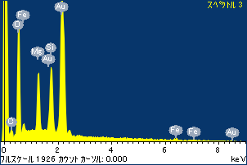

ﾌﾟﾛｼﾞｪｸﾄ : ﾌﾟﾛｼﾞｪｸﾄ 1

ｵｰﾅｰ : Administrator

領域 分析領域 7

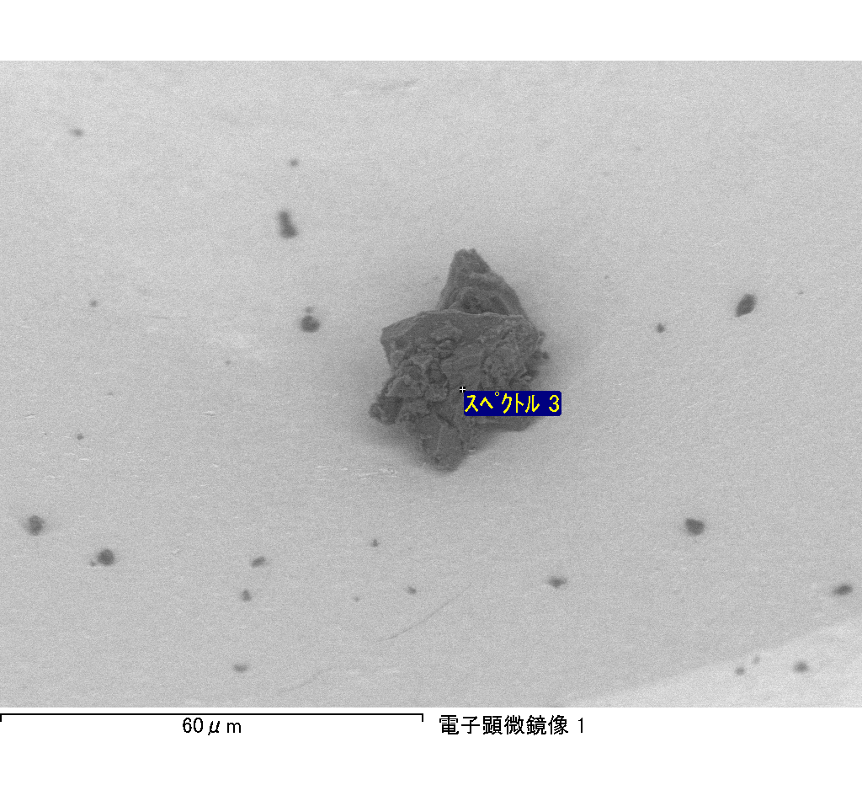

ｽﾍﾟｸﾄﾙﾗﾍﾞﾙ: ｽﾍﾟｸﾄﾙ 3

ﾗｲﾌﾞﾀｲﾑ 120.0 s

収集ｼﾞｵﾒﾄﾘ[度] :

試料傾斜角 = 0.0

方位角 = 0.0

ｴﾚﾍﾞｰｼｮﾝ = 30.0

加速電圧 = 10.00 kV

ｽﾍﾟｸﾄﾙ全ｶｳﾝﾄ数 = 190586

|  |  |  |  |
| --- | --- | --- | --- |
| ｻﾝﾌﾟﾙﾃﾞｰﾀ : | ｴﾈﾙｷﾞｰ[eV] | 分解能[eV] | ｶｳﾝﾄ数 |
| ｽﾄﾛｰﾌﾞ : | 3.8 | 51.83 | 1195414 |
|  |  |  |  |

定量最適化がおこなわれていません

ｽﾍﾟｸﾄﾙﾗﾍﾞﾙ: ｽﾍﾟｸﾄﾙ 4

ﾗｲﾌﾞﾀｲﾑ 120.0 s

収集ｼﾞｵﾒﾄﾘ[度] :

試料傾斜角 = 0.0

方位角 = 0.0

ｴﾚﾍﾞｰｼｮﾝ = 30.0

加速電圧 = 10.00 kV

ｽﾍﾟｸﾄﾙ全ｶｳﾝﾄ数 = 188167

|  |  |  |  |
| --- | --- | --- | --- |
| ｻﾝﾌﾟﾙﾃﾞｰﾀ : | ｴﾈﾙｷﾞｰ[eV] | 分解能[eV] | ｶｳﾝﾄ数 |
| ｽﾄﾛｰﾌﾞ : | 3.8 | 51.81 | 1197367 |
|  |  |  |  |

定量最適化がおこなわれていません

ｽﾍﾟｸﾄﾙ処理 :

省略されたﾋﾟｰｸはありません

処理ｵﾌﾟｼｮﾝ : 酸素 ｽﾄｲｷｵﾒﾄﾘ (ﾉｰﾏﾗｲｽﾞ)

繰り返し回数 = 1

ｽﾀﾝﾀﾞｰﾄﾞ :

Na Albite 1999/06/01

Mg MgO 1999/06/01

Al Al2O3 1999/06/01

Si SiO2 1999/06/01

P GaP 1999/06/01

S FeS2 1999/06/01

K MAD-10 Feldspar 1999/06/01

Ca Wollastonite 1999/06/01

Cr Cr 1999/06/01

Mn Mn 1999/06/01

Fe Fe 1999/06/01

Ni Ni 1999/06/01

|  |  |  |  |  |  |
| --- | --- | --- | --- | --- | --- |
| 元素 | 質量濃度 | 原子数 | 化合物 | 化学式 |  |
|  | [%] | 濃度[%] | 濃度[%] |  |  |
| Na K | -6.84 | -4.31 | -9.22 | Na2O |  |
| Mg K | -48.31 | -28.81 | -80.10 | MgO |  |
| Al K | -6.18 | -3.32 | -11.68 | Al2O3 |  |
| Si K | -69.02 | -35.63 | -147.65 | SiO2 |  |
| P K | 92.18 | 43.15 | 211.21 | P2O5 |  |
| S K | 114.27 | 51.67 | 285.32 | SO3 |  |
| K K | -1.28 | -0.47 | -1.54 | K2O |  |
| Ca K | -114.10 | -41.27 | -159.65 | CaO |  |
| Cr K | -5.99 | -1.67 | -8.76 | Cr2O3 |  |
| Mn K | 11.05 | 2.92 | 14.27 | MnO |  |
| Fe K | 8.19 | 2.13 | 10.54 | FeO |  |
| Ni K | -2.16 | -0.53 | -2.75 | NiO |  |
| O | 128.19 | 116.16 |  |  |  |
| ﾄｰﾀﾙ | 100.00 |  |  |  |  |

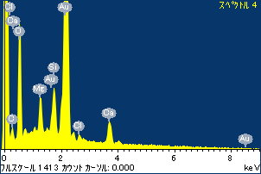

ﾌﾟﾛｼﾞｪｸﾄ : ﾌﾟﾛｼﾞｪｸﾄ 1

ｵｰﾅｰ : Administrator

領域 分析領域 7

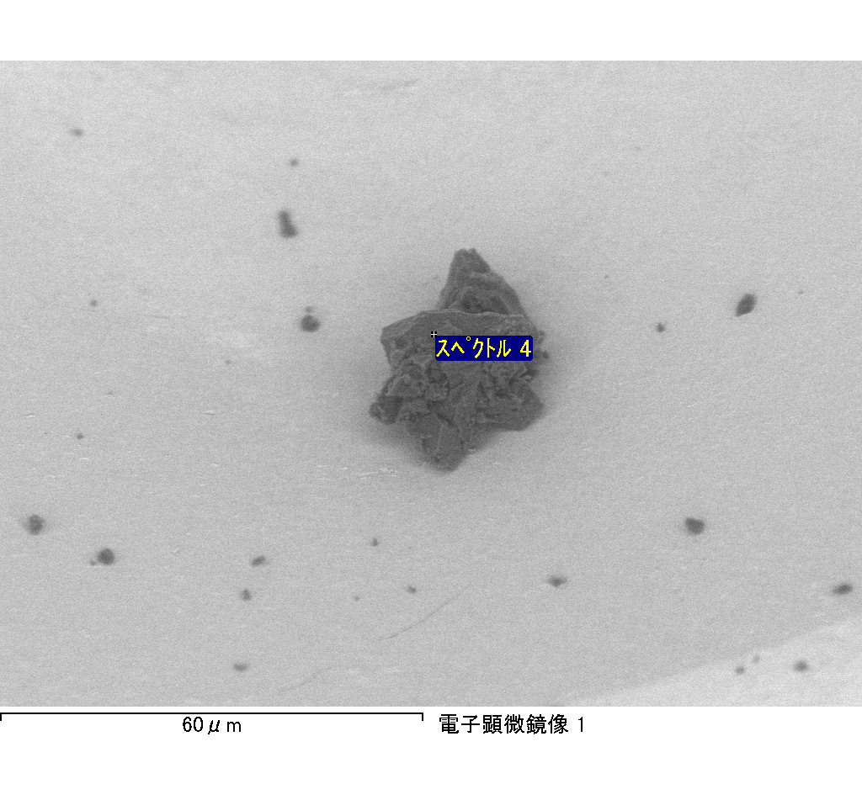

ｽﾍﾟｸﾄﾙﾗﾍﾞﾙ: ｽﾍﾟｸﾄﾙ 6

ﾗｲﾌﾞﾀｲﾑ 120.0 s

収集ｼﾞｵﾒﾄﾘ[度] :

試料傾斜角 = 0.0

方位角 = 0.0

ｴﾚﾍﾞｰｼｮﾝ = 30.0

加速電圧 = 10.00 kV

ｽﾍﾟｸﾄﾙ全ｶｳﾝﾄ数 = 179725

|  |  |  |  |
| --- | --- | --- | --- |
| ｻﾝﾌﾟﾙﾃﾞｰﾀ : | ｴﾈﾙｷﾞｰ[eV] | 分解能[eV] | ｶｳﾝﾄ数 |
| ｽﾄﾛｰﾌﾞ : | 3.8 | 51.78 | 1196572 |
|  |  |  |  |

定量最適化がおこなわれていません

ｽﾍﾟｸﾄﾙ処理 :

定量計算に使用されていないﾋﾟｰｸ : 2.814 keV

処理ｵﾌﾟｼｮﾝ : 酸素 ｽﾄｲｷｵﾒﾄﾘ (ﾉｰﾏﾗｲｽﾞ)

繰り返し回数 = 1

ｽﾀﾝﾀﾞｰﾄﾞ :

Na Albite 1999/06/01

Mg MgO 1999/06/01

Al Al2O3 1999/06/01

Si SiO2 1999/06/01

P GaP 1999/06/01

S FeS2 1999/06/01

K MAD-10 Feldspar 1999/06/01

Ca Wollastonite 1999/06/01

Cr Cr 1999/06/01

Mn Mn 1999/06/01

Fe Fe 1999/06/01

Ni Ni 1999/06/01

|  |  |  |  |  |  |
| --- | --- | --- | --- | --- | --- |
| 元素 | 質量濃度 | 原子数 | 化合物 | 化学式 |  |
|  | [%] | 濃度[%] | 濃度[%] |  |  |
| Na K | 6.78 | -17.20 | 9.14 | Na2O |  |
| Mg K | 38.47 | -92.29 | 63.78 | MgO |  |
| Al K | 0.91 | -1.96 | 1.72 | Al2O3 |  |
| Si K | 32.12 | -66.70 | 68.72 | SiO2 |  |
| P K | -60.86 | 114.59 | -139.44 | P2O5 |  |
| S K | -114.85 | 208.91 | -286.77 | SO3 |  |
| K K | -1.14 | 1.70 | -1.37 | K2O |  |
| Ca K | 168.61 | -245.36 | 235.91 | CaO |  |
| Cr K | -2.88 | 3.23 | -4.20 | Cr2O3 |  |
| Mn K | -0.94 | 1.00 | -1.21 | MnO |  |
| Fe K | 39.80 | -41.56 | 51.20 | FeO |  |
| Ni K | 80.57 | -80.04 | 102.53 | NiO |  |
| O | -86.60 | 315.70 |  |  |  |
| ﾄｰﾀﾙ | 100.00 |  |  |  |  |

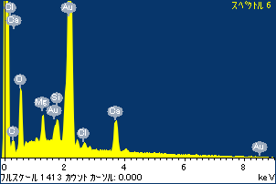

ﾌﾟﾛｼﾞｪｸﾄ : ﾌﾟﾛｼﾞｪｸﾄ 1

ｵｰﾅｰ : Administrator

領域 分析領域 7

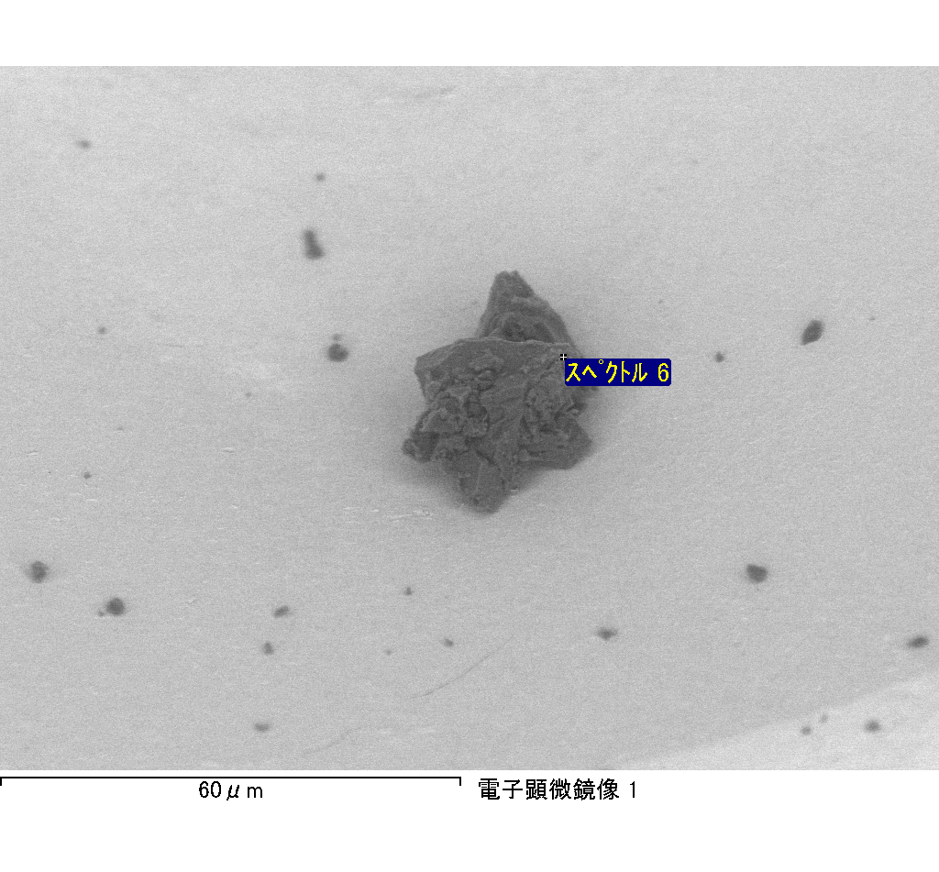

ｽﾍﾟｸﾄﾙﾗﾍﾞﾙ: ｽﾍﾟｸﾄﾙ 7

ﾗｲﾌﾞﾀｲﾑ 120.0 s

収集ｼﾞｵﾒﾄﾘ[度] :

試料傾斜角 = 0.0

方位角 = 0.0

ｴﾚﾍﾞｰｼｮﾝ = 30.0

加速電圧 = 10.00 kV

ｽﾍﾟｸﾄﾙ全ｶｳﾝﾄ数 = 190621

|  |  |  |  |
| --- | --- | --- | --- |
| ｻﾝﾌﾟﾙﾃﾞｰﾀ : | ｴﾈﾙｷﾞｰ[eV] | 分解能[eV] | ｶｳﾝﾄ数 |
| ｽﾄﾛｰﾌﾞ : | 3.8 | 51.81 | 1195762 |
|  |  |  |  |

定量最適化がおこなわれていません

ｽﾍﾟｸﾄﾙ処理 :

省略されたﾋﾟｰｸはありません

処理ｵﾌﾟｼｮﾝ : 酸素 ｽﾄｲｷｵﾒﾄﾘ (ﾉｰﾏﾗｲｽﾞ)

繰り返し回数 = 2

ｽﾀﾝﾀﾞｰﾄﾞ :

Na Albite 1999/06/01

Mg MgO 1999/06/01

Al Al2O3 1999/06/01

Si SiO2 1999/06/01

P GaP 1999/06/01

S FeS2 1999/06/01

K MAD-10 Feldspar 1999/06/01

Ca Wollastonite 1999/06/01

Cr Cr 1999/06/01

Mn Mn 1999/06/01

Fe Fe 1999/06/01

Ni Ni 1999/06/01

|  |  |  |  |  |  |
| --- | --- | --- | --- | --- | --- |
| 元素 | 質量濃度 | 原子数 | 化合物 | 化学式 |  |
|  | [%] | 濃度[%] | 濃度[%] |  |  |
| Na K | -1.27 | -0.90 | -1.72 | Na2O |  |
| Mg K | -92.43 | -61.92 | -153.26 | MgO |  |
| Al K | -2.19 | -1.32 | -4.13 | Al2O3 |  |
| Si K | -151.54 | -87.87 | -324.19 | SiO2 |  |
| P K | 152.54 | 80.20 | 349.52 | P2O5 |  |
| S K | 119.21 | 60.55 | 297.65 | SO3 |  |
| K K | -0.42 | -0.17 | -0.50 | K2O |  |
| Ca K | -6.84 | -2.78 | -9.57 | CaO |  |
| Cr K | 0.76 | 0.24 | 1.11 | Cr2O3 |  |
| Mn K | -5.77 | -1.71 | -7.45 | MnO |  |
| Fe K | -65.41 | -19.07 | -84.14 | FeO |  |
| Ni K | 28.83 | 8.00 | 36.68 | NiO |  |
| O | 124.53 | 126.76 |  |  |  |
| ﾄｰﾀﾙ | 100.00 |  |  |  |  |

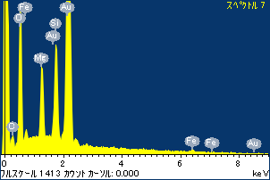

ﾌﾟﾛｼﾞｪｸﾄ : ﾌﾟﾛｼﾞｪｸﾄ 1

ｵｰﾅｰ : Administrator

領域 分析領域 7

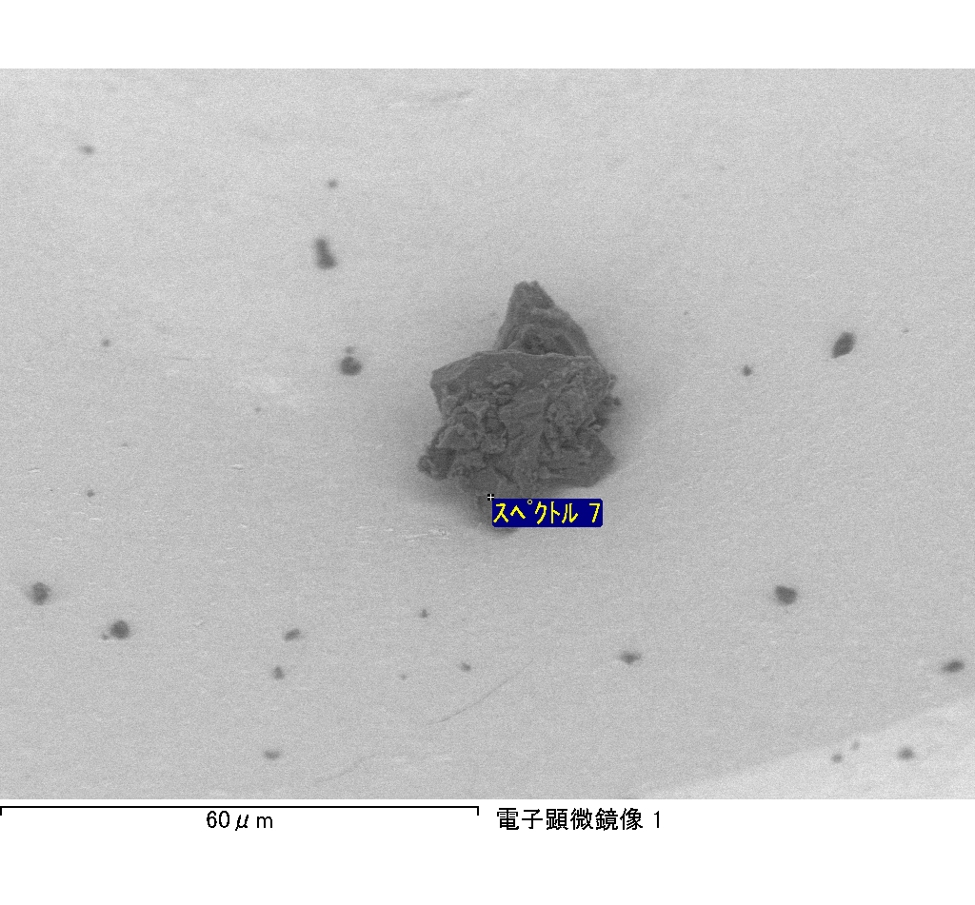

ｽﾍﾟｸﾄﾙﾗﾍﾞﾙ: ｽﾍﾟｸﾄﾙ 8

ﾗｲﾌﾞﾀｲﾑ 120.0 s

収集ｼﾞｵﾒﾄﾘ[度] :

試料傾斜角 = 0.0

方位角 = 0.0

ｴﾚﾍﾞｰｼｮﾝ = 30.0

加速電圧 = 10.00 kV

ｽﾍﾟｸﾄﾙ全ｶｳﾝﾄ数 = 189315

|  |  |  |  |
| --- | --- | --- | --- |
| ｻﾝﾌﾟﾙﾃﾞｰﾀ : | ｴﾈﾙｷﾞｰ[eV] | 分解能[eV] | ｶｳﾝﾄ数 |
| ｽﾄﾛｰﾌﾞ : | 3.8 | 51.78 | 1196716 |
|  |  |  |  |

定量最適化がおこなわれていません

ｽﾍﾟｸﾄﾙ処理 :

省略されたﾋﾟｰｸはありません

処理ｵﾌﾟｼｮﾝ : 酸素 ｽﾄｲｷｵﾒﾄﾘ (ﾉｰﾏﾗｲｽﾞ)

繰り返し回数 = 2

ｽﾀﾝﾀﾞｰﾄﾞ :

Na Albite 1999/06/01

Mg MgO 1999/06/01

Al Al2O3 1999/06/01

Si SiO2 1999/06/01

P GaP 1999/06/01

S FeS2 1999/06/01

K MAD-10 Feldspar 1999/06/01

Ca Wollastonite 1999/06/01

Cr Cr 1999/06/01

Mn Mn 1999/06/01

Fe Fe 1999/06/01

Ni Ni 1999/06/01

|  |  |  |  |  |  |
| --- | --- | --- | --- | --- | --- |
| 元素 | 質量濃度 | 原子数 | 化合物 | 化学式 |  |
|  | [%] | 濃度[%] | 濃度[%] |  |  |
| Na K | -86.02 | -47.14 | -115.95 | Na2O |  |
| Mg K | -22.12 | -11.46 | -36.67 | MgO |  |
| Al K | -135.21 | -63.13 | -255.46 | Al2O3 |  |
| Si K | -382.21 | -171.43 | -817.65 | SiO2 |  |
| P K | 342.30 | 139.22 | 784.32 | P2O5 |  |
| S K | 270.33 | 106.21 | 675.00 | SO3 |  |
| K K | -10.58 | -3.41 | -12.74 | K2O |  |
| Ca K | -15.79 | -4.96 | -22.09 | CaO |  |
| Cr K | 17.48 | 4.24 | 25.55 | Cr2O3 |  |
| Mn K | 38.92 | 8.93 | 50.26 | MnO |  |
| Fe K | -51.94 | -11.72 | -66.82 | FeO |  |
| Ni K | -84.66 | -18.17 | -107.73 | NiO |  |
| O | 219.49 | 172.82 |  |  |  |
| ﾄｰﾀﾙ | 100.00 |  |  |  |  |

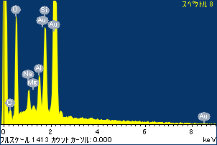

ﾌﾟﾛｼﾞｪｸﾄ : ﾌﾟﾛｼﾞｪｸﾄ 1

ｵｰﾅｰ : Administrator

領域 分析領域 7

