ｽﾍﾟｸﾄﾙﾗﾍﾞﾙ: ｽﾍﾟｸﾄﾙ 1

ﾗｲﾌﾞﾀｲﾑ 120.0 s

収集ｼﾞｵﾒﾄﾘ[度] :

試料傾斜角 = 0.0

方位角 = 0.0

ｴﾚﾍﾞｰｼｮﾝ = 30.0

加速電圧 = 10.00 kV

ｽﾍﾟｸﾄﾙ全ｶｳﾝﾄ数 = 205689

|  |  |  |  |
| --- | --- | --- | --- |
| ｻﾝﾌﾟﾙﾃﾞｰﾀ : | ｴﾈﾙｷﾞｰ[eV] | 分解能[eV] | ｶｳﾝﾄ数 |
| ｽﾄﾛｰﾌﾞ : | 3.8 | 52.05 | 1196185 |
|  |  |  |  |

定量最適化がおこなわれていません

ｽﾍﾟｸﾄﾙ処理 :

省略されたﾋﾟｰｸはありません

処理ｵﾌﾟｼｮﾝ : 酸素 ｽﾄｲｷｵﾒﾄﾘ (ﾉｰﾏﾗｲｽﾞ)

繰り返し回数 = 2

ｽﾀﾝﾀﾞｰﾄﾞ :

Na Albite 1999/06/01

Mg MgO 1999/06/01

Al Al2O3 1999/06/01

Si SiO2 1999/06/01

P GaP 1999/06/01

S FeS2 1999/06/01

K MAD-10 Feldspar 1999/06/01

Ca Wollastonite 1999/06/01

Cr Cr 1999/06/01

Mn Mn 1999/06/01

Fe Fe 1999/06/01

Ni Ni 1999/06/01

|  |  |  |  |  |  |
| --- | --- | --- | --- | --- | --- |
| 元素 | 質量濃度 | 原子数 | 化合物 | 化学式 |  |
|  | [%] | 濃度[%] | 濃度[%] |  |  |
| Na K | -11.21 | -2.62 | -15.11 | Na2O |  |
| Mg K | -561.07 | -123.99 | -930.30 | MgO |  |
| Al K | -6.21 | -1.24 | -11.74 | Al2O3 |  |
| Si K | -453.29 | -86.71 | -969.73 | SiO2 |  |
| P K | 617.55 | 107.12 | 1415.01 | P2O5 |  |
| S K | 501.68 | 84.06 | 1252.65 | SO3 |  |
| K K | -0.35 | -0.05 | -0.42 | K2O |  |
| Ca K | 2.49 | 0.33 | 3.48 | CaO |  |
| Cr K | -23.70 | -2.45 | -34.64 | Cr2O3 |  |
| Mn K | 4.97 | 0.49 | 6.42 | MnO |  |
| Fe K | -396.34 | -38.13 | -509.88 | FeO |  |
| Ni K | -83.09 | -7.60 | -105.74 | NiO |  |
| O | 508.59 | 170.79 |  |  |  |
| ﾄｰﾀﾙ | 100.00 |  |  |  |  |

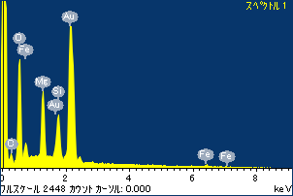

ﾌﾟﾛｼﾞｪｸﾄ : ﾌﾟﾛｼﾞｪｸﾄ 1

ｵｰﾅｰ : Administrator

領域 分析領域 1

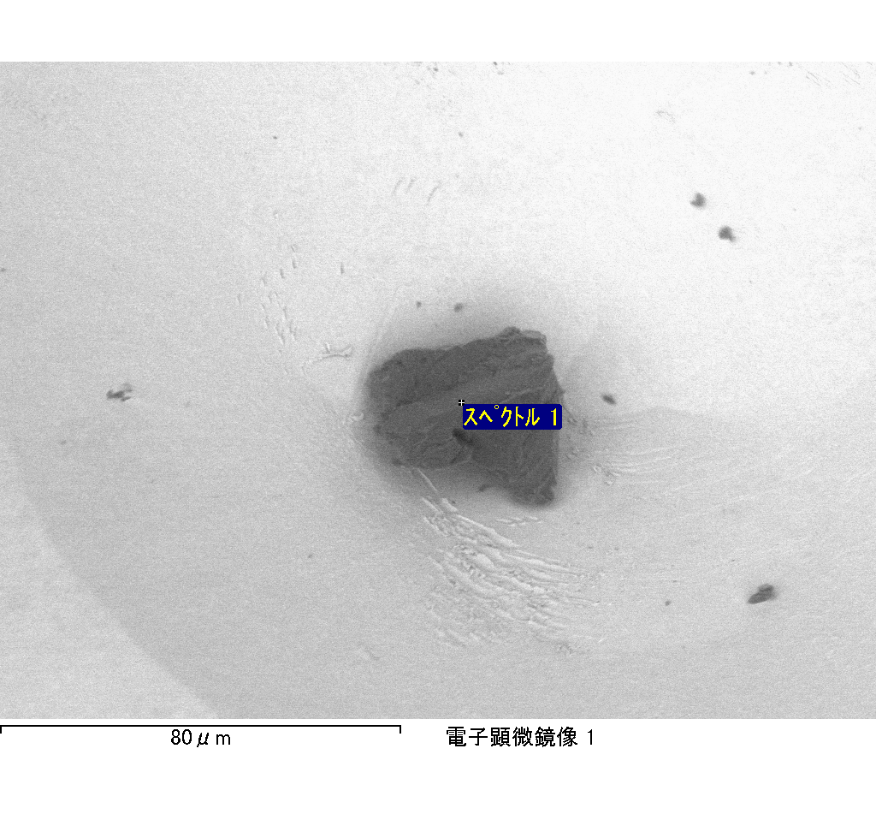

ｽﾍﾟｸﾄﾙﾗﾍﾞﾙ: ｽﾍﾟｸﾄﾙ 1

ﾗｲﾌﾞﾀｲﾑ 120.0 s

収集ｼﾞｵﾒﾄﾘ[度] :

試料傾斜角 = 0.0

方位角 = 0.0

ｴﾚﾍﾞｰｼｮﾝ = 30.0

加速電圧 = 10.00 kV

ｽﾍﾟｸﾄﾙ全ｶｳﾝﾄ数 = 201950

|  |  |  |  |
| --- | --- | --- | --- |
| ｻﾝﾌﾟﾙﾃﾞｰﾀ : | ｴﾈﾙｷﾞｰ[eV] | 分解能[eV] | ｶｳﾝﾄ数 |
| ｽﾄﾛｰﾌﾞ : | 3.8 | 51.83 | 1195678 |
|  |  |  |  |

定量最適化がおこなわれていません

ｽﾍﾟｸﾄﾙ処理 :

定量計算に使用されていないﾋﾟｰｸ : 2.765 keV

処理ｵﾌﾟｼｮﾝ : 酸素 ｽﾄｲｷｵﾒﾄﾘ (ﾉｰﾏﾗｲｽﾞ)

繰り返し回数 = 2

ｽﾀﾝﾀﾞｰﾄﾞ :

Na Albite 1999/06/01

Mg MgO 1999/06/01

Al Al2O3 1999/06/01

Si SiO2 1999/06/01

P GaP 1999/06/01

S FeS2 1999/06/01

K MAD-10 Feldspar 1999/06/01

Ca Wollastonite 1999/06/01

Cr Cr 1999/06/01

Mn Mn 1999/06/01

Fe Fe 1999/06/01

Ni Ni 1999/06/01

|  |  |  |  |  |  |
| --- | --- | --- | --- | --- | --- |
| 元素 | 質量濃度 | 原子数 | 化合物 | 化学式 |  |
|  | [%] | 濃度[%] | 濃度[%] |  |  |
| Na K | 0.37 | 0.24 | 0.50 | Na2O |  |
| Mg K | -154.27 | -95.20 | -255.79 | MgO |  |
| Al K | -1.03 | -0.57 | -1.94 | Al2O3 |  |
| Si K | -118.80 | -63.46 | -254.14 | SiO2 |  |
| P K | 160.02 | 77.51 | 366.66 | P2O5 |  |
| S K | 132.03 | 61.78 | 329.67 | SO3 |  |
| K K | 0.48 | 0.18 | 0.58 | K2O |  |
| Ca K | 2.87 | 1.08 | 4.02 | CaO |  |
| Cr K | -3.16 | -0.91 | -4.61 | Cr2O3 |  |
| Mn K | -6.56 | -1.79 | -8.47 | MnO |  |
| Fe K | -117.11 | -31.46 | -150.66 | FeO |  |
| Ni K | 58.30 | 14.90 | 74.19 | NiO |  |
| O | 146.84 | 137.71 |  |  |  |
| ﾄｰﾀﾙ | 100.00 |  |  |  |  |

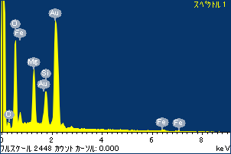

ﾌﾟﾛｼﾞｪｸﾄ : ﾌﾟﾛｼﾞｪｸﾄ 1

ｵｰﾅｰ : Administrator

領域 分析領域 3

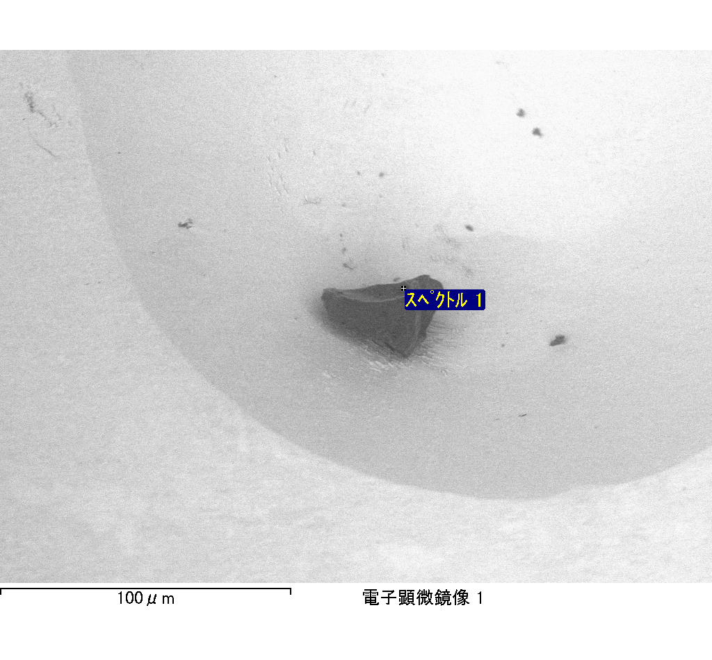

ｽﾍﾟｸﾄﾙﾗﾍﾞﾙ: ｽﾍﾟｸﾄﾙ 2

ﾗｲﾌﾞﾀｲﾑ 120.0 s

収集ｼﾞｵﾒﾄﾘ[度] :

試料傾斜角 = 0.0

方位角 = 0.0

ｴﾚﾍﾞｰｼｮﾝ = 30.0

加速電圧 = 10.00 kV

ｽﾍﾟｸﾄﾙ全ｶｳﾝﾄ数 = 173781

|  |  |  |  |
| --- | --- | --- | --- |
| ｻﾝﾌﾟﾙﾃﾞｰﾀ : | ｴﾈﾙｷﾞｰ[eV] | 分解能[eV] | ｶｳﾝﾄ数 |
| ｽﾄﾛｰﾌﾞ : | 3.8 | 51.88 | 1199256 |
|  |  |  |  |

定量最適化がおこなわれていません

ｽﾍﾟｸﾄﾙ処理 :

省略されたﾋﾟｰｸはありません

処理ｵﾌﾟｼｮﾝ : 酸素 ｽﾄｲｷｵﾒﾄﾘ (ﾉｰﾏﾗｲｽﾞ)

繰り返し回数 = 2

ｽﾀﾝﾀﾞｰﾄﾞ :

Na Albite 1999/06/01

Mg MgO 1999/06/01

Al Al2O3 1999/06/01

Si SiO2 1999/06/01

P GaP 1999/06/01

S FeS2 1999/06/01

K MAD-10 Feldspar 1999/06/01

Ca Wollastonite 1999/06/01

Cr Cr 1999/06/01

Mn Mn 1999/06/01

Fe Fe 1999/06/01

Ni Ni 1999/06/01

|  |  |  |  |  |  |
| --- | --- | --- | --- | --- | --- |
| 元素 | 質量濃度 | 原子数 | 化合物 | 化学式 |  |
|  | [%] | 濃度[%] | 濃度[%] |  |  |
| Na K | -0.24 | -0.16 | -0.32 | Na2O |  |
| Mg K | -18.05 | -11.73 | -29.93 | MgO |  |
| Al K | -1.43 | -0.84 | -2.71 | Al2O3 |  |
| Si K | -18.76 | -10.55 | -40.12 | SiO2 |  |
| P K | 53.84 | 27.46 | 123.36 | P2O5 |  |
| S K | 45.00 | 22.17 | 112.35 | SO3 |  |
| K K | -0.06 | -0.02 | -0.07 | K2O |  |
| Ca K | 0.47 | 0.18 | 0.65 | CaO |  |
| Cr K | -0.53 | -0.16 | -0.77 | Cr2O3 |  |
| Mn K | 4.42 | 1.27 | 5.70 | MnO |  |
| Fe K | -45.95 | -13.00 | -59.11 | FeO |  |
| Ni K | -7.10 | -1.91 | -9.04 | NiO |  |
| O | 88.39 | 87.29 |  |  |  |
| ﾄｰﾀﾙ | 100.00 |  |  |  |  |

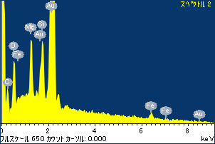

ﾌﾟﾛｼﾞｪｸﾄ : ﾌﾟﾛｼﾞｪｸﾄ 1

ｵｰﾅｰ : Administrator

領域 分析領域 3

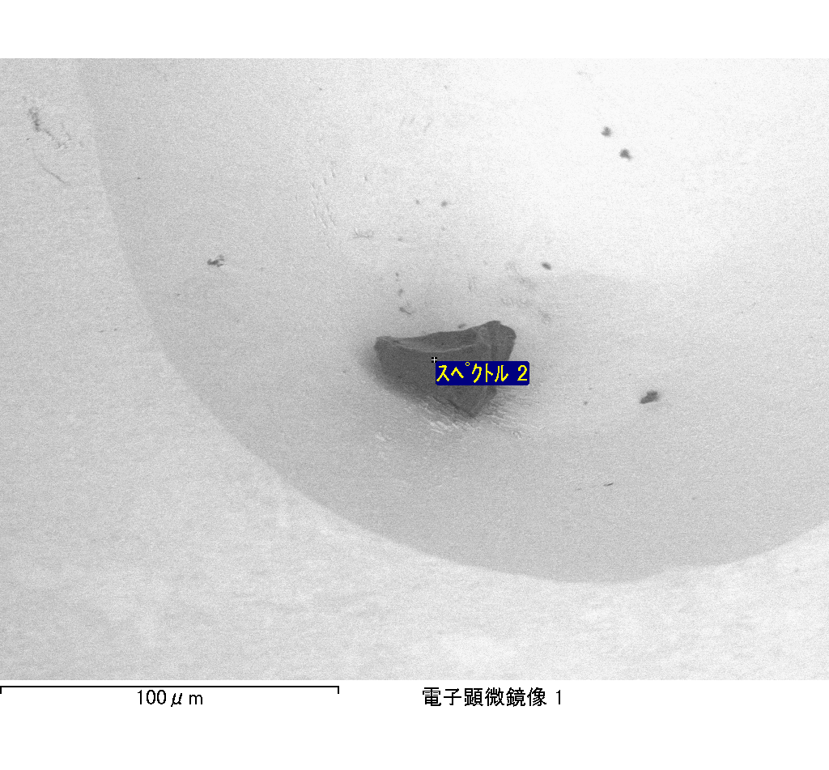

ｽﾍﾟｸﾄﾙﾗﾍﾞﾙ: ｽﾍﾟｸﾄﾙ 3

ﾗｲﾌﾞﾀｲﾑ 120.0 s

収集ｼﾞｵﾒﾄﾘ[度] :

試料傾斜角 = 0.0

方位角 = 0.0

ｴﾚﾍﾞｰｼｮﾝ = 30.0

加速電圧 = 10.00 kV

ｽﾍﾟｸﾄﾙ全ｶｳﾝﾄ数 = 187947

|  |  |  |  |
| --- | --- | --- | --- |
| ｻﾝﾌﾟﾙﾃﾞｰﾀ : | ｴﾈﾙｷﾞｰ[eV] | 分解能[eV] | ｶｳﾝﾄ数 |
| ｽﾄﾛｰﾌﾞ : | 3.8 | 51.87 | 1198003 |
|  |  |  |  |

定量最適化がおこなわれていません

ｽﾍﾟｸﾄﾙ処理 :

省略されたﾋﾟｰｸはありません

処理ｵﾌﾟｼｮﾝ : 酸素 ｽﾄｲｷｵﾒﾄﾘ (ﾉｰﾏﾗｲｽﾞ)

繰り返し回数 = 2

ｽﾀﾝﾀﾞｰﾄﾞ :

Na Albite 1999/06/01

Mg MgO 1999/06/01

Al Al2O3 1999/06/01

Si SiO2 1999/06/01

P GaP 1999/06/01

S FeS2 1999/06/01

K MAD-10 Feldspar 1999/06/01

Ca Wollastonite 1999/06/01

Cr Cr 1999/06/01

Mn Mn 1999/06/01

Fe Fe 1999/06/01

Ni Ni 1999/06/01

|  |  |  |  |  |  |
| --- | --- | --- | --- | --- | --- |
| 元素 | 質量濃度 | 原子数 | 化合物 | 化学式 |  |
|  | [%] | 濃度[%] | 濃度[%] |  |  |
| Na K | -2.24 | -1.30 | -3.02 | Na2O |  |
| Mg K | -94.08 | -51.54 | -155.99 | MgO |  |
| Al K | -0.85 | -0.42 | -1.60 | Al2O3 |  |
| Si K | -72.40 | -34.34 | -154.89 | SiO2 |  |
| P K | 122.05 | 52.48 | 279.64 | P2O5 |  |
| S K | 99.87 | 41.48 | 249.36 | SO3 |  |
| K K | -0.77 | -0.26 | -0.92 | K2O |  |
| Ca K | 1.52 | 0.51 | 2.13 | CaO |  |
| Cr K | 8.53 | 2.18 | 12.47 | Cr2O3 |  |
| Mn K | -1.28 | -0.31 | -1.65 | MnO |  |
| Fe K | -67.76 | -16.16 | -87.18 | FeO |  |
| Ni K | -30.13 | -6.83 | -38.34 | NiO |  |
| O | 137.55 | 114.51 |  |  |  |
| ﾄｰﾀﾙ | 100.00 |  |  |  |  |

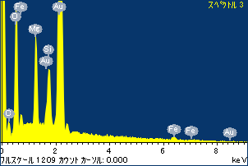

ﾌﾟﾛｼﾞｪｸﾄ : ﾌﾟﾛｼﾞｪｸﾄ 1

ｵｰﾅｰ : Administrator

領域 分析領域 3

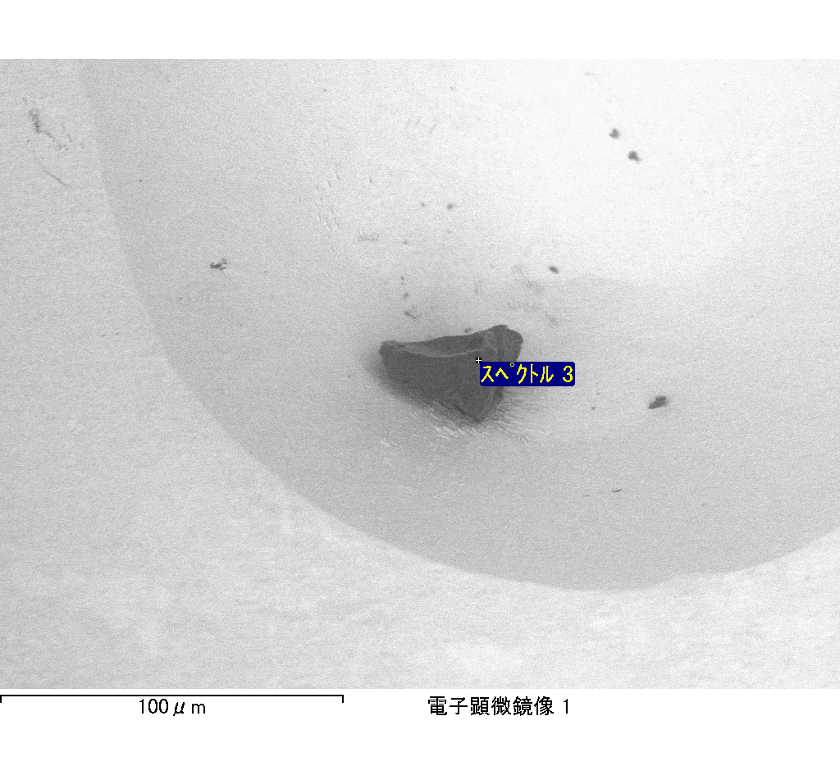

ｽﾍﾟｸﾄﾙﾗﾍﾞﾙ: ｽﾍﾟｸﾄﾙ 1

ﾗｲﾌﾞﾀｲﾑ 120.0 s

収集ｼﾞｵﾒﾄﾘ[度] :

試料傾斜角 = 0.0

方位角 = 0.0

ｴﾚﾍﾞｰｼｮﾝ = 30.0

加速電圧 = 10.00 kV

ｽﾍﾟｸﾄﾙ全ｶｳﾝﾄ数 = 178257

|  |  |  |  |
| --- | --- | --- | --- |
| ｻﾝﾌﾟﾙﾃﾞｰﾀ : | ｴﾈﾙｷﾞｰ[eV] | 分解能[eV] | ｶｳﾝﾄ数 |
| ｽﾄﾛｰﾌﾞ : | 3.8 | 51.86 | 1196389 |
|  |  |  |  |

定量最適化がおこなわれていません

ｽﾍﾟｸﾄﾙ処理 :

省略されたﾋﾟｰｸはありません

処理ｵﾌﾟｼｮﾝ : 酸素 ｽﾄｲｷｵﾒﾄﾘ (ﾉｰﾏﾗｲｽﾞ)

繰り返し回数 = 2

ｽﾀﾝﾀﾞｰﾄﾞ :

Na Albite 1999/06/01

Mg MgO 1999/06/01

Al Al2O3 1999/06/01

Si SiO2 1999/06/01

P GaP 1999/06/01

S FeS2 1999/06/01

K MAD-10 Feldspar 1999/06/01

Ca Wollastonite 1999/06/01

Cr Cr 1999/06/01

Mn Mn 1999/06/01

Fe Fe 1999/06/01

Ni Ni 1999/06/01

|  |  |  |  |  |  |
| --- | --- | --- | --- | --- | --- |
| 元素 | 質量濃度 | 原子数 | 化合物 | 化学式 |  |
|  | [%] | 濃度[%] | 濃度[%] |  |  |
| Na K | -0.16 | -0.14 | -0.21 | Na2O |  |
| Mg K | -18.80 | -16.10 | -31.18 | MgO |  |
| Al K | -0.30 | -0.23 | -0.57 | Al2O3 |  |
| Si K | -17.10 | -12.68 | -36.59 | SiO2 |  |
| P K | 37.20 | 25.01 | 85.23 | P2O5 |  |
| S K | 30.85 | 20.04 | 77.04 | SO3 |  |
| K K | -0.04 | -0.02 | -0.05 | K2O |  |
| Ca K | -0.37 | -0.19 | -0.52 | CaO |  |
| Cr K | 2.76 | 1.10 | 4.03 | Cr2O3 |  |
| Mn K | -0.22 | -0.08 | -0.28 | MnO |  |
| Fe K | -18.59 | -6.93 | -23.92 | FeO |  |
| Ni K | 21.24 | 7.53 | 27.03 | NiO |  |
| O | 63.55 | 82.71 |  |  |  |
| ﾄｰﾀﾙ | 100.00 |  |  |  |  |

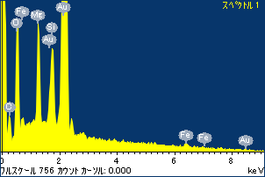

ﾌﾟﾛｼﾞｪｸﾄ : ﾌﾟﾛｼﾞｪｸﾄ 1

ｵｰﾅｰ : Administrator

領域 分析領域 4

