ｽﾍﾟｸﾄﾙﾗﾍﾞﾙ: ｽﾍﾟｸﾄﾙ 1

ﾗｲﾌﾞﾀｲﾑ 120.0 s

収集ｼﾞｵﾒﾄﾘ[度] :

試料傾斜角 = 0.0

方位角 = 0.0

ｴﾚﾍﾞｰｼｮﾝ = 30.0

加速電圧 = 10.00 kV

ｽﾍﾟｸﾄﾙ全ｶｳﾝﾄ数 = 202619

|  |  |  |  |
| --- | --- | --- | --- |
| ｻﾝﾌﾟﾙﾃﾞｰﾀ : | ｴﾈﾙｷﾞｰ[eV] | 分解能[eV] | ｶｳﾝﾄ数 |
| ｽﾄﾛｰﾌﾞ : | 3.8 | 51.83 | 1195738 |
|  |  |  |  |

定量最適化がおこなわれていません

ｽﾍﾟｸﾄﾙ処理 :

定量計算に使用されていないﾋﾟｰｸ : 2.780 keV

処理ｵﾌﾟｼｮﾝ : 酸素 ｽﾄｲｷｵﾒﾄﾘ (ﾉｰﾏﾗｲｽﾞ)

繰り返し回数 = 1

ｽﾀﾝﾀﾞｰﾄﾞ :

Na Albite 1999/06/01

Mg MgO 1999/06/01

Al Al2O3 1999/06/01

Si SiO2 1999/06/01

P GaP 1999/06/01

S FeS2 1999/06/01

K MAD-10 Feldspar 1999/06/01

Ca Wollastonite 1999/06/01

Cr Cr 1999/06/01

Mn Mn 1999/06/01

Fe Fe 1999/06/01

Ni Ni 1999/06/01

|  |  |  |  |  |  |
| --- | --- | --- | --- | --- | --- |
| 元素 | 質量濃度 | 原子数 | 化合物 | 化学式 |  |
|  | [%] | 濃度[%] | 濃度[%] |  |  |
| Na K | -0.16 | -0.13 | -0.21 | Na2O |  |
| Mg K | -1.52 | -1.25 | -2.53 | MgO |  |
| Al K | -0.18 | -0.13 | -0.34 | Al2O3 |  |
| Si K | -1.77 | -1.26 | -3.80 | SiO2 |  |
| P K | 24.91 | 15.99 | 57.07 | P2O5 |  |
| S K | 21.61 | 13.40 | 53.95 | SO3 |  |
| K K | -0.17 | -0.09 | -0.21 | K2O |  |
| Ca K | -1.11 | -0.55 | -1.55 | CaO |  |
| Cr K | -1.07 | -0.41 | -1.56 | Cr2O3 |  |
| Mn K | -0.28 | -0.10 | -0.36 | MnO |  |
| Fe K | -2.44 | -0.87 | -3.13 | FeO |  |
| Ni K | 2.09 | 0.71 | 2.66 | NiO |  |
| O | 60.09 | 74.68 |  |  |  |
| ﾄｰﾀﾙ | 100.00 |  |  |  |  |

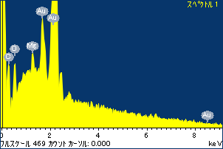

ﾌﾟﾛｼﾞｪｸﾄ : ﾌﾟﾛｼﾞｪｸﾄ 1

ｵｰﾅｰ : Administrator

領域 分析領域 10

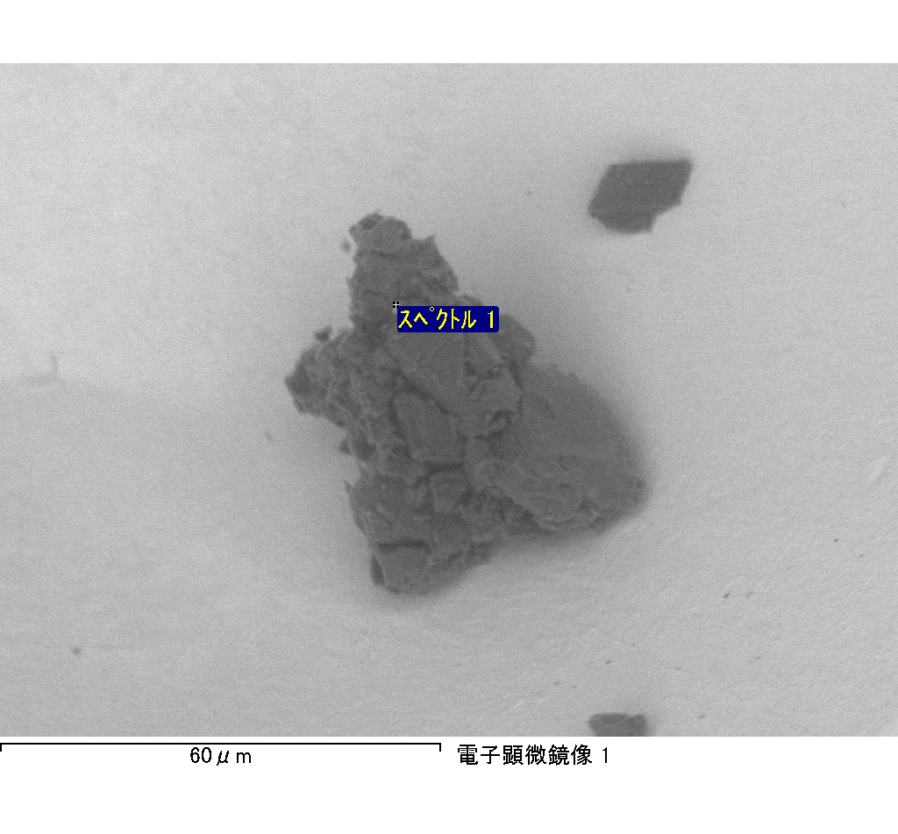

ｽﾍﾟｸﾄﾙﾗﾍﾞﾙ: ｽﾍﾟｸﾄﾙ 2

ﾗｲﾌﾞﾀｲﾑ 120.0 s

収集ｼﾞｵﾒﾄﾘ[度] :

試料傾斜角 = 0.0

方位角 = 0.0

ｴﾚﾍﾞｰｼｮﾝ = 30.0

加速電圧 = 10.00 kV

ｽﾍﾟｸﾄﾙ全ｶｳﾝﾄ数 = 156094

|  |  |  |  |
| --- | --- | --- | --- |
| ｻﾝﾌﾟﾙﾃﾞｰﾀ : | ｴﾈﾙｷﾞｰ[eV] | 分解能[eV] | ｶｳﾝﾄ数 |
| ｽﾄﾛｰﾌﾞ : | 3.8 | 51.88 | 1198326 |
|  |  |  |  |

定量最適化がおこなわれていません

ｽﾍﾟｸﾄﾙ処理 :

省略されたﾋﾟｰｸはありません

処理ｵﾌﾟｼｮﾝ : 酸素 ｽﾄｲｷｵﾒﾄﾘ (ﾉｰﾏﾗｲｽﾞ)

繰り返し回数 = 1

ｽﾀﾝﾀﾞｰﾄﾞ :

Na Albite 1999/06/01

Mg MgO 1999/06/01

Al Al2O3 1999/06/01

Si SiO2 1999/06/01

P GaP 1999/06/01

S FeS2 1999/06/01

K MAD-10 Feldspar 1999/06/01

Ca Wollastonite 1999/06/01

Cr Cr 1999/06/01

Mn Mn 1999/06/01

Fe Fe 1999/06/01

Ni Ni 1999/06/01

|  |  |  |  |  |  |
| --- | --- | --- | --- | --- | --- |
| 元素 | 質量濃度 | 原子数 | 化合物 | 化学式 |  |
|  | [%] | 濃度[%] | 濃度[%] |  |  |
| Na K | -0.26 | -0.21 | -0.35 | Na2O |  |
| Mg K | -1.57 | -1.24 | -2.61 | MgO |  |
| Al K | -0.26 | -0.19 | -0.50 | Al2O3 |  |
| Si K | -3.01 | -2.06 | -6.44 | SiO2 |  |
| P K | 27.83 | 17.26 | 63.77 | P2O5 |  |
| S K | 23.16 | 13.88 | 57.84 | SO3 |  |
| K K | -0.14 | -0.07 | -0.17 | K2O |  |
| Ca K | -1.98 | -0.95 | -2.76 | CaO |  |
| Cr K | 1.08 | 0.40 | 1.58 | Cr2O3 |  |
| Mn K | -0.75 | -0.26 | -0.96 | MnO |  |
| Fe K | -4.21 | -1.45 | -5.42 | FeO |  |
| Ni K | -3.13 | -1.03 | -3.99 | NiO |  |
| O | 63.23 | 75.92 |  |  |  |
| ﾄｰﾀﾙ | 100.00 |  |  |  |  |

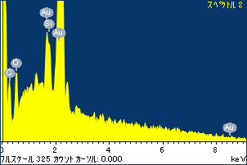

ﾌﾟﾛｼﾞｪｸﾄ : ﾌﾟﾛｼﾞｪｸﾄ 1

ｵｰﾅｰ : Administrator

領域 分析領域 10

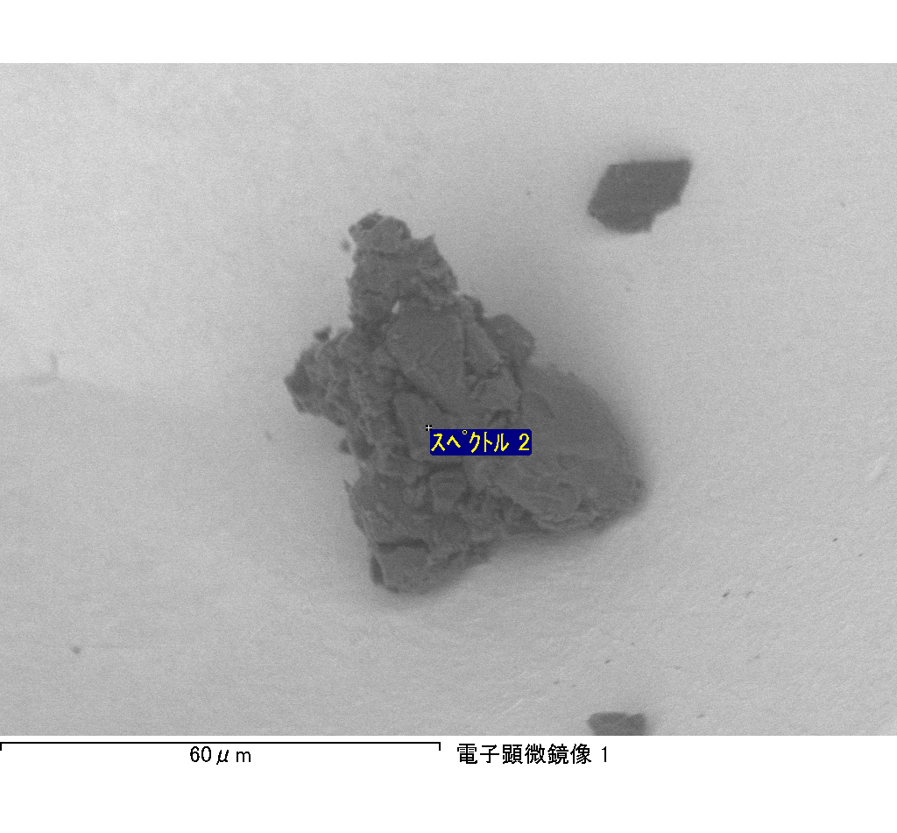

ｽﾍﾟｸﾄﾙ処理 :

省略されたﾋﾟｰｸはありません

処理ｵﾌﾟｼｮﾝ : 酸素 ｽﾄｲｷｵﾒﾄﾘ (ﾉｰﾏﾗｲｽﾞ)

繰り返し回数 = 2

ｽﾀﾝﾀﾞｰﾄﾞ :

Na Albite 1999/06/01

Mg MgO 1999/06/01

Al Al2O3 1999/06/01

Si SiO2 1999/06/01

P GaP 1999/06/01

S FeS2 1999/06/01

K MAD-10 Feldspar 1999/06/01

Ca Wollastonite 1999/06/01

Cr Cr 1999/06/01

Mn Mn 1999/06/01

Fe Fe 1999/06/01

Ni Ni 1999/06/01

|  |  |  |  |  |  |
| --- | --- | --- | --- | --- | --- |
| 元素 | 質量濃度 | 原子数 | 化合物 | 化学式 |  |
|  | [%] | 濃度[%] | 濃度[%] |  |  |
| Na K | 76.87 | -4.36 | 103.61 | Na2O |  |
| Mg K | 4294.91 | -230.40 | 7121.25 | MgO |  |
| Al K | 50.17 | -2.42 | 94.78 | Al2O3 |  |
| Si K | 3451.02 | -160.25 | 7382.73 | SiO2 |  |
| P K | -4168.95 | 175.54 | -9552.42 | P2O5 |  |
| S K | -3542.82 | 144.10 | -8846.11 | SO3 |  |
| K K | -75.43 | 2.52 | -90.87 | K2O |  |
| Ca K | -65.87 | 2.14 | -92.16 | CaO |  |
| Cr K | -66.51 | 1.67 | -97.21 | Cr2O3 |  |
| Mn K | -112.03 | 2.66 | -144.65 | MnO |  |
| Fe K | 3813.49 | -89.06 | 4905.97 | FeO |  |
| Ni K | -538.25 | 11.96 | -684.93 | NiO |  |
| O | -3016.58 | 245.90 |  |  |  |
| ﾄｰﾀﾙ | 100.00 |  |  |  |  |

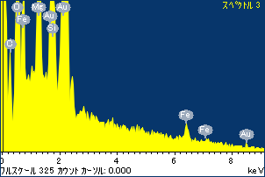

ﾌﾟﾛｼﾞｪｸﾄ : ﾌﾟﾛｼﾞｪｸﾄ 1

ｵｰﾅｰ : Administrator

領域 分析領域 10

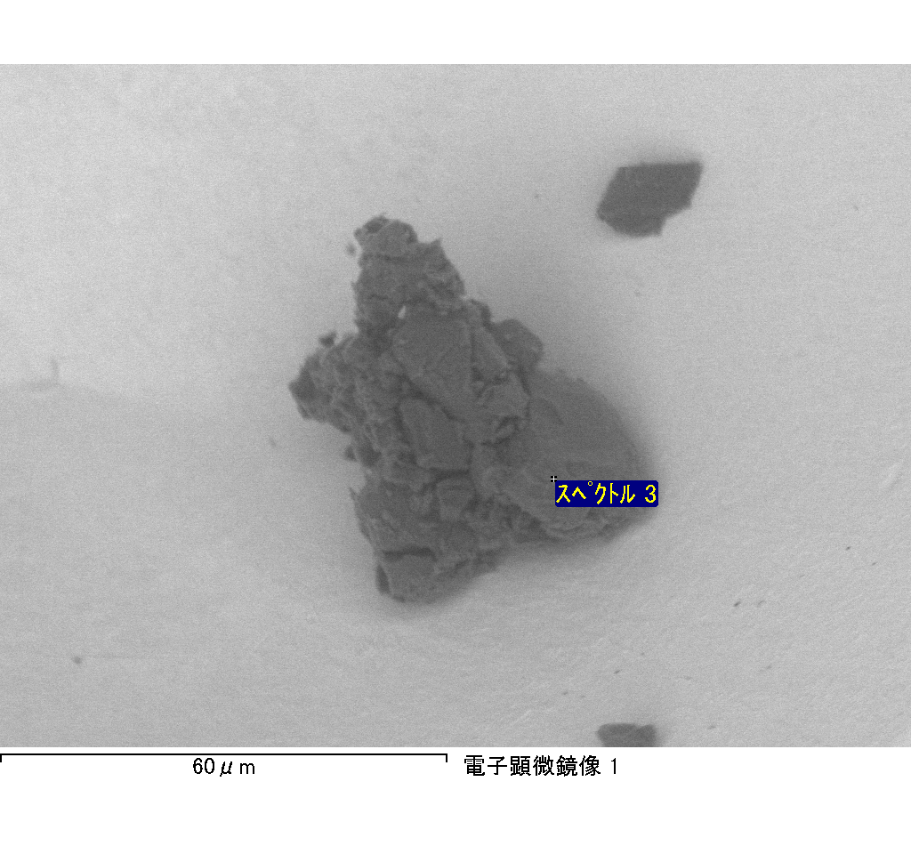

ｽﾍﾟｸﾄﾙﾗﾍﾞﾙ: ｽﾍﾟｸﾄﾙ 3

ﾗｲﾌﾞﾀｲﾑ 120.0 s

収集ｼﾞｵﾒﾄﾘ[度] :

試料傾斜角 = 0.0

方位角 = 0.0

ｴﾚﾍﾞｰｼｮﾝ = 30.0

加速電圧 = 10.00 kV

ｽﾍﾟｸﾄﾙ全ｶｳﾝﾄ数 = 193490

|  |  |  |  |
| --- | --- | --- | --- |
| ｻﾝﾌﾟﾙﾃﾞｰﾀ : | ｴﾈﾙｷﾞｰ[eV] | 分解能[eV] | ｶｳﾝﾄ数 |
| ｽﾄﾛｰﾌﾞ : | 3.8 | 51.89 | 1195698 |
|  |  |  |  |

定量最適化がおこなわれていません

ｽﾍﾟｸﾄﾙ処理 :

省略されたﾋﾟｰｸはありません

処理ｵﾌﾟｼｮﾝ : 酸素 ｽﾄｲｷｵﾒﾄﾘ (ﾉｰﾏﾗｲｽﾞ)

繰り返し回数 = 2

ｽﾀﾝﾀﾞｰﾄﾞ :

Na Albite 1999/06/01

Mg MgO 1999/06/01

Al Al2O3 1999/06/01

Si SiO2 1999/06/01

P GaP 1999/06/01

S FeS2 1999/06/01

K MAD-10 Feldspar 1999/06/01

Ca Wollastonite 1999/06/01

Cr Cr 1999/06/01

Mn Mn 1999/06/01

Fe Fe 1999/06/01

Ni Ni 1999/06/01

|  |  |  |  |  |  |
| --- | --- | --- | --- | --- | --- |
| 元素 | 質量濃度 | 原子数 | 化合物 | 化学式 |  |
|  | [%] | 濃度[%] | 濃度[%] |  |  |
| Na K | 15.53 | -111.47 | 20.93 | Na2O |  |
| Mg K | 156.13 | -1059.87 | 258.87 | MgO |  |
| Al K | 8.12 | -49.66 | 15.34 | Al2O3 |  |
| Si K | 374.08 | -2198.18 | 800.27 | SiO2 |  |
| P K | -311.46 | 1659.54 | -713.65 | P2O5 |  |
| S K | -260.44 | 1340.51 | -650.29 | SO3 |  |
| K K | 3.70 | -15.63 | 4.46 | K2O |  |
| Ca K | 188.61 | -776.65 | 263.90 | CaO |  |
| Cr K | 11.42 | -36.25 | 16.69 | Cr2O3 |  |
| Mn K | 3.99 | -12.00 | 5.16 | MnO |  |
| Fe K | 121.09 | -357.83 | 155.77 | FeO |  |
| Ni K | -60.88 | 171.13 | -77.47 | NiO |  |
| O | -149.91 | 1546.37 |  |  |  |
| ﾄｰﾀﾙ | 100.00 |  |  |  |  |

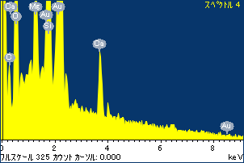

ﾌﾟﾛｼﾞｪｸﾄ : ﾌﾟﾛｼﾞｪｸﾄ 1

ｵｰﾅｰ : Administrator

領域 分析領域 10

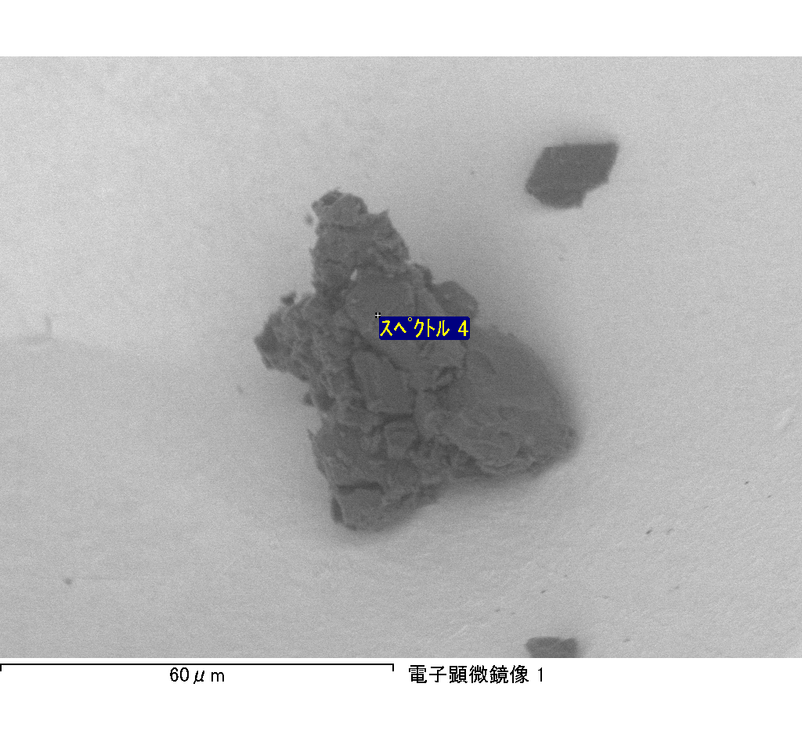

ｽﾍﾟｸﾄﾙﾗﾍﾞﾙ: ｽﾍﾟｸﾄﾙ 4

ﾗｲﾌﾞﾀｲﾑ 120.0 s

収集ｼﾞｵﾒﾄﾘ[度] :

試料傾斜角 = 0.0

方位角 = 0.0

ｴﾚﾍﾞｰｼｮﾝ = 30.0

加速電圧 = 10.00 kV

ｽﾍﾟｸﾄﾙ全ｶｳﾝﾄ数 = 184392

|  |  |  |  |
| --- | --- | --- | --- |
| ｻﾝﾌﾟﾙﾃﾞｰﾀ : | ｴﾈﾙｷﾞｰ[eV] | 分解能[eV] | ｶｳﾝﾄ数 |
| ｽﾄﾛｰﾌﾞ : | 3.8 | 51.84 | 1197448 |
|  |  |  |  |

定量最適化がおこなわれていません