ｽﾍﾟｸﾄﾙ処理 :

定量計算に使用されていないﾋﾟｰｸ : 2.796 keV

処理ｵﾌﾟｼｮﾝ : 酸素 ｽﾄｲｷｵﾒﾄﾘ (ﾉｰﾏﾗｲｽﾞ)

繰り返し回数 = 2

ｽﾀﾝﾀﾞｰﾄﾞ :

Na Albite 1999/06/01

Mg MgO 1999/06/01

Al Al2O3 1999/06/01

Si SiO2 1999/06/01

P GaP 1999/06/01

S FeS2 1999/06/01

K MAD-10 Feldspar 1999/06/01

Ca Wollastonite 1999/06/01

Cr Cr 1999/06/01

Mn Mn 1999/06/01

Fe Fe 1999/06/01

Ni Ni 1999/06/01

|  |  |  |  |  |  |
| --- | --- | --- | --- | --- | --- |
| 元素 | 質量濃度 | 原子数 | 化合物 | 化学式 |  |
|  | [%] | 濃度[%] | 濃度[%] |  |  |
| Na K | 7.65 | 1.12 | 10.31 | Na2O |  |
| Mg K | -72.14 | -10.03 | -119.61 | MgO |  |
| Al K | -3.24 | -0.41 | -6.12 | Al2O3 |  |
| Si K | -96.03 | -11.56 | -205.45 | SiO2 |  |
| P K | 458.36 | 50.01 | 1050.25 | P2O5 |  |
| S K | 200.21 | 21.10 | 499.90 | SO3 |  |
| K K | -12.99 | -1.12 | -15.65 | K2O |  |
| Ca K | -10.27 | -0.87 | -14.37 | CaO |  |
| Cr K | 42.65 | 2.77 | 62.34 | Cr2O3 |  |
| Mn K | 39.75 | 2.45 | 51.33 | MnO |  |
| Fe K | -877.67 | -53.11 | -1129.10 | FeO |  |
| Ni K | -65.88 | -3.79 | -83.84 | NiO |  |
| O | 489.60 | 103.43 |  |  |  |
| ﾄｰﾀﾙ | 100.00 |  |  |  |  |

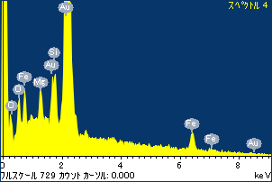

ﾌﾟﾛｼﾞｪｸﾄ : ﾌﾟﾛｼﾞｪｸﾄ 1

ｵｰﾅｰ : Administrator

領域 分析領域 1

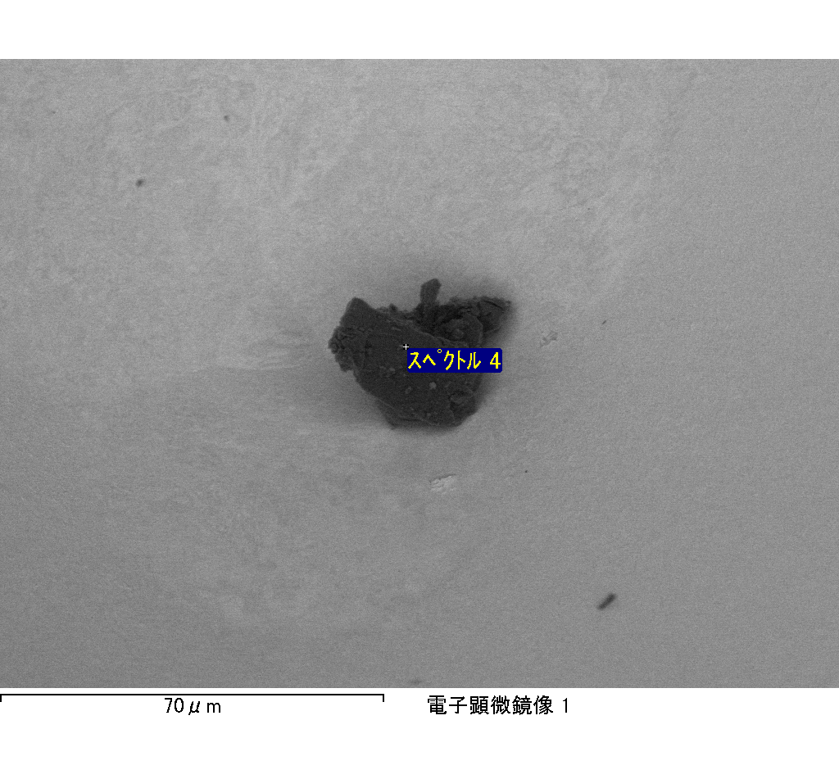

ｽﾍﾟｸﾄﾙﾗﾍﾞﾙ: ｽﾍﾟｸﾄﾙ 4

ﾗｲﾌﾞﾀｲﾑ 120.0 s

収集ｼﾞｵﾒﾄﾘ[度] :

試料傾斜角 = 0.0

方位角 = 0.0

ｴﾚﾍﾞｰｼｮﾝ = 30.0

加速電圧 = 10.00 kV

ｽﾍﾟｸﾄﾙ全ｶｳﾝﾄ数 = 188829

|  |  |  |  |
| --- | --- | --- | --- |
| ｻﾝﾌﾟﾙﾃﾞｰﾀ : | ｴﾈﾙｷﾞｰ[eV] | 分解能[eV] | ｶｳﾝﾄ数 |
| ｽﾄﾛｰﾌﾞ : | 3.8 | 51.94 | 1196673 |
|  |  |  |  |

定量最適化がおこなわれていません

ｽﾍﾟｸﾄﾙﾗﾍﾞﾙ: ｽﾍﾟｸﾄﾙ 5

ﾗｲﾌﾞﾀｲﾑ 120.0 s

収集ｼﾞｵﾒﾄﾘ[度] :

試料傾斜角 = 0.0

方位角 = 0.0

ｴﾚﾍﾞｰｼｮﾝ = 30.0

加速電圧 = 10.00 kV

ｽﾍﾟｸﾄﾙ全ｶｳﾝﾄ数 = 198401

|  |  |  |  |
| --- | --- | --- | --- |
| ｻﾝﾌﾟﾙﾃﾞｰﾀ : | ｴﾈﾙｷﾞｰ[eV] | 分解能[eV] | ｶｳﾝﾄ数 |
| ｽﾄﾛｰﾌﾞ : | 3.8 | 51.93 | 1196234 |
|  |  |  |  |

定量最適化がおこなわれていません

ｽﾍﾟｸﾄﾙ処理 :

省略されたﾋﾟｰｸはありません

処理ｵﾌﾟｼｮﾝ : 酸素 ｽﾄｲｷｵﾒﾄﾘ (ﾉｰﾏﾗｲｽﾞ)

繰り返し回数 = 2

ｽﾀﾝﾀﾞｰﾄﾞ :

Na Albite 1999/06/01

Mg MgO 1999/06/01

Al Al2O3 1999/06/01

Si SiO2 1999/06/01

P GaP 1999/06/01

S FeS2 1999/06/01

K MAD-10 Feldspar 1999/06/01

Ca Wollastonite 1999/06/01

Cr Cr 1999/06/01

Mn Mn 1999/06/01

Fe Fe 1999/06/01

Ni Ni 1999/06/01

|  |  |  |  |  |  |
| --- | --- | --- | --- | --- | --- |
| 元素 | 質量濃度 | 原子数 | 化合物 | 化学式 |  |
|  | [%] | 濃度[%] | 濃度[%] |  |  |
| Na K | 0.71 | 1.41 | 0.96 | Na2O |  |
| Mg K | 3.14 | 5.87 | 5.20 | MgO |  |
| Al K | 0.29 | 0.48 | 0.54 | Al2O3 |  |
| Si K | 8.83 | 14.31 | 18.90 | SiO2 |  |
| P K | -38.69 | -56.83 | -88.64 | P2O5 |  |
| S K | 12.42 | 17.63 | 31.02 | SO3 |  |
| K K | 0.61 | 0.71 | 0.73 | K2O |  |
| Ca K | 5.43 | 6.17 | 7.60 | CaO |  |
| Cr K | -0.66 | -0.57 | -0.96 | Cr2O3 |  |
| Mn K | 1.29 | 1.06 | 1.66 | MnO |  |
| Fe K | 104.02 | 84.75 | 133.82 | FeO |  |
| Ni K | -8.51 | -6.60 | -10.83 | NiO |  |
| O | 11.12 | 31.61 |  |  |  |
| ﾄｰﾀﾙ | 100.00 |  |  |  |  |

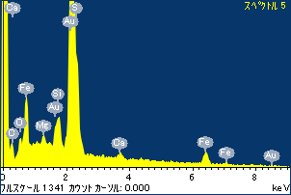

ﾌﾟﾛｼﾞｪｸﾄ : ﾌﾟﾛｼﾞｪｸﾄ 1

ｵｰﾅｰ : Administrator

領域 分析領域 1

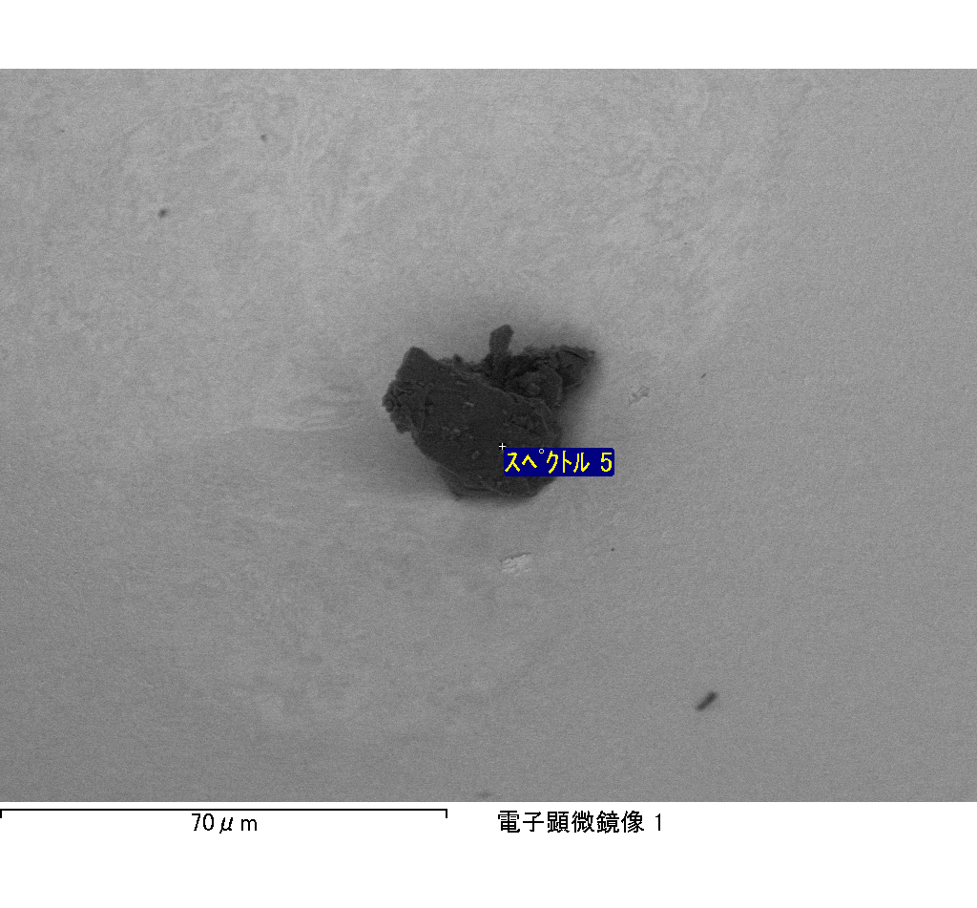

ｽﾍﾟｸﾄﾙﾗﾍﾞﾙ: ｽﾍﾟｸﾄﾙ 6

ﾗｲﾌﾞﾀｲﾑ 120.0 s

収集ｼﾞｵﾒﾄﾘ[度] :

試料傾斜角 = 0.0

方位角 = 0.0

ｴﾚﾍﾞｰｼｮﾝ = 30.0

加速電圧 = 10.00 kV

ｽﾍﾟｸﾄﾙ全ｶｳﾝﾄ数 = 198376

|  |  |  |  |
| --- | --- | --- | --- |
| ｻﾝﾌﾟﾙﾃﾞｰﾀ : | ｴﾈﾙｷﾞｰ[eV] | 分解能[eV] | ｶｳﾝﾄ数 |
| ｽﾄﾛｰﾌﾞ : | 3.8 | 51.97 | 1196449 |
|  |  |  |  |

定量最適化がおこなわれていません

ｽﾍﾟｸﾄﾙ処理 :

省略されたﾋﾟｰｸはありません

処理ｵﾌﾟｼｮﾝ : 酸素 ｽﾄｲｷｵﾒﾄﾘ (ﾉｰﾏﾗｲｽﾞ)

繰り返し回数 = 2

ｽﾀﾝﾀﾞｰﾄﾞ :

Na Albite 1999/06/01

Mg MgO 1999/06/01

Al Al2O3 1999/06/01

Si SiO2 1999/06/01

P GaP 1999/06/01

S FeS2 1999/06/01

K MAD-10 Feldspar 1999/06/01

Ca Wollastonite 1999/06/01

Cr Cr 1999/06/01

Mn Mn 1999/06/01

Fe Fe 1999/06/01

Ni Ni 1999/06/01

|  |  |  |  |  |  |
| --- | --- | --- | --- | --- | --- |
| 元素 | 質量濃度 | 原子数 | 化合物 | 化学式 |  |
|  | [%] | 濃度[%] | 濃度[%] |  |  |
| Na K | -1.61 | -1.00 | -2.18 | Na2O |  |
| Mg K | -59.27 | -34.69 | -98.28 | MgO |  |
| Al K | -3.98 | -2.10 | -7.53 | Al2O3 |  |
| Si K | -160.01 | -81.06 | -342.31 | SiO2 |  |
| P K | 168.74 | 77.51 | 386.65 | P2O5 |  |
| S K | 126.30 | 56.05 | 315.37 | SO3 |  |
| K K | 0.35 | 0.13 | 0.42 | K2O |  |
| Ca K | -92.29 | -32.76 | -129.13 | CaO |  |
| Cr K | -12.65 | -3.46 | -18.49 | Cr2O3 |  |
| Mn K | 12.11 | 3.14 | 15.63 | MnO |  |
| Fe K | -40.02 | -10.20 | -51.48 | FeO |  |
| Ni K | 24.60 | 5.96 | 31.31 | NiO |  |
| O | 137.72 | 122.48 |  |  |  |
| ﾄｰﾀﾙ | 100.00 |  |  |  |  |

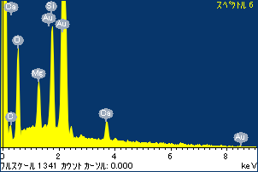

ﾌﾟﾛｼﾞｪｸﾄ : ﾌﾟﾛｼﾞｪｸﾄ 1

ｵｰﾅｰ : Administrator

領域 分析領域 1

