ｽﾍﾟｸﾄﾙﾗﾍﾞﾙ: ｽﾍﾟｸﾄﾙ 2

ﾗｲﾌﾞﾀｲﾑ 120.0 s

収集ｼﾞｵﾒﾄﾘ[度] :

試料傾斜角 = 0.0

方位角 = 0.0

ｴﾚﾍﾞｰｼｮﾝ = 30.0

加速電圧 = 10.00 kV

ｽﾍﾟｸﾄﾙ全ｶｳﾝﾄ数 = 206676

|  |  |  |  |
| --- | --- | --- | --- |
| ｻﾝﾌﾟﾙﾃﾞｰﾀ : | ｴﾈﾙｷﾞｰ[eV] | 分解能[eV] | ｶｳﾝﾄ数 |
| ｽﾄﾛｰﾌﾞ : | 3.8 | 51.91 | 1195220 |
|  |  |  |  |

定量最適化がおこなわれていません

ｽﾍﾟｸﾄﾙ処理 :

省略されたﾋﾟｰｸはありません

処理ｵﾌﾟｼｮﾝ : 酸素 ｽﾄｲｷｵﾒﾄﾘ (ﾉｰﾏﾗｲｽﾞ)

繰り返し回数 = 2

ｽﾀﾝﾀﾞｰﾄﾞ :

Na Albite 1999/06/01

Mg MgO 1999/06/01

Al Al2O3 1999/06/01

Si SiO2 1999/06/01

P GaP 1999/06/01

S FeS2 1999/06/01

K MAD-10 Feldspar 1999/06/01

Ca Wollastonite 1999/06/01

Cr Cr 1999/06/01

Mn Mn 1999/06/01

Fe Fe 1999/06/01

Ni Ni 1999/06/01

|  |  |  |  |  |  |
| --- | --- | --- | --- | --- | --- |
| 元素 | 質量濃度 | 原子数 | 化合物 | 化学式 |  |
|  | [%] | 濃度[%] | 濃度[%] |  |  |
| Na K | 0.67 | 4.67 | 0.90 | Na2O |  |
| Mg K | 186.69 | 1232.22 | 309.54 | MgO |  |
| Al K | -0.36 | -2.14 | -0.68 | Al2O3 |  |
| Si K | 149.92 | 856.57 | 320.72 | SiO2 |  |
| P K | -169.67 | -879.04 | -388.78 | P2O5 |  |
| S K | -137.60 | -688.62 | -343.56 | SO3 |  |
| K K | -0.88 | -3.61 | -1.06 | K2O |  |
| Ca K | -2.54 | -10.17 | -3.55 | CaO |  |
| Cr K | -6.16 | -19.00 | -9.00 | Cr2O3 |  |
| Mn K | 23.04 | 67.31 | 29.75 | MnO |  |
| Fe K | 164.16 | 471.69 | 211.19 | FeO |  |
| Ni K | -20.02 | -54.72 | -25.48 | NiO |  |
| O | -87.25 | -875.16 |  |  |  |
| ﾄｰﾀﾙ | 100.00 |  |  |  |  |

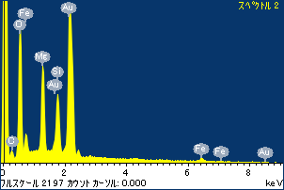

ﾌﾟﾛｼﾞｪｸﾄ : ﾌﾟﾛｼﾞｪｸﾄ 1

ｵｰﾅｰ : Administrator

領域 分析領域 3

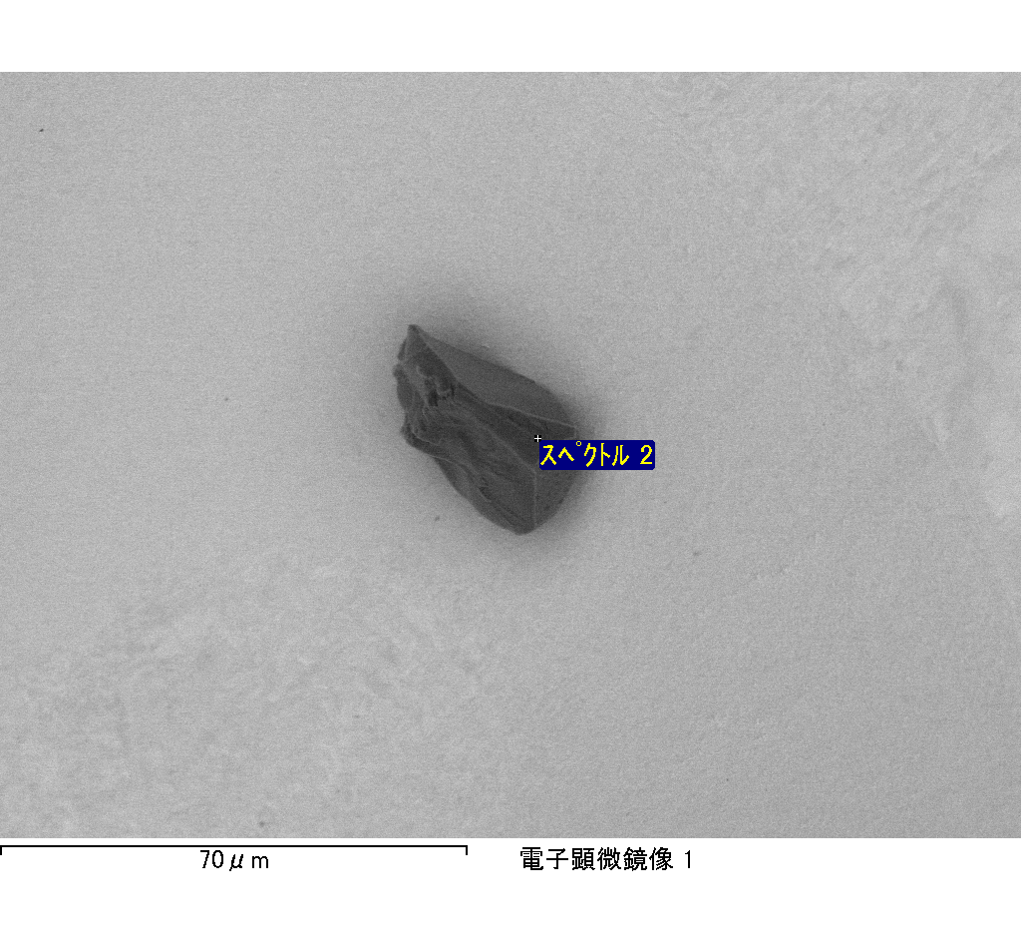

ｽﾍﾟｸﾄﾙﾗﾍﾞﾙ: ｽﾍﾟｸﾄﾙ 3

ﾗｲﾌﾞﾀｲﾑ 120.0 s

収集ｼﾞｵﾒﾄﾘ[度] :

試料傾斜角 = 0.0

方位角 = 0.0

ｴﾚﾍﾞｰｼｮﾝ = 30.0

加速電圧 = 10.00 kV

ｽﾍﾟｸﾄﾙ全ｶｳﾝﾄ数 = 200705

|  |  |  |  |
| --- | --- | --- | --- |
| ｻﾝﾌﾟﾙﾃﾞｰﾀ : | ｴﾈﾙｷﾞｰ[eV] | 分解能[eV] | ｶｳﾝﾄ数 |
| ｽﾄﾛｰﾌﾞ : | 3.8 | 51.91 | 1194080 |
|  |  |  |  |

定量最適化がおこなわれていません

ｽﾍﾟｸﾄﾙ処理 :

省略されたﾋﾟｰｸはありません

処理ｵﾌﾟｼｮﾝ : 酸素 ｽﾄｲｷｵﾒﾄﾘ (ﾉｰﾏﾗｲｽﾞ)

繰り返し回数 = 2

ｽﾀﾝﾀﾞｰﾄﾞ :

Na Albite 1999/06/01

Mg MgO 1999/06/01

Al Al2O3 1999/06/01

Si SiO2 1999/06/01

P GaP 1999/06/01

S FeS2 1999/06/01

K MAD-10 Feldspar 1999/06/01

Ca Wollastonite 1999/06/01

Cr Cr 1999/06/01

Mn Mn 1999/06/01

Fe Fe 1999/06/01

Ni Ni 1999/06/01

|  |  |  |  |  |  |
| --- | --- | --- | --- | --- | --- |
| 元素 | 質量濃度 | 原子数 | 化合物 | 化学式 |  |
|  | [%] | 濃度[%] | 濃度[%] |  |  |
| Na K | 0.17 | 0.31 | 0.22 | Na2O |  |
| Mg K | 67.82 | 118.15 | 112.45 | MgO |  |
| Al K | 27.53 | 43.22 | 52.01 | Al2O3 |  |
| Si K | 56.44 | 85.12 | 120.74 | SiO2 |  |
| P K | -71.90 | -98.33 | -164.76 | P2O5 |  |
| S K | -56.29 | -74.36 | -140.56 | SO3 |  |
| K K | -0.30 | -0.33 | -0.37 | K2O |  |
| Ca K | -0.36 | -0.38 | -0.50 | CaO |  |
| Cr K | 3.31 | 2.70 | 4.84 | Cr2O3 |  |
| Mn K | 1.90 | 1.46 | 2.45 | MnO |  |
| Fe K | 75.20 | 57.04 | 96.74 | FeO |  |
| Ni K | 13.14 | 9.48 | 16.73 | NiO |  |
| O | -16.65 | -44.07 |  |  |  |
| ﾄｰﾀﾙ | 100.00 |  |  |  |  |

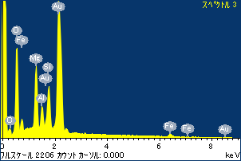

ﾌﾟﾛｼﾞｪｸﾄ : ﾌﾟﾛｼﾞｪｸﾄ 1

ｵｰﾅｰ : Administrator

領域 分析領域 3

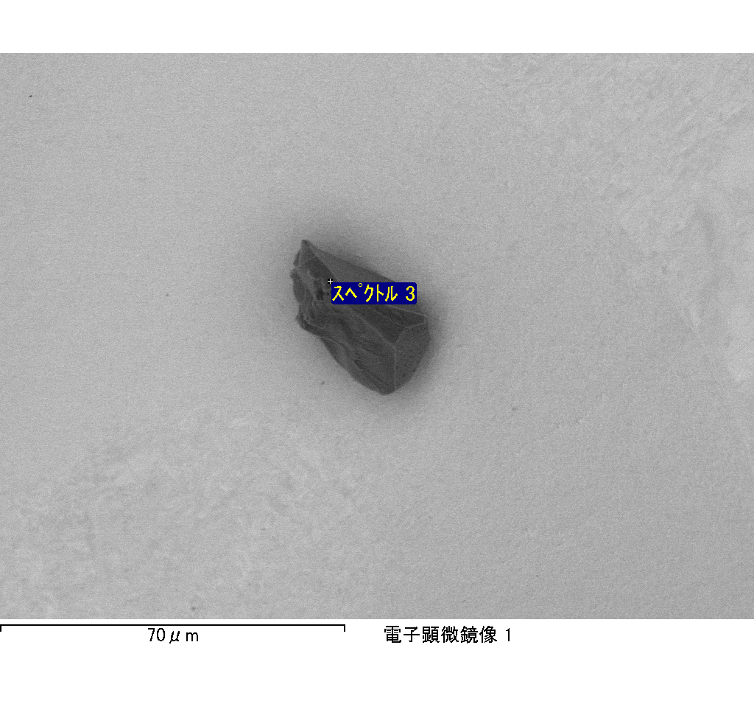

ｽﾍﾟｸﾄﾙﾗﾍﾞﾙ: ｽﾍﾟｸﾄﾙ 7

ﾗｲﾌﾞﾀｲﾑ 120.0 s

収集ｼﾞｵﾒﾄﾘ[度] :

試料傾斜角 = 0.0

方位角 = 0.0

ｴﾚﾍﾞｰｼｮﾝ = 30.0

加速電圧 = 10.00 kV

ｽﾍﾟｸﾄﾙ全ｶｳﾝﾄ数 = 207762

|  |  |  |  |
| --- | --- | --- | --- |
| ｻﾝﾌﾟﾙﾃﾞｰﾀ : | ｴﾈﾙｷﾞｰ[eV] | 分解能[eV] | ｶｳﾝﾄ数 |
| ｽﾄﾛｰﾌﾞ : | 3.8 | 51.85 | 1194404 |
|  |  |  |  |

定量最適化がおこなわれていません

ｽﾍﾟｸﾄﾙ処理 :

省略されたﾋﾟｰｸはありません

処理ｵﾌﾟｼｮﾝ : 酸素 ｽﾄｲｷｵﾒﾄﾘ (ﾉｰﾏﾗｲｽﾞ)

繰り返し回数 = 2

ｽﾀﾝﾀﾞｰﾄﾞ :

Na Albite 1999/06/01

Mg MgO 1999/06/01

Al Al2O3 1999/06/01

Si SiO2 1999/06/01

P GaP 1999/06/01

S FeS2 1999/06/01

K MAD-10 Feldspar 1999/06/01

Ca Wollastonite 1999/06/01

Cr Cr 1999/06/01

Mn Mn 1999/06/01

Fe Fe 1999/06/01

Ni Ni 1999/06/01

|  |  |  |  |  |  |
| --- | --- | --- | --- | --- | --- |
| 元素 | 質量濃度 | 原子数 | 化合物 | 化学式 |  |
|  | [%] | 濃度[%] | 濃度[%] |  |  |
| Na K | -0.54 | -2.57 | -0.73 | Na2O |  |
| Mg K | 173.71 | 785.16 | 288.02 | MgO |  |
| Al K | 0.00 | -0.01 | 0.00 | Al2O3 |  |
| Si K | 139.10 | 544.25 | 297.58 | SiO2 |  |
| P K | -156.18 | -554.08 | -357.85 | P2O5 |  |
| S K | -128.08 | -438.95 | -319.80 | SO3 |  |
| K K | -0.48 | -1.35 | -0.58 | K2O |  |
| Ca K | 3.39 | 9.28 | 4.74 | CaO |  |
| Cr K | 7.53 | 15.91 | 11.00 | Cr2O3 |  |
| Mn K | -13.60 | -27.20 | -17.56 | MnO |  |
| Fe K | 131.31 | 258.37 | 168.92 | FeO |  |
| Ni K | 20.63 | 38.61 | 26.25 | NiO |  |
| O | -76.79 | -527.42 |  |  |  |
| ﾄｰﾀﾙ | 100.00 |  |  |  |  |

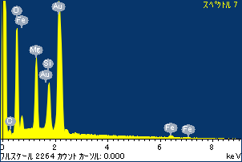

ﾌﾟﾛｼﾞｪｸﾄ : ﾌﾟﾛｼﾞｪｸﾄ 1

ｵｰﾅｰ : Administrator

領域 分析領域 3

