ｽﾍﾟｸﾄﾙﾗﾍﾞﾙ: ｽﾍﾟｸﾄﾙ 1

ﾗｲﾌﾞﾀｲﾑ 120.0 s

収集ｼﾞｵﾒﾄﾘ[度] :

試料傾斜角 = 0.0

方位角 = 0.0

ｴﾚﾍﾞｰｼｮﾝ = 30.0

加速電圧 = 10.00 kV

ｽﾍﾟｸﾄﾙ全ｶｳﾝﾄ数 = 140311

|  |  |  |  |
| --- | --- | --- | --- |
| ｻﾝﾌﾟﾙﾃﾞｰﾀ : | ｴﾈﾙｷﾞｰ[eV] | 分解能[eV] | ｶｳﾝﾄ数 |
| ｽﾄﾛｰﾌﾞ : | 3.8 | 52.12 | 1200819 |
|  |  |  |  |

定量最適化がおこなわれていません

ｽﾍﾟｸﾄﾙ処理 :

省略されたﾋﾟｰｸはありません

処理ｵﾌﾟｼｮﾝ : 酸素 ｽﾄｲｷｵﾒﾄﾘ (ﾉｰﾏﾗｲｽﾞ)

繰り返し回数 = 2

ｽﾀﾝﾀﾞｰﾄﾞ :

Na Albite 1999/06/01

Mg MgO 1999/06/01

Al Al2O3 1999/06/01

Si SiO2 1999/06/01

P GaP 1999/06/01

S FeS2 1999/06/01

K MAD-10 Feldspar 1999/06/01

Ca Wollastonite 1999/06/01

Cr Cr 1999/06/01

Mn Mn 1999/06/01

Fe Fe 1999/06/01

Ni Ni 1999/06/01

|  |  |  |  |  |  |
| --- | --- | --- | --- | --- | --- |
| 元素 | 質量濃度 | 原子数 | 化合物 | 化学式 |  |
|  | [%] | 濃度[%] | 濃度[%] |  |  |
| Na K | -25.23 | -21.30 | -34.00 | Na2O |  |
| Mg K | -0.83 | -0.66 | -1.37 | MgO |  |
| Al K | -35.23 | -25.34 | -66.56 | Al2O3 |  |
| Si K | -106.50 | -73.60 | -227.83 | SiO2 |  |
| P K | 101.57 | 63.65 | 232.72 | P2O5 |  |
| S K | 84.27 | 51.02 | 210.42 | SO3 |  |
| K K | -2.38 | -1.18 | -2.87 | K2O |  |
| Ca K | -6.25 | -3.03 | -8.74 | CaO |  |
| Cr K | -4.97 | -1.85 | -7.26 | Cr2O3 |  |
| Mn K | 3.93 | 1.39 | 5.08 | MnO |  |
| Fe K | 2.32 | 0.81 | 2.98 | FeO |  |
| Ni K | -2.02 | -0.67 | -2.58 | NiO |  |
| O | 91.31 | 110.77 |  |  |  |
| ﾄｰﾀﾙ | 100.00 |  |  |  |  |

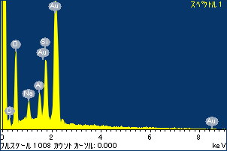

ﾌﾟﾛｼﾞｪｸﾄ : ﾌﾟﾛｼﾞｪｸﾄ 1

ｵｰﾅｰ : Administrator

領域 分析領域 5

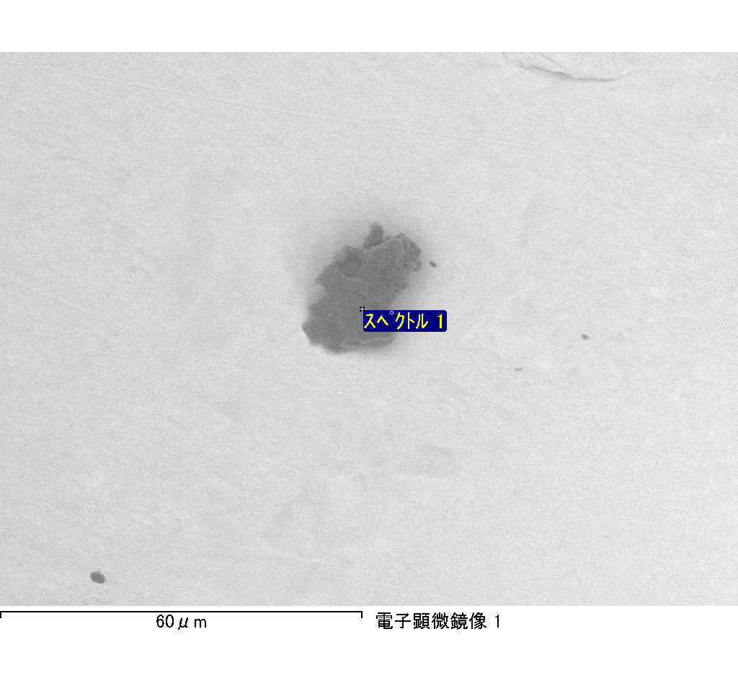

ｽﾍﾟｸﾄﾙﾗﾍﾞﾙ: ｽﾍﾟｸﾄﾙ 2

ﾗｲﾌﾞﾀｲﾑ 120.0 s

収集ｼﾞｵﾒﾄﾘ[度] :

試料傾斜角 = 0.0

方位角 = 0.0

ｴﾚﾍﾞｰｼｮﾝ = 30.0

加速電圧 = 10.00 kV

ｽﾍﾟｸﾄﾙ全ｶｳﾝﾄ数 = 137848

|  |  |  |  |
| --- | --- | --- | --- |
| ｻﾝﾌﾟﾙﾃﾞｰﾀ : | ｴﾈﾙｷﾞｰ[eV] | 分解能[eV] | ｶｳﾝﾄ数 |
| ｽﾄﾛｰﾌﾞ : | 3.8 | 52.09 | 1200197 |
|  |  |  |  |

定量最適化がおこなわれていません

ｽﾍﾟｸﾄﾙ処理 :

省略されたﾋﾟｰｸはありません

処理ｵﾌﾟｼｮﾝ : 酸素 ｽﾄｲｷｵﾒﾄﾘ (ﾉｰﾏﾗｲｽﾞ)

繰り返し回数 = 2

ｽﾀﾝﾀﾞｰﾄﾞ :

Na Albite 1999/06/01

Mg MgO 1999/06/01

Al Al2O3 1999/06/01

Si SiO2 1999/06/01

P GaP 1999/06/01

S FeS2 1999/06/01

K MAD-10 Feldspar 1999/06/01

Ca Wollastonite 1999/06/01

Cr Cr 1999/06/01

Mn Mn 1999/06/01

Fe Fe 1999/06/01

Ni Ni 1999/06/01

|  |  |  |  |  |  |
| --- | --- | --- | --- | --- | --- |
| 元素 | 質量濃度 | 原子数 | 化合物 | 化学式 |  |
|  | [%] | 濃度[%] | 濃度[%] |  |  |
| Na K | -53.18 | -31.82 | -71.69 | Na2O |  |
| Mg K | -10.55 | -5.97 | -17.49 | MgO |  |
| Al K | -88.10 | -44.91 | -166.45 | Al2O3 |  |
| Si K | -246.02 | -120.48 | -526.31 | SiO2 |  |
| P K | 233.78 | 103.81 | 535.67 | P2O5 |  |
| S K | 184.82 | 79.28 | 461.48 | SO3 |  |
| K K | -13.69 | -4.82 | -16.49 | K2O |  |
| Ca K | -16.68 | -5.72 | -23.33 | CaO |  |
| Cr K | -3.53 | -0.94 | -5.17 | Cr2O3 |  |
| Mn K | 9.56 | 2.39 | 12.35 | MnO |  |
| Fe K | -24.90 | -6.13 | -32.03 | FeO |  |
| Ni K | -39.71 | -9.30 | -50.53 | NiO |  |
| O | 168.19 | 144.60 |  |  |  |
| ﾄｰﾀﾙ | 100.00 |  |  |  |  |

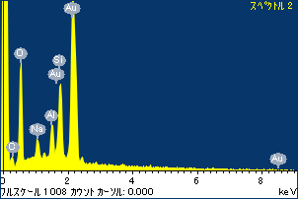

ﾌﾟﾛｼﾞｪｸﾄ : ﾌﾟﾛｼﾞｪｸﾄ 1

ｵｰﾅｰ : Administrator

領域 分析領域 5

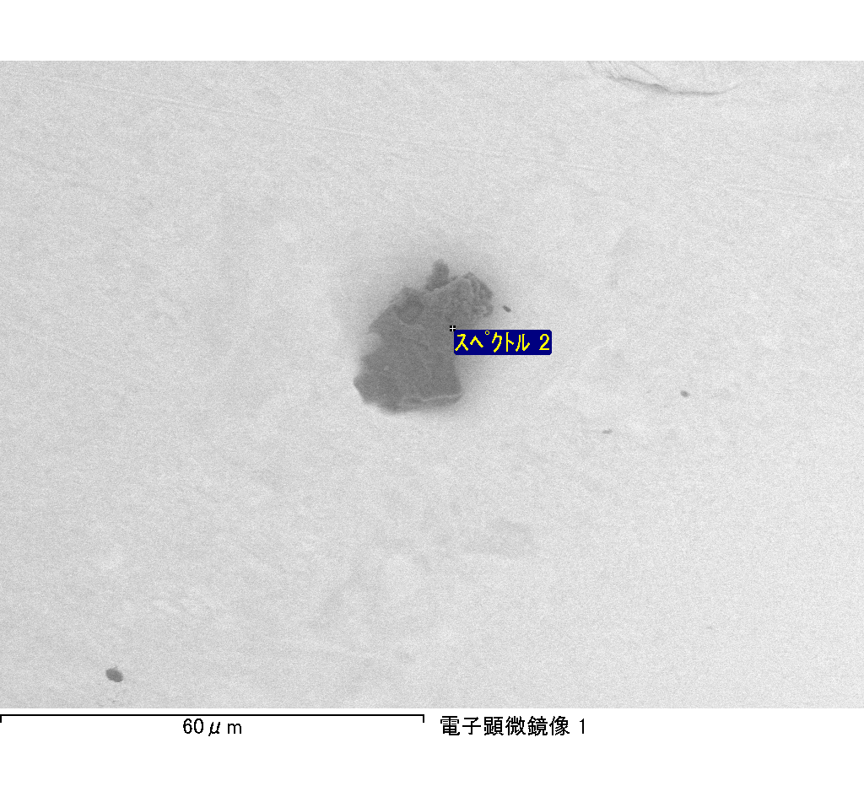

ｽﾍﾟｸﾄﾙﾗﾍﾞﾙ: ｽﾍﾟｸﾄﾙ 5

ﾗｲﾌﾞﾀｲﾑ 120.0 s

収集ｼﾞｵﾒﾄﾘ[度] :

試料傾斜角 = 0.0

方位角 = 0.0

ｴﾚﾍﾞｰｼｮﾝ = 30.0

加速電圧 = 10.00 kV

ｽﾍﾟｸﾄﾙ全ｶｳﾝﾄ数 = 143033

|  |  |  |  |
| --- | --- | --- | --- |
| ｻﾝﾌﾟﾙﾃﾞｰﾀ : | ｴﾈﾙｷﾞｰ[eV] | 分解能[eV] | ｶｳﾝﾄ数 |
| ｽﾄﾛｰﾌﾞ : | 3.8 | 52.06 | 1200151 |
|  |  |  |  |

定量最適化がおこなわれていません

ｽﾍﾟｸﾄﾙ処理 :

省略されたﾋﾟｰｸはありません

処理ｵﾌﾟｼｮﾝ : 酸素 ｽﾄｲｷｵﾒﾄﾘ (ﾉｰﾏﾗｲｽﾞ)

繰り返し回数 = 2

ｽﾀﾝﾀﾞｰﾄﾞ :

Na Albite 1999/06/01

Mg MgO 1999/06/01

Al Al2O3 1999/06/01

Si SiO2 1999/06/01

P GaP 1999/06/01

S FeS2 1999/06/01

K MAD-10 Feldspar 1999/06/01

Ca Wollastonite 1999/06/01

Cr Cr 1999/06/01

Mn Mn 1999/06/01

Fe Fe 1999/06/01

Ni Ni 1999/06/01

|  |  |  |  |  |  |
| --- | --- | --- | --- | --- | --- |
| 元素 | 質量濃度 | 原子数 | 化合物 | 化学式 |  |
|  | [%] | 濃度[%] | 濃度[%] |  |  |
| Na K | -18.18 | -14.93 | -24.51 | Na2O |  |
| Mg K | -15.54 | -12.06 | -25.76 | MgO |  |
| Al K | -25.50 | -17.83 | -48.17 | Al2O3 |  |
| Si K | -93.85 | -63.07 | -200.77 | SiO2 |  |
| P K | 101.02 | 61.56 | 231.48 | P2O5 |  |
| S K | 76.45 | 45.00 | 190.88 | SO3 |  |
| K K | -4.64 | -2.24 | -5.59 | K2O |  |
| Ca K | -6.65 | -3.13 | -9.30 | CaO |  |
| Cr K | -6.85 | -2.49 | -10.01 | Cr2O3 |  |
| Mn K | -1.02 | -0.35 | -1.32 | MnO |  |
| Fe K | -6.28 | -2.12 | -8.08 | FeO |  |
| Ni K | 8.77 | 2.82 | 11.16 | NiO |  |
| O | 92.27 | 108.85 |  |  |  |
| ﾄｰﾀﾙ | 100.00 |  |  |  |  |

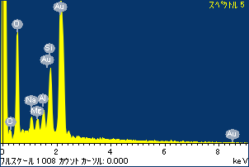

ﾌﾟﾛｼﾞｪｸﾄ : ﾌﾟﾛｼﾞｪｸﾄ 1

ｵｰﾅｰ : Administrator

領域 分析領域 5

