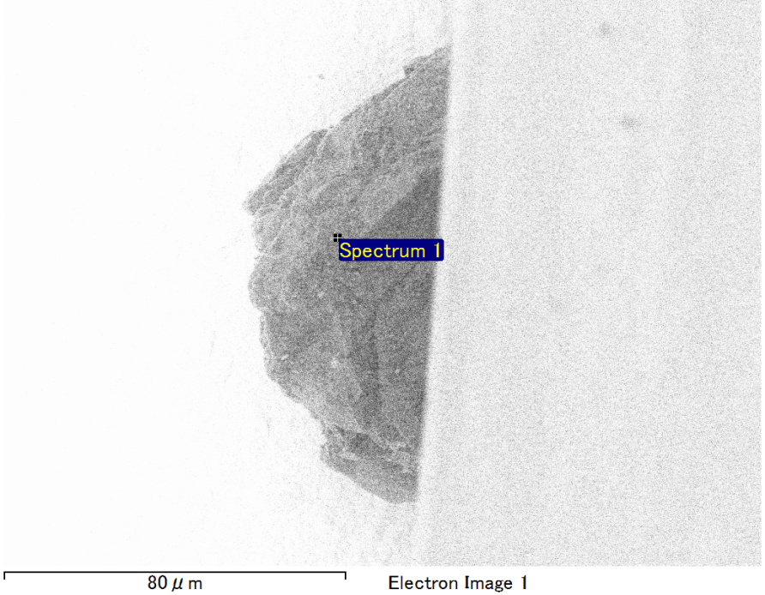

Spectrum Label: Spectrum 1

Livetime 90.0 s

Acquisition geometry ( degrees ):

Tilt = 0.0

Azimuth = 0.0

Elevation = 30.0

Accelerating voltage = 10.00 kV

Total spectrum counts = 70937

|  |  |  |  |
| --- | --- | --- | --- |
| Sample data : | Energy (eV) | Resn. (eV) | Area |
| Strobe : | 3.8 | 43.46 | 936579 |
|  |  |  |  |
| Optimization data : Cobalt K series |  |  |  |
|  | Energy (eV) | Resn. (eV) | Area |
| Strobe : | .1 | 41.16 | 1008028 |
| Optimization element : | 6916.2 | 136.04 | 88085 |

Spectrum processing :

No peaks omitted

Processing option : Oxygen by stoichiometry (Normalised)

Number of iterations = 1

Standard :

Mg MgO 1-Jun-1999 12:00 AM

Si SiO2 1-Jun-1999 12:00 AM

Fe Fe 1-Jun-1999 12:00 AM

Au Au 1-Jun-1999 12:00 AM

|  |  |  |  |  |  |
| --- | --- | --- | --- | --- | --- |
| Element | Weight% | Atomic% | Compd% | Formula |  |
|  |  |  |  |  |  |
| Mg K | 5.20 | 9.18 | 8.63 | MgO |  |
| Si K | 7.04 | 10.75 | 15.06 | SiO2 |  |
| Fe L | 13.55 | 10.41 | 17.44 | FeO |  |
| Au M | 52.48 | 11.43 | 58.88 | Au2O3 |  |
| O | 21.72 | 58.23 |  |  |  |
| Totals | 100.00 |  |  |  |  |

Project: Project 1

Owner: Operator

Site: Site of Interest 1

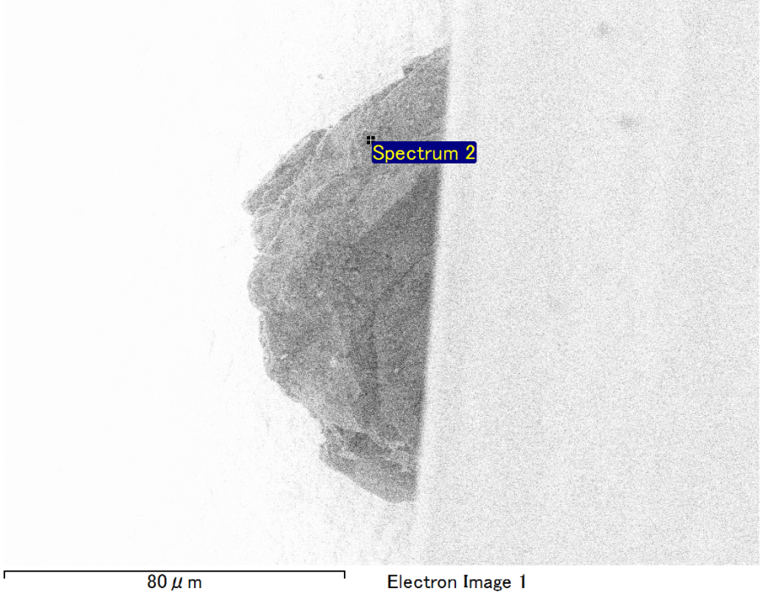

Spectrum Label: Spectrum 2

Livetime 90.0 s

Acquisition geometry ( degrees ):

Tilt = 0.0

Azimuth = 0.0

Elevation = 30.0

Accelerating voltage = 10.00 kV

Total spectrum counts = 68044

|  |  |  |  |
| --- | --- | --- | --- |
| Sample data : | Energy (eV) | Resn. (eV) | Area |
| Strobe : | 3.8 | 42.80 | 939800 |
|  |  |  |  |
| Optimization data : Cobalt K series |  |  |  |
|  | Energy (eV) | Resn. (eV) | Area |
| Strobe : | .1 | 41.16 | 1008028 |
| Optimization element : | 6916.2 | 136.04 | 88085 |

Spectrum processing :

Peak possibly omitted : 0.720 keV

Processing option : Oxygen by stoichiometry (Normalised)

Number of iterations = 1

Standard :

Na Albite 1-Jun-1999 12:00 AM

Mg MgO 1-Jun-1999 12:00 AM

Al Al2O3 1-Jun-1999 12:00 AM

Si SiO2 1-Jun-1999 12:00 AM

Au Au 1-Jun-1999 12:00 AM

|  |  |  |  |  |  |
| --- | --- | --- | --- | --- | --- |
| Element | Weight% | Atomic% | Compd% | Formula |  |
|  |  |  |  |  |  |
| Na K | 2.60 | 4.79 | 3.50 | Na2O |  |
| Mg K | 1.20 | 2.09 | 1.99 | MgO |  |
| Al K | 3.39 | 5.33 | 6.40 | Al2O3 |  |
| Si K | 9.41 | 14.22 | 20.14 | SiO2 |  |
| Au M | 60.59 | 13.05 | 67.97 | Au2O3 |  |
| O | 22.81 | 60.51 |  |  |  |
| Totals | 100.00 |  |  |  |  |

Project: Project 1

Owner: Operator

Site: Site of Interest 1

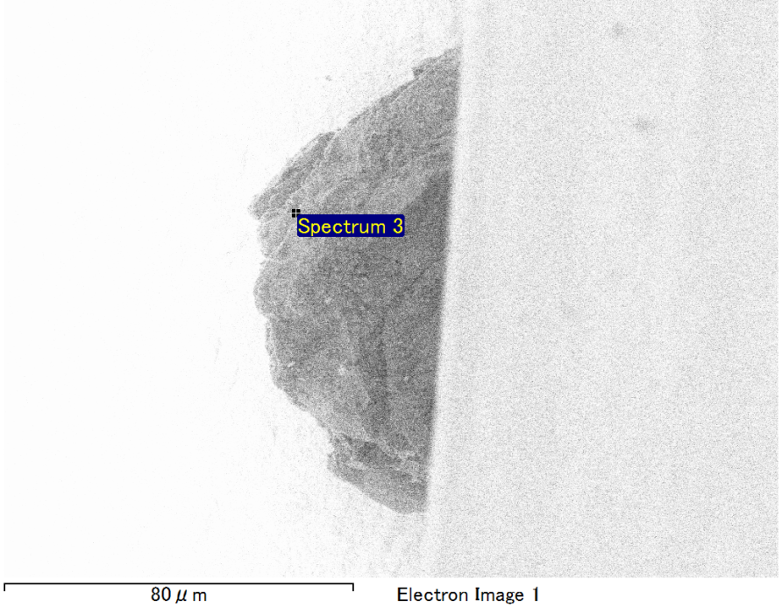

Spectrum Label: Spectrum 3

Livetime 90.0 s

Acquisition geometry ( degrees ):

Tilt = 0.0

Azimuth = 0.0

Elevation = 30.0

Accelerating voltage = 10.00 kV

Total spectrum counts = 64806

|  |  |  |  |
| --- | --- | --- | --- |
| Sample data : | Energy (eV) | Resn. (eV) | Area |
| Strobe : | 3.8 | 42.20 | 940364 |
|  |  |  |  |
| Optimization data : Cobalt K series |  |  |  |
|  | Energy (eV) | Resn. (eV) | Area |
| Strobe : | .1 | 41.16 | 1008028 |
| Optimization element : | 6916.2 | 136.04 | 88085 |

Spectrum processing :

Peak possibly omitted : 0.700 keV

Processing option : Oxygen by stoichiometry (Normalised)

Number of iterations = 1

Standard :

Mg MgO 1-Jun-1999 12:00 AM

Si SiO2 1-Jun-1999 12:00 AM

Ca Wollastonite 1-Jun-1999 12:00 AM

Au Au 1-Jun-1999 12:00 AM

|  |  |  |  |  |  |
| --- | --- | --- | --- | --- | --- |
| Element | Weight% | Atomic% | Compd% | Formula |  |
|  |  |  |  |  |  |
| Mg K | 3.29 | 6.68 | 5.46 | MgO |  |
| Si K | 6.69 | 11.73 | 14.30 | SiO2 |  |
| Ca K | 4.00 | 4.91 | 5.59 | CaO |  |
| Au M | 66.54 | 16.65 | 74.65 | Au2O3 |  |
| O | 19.49 | 60.03 |  |  |  |
| Totals | 100.00 |  |  |  |  |

Project: Project 1

Owner: Operator

Site: Site of Interest 1

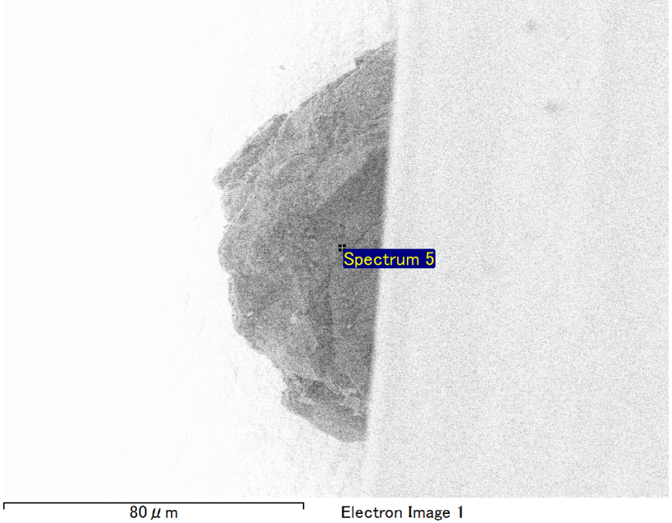

Spectrum Label: Spectrum 5

Livetime 90.0 s

Acquisition geometry ( degrees ):

Tilt = 0.0

Azimuth = 0.0

Elevation = 30.0

Accelerating voltage = 10.00 kV

Total spectrum counts = 60919

|  |  |  |  |
| --- | --- | --- | --- |
| Sample data : | Energy (eV) | Resn. (eV) | Area |
| Strobe : | 3.8 | 41.73 | 943642 |
|  |  |  |  |
| Optimization data : Cobalt K series |  |  |  |
|  | Energy (eV) | Resn. (eV) | Area |
| Strobe : | .1 | 41.16 | 1008028 |
| Optimization element : | 6916.2 | 136.04 | 88085 |

Spectrum processing :

Peak possibly omitted : 0.715 keV

Processing option : Oxygen by stoichiometry (Normalised)

Number of iterations = 1

Standard :

Na Albite 1-Jun-1999 12:00 AM

Al Al2O3 1-Jun-1999 12:00 AM

Si SiO2 1-Jun-1999 12:00 AM

Au Au 1-Jun-1999 12:00 AM

|  |  |  |  |  |  |
| --- | --- | --- | --- | --- | --- |
| Element | Weight% | Atomic% | Compd% | Formula |  |
|  |  |  |  |  |  |
| Na K | 3.09 | 5.42 | 4.17 | Na2O |  |
| Al K | 3.44 | 5.13 | 6.49 | Al2O3 |  |
| Si K | 11.51 | 16.52 | 24.63 | SiO2 |  |
| Au M | 57.69 | 11.80 | 64.71 | Au2O3 |  |
| O | 24.28 | 61.14 |  |  |  |
| Totals | 100.00 |  |  |  |  |

Project: Project 1

Owner: Operator

Site: Site of Interest 1

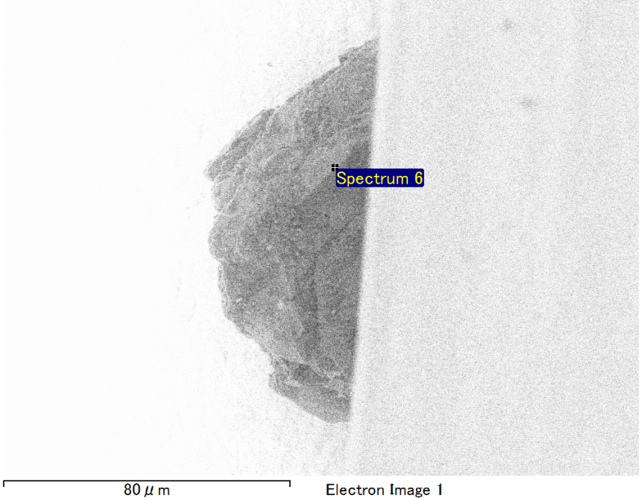

Spectrum Label: Spectrum 6

Livetime 90.0 s

Acquisition geometry ( degrees ):

Tilt = 0.0

Azimuth = 0.0

Elevation = 30.0

Accelerating voltage = 10.00 kV

Total spectrum counts = 60088

|  |  |  |  |
| --- | --- | --- | --- |
| Sample data : | Energy (eV) | Resn. (eV) | Area |
| Strobe : | 3.8 | 41.49 | 942594 |
|  |  |  |  |
| Optimization data : Cobalt K series |  |  |  |
|  | Energy (eV) | Resn. (eV) | Area |
| Strobe : | .1 | 41.16 | 1008028 |
| Optimization element : | 6916.2 | 136.04 | 88085 |

Spectrum processing :

No peaks omitted

Processing option : Oxygen by stoichiometry (Normalised)

Number of iterations = 1

Standard :

Mg MgO 1-Jun-1999 12:00 AM

Si SiO2 1-Jun-1999 12:00 AM

Fe Fe 1-Jun-1999 12:00 AM

Au Au 1-Jun-1999 12:00 AM

|  |  |  |  |  |  |
| --- | --- | --- | --- | --- | --- |
| Element | Weight% | Atomic% | Compd% | Formula |  |
|  |  |  |  |  |  |
| Mg K | 6.27 | 11.03 | 10.40 | MgO |  |
| Si K | 5.49 | 8.36 | 11.74 | SiO2 |  |
| Fe L | 16.76 | 12.83 | 21.56 | FeO |  |
| Au M | 50.19 | 10.89 | 56.30 | Au2O3 |  |
| O | 21.30 | 56.90 |  |  |  |
| Totals | 100.00 |  |  |  |  |

Project: Project 1

Owner: Operator

Site: Site of Interest 1