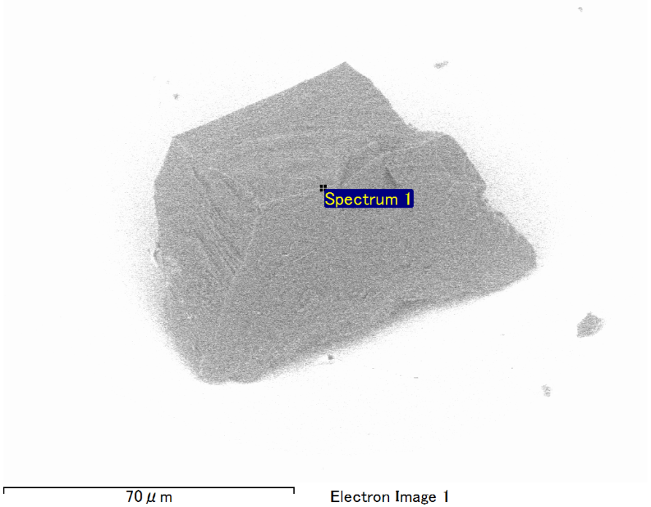

Spectrum Label: Spectrum 1

Livetime 90.0 s

Acquisition geometry ( degrees ):

Tilt = 0.0

Azimuth = 0.0

Elevation = 30.0

Accelerating voltage = 10.00 kV

Total spectrum counts = 67355

|  |  |  |  |
| --- | --- | --- | --- |
| Sample data : | Energy (eV) | Resn. (eV) | Area |
| Strobe : | 3.8 | 40.24 | 943888 |
|  |  |  |  |
| Optimization data : Cobalt K series |  |  |  |
|  | Energy (eV) | Resn. (eV) | Area |
| Strobe : | .1 | 41.16 | 1008028 |
| Optimization element : | 6916.2 | 136.04 | 88085 |

Spectrum processing :

Peak possibly omitted : 0.701 keV

Processing option : Oxygen by stoichiometry (Normalised)

Number of iterations = 2

Standard :

C CaCO3 1-Jun-1999 12:00 AM

Mg MgO 1-Jun-1999 12:00 AM

Al Al2O3 1-Jun-1999 12:00 AM

Si SiO2 1-Jun-1999 12:00 AM

Au Au 1-Jun-1999 12:00 AM

|  |  |  |  |  |  |
| --- | --- | --- | --- | --- | --- |
| Element | Weight% | Atomic% | Compd% | Formula |  |
|  |  |  |  |  |  |
| C K | 2.81 | 8.73 | 10.28 | CO2 |  |
| Mg K | 3.57 | 5.49 | 5.92 | MgO |  |
| Al K | 6.99 | 9.68 | 13.21 | Al2O3 |  |
| Si K | 2.85 | 3.79 | 6.10 | SiO2 |  |
| Au M | 57.48 | 10.90 | 64.49 | Au2O3 |  |
| O | 26.30 | 61.41 |  |  |  |
| Totals | 100.00 |  |  |  |  |

Project: Project 1

Owner: Operator

Site: Site of Interest 5

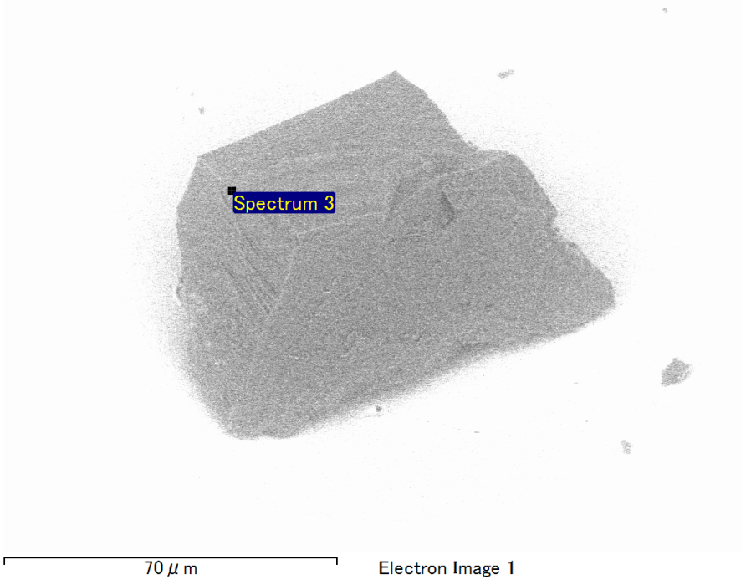

Spectrum Label: Spectrum 3

Livetime 90.0 s

Acquisition geometry ( degrees ):

Tilt = 0.0

Azimuth = 0.0

Elevation = 30.0

Accelerating voltage = 10.00 kV

Total spectrum counts = 66000

|  |  |  |  |
| --- | --- | --- | --- |
| Sample data : | Energy (eV) | Resn. (eV) | Area |
| Strobe : | 3.8 | 40.20 | 945761 |
|  |  |  |  |
| Optimization data : Cobalt K series |  |  |  |
|  | Energy (eV) | Resn. (eV) | Area |
| Strobe : | .1 | 41.16 | 1008028 |
| Optimization element : | 6916.2 | 136.04 | 88085 |

Spectrum processing :

No peaks omitted

Processing option : Oxygen by stoichiometry (Normalised)

Number of iterations = 2

Standard :

C CaCO3 1-Jun-1999 12:00 AM

Mg MgO 1-Jun-1999 12:00 AM

Si SiO2 1-Jun-1999 12:00 AM

Fe Fe 1-Jun-1999 12:00 AM

Au Au 1-Jun-1999 12:00 AM

|  |  |  |  |  |  |
| --- | --- | --- | --- | --- | --- |
| Element | Weight% | Atomic% | Compd% | Formula |  |
|  |  |  |  |  |  |
| C K | 3.33 | 11.23 | 12.21 | CO2 |  |
| Mg K | 4.02 | 6.68 | 6.66 | MgO |  |
| Si K | 3.03 | 4.36 | 6.48 | SiO2 |  |
| Fe L | 6.57 | 4.76 | 8.45 | FeO |  |
| Au M | 59.01 | 12.13 | 66.20 | Au2O3 |  |
| O | 24.04 | 60.83 |  |  |  |
| Totals | 100.00 |  |  |  |  |

Project: Project 1

Owner: Operator

Site: Site of Interest 5

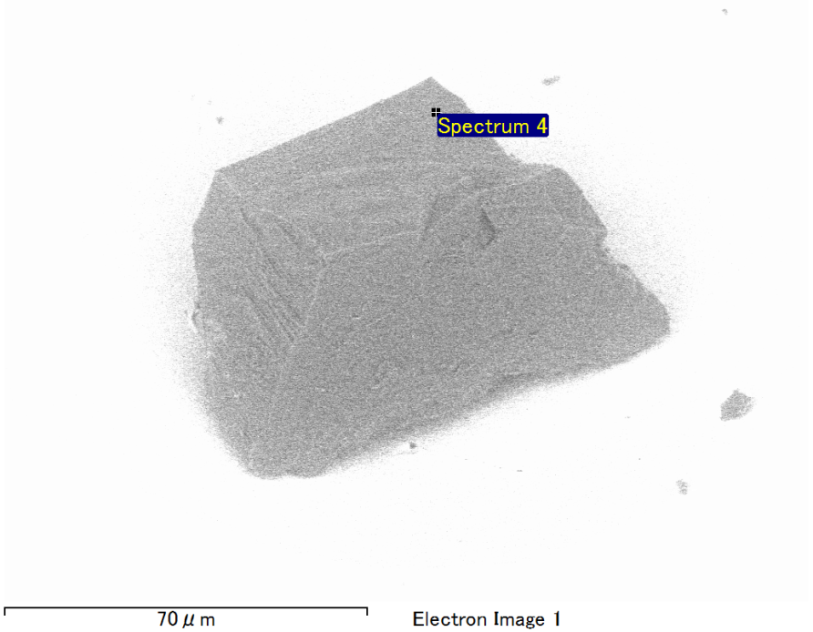

Spectrum Label: Spectrum 4

Livetime 90.0 s

Acquisition geometry ( degrees ):

Tilt = 0.0

Azimuth = 0.0

Elevation = 30.0

Accelerating voltage = 10.00 kV

Total spectrum counts = 67932

|  |  |  |  |
| --- | --- | --- | --- |
| Sample data : | Energy (eV) | Resn. (eV) | Area |
| Strobe : | 3.8 | 40.16 | 943418 |
|  |  |  |  |
| Optimization data : Cobalt K series |  |  |  |
|  | Energy (eV) | Resn. (eV) | Area |
| Strobe : | .1 | 41.16 | 1008028 |
| Optimization element : | 6916.2 | 136.04 | 88085 |

Spectrum processing :

No peaks omitted

Processing option : Oxygen by stoichiometry (Normalised)

Number of iterations = 2

Standard :

C CaCO3 1-Jun-1999 12:00 AM

Mg MgO 1-Jun-1999 12:00 AM

Si SiO2 1-Jun-1999 12:00 AM

Fe Fe 1-Jun-1999 12:00 AM

Au Au 1-Jun-1999 12:00 AM

|  |  |  |  |  |  |
| --- | --- | --- | --- | --- | --- |
| Element | Weight% | Atomic% | Compd% | Formula |  |
|  |  |  |  |  |  |
| C K | 2.79 | 8.47 | 10.24 | CO2 |  |
| Mg K | 5.89 | 8.82 | 9.77 | MgO |  |
| Si K | 4.36 | 5.65 | 9.32 | SiO2 |  |
| Fe L | 14.06 | 9.17 | 18.09 | FeO |  |
| Au M | 46.87 | 8.66 | 52.59 | Au2O3 |  |
| O | 26.02 | 59.23 |  |  |  |
| Totals | 100.00 |  |  |  |  |

Project: Project 1

Owner: Operator

Site: Site of Interest 5