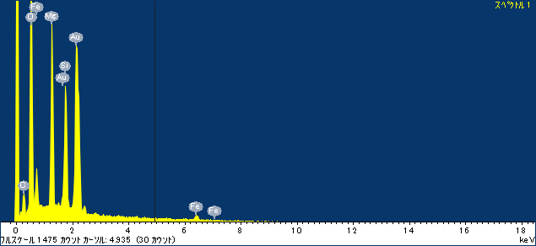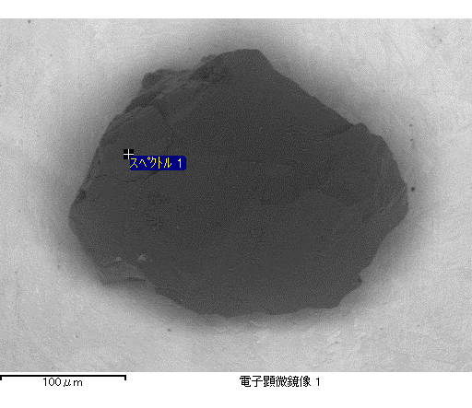

ｺﾒﾝﾄ :

2016/12/19 11:51:16

ﾌﾟﾛｼﾞｪｸﾄ 1

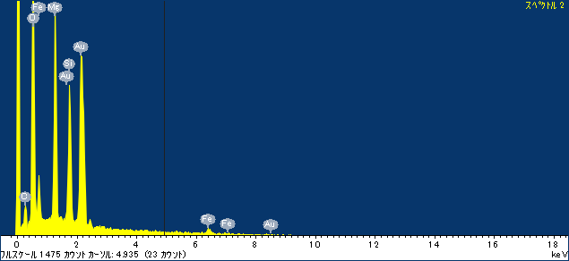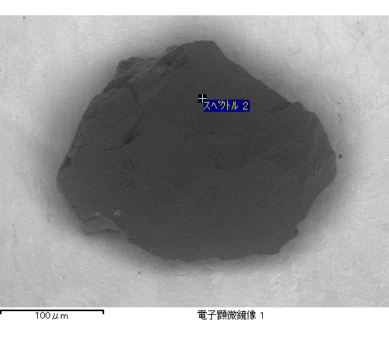

ｺﾒﾝﾄ :

2016/12/19 11:51:30

ﾌﾟﾛｼﾞｪｸﾄ 1

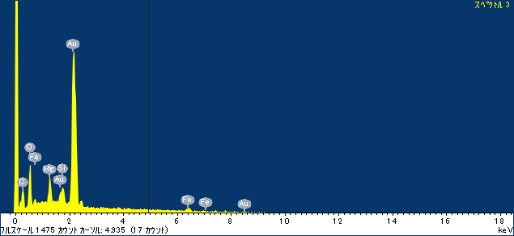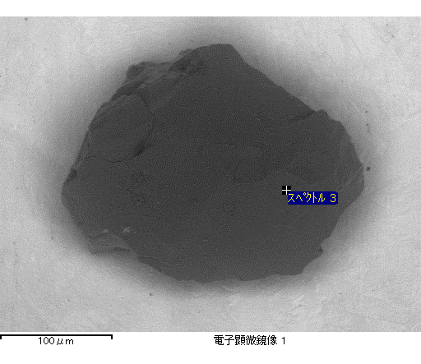

ｺﾒﾝﾄ :

2016/12/19 11:51:37

ﾌﾟﾛｼﾞｪｸﾄ 1

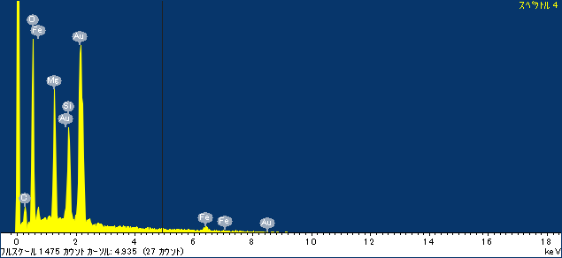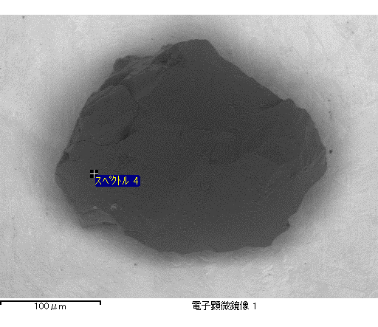

ｺﾒﾝﾄ :

2016/12/19 11:51:41

ﾌﾟﾛｼﾞｪｸﾄ 1

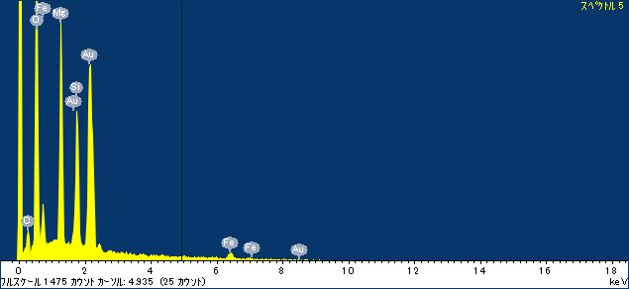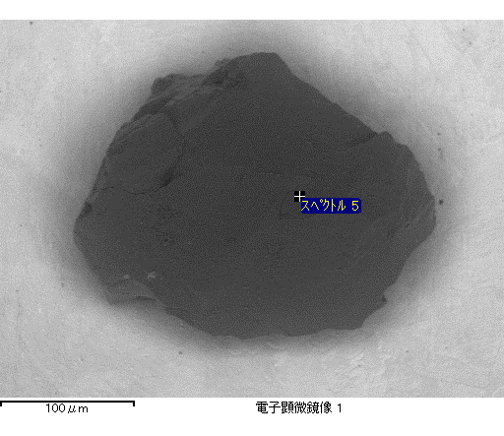

ｺﾒﾝﾄ :

2016/12/19 11:51:45

ﾌﾟﾛｼﾞｪｸﾄ 1

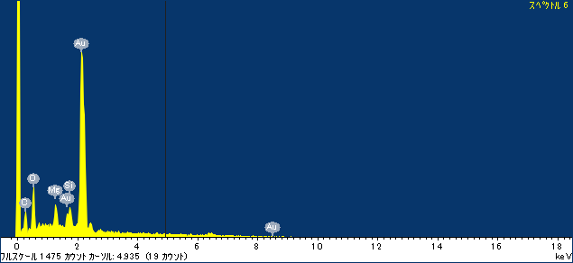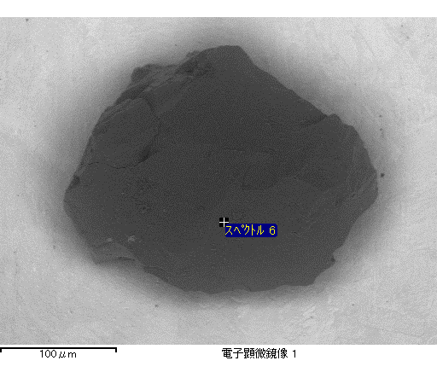

ｺﾒﾝﾄ :

2016/12/19 11:51:50

ﾌﾟﾛｼﾞｪｸﾄ 1

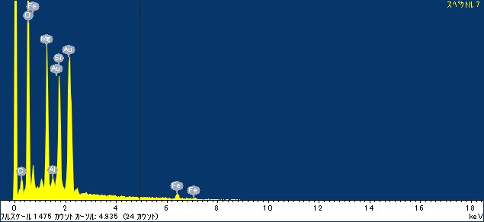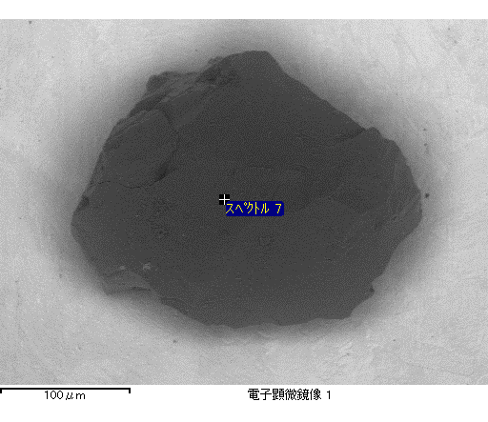

ｺﾒﾝﾄ :

2016/12/19 11:51:55

ﾌﾟﾛｼﾞｪｸﾄ 1