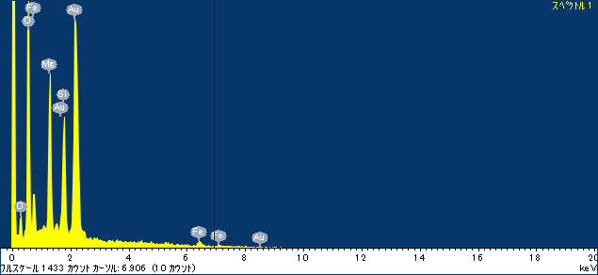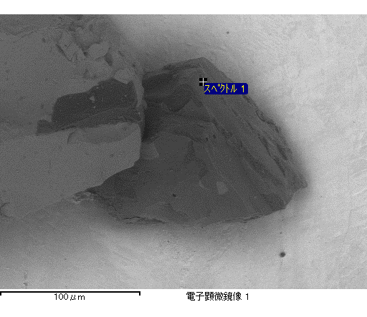

ｺﾒﾝﾄ :

2016/12/08 17:11:08

ﾌﾟﾛｼﾞｪｸﾄ 1

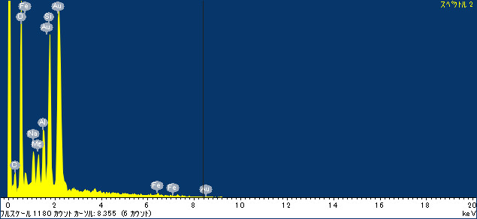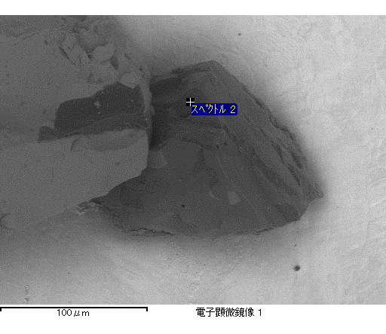

ｺﾒﾝﾄ :

2016/12/08 17:11:15

ﾌﾟﾛｼﾞｪｸﾄ 1

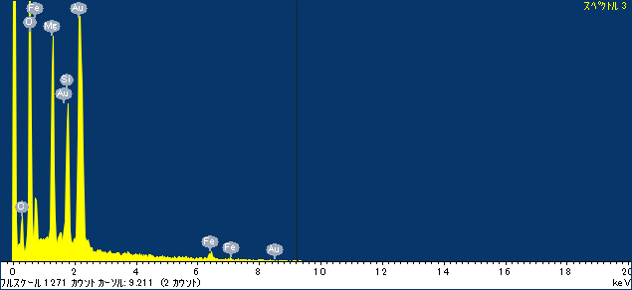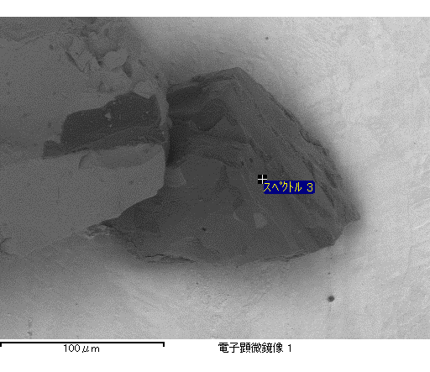

ｺﾒﾝﾄ :

2016/12/08 17:11:24

ﾌﾟﾛｼﾞｪｸﾄ 1

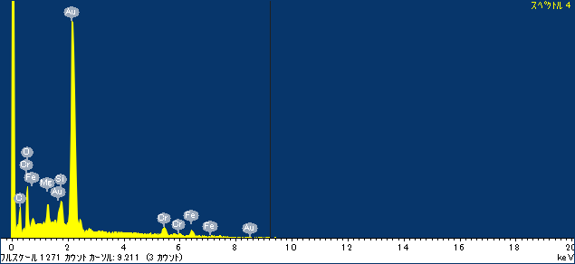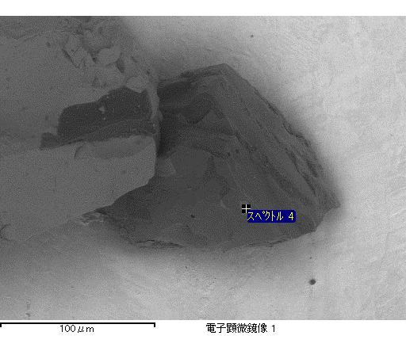

ｺﾒﾝﾄ :

2016/12/08 17:11:31

ﾌﾟﾛｼﾞｪｸﾄ 1

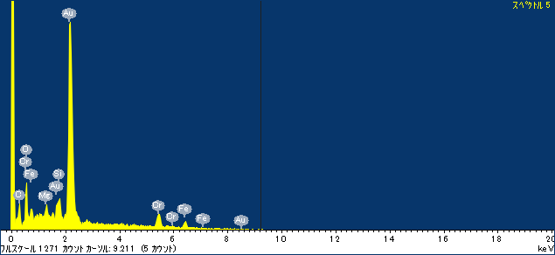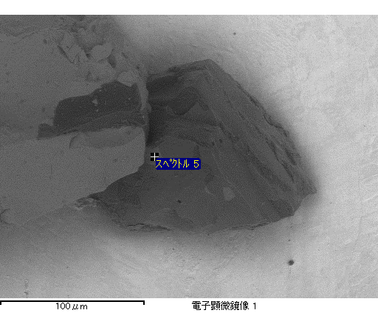

ｺﾒﾝﾄ :

2016/12/08 17:11:37

ﾌﾟﾛｼﾞｪｸﾄ 1

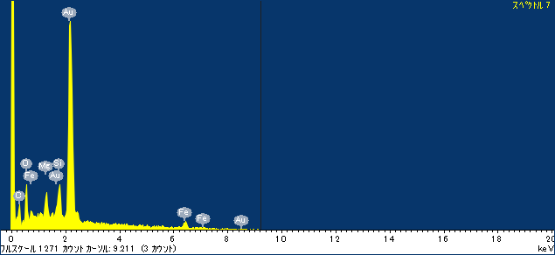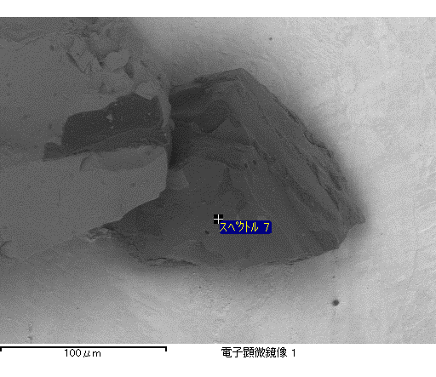

ｺﾒﾝﾄ :

2016/12/08 17:11:44

ﾌﾟﾛｼﾞｪｸﾄ 1