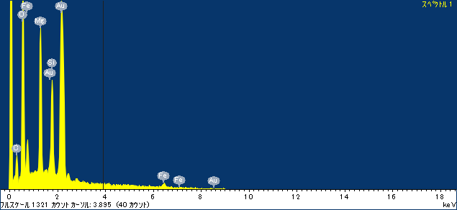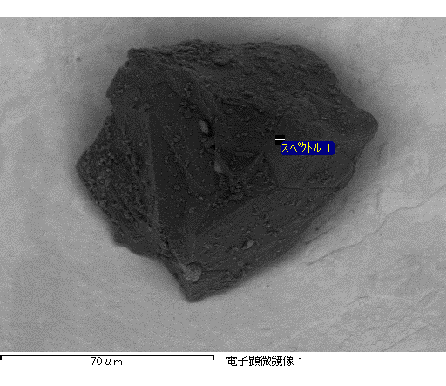

ｺﾒﾝﾄ :

2016/12/19 11:40:56

ﾌﾟﾛｼﾞｪｸﾄ 1

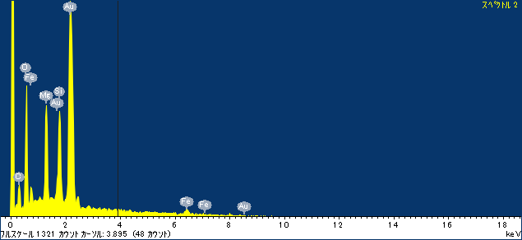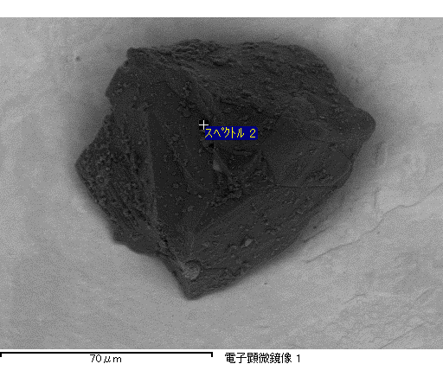

ｺﾒﾝﾄ :

2016/12/19 11:41:14

ﾌﾟﾛｼﾞｪｸﾄ 1

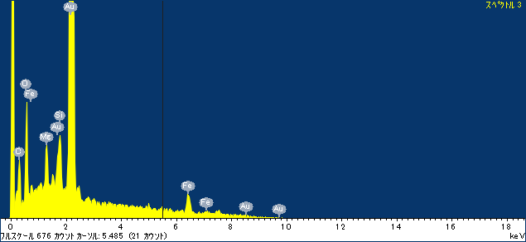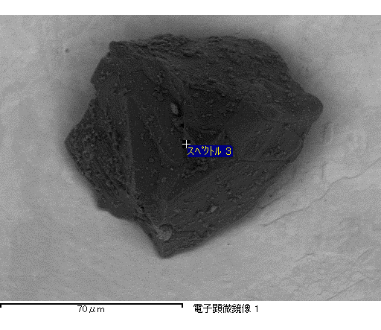

ｺﾒﾝﾄ :

2016/12/19 11:41:26

ﾌﾟﾛｼﾞｪｸﾄ 1

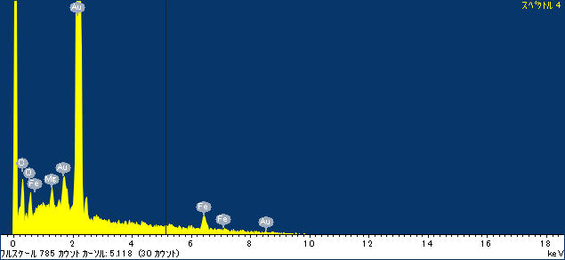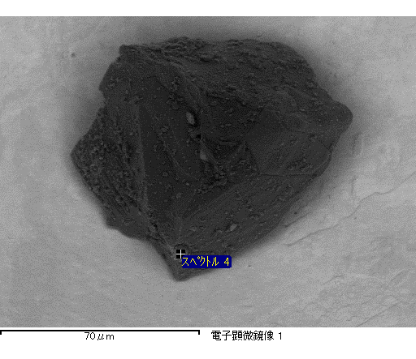

ｺﾒﾝﾄ :

2016/12/19 11:41:35

ﾌﾟﾛｼﾞｪｸﾄ 1

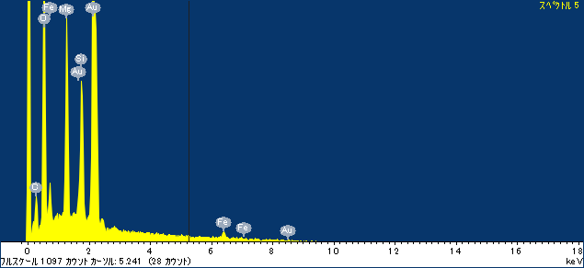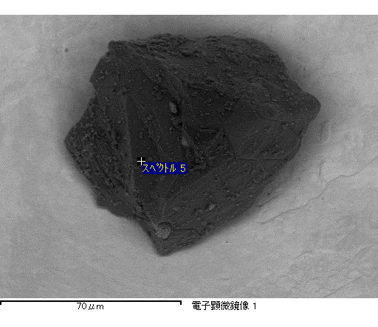

ｺﾒﾝﾄ :

2016/12/19 11:41:47

ﾌﾟﾛｼﾞｪｸﾄ 1

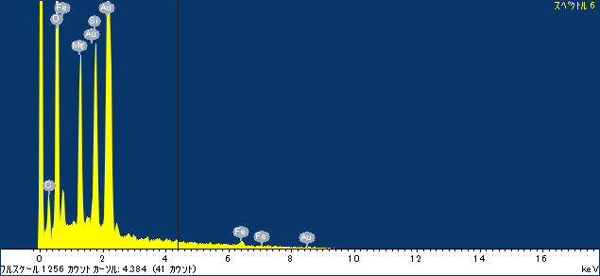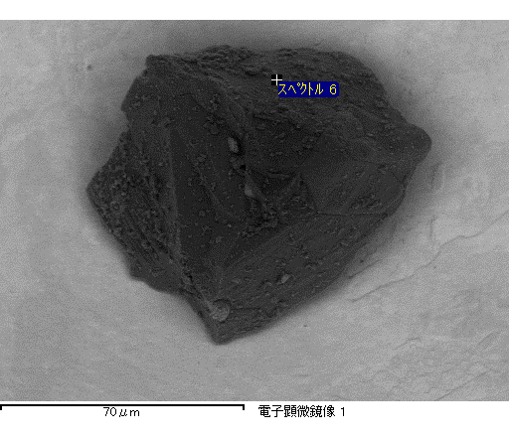

ｺﾒﾝﾄ :

2016/12/19 11:41:56

ﾌﾟﾛｼﾞｪｸﾄ 1

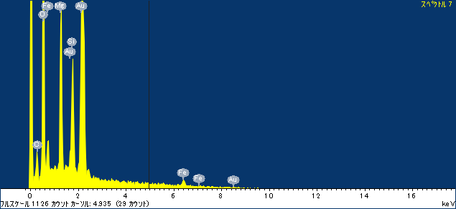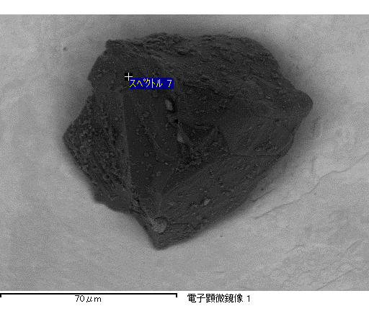

ｺﾒﾝﾄ :

2016/12/19 11:42:28

ﾌﾟﾛｼﾞｪｸﾄ 1