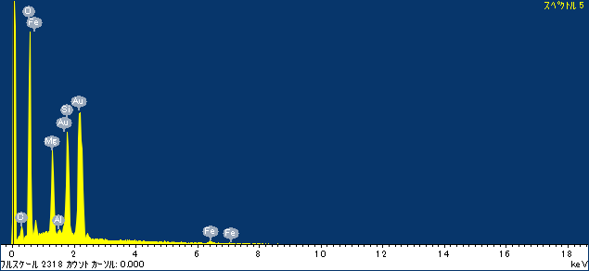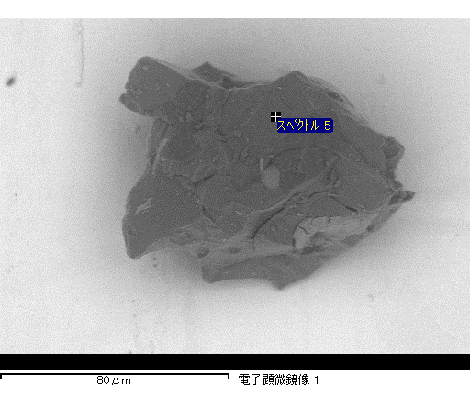

ｺﾒﾝﾄ :

2017/02/16 15:14:58

ﾌﾟﾛｼﾞｪｸﾄ 1

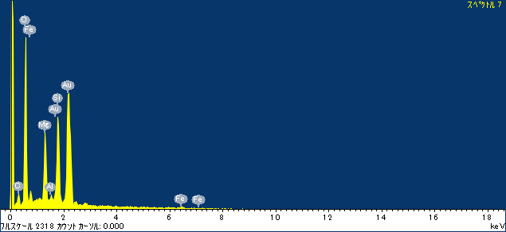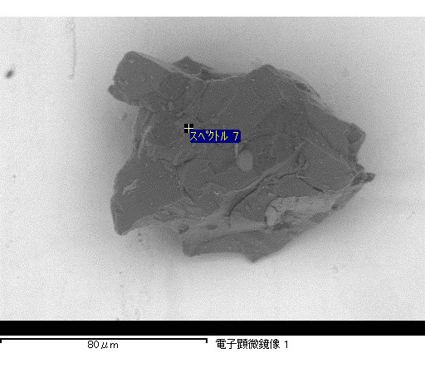

ｺﾒﾝﾄ :

2017/02/16 15:15:12

ﾌﾟﾛｼﾞｪｸﾄ 1

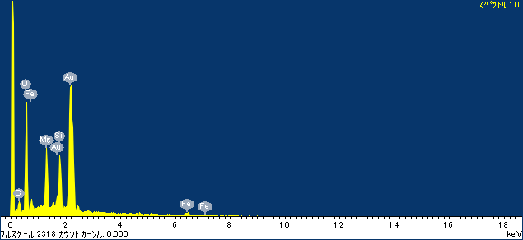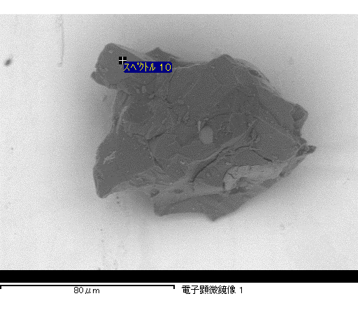

ｺﾒﾝﾄ :

2017/02/16 15:15:26

ﾌﾟﾛｼﾞｪｸﾄ 1

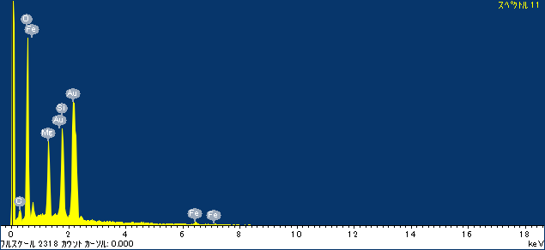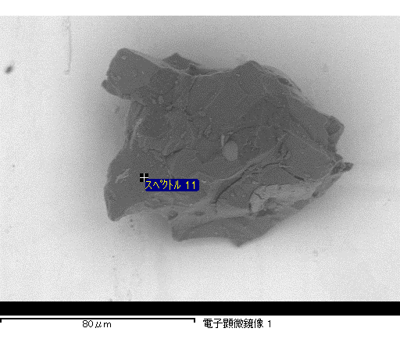

ｺﾒﾝﾄ :

2017/02/16 15:15:36

ﾌﾟﾛｼﾞｪｸﾄ 1

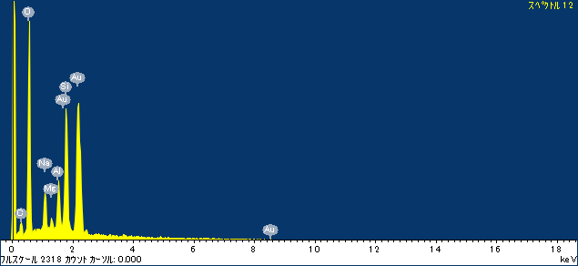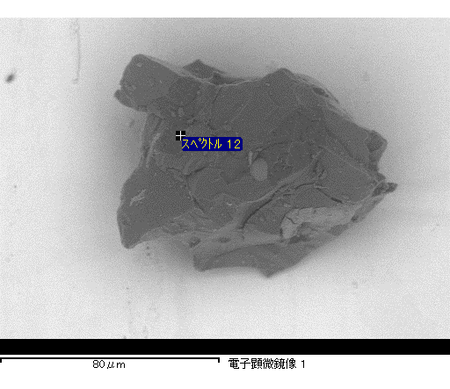

ｺﾒﾝﾄ :

2017/02/16 15:15:48

ﾌﾟﾛｼﾞｪｸﾄ 1