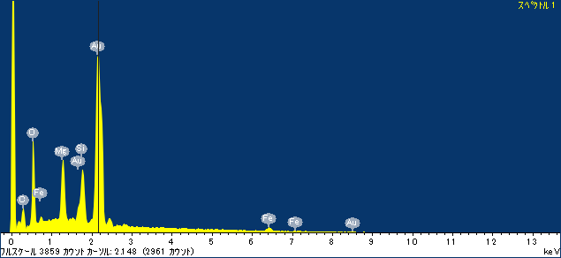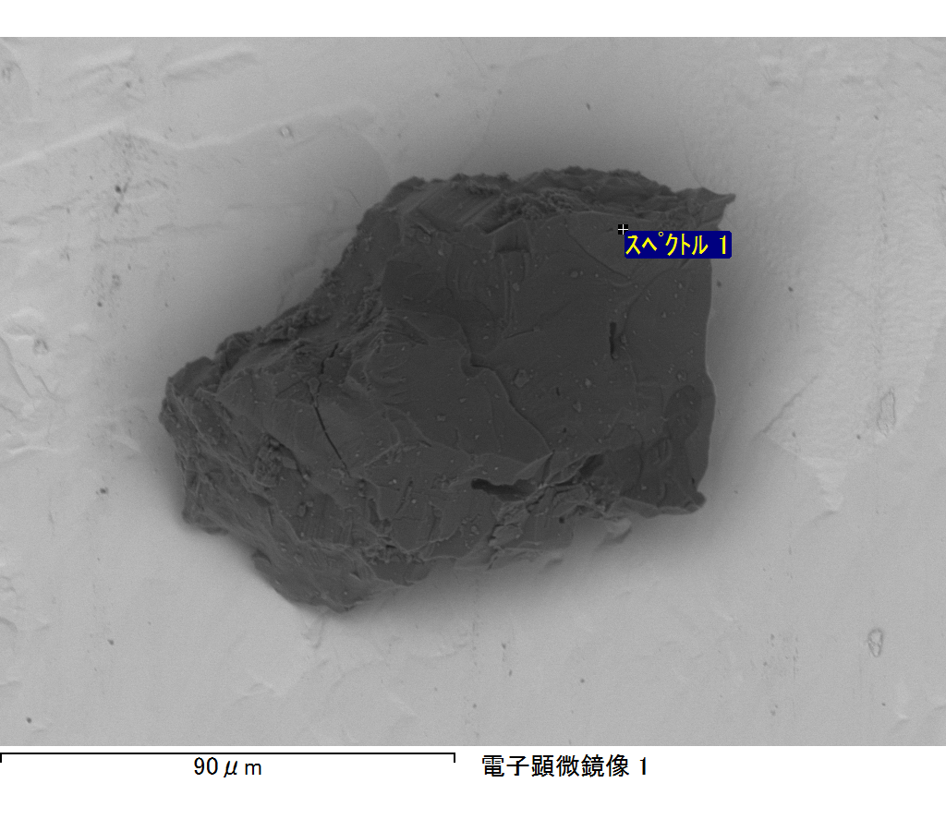

ｺﾒﾝﾄ :

2017/03/01 15:25:20

ﾌﾟﾛｼﾞｪｸﾄ 1

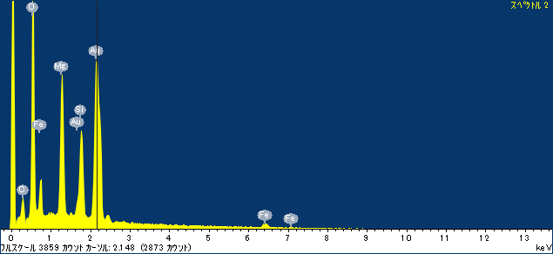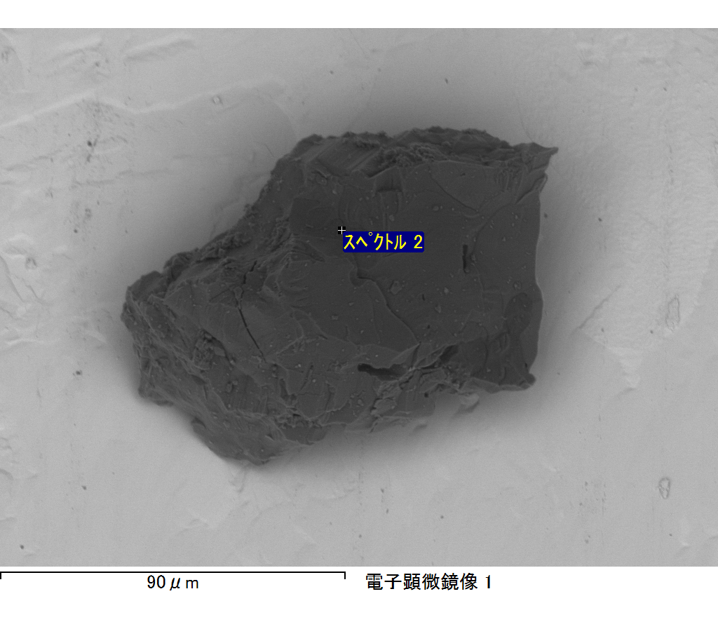

ｺﾒﾝﾄ :

2017/03/01 15:25:27

ﾌﾟﾛｼﾞｪｸﾄ 1

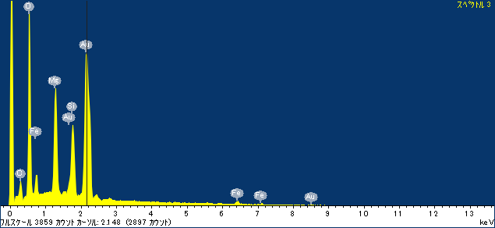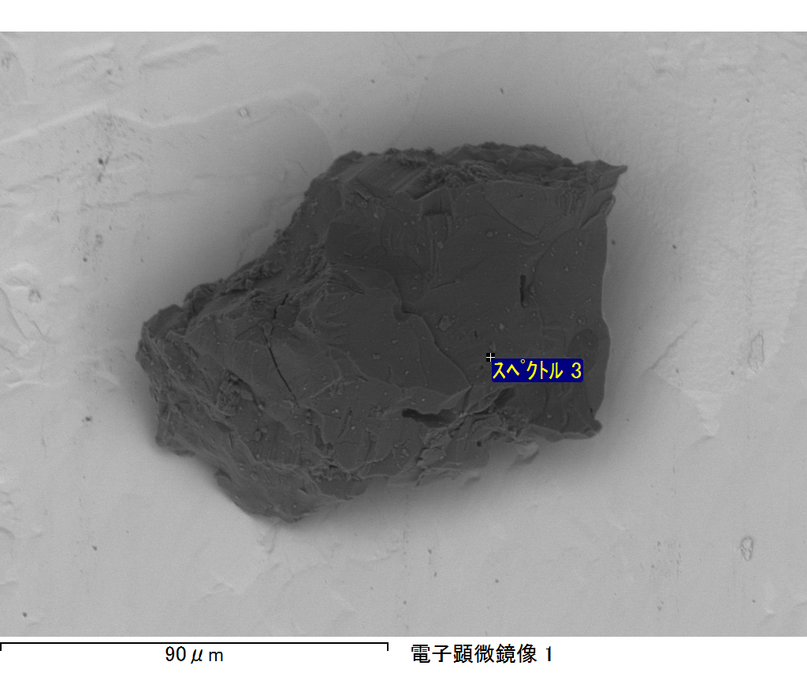

ｺﾒﾝﾄ :

2017/03/01 15:25:32

ﾌﾟﾛｼﾞｪｸﾄ 1

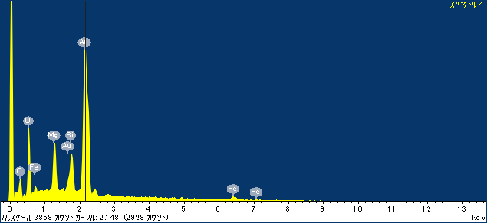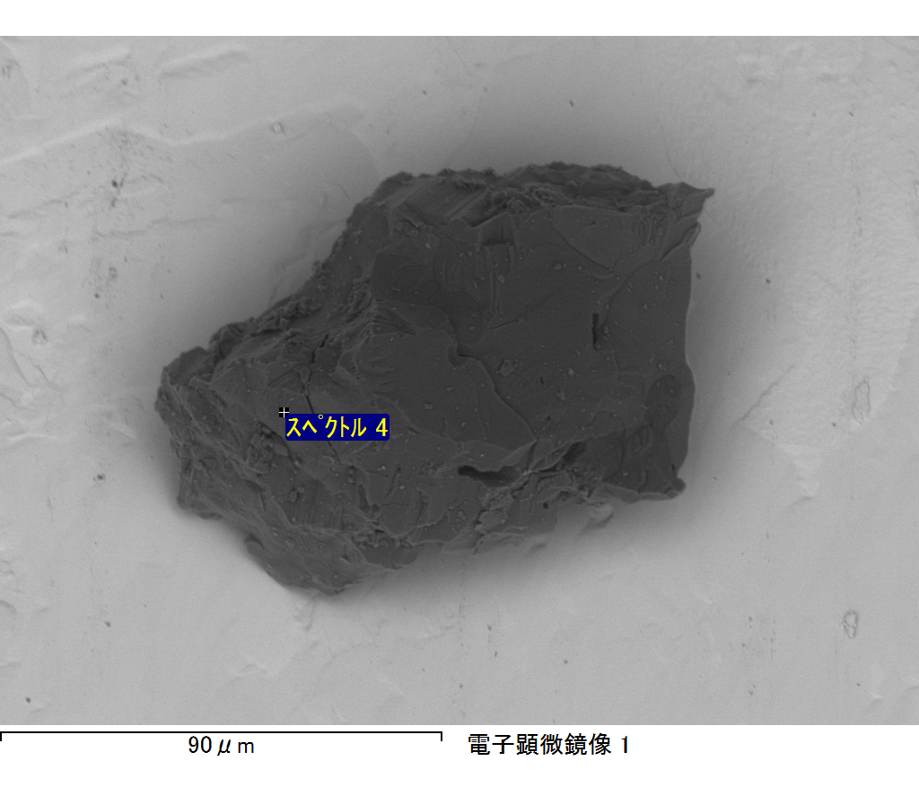

ｺﾒﾝﾄ :

2017/03/01 15:25:39

ﾌﾟﾛｼﾞｪｸﾄ 1

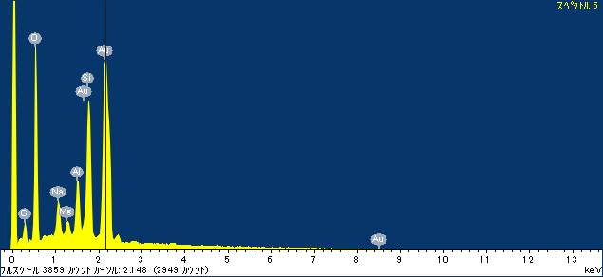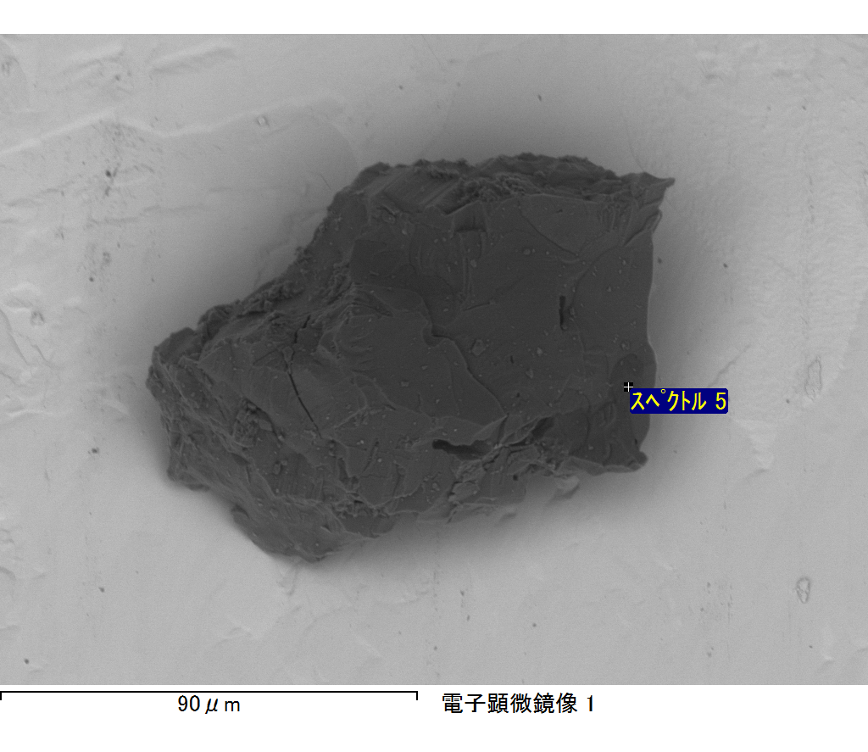

ｺﾒﾝﾄ :

2017/03/01 15:25:44

ﾌﾟﾛｼﾞｪｸﾄ 1

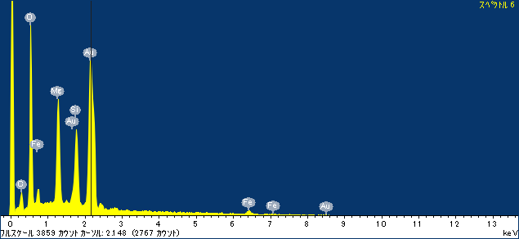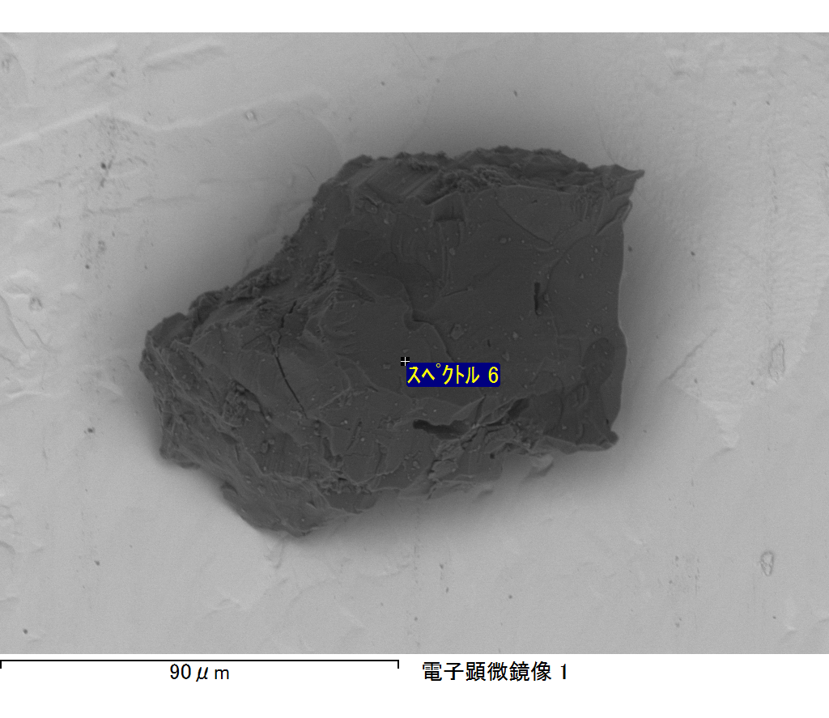

ｺﾒﾝﾄ :

2017/03/01 15:25:51

ﾌﾟﾛｼﾞｪｸﾄ 1

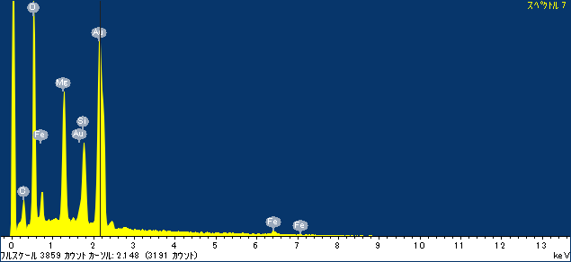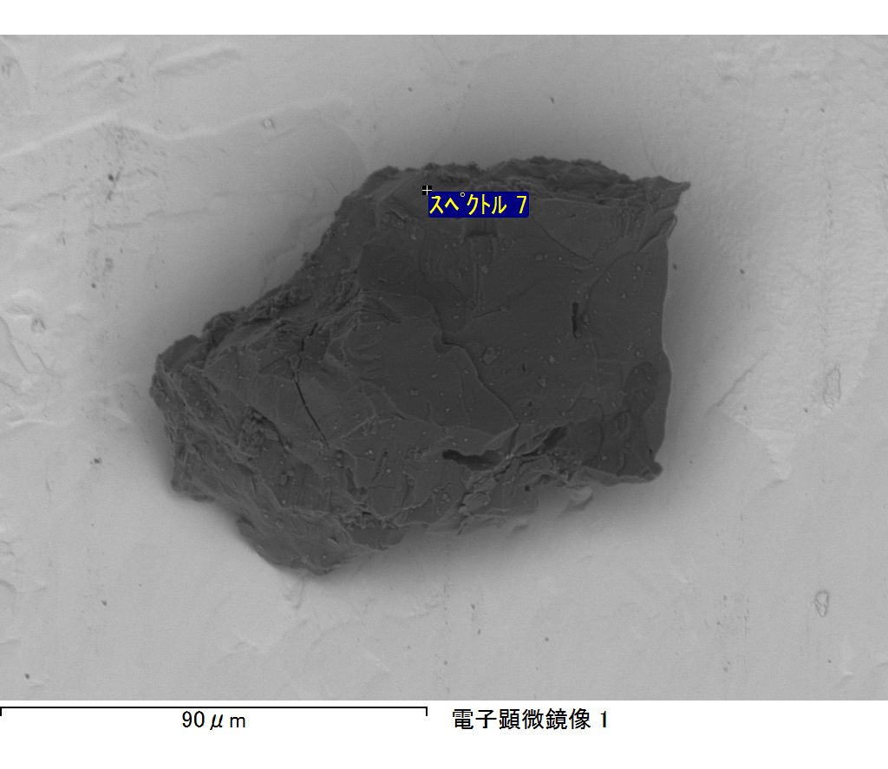

ｺﾒﾝﾄ :

2017/03/01 15:25:55

ﾌﾟﾛｼﾞｪｸﾄ 1