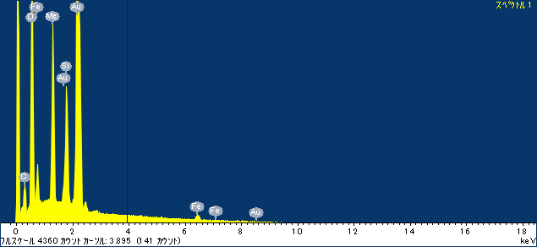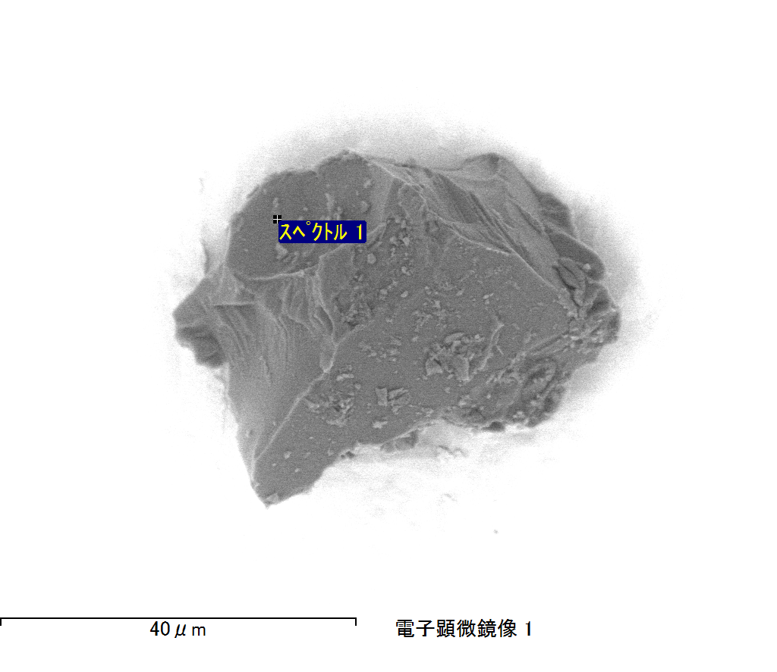

ｺﾒﾝﾄ :

2017/02/28 16:35:06

ﾌﾟﾛｼﾞｪｸﾄ 1

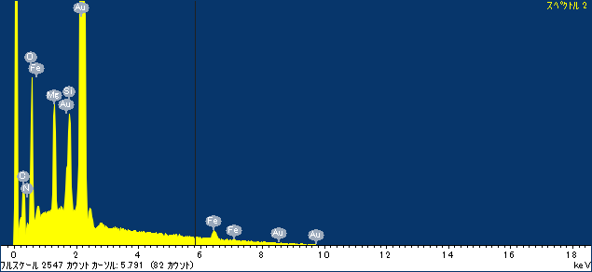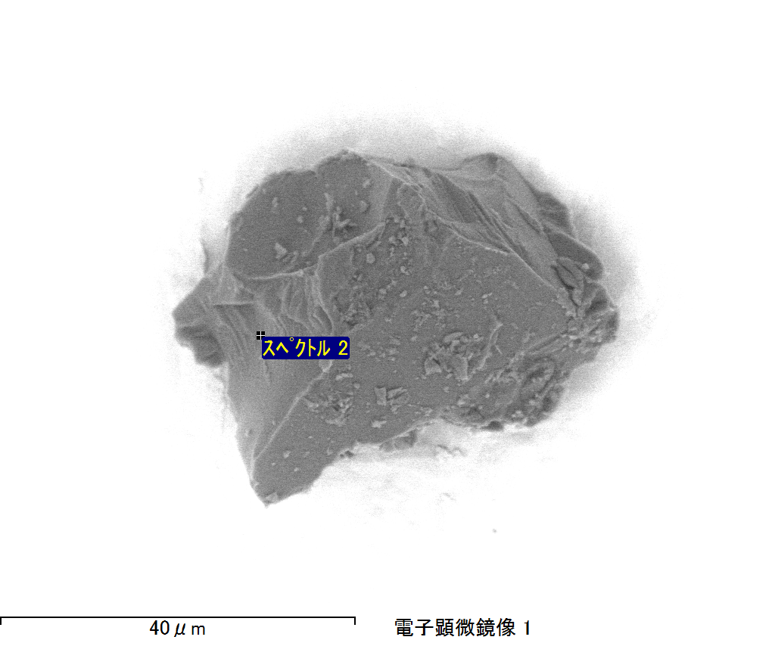

ｺﾒﾝﾄ :

2017/02/28 16:35:20

ﾌﾟﾛｼﾞｪｸﾄ 1

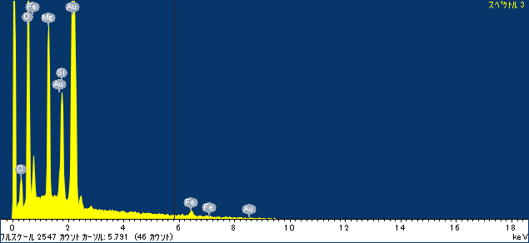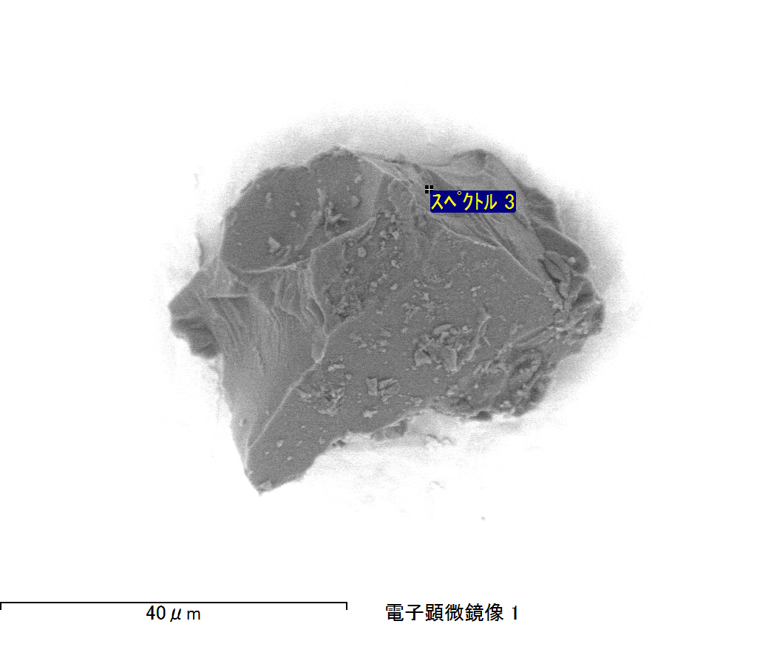

ｺﾒﾝﾄ :

2017/02/28 16:35:27

ﾌﾟﾛｼﾞｪｸﾄ 1

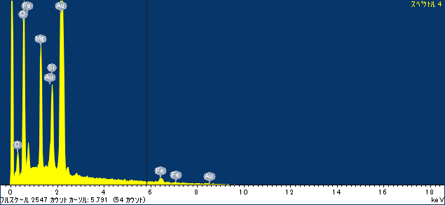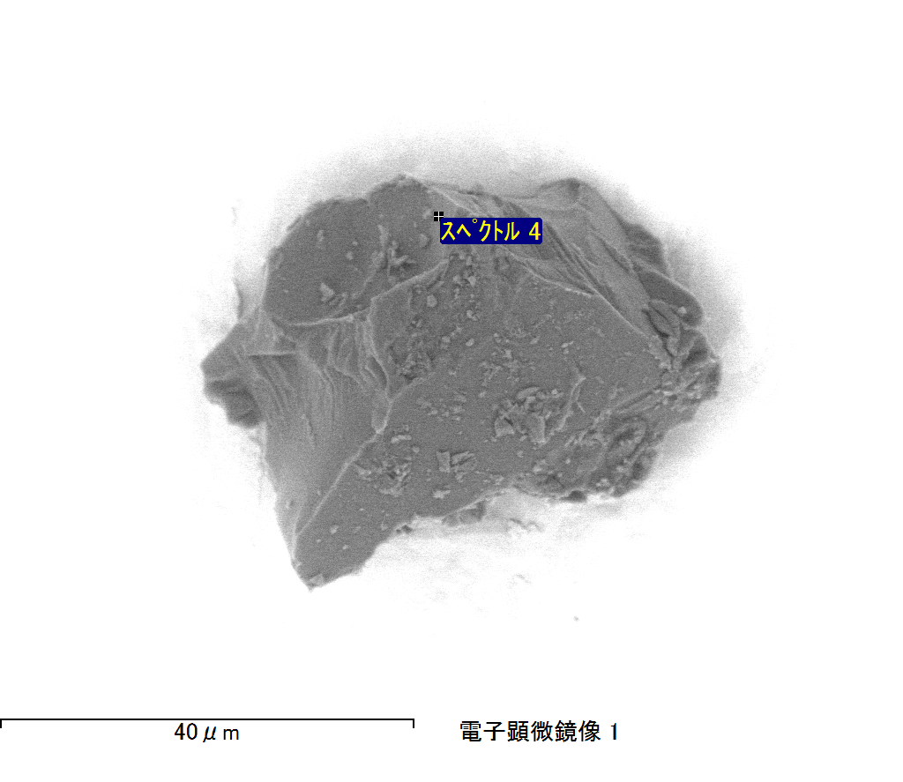

ｺﾒﾝﾄ :

2017/02/28 16:35:36

ﾌﾟﾛｼﾞｪｸﾄ 1

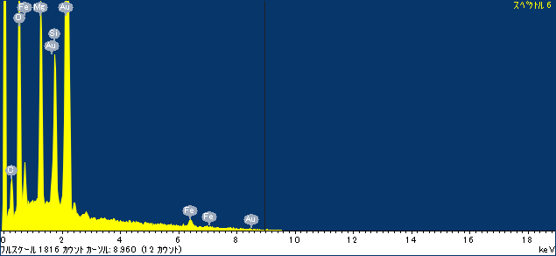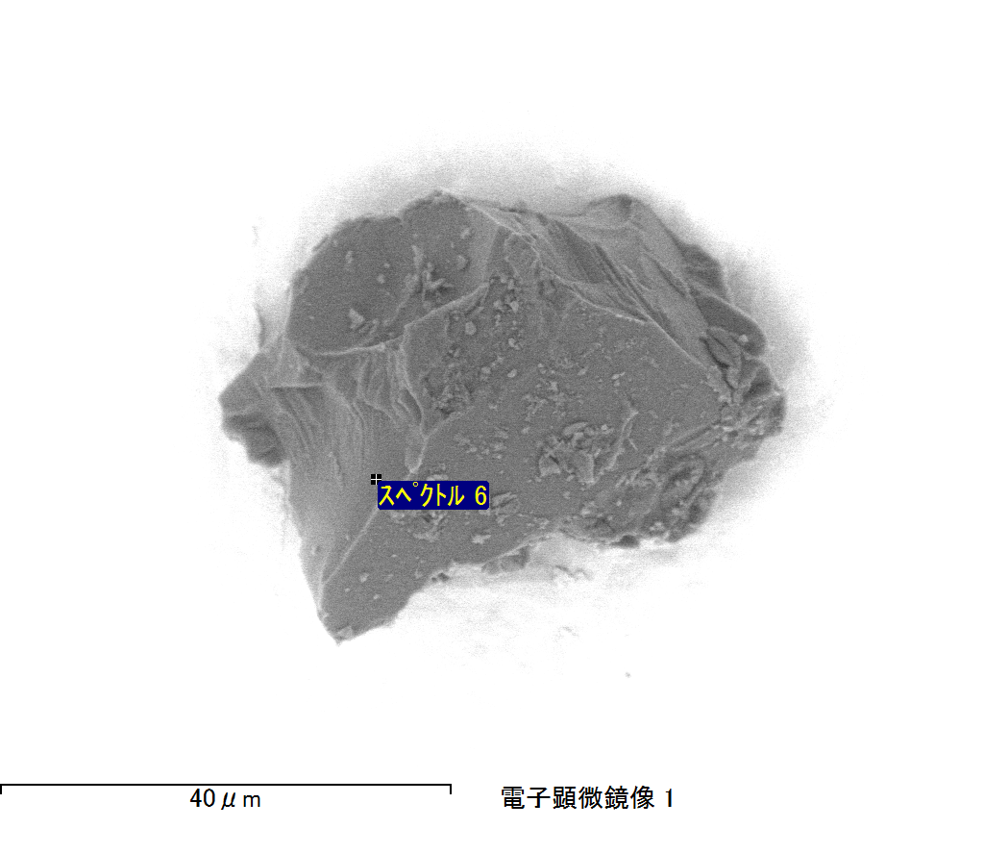

ｺﾒﾝﾄ :

2017/02/28 16:36:53

ﾌﾟﾛｼﾞｪｸﾄ 1

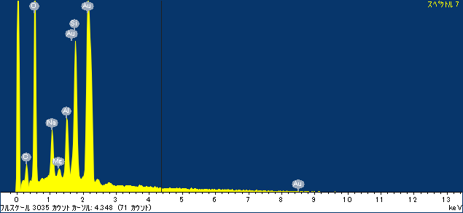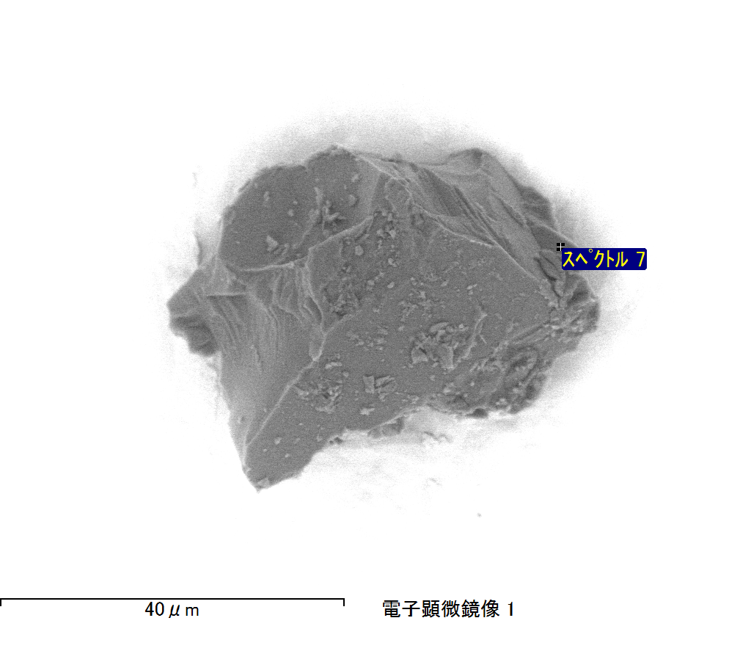

ｺﾒﾝﾄ :

2017/02/28 16:39:23

ﾌﾟﾛｼﾞｪｸﾄ 1

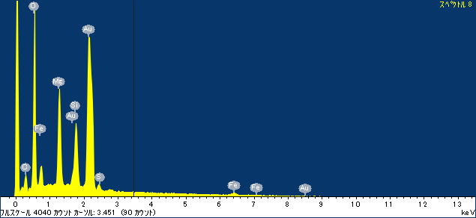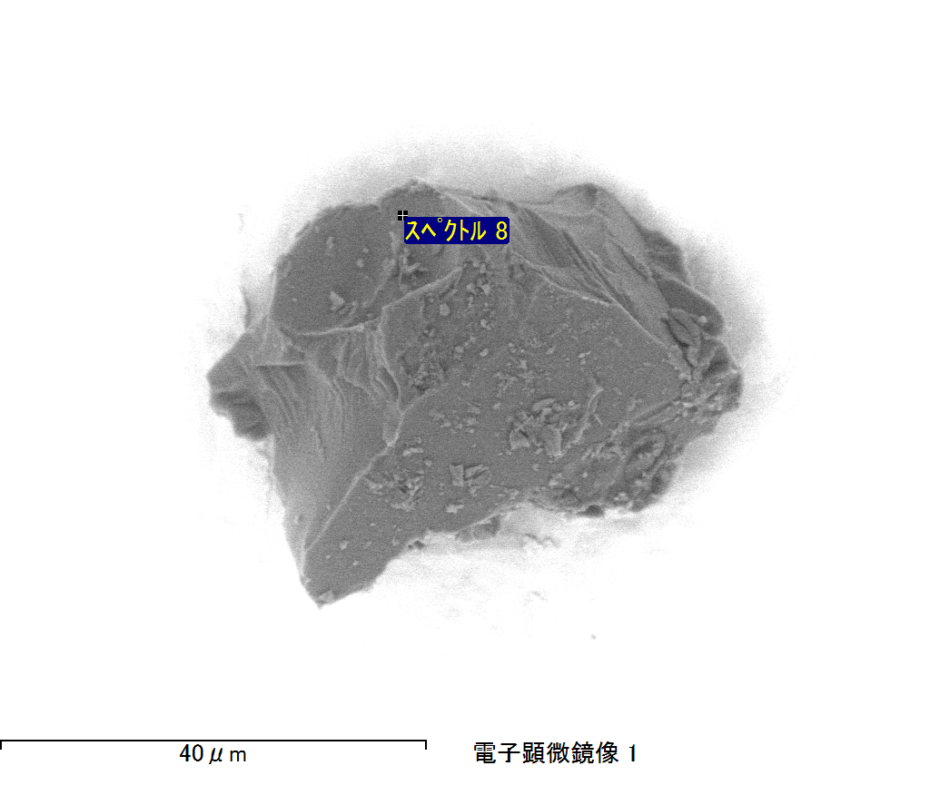

ｺﾒﾝﾄ :

2017/02/28 16:39:39

ﾌﾟﾛｼﾞｪｸﾄ 1