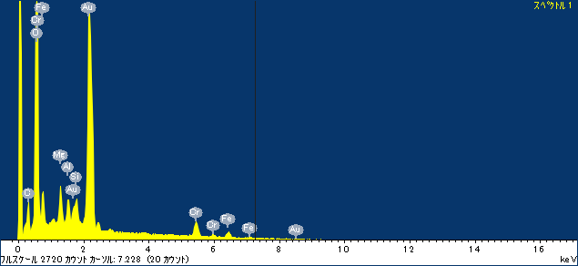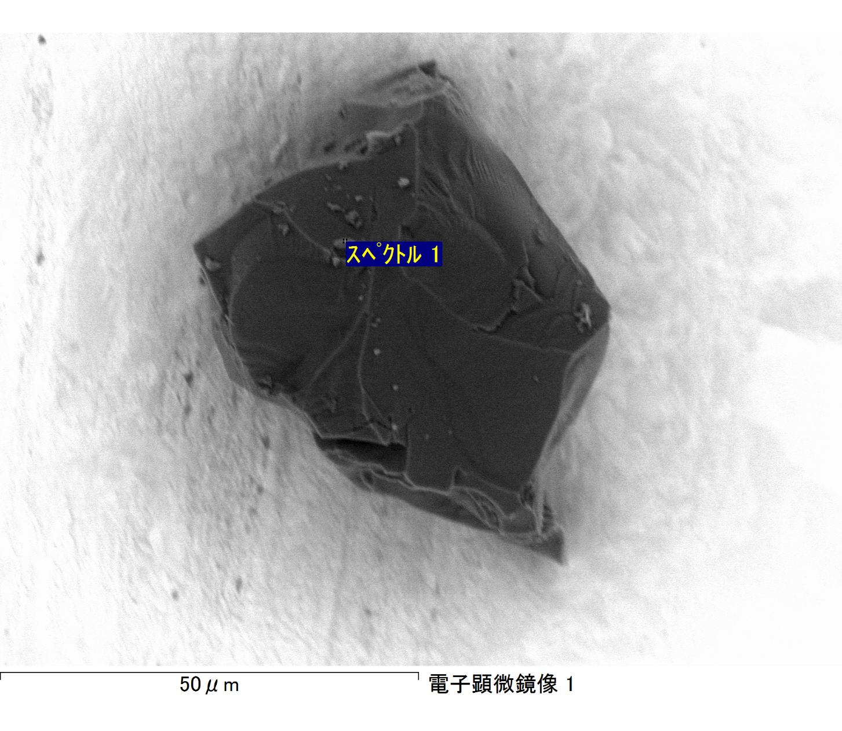

ｺﾒﾝﾄ :

2017/03/17 10:52:08

ﾌﾟﾛｼﾞｪｸﾄ 1

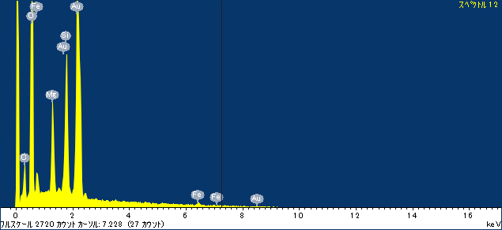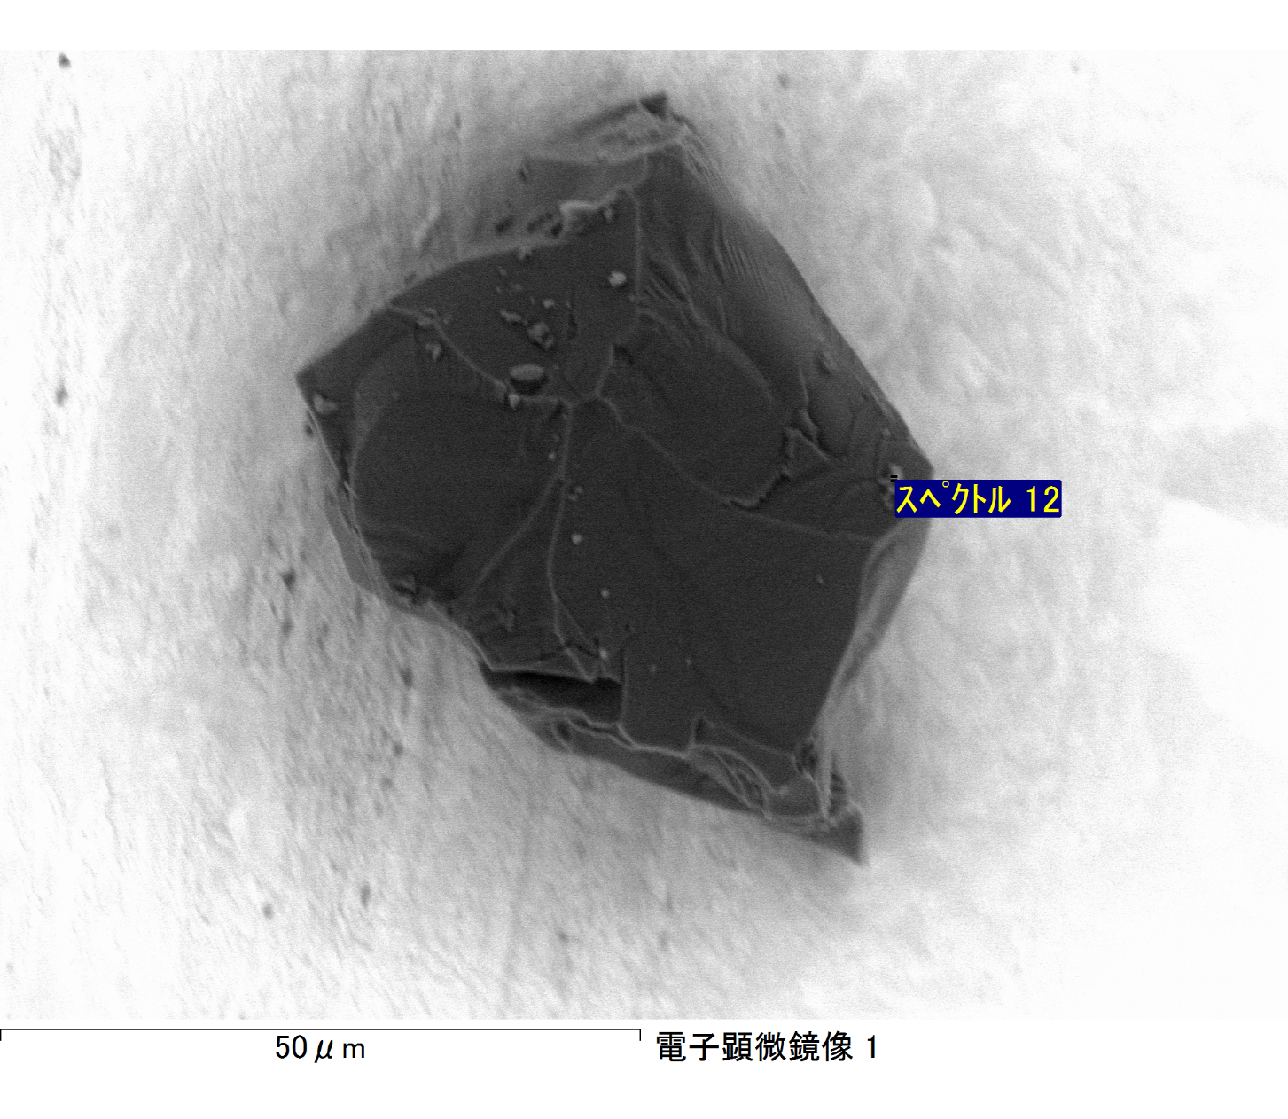

ｺﾒﾝﾄ :

2017/03/17 10:52:24

ﾌﾟﾛｼﾞｪｸﾄ 1

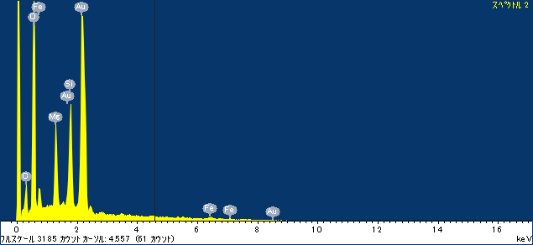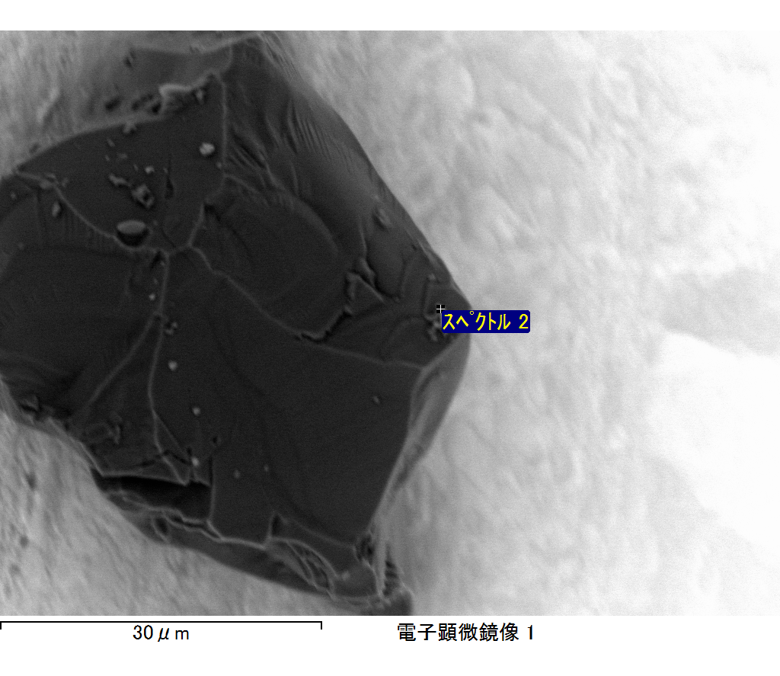

ｺﾒﾝﾄ :

2017/03/17 11:00:27

ﾌﾟﾛｼﾞｪｸﾄ 1

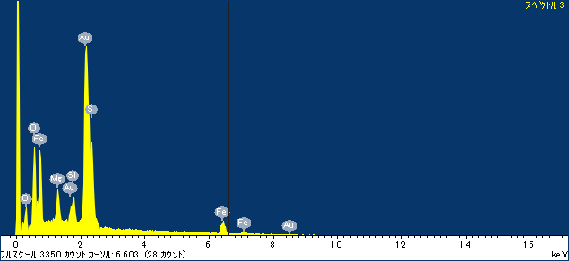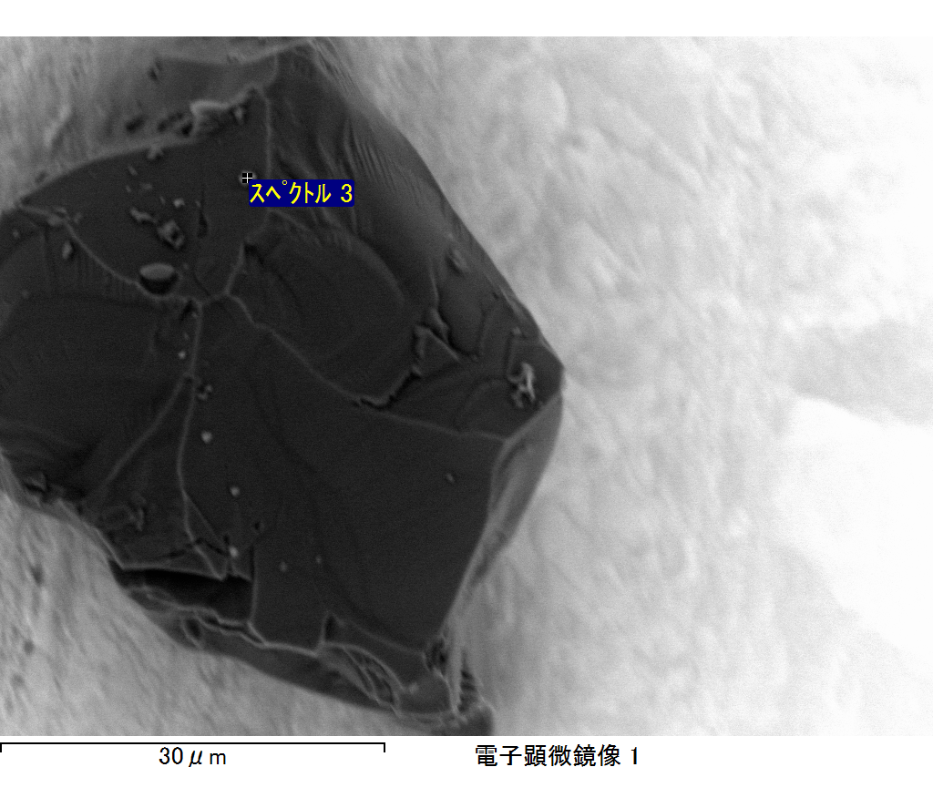

ｺﾒﾝﾄ :

2017/03/17 11:00:37

ﾌﾟﾛｼﾞｪｸﾄ 1

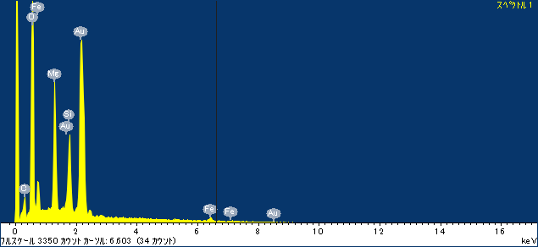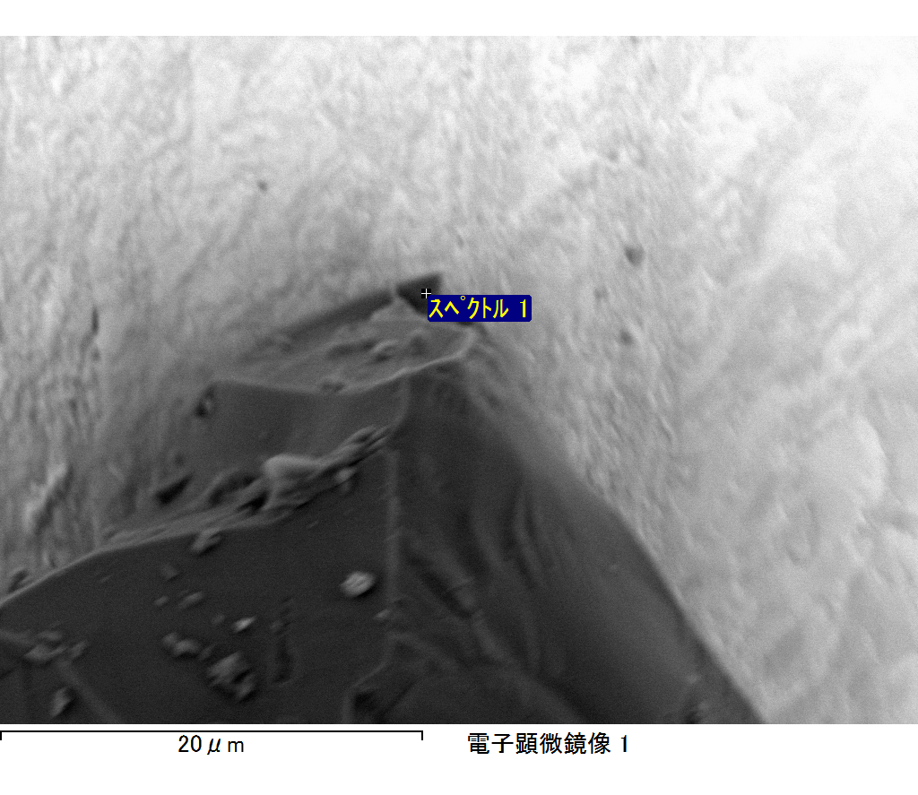

ｺﾒﾝﾄ :

2017/03/17 11:09:33

ﾌﾟﾛｼﾞｪｸﾄ 1

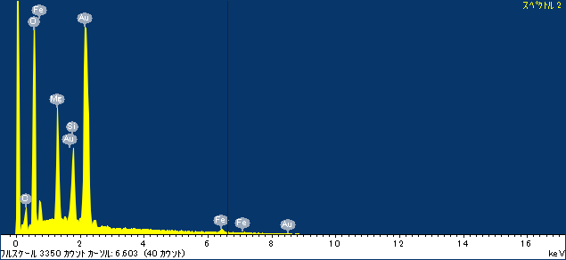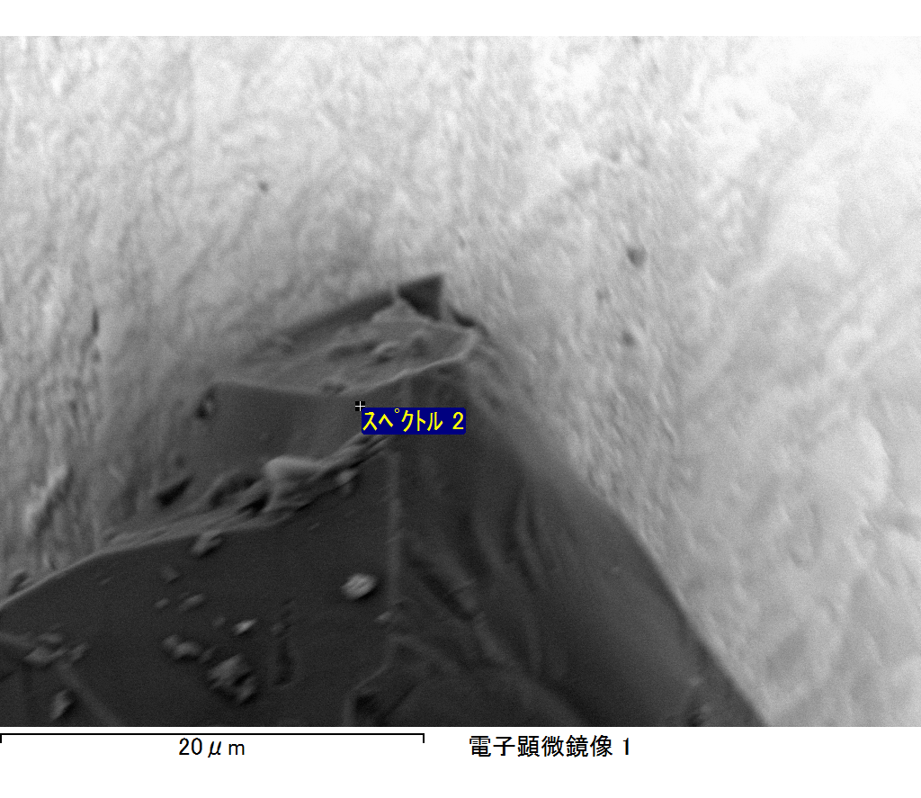

ｺﾒﾝﾄ :

2017/03/17 11:09:37

ﾌﾟﾛｼﾞｪｸﾄ 1