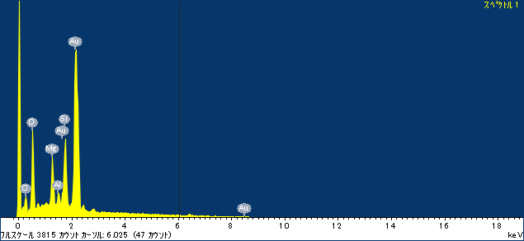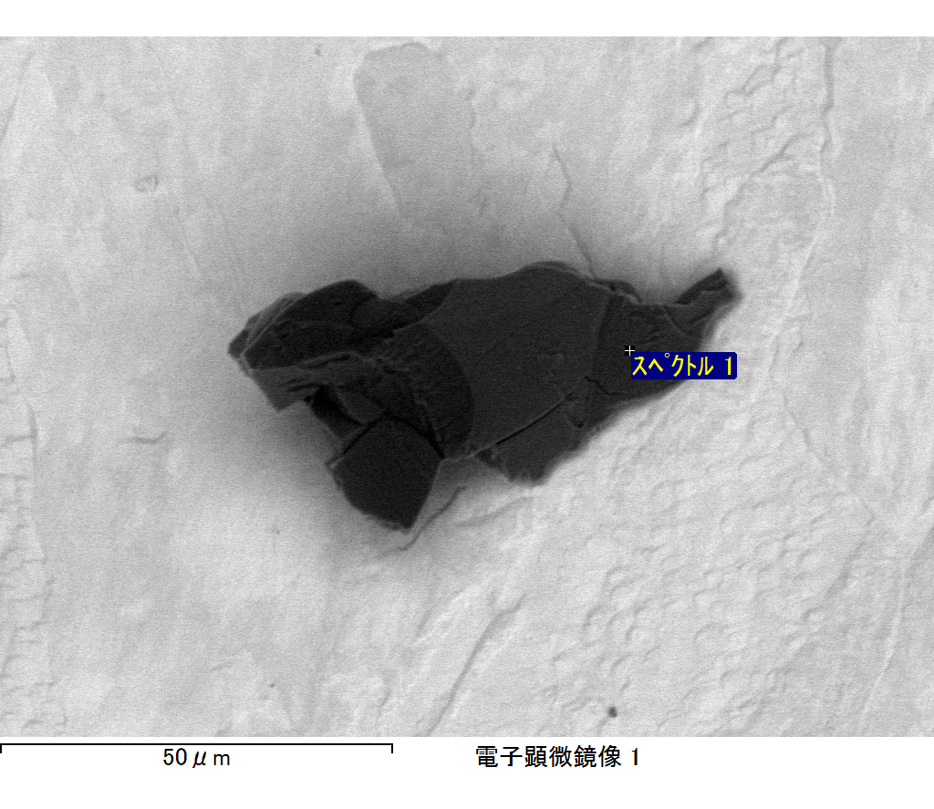

ｺﾒﾝﾄ :

2017/06/01 16:04:22

ﾌﾟﾛｼﾞｪｸﾄ 1

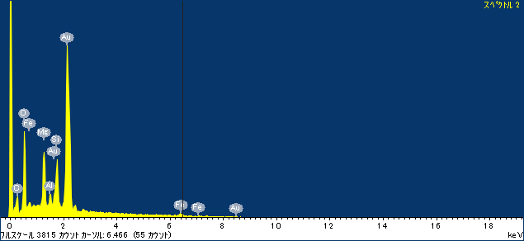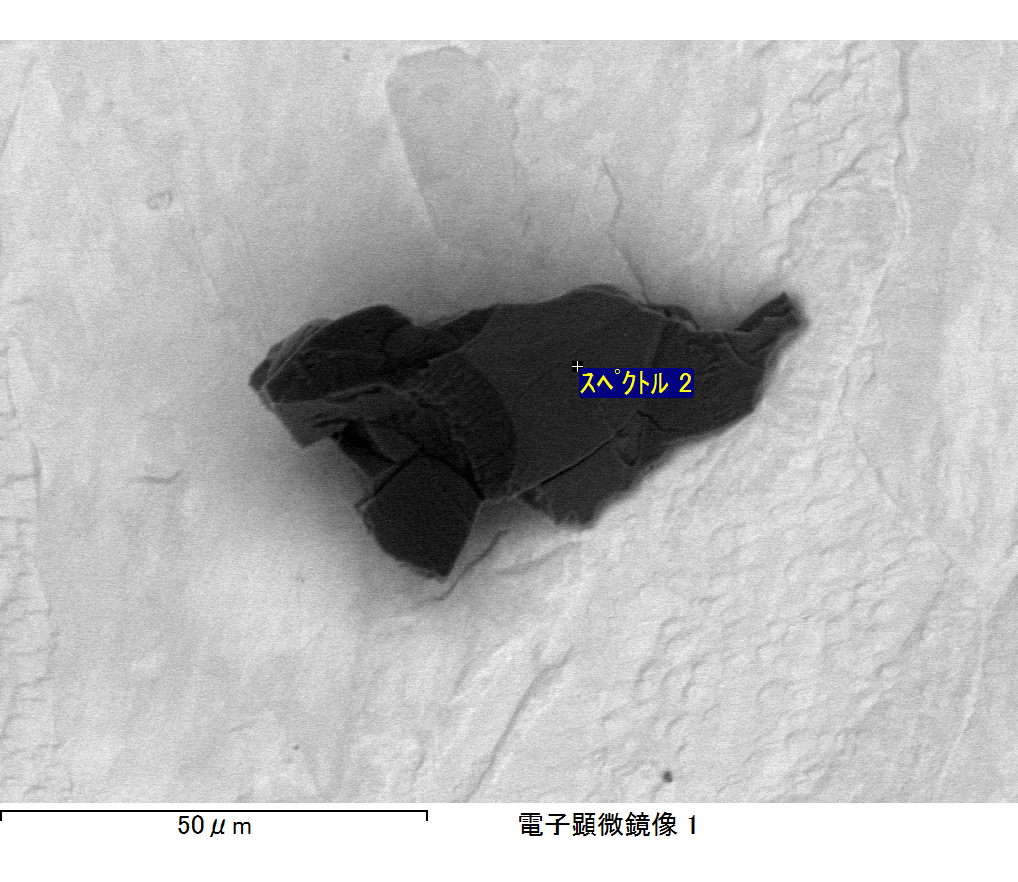

ｺﾒﾝﾄ :

2017/06/01 16:04:30

ﾌﾟﾛｼﾞｪｸﾄ 1

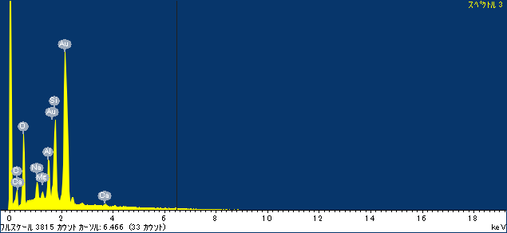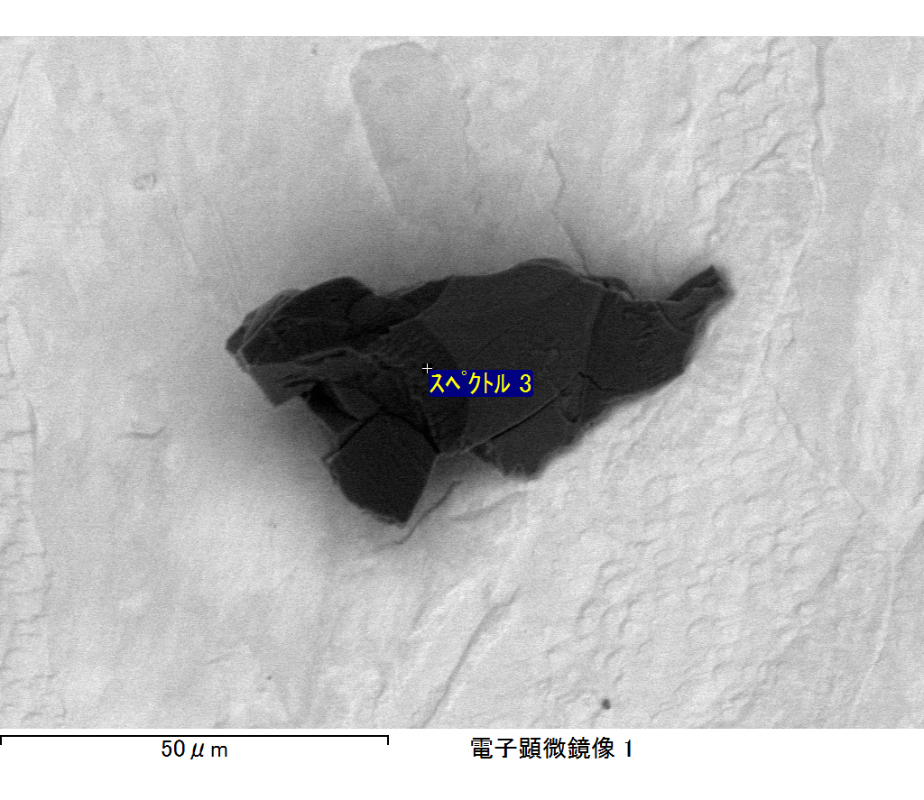

ｺﾒﾝﾄ :

2017/06/01 16:04:38

ﾌﾟﾛｼﾞｪｸﾄ 1

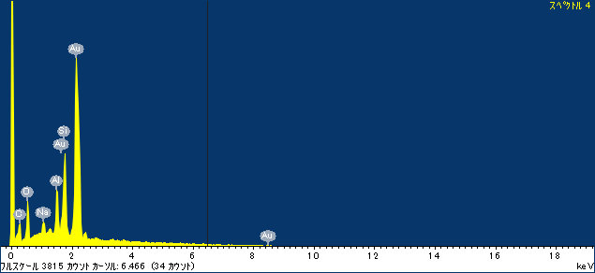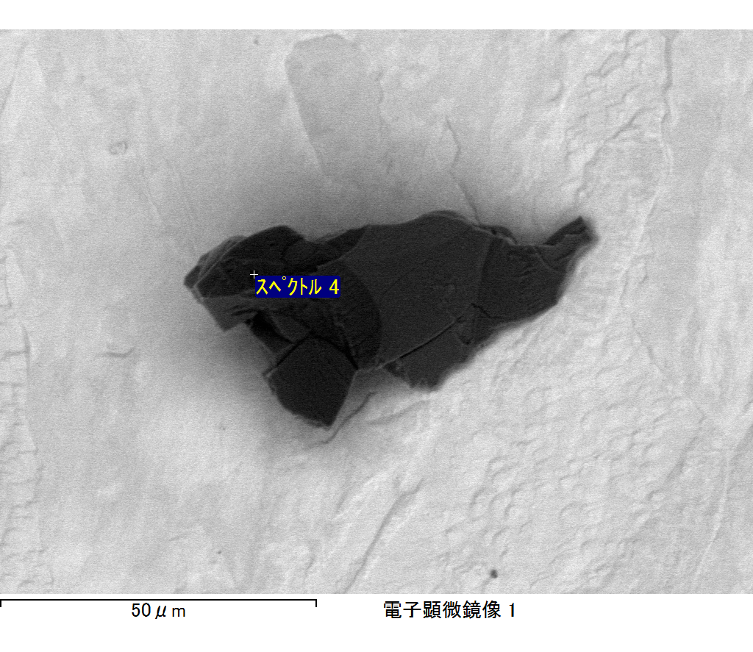

ｺﾒﾝﾄ :

2017/06/01 16:05:58

ﾌﾟﾛｼﾞｪｸﾄ 1

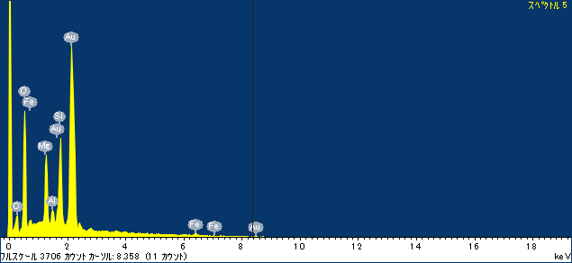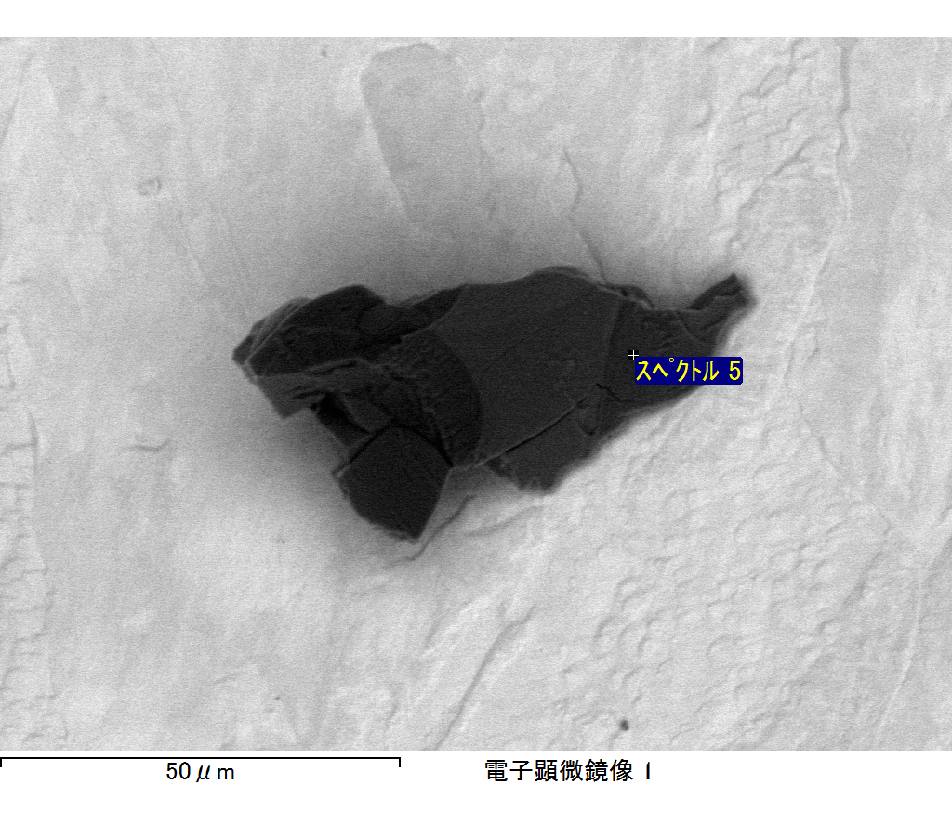

ｺﾒﾝﾄ :

2017/06/01 16:06:31

ﾌﾟﾛｼﾞｪｸﾄ 1

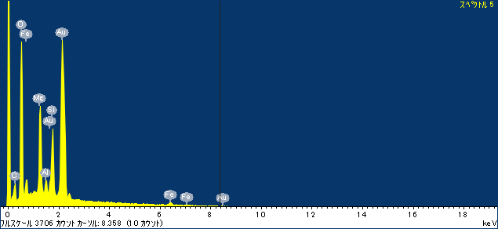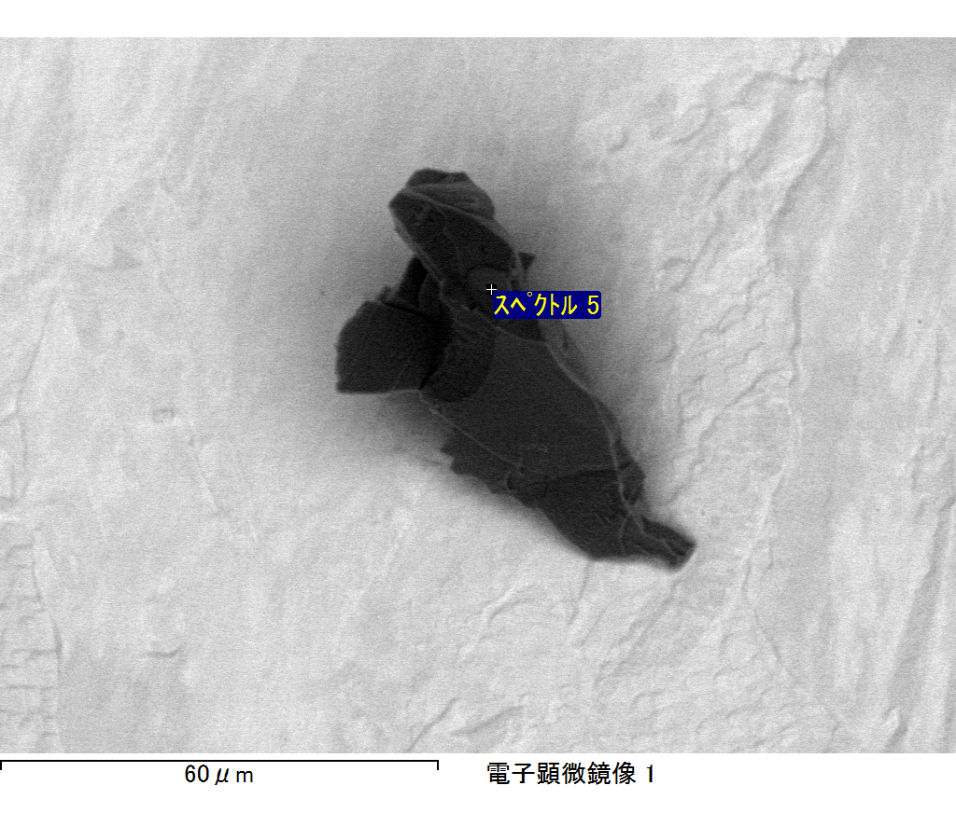

ｺﾒﾝﾄ :

2017/06/01 16:21:04

ﾌﾟﾛｼﾞｪｸﾄ 1

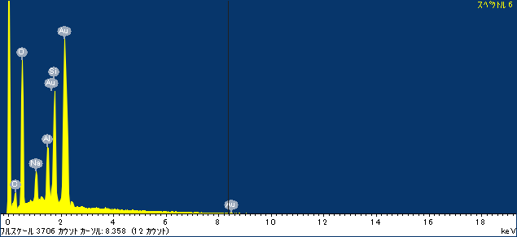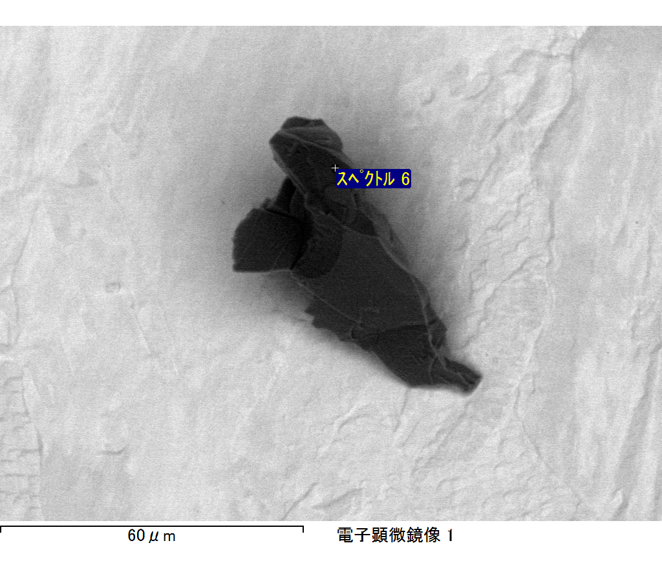

ｺﾒﾝﾄ :

2017/06/01 16:21:09

ﾌﾟﾛｼﾞｪｸﾄ 1