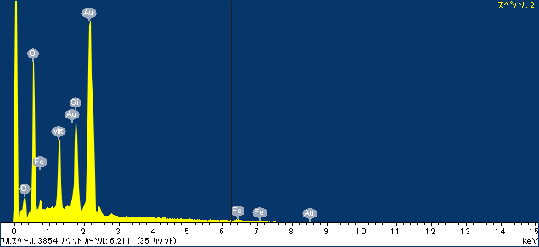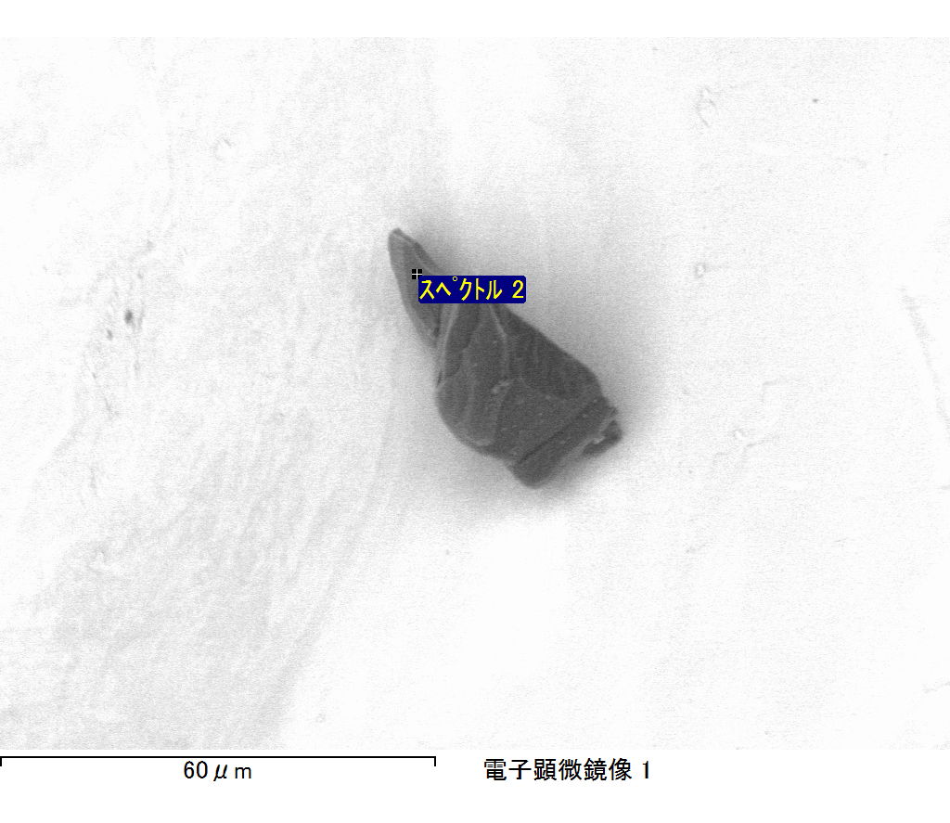

ｺﾒﾝﾄ :

2017/06/01 15:03:24

ﾌﾟﾛｼﾞｪｸﾄ 1

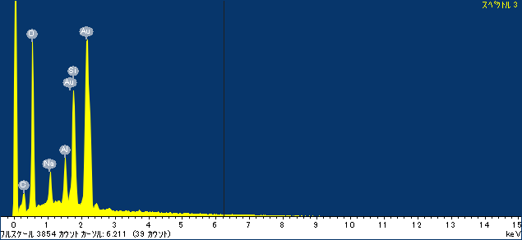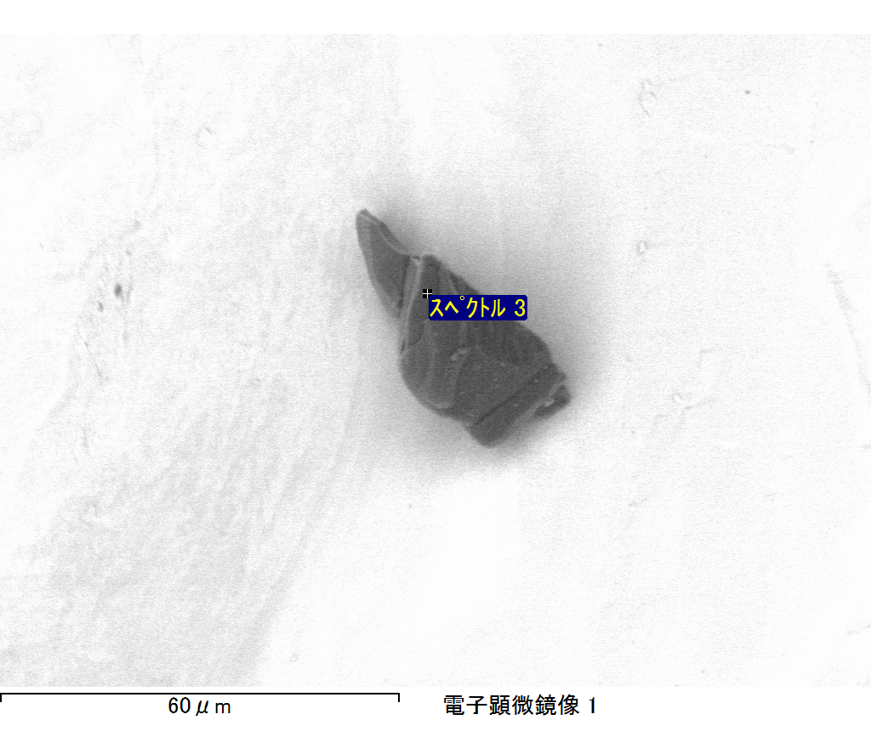

ｺﾒﾝﾄ :

2017/06/01 15:03:29

ﾌﾟﾛｼﾞｪｸﾄ 1

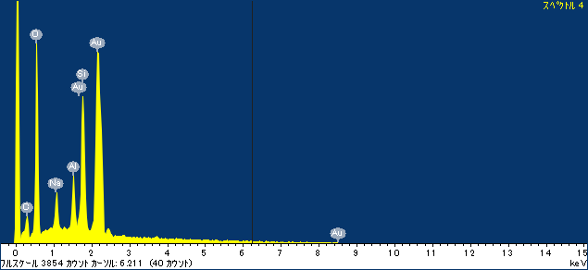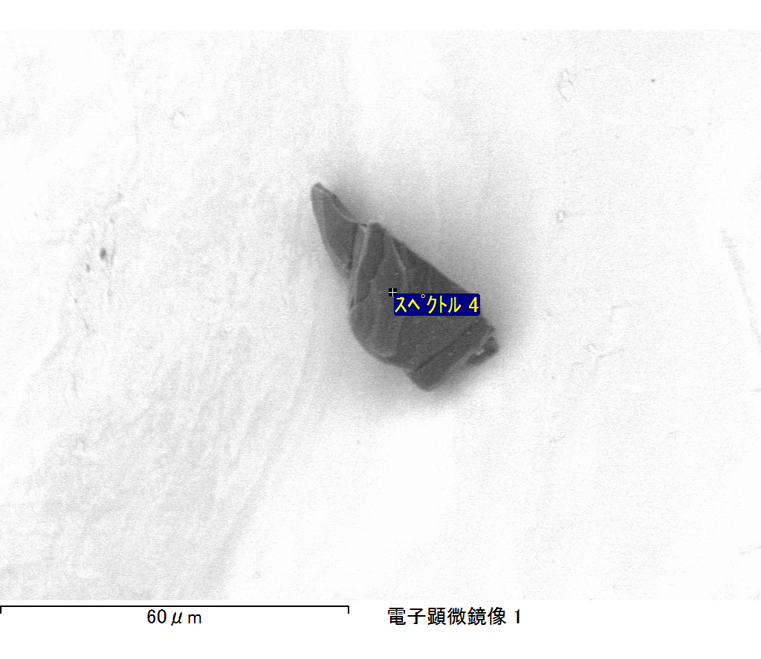

ｺﾒﾝﾄ :

2017/06/01 15:03:34

ﾌﾟﾛｼﾞｪｸﾄ 1

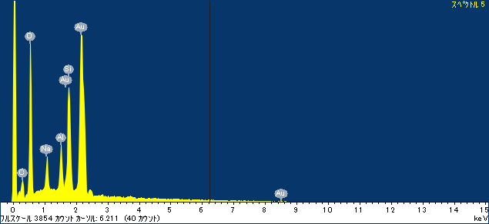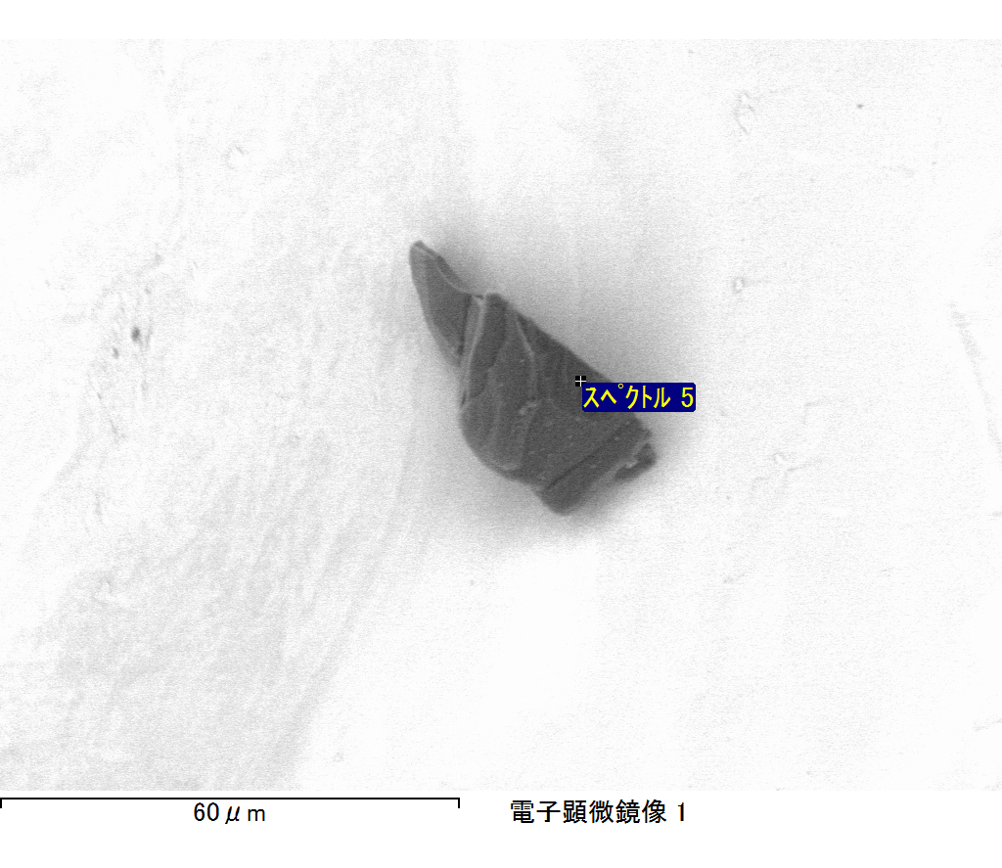

ｺﾒﾝﾄ :

2017/06/01 15:03:41

ﾌﾟﾛｼﾞｪｸﾄ 1

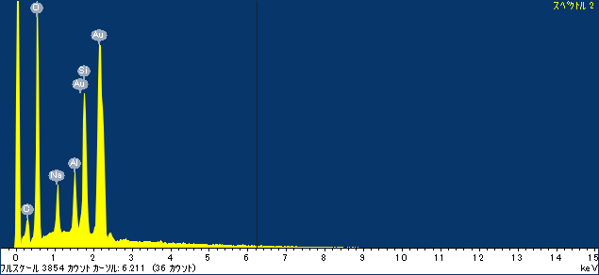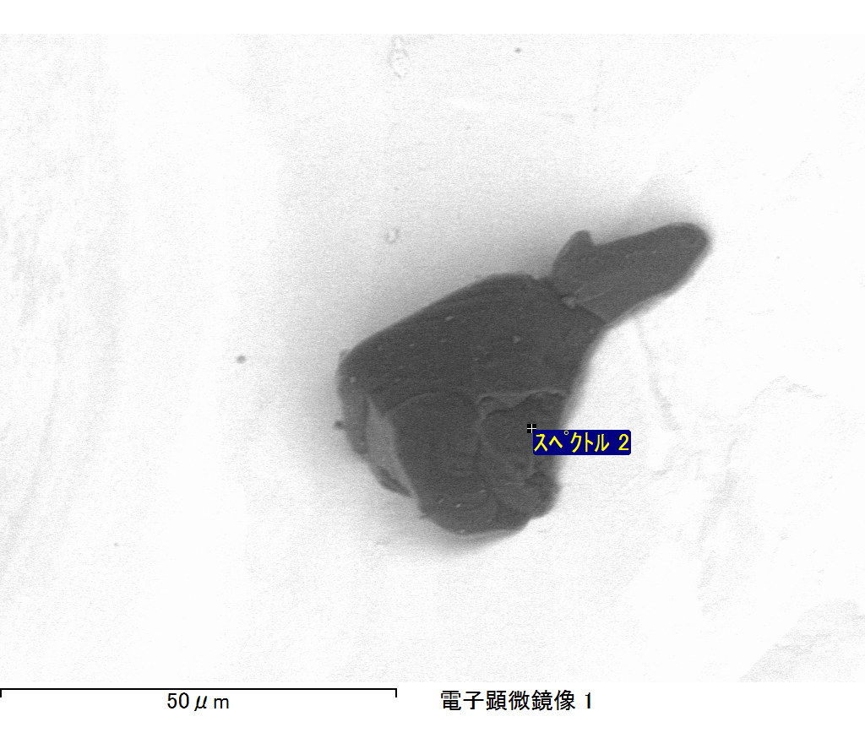

ｺﾒﾝﾄ :

2017/06/01 15:04:02

ﾌﾟﾛｼﾞｪｸﾄ 1

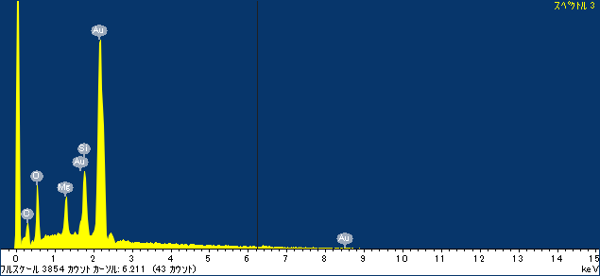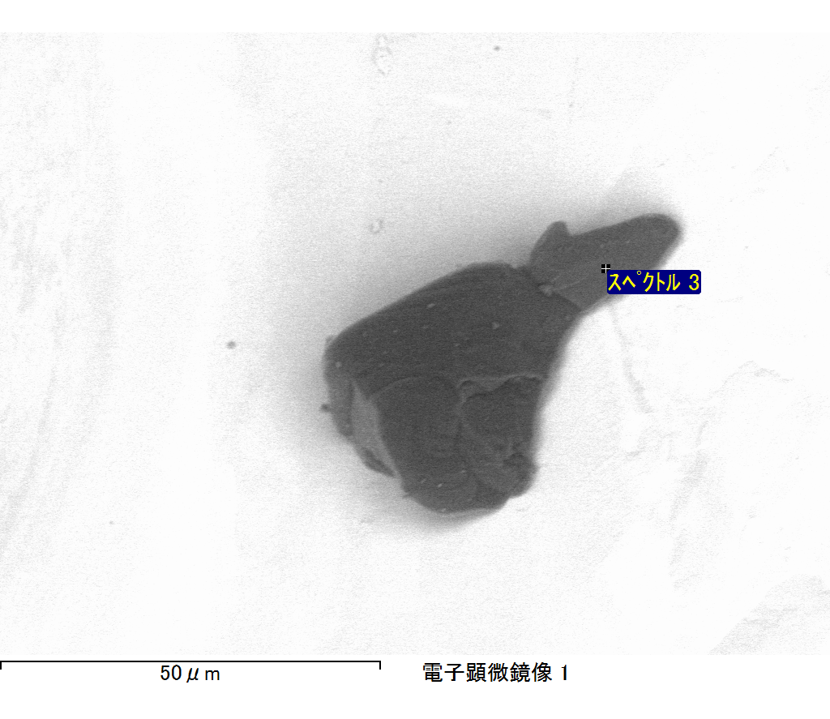

ｺﾒﾝﾄ :

2017/06/01 15:04:08

ﾌﾟﾛｼﾞｪｸﾄ 1