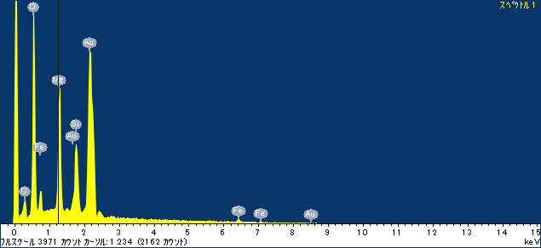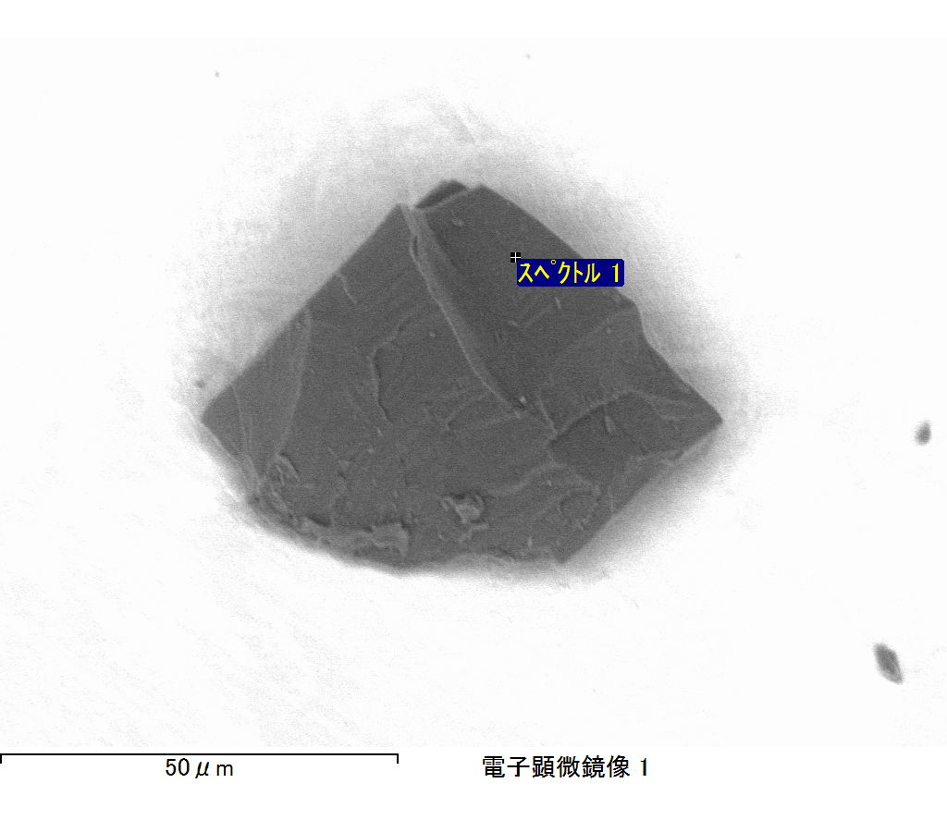

ｺﾒﾝﾄ :

2017/06/01 15:14:53

ﾌﾟﾛｼﾞｪｸﾄ 1

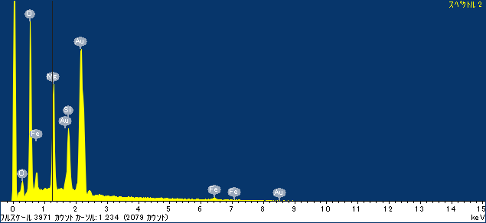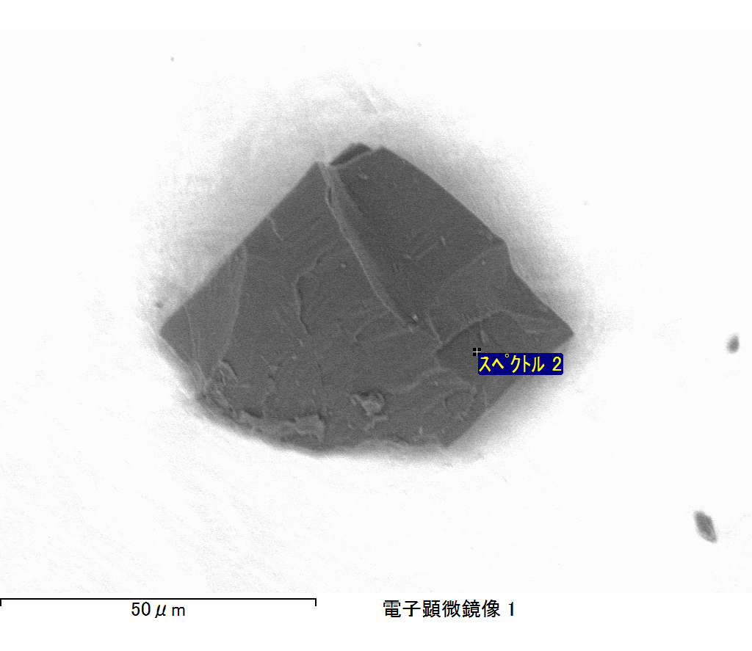

ｺﾒﾝﾄ :

2017/06/01 15:15:01

ﾌﾟﾛｼﾞｪｸﾄ 1

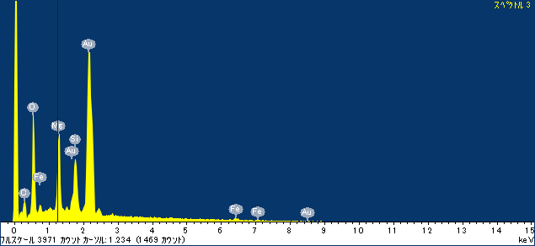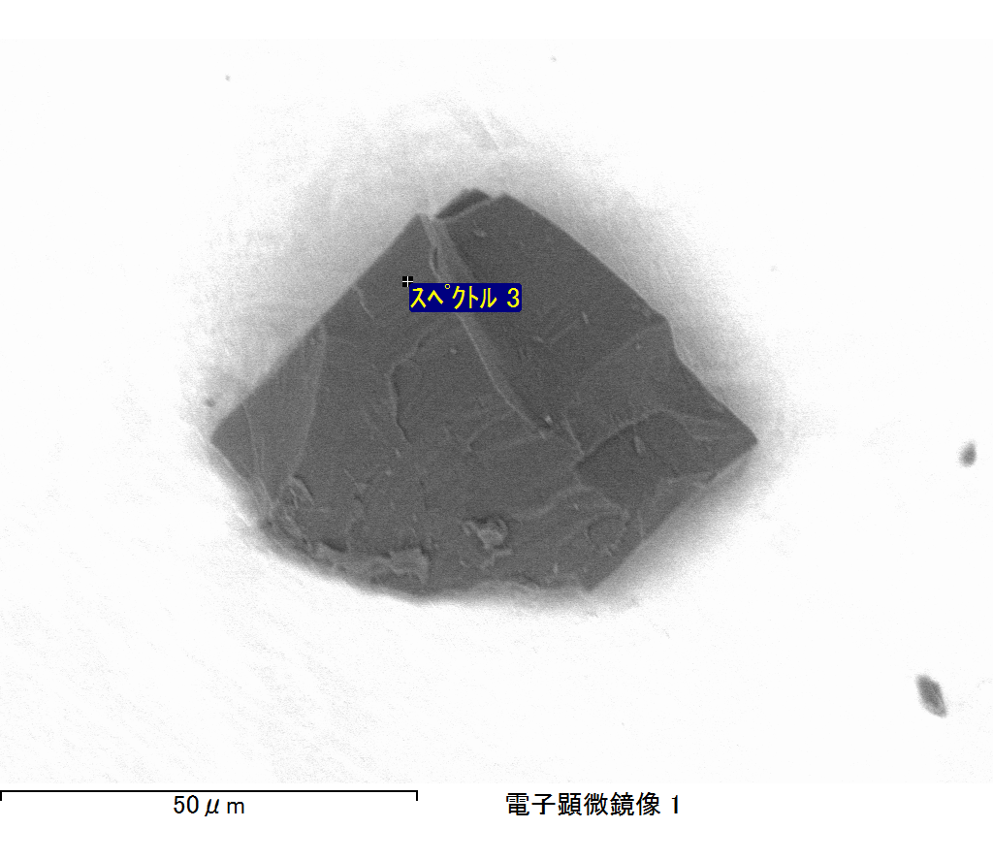

ｺﾒﾝﾄ :

2017/06/01 15:15:07

ﾌﾟﾛｼﾞｪｸﾄ 1

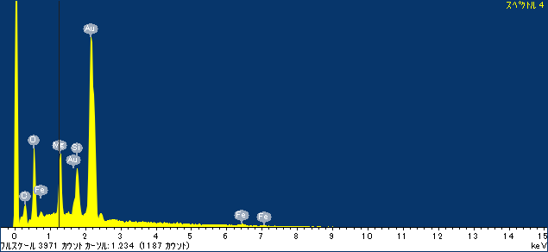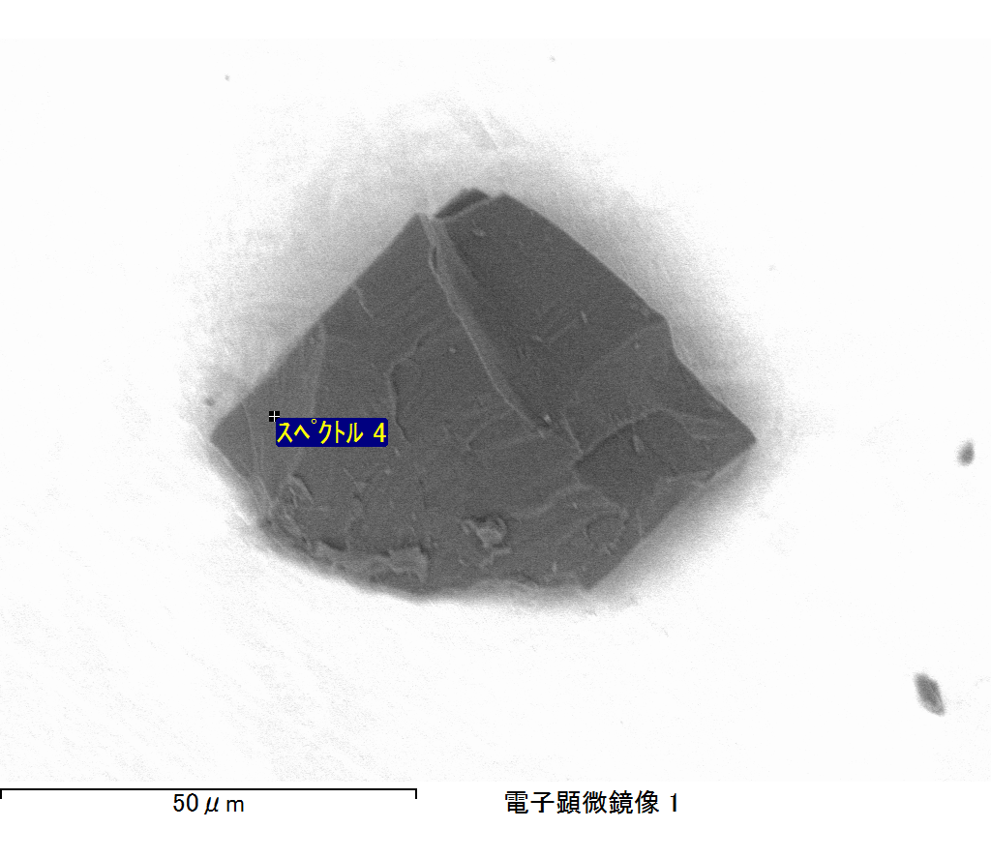

ｺﾒﾝﾄ :

2017/06/01 15:15:16

ﾌﾟﾛｼﾞｪｸﾄ 1

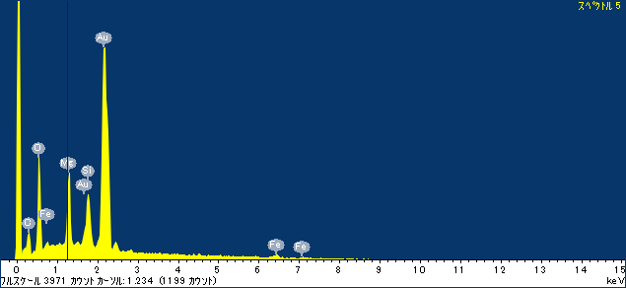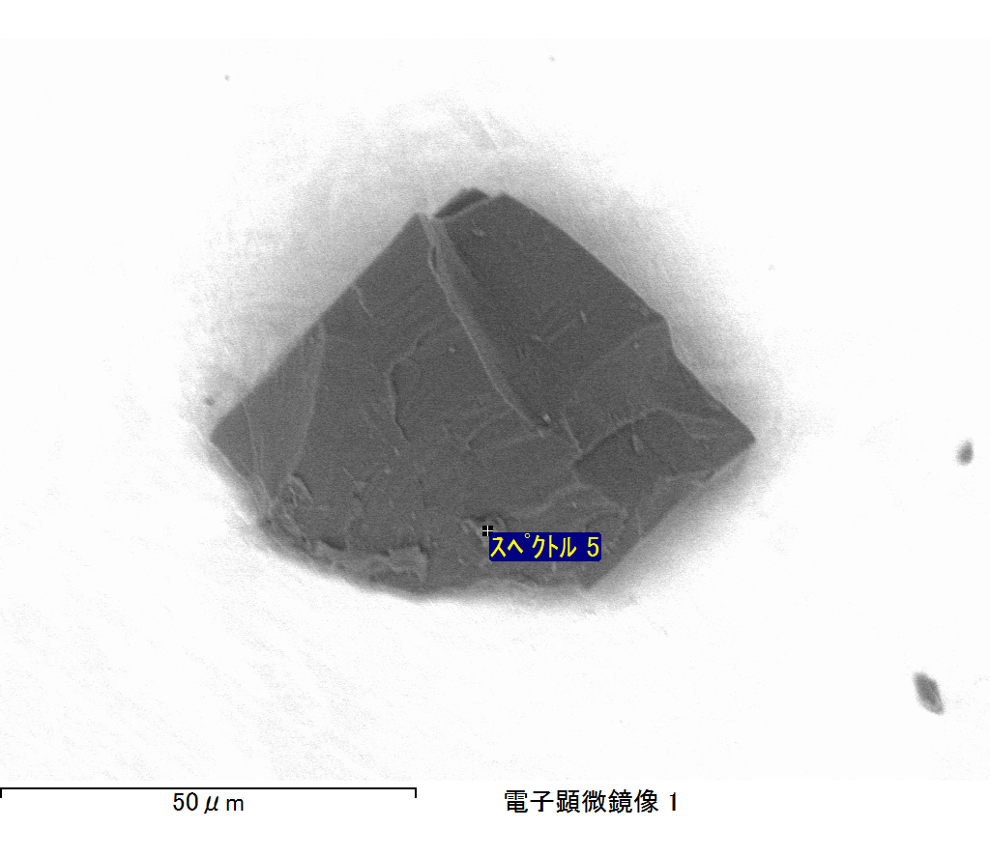

ｺﾒﾝﾄ :

2017/06/01 15:15:21

ﾌﾟﾛｼﾞｪｸﾄ 1

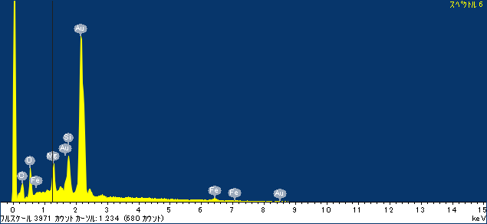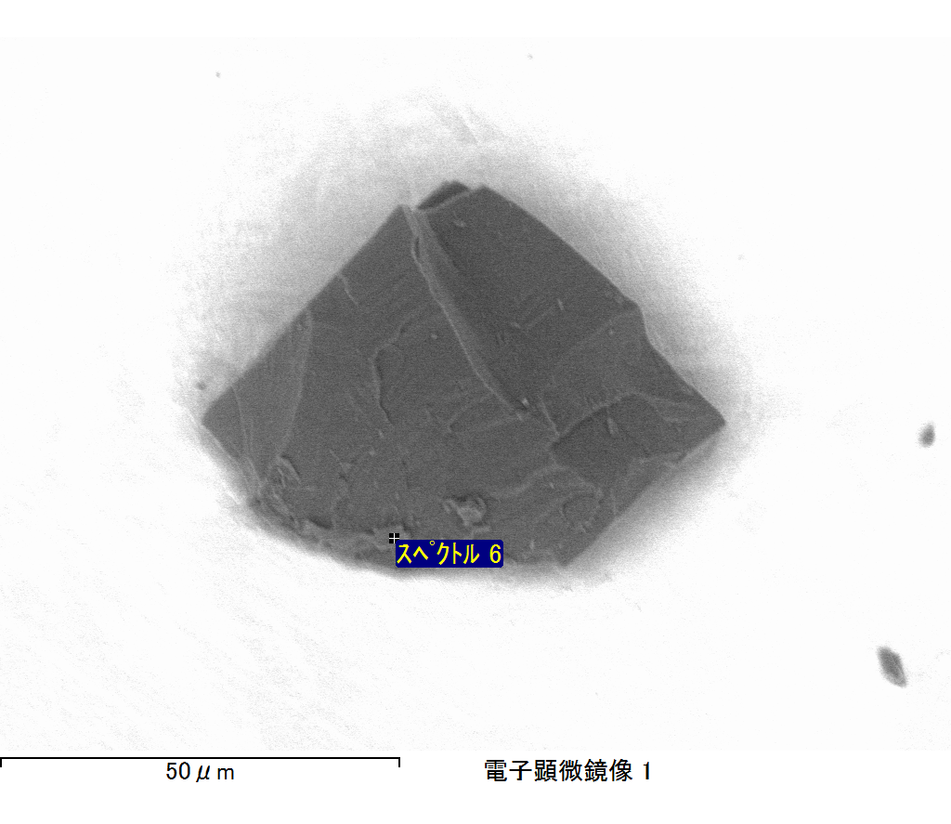

ｺﾒﾝﾄ :

2017/06/01 15:15:27

ﾌﾟﾛｼﾞｪｸﾄ 1