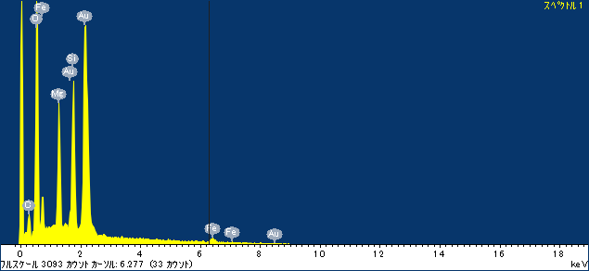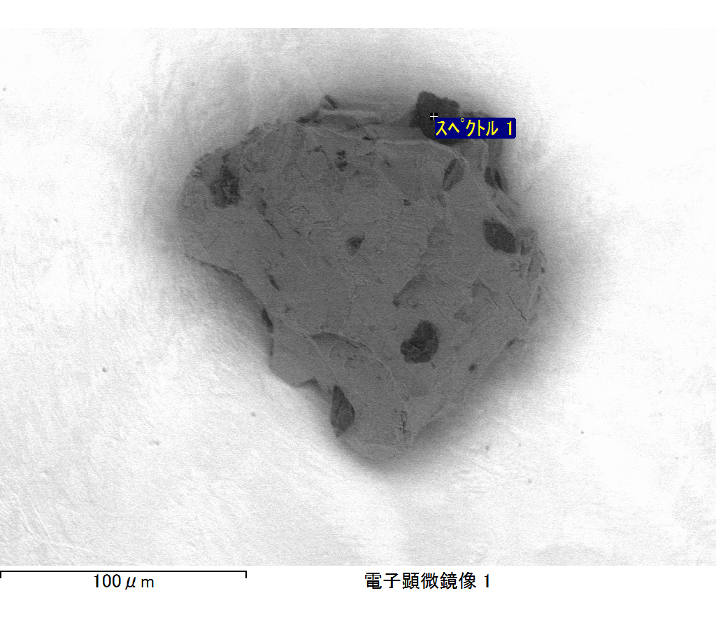

ｺﾒﾝﾄ :

2017/06/14 16:52:51

ﾌﾟﾛｼﾞｪｸﾄ 1

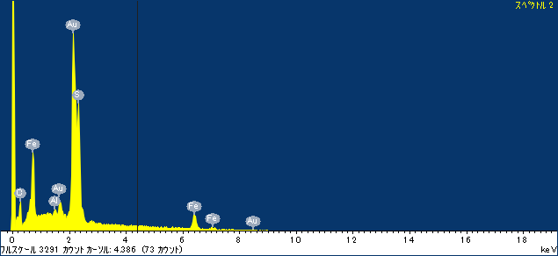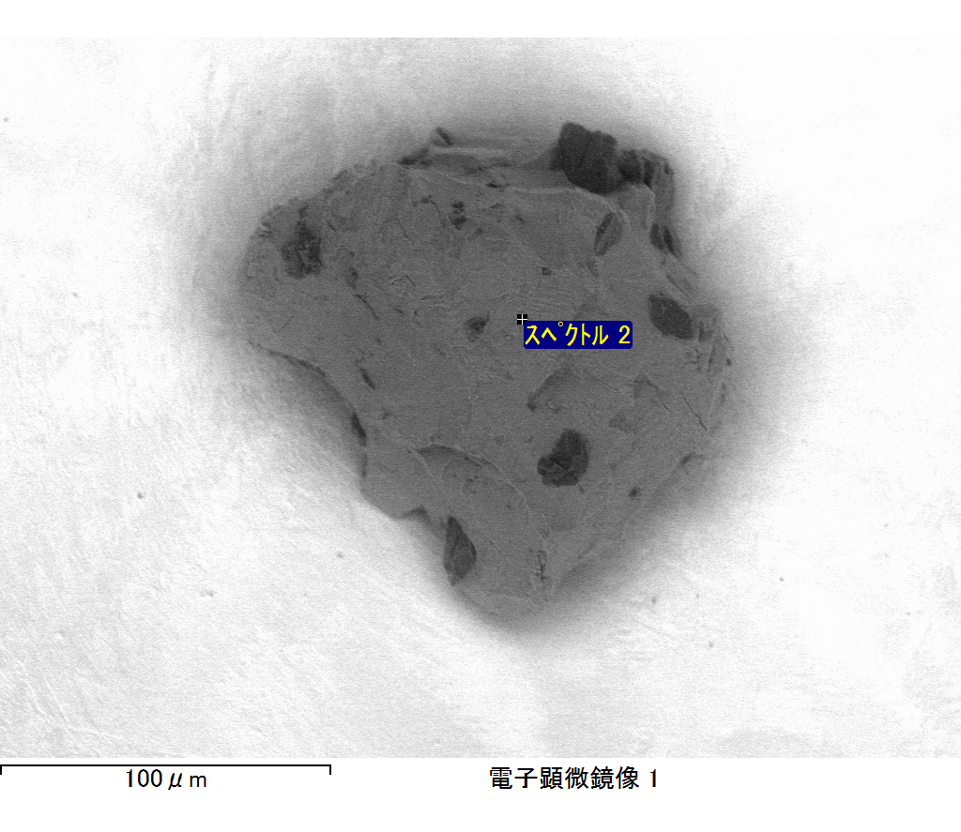

ｺﾒﾝﾄ :

2017/06/14 16:53:01

ﾌﾟﾛｼﾞｪｸﾄ 1

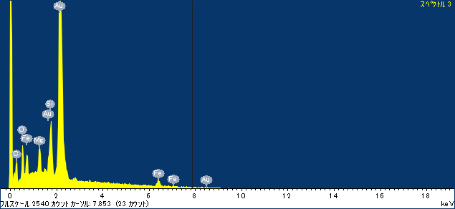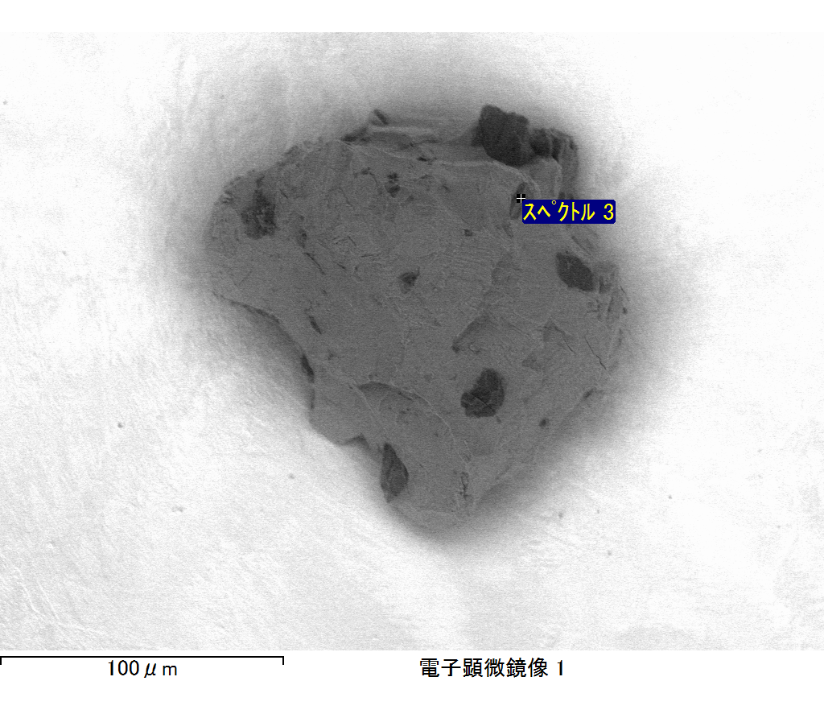

ｺﾒﾝﾄ :

2017/06/14 16:53:22

ﾌﾟﾛｼﾞｪｸﾄ 1

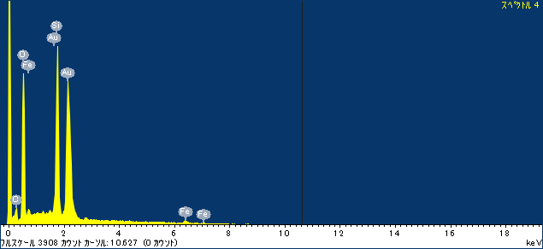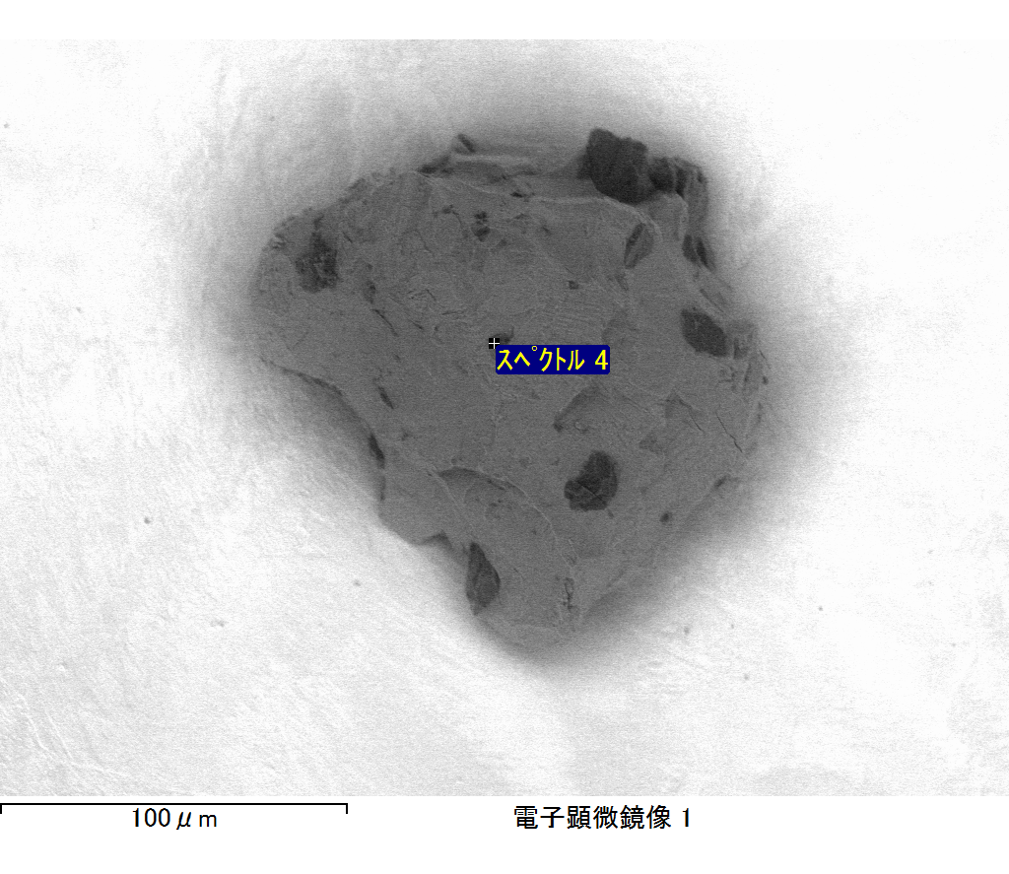

ｺﾒﾝﾄ :

2017/06/14 16:53:31

ﾌﾟﾛｼﾞｪｸﾄ 1

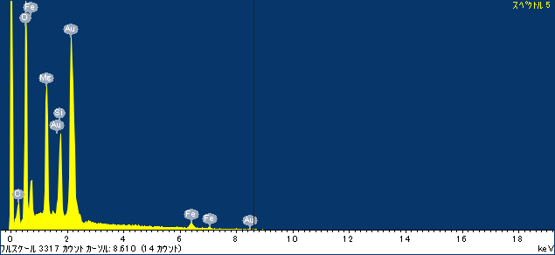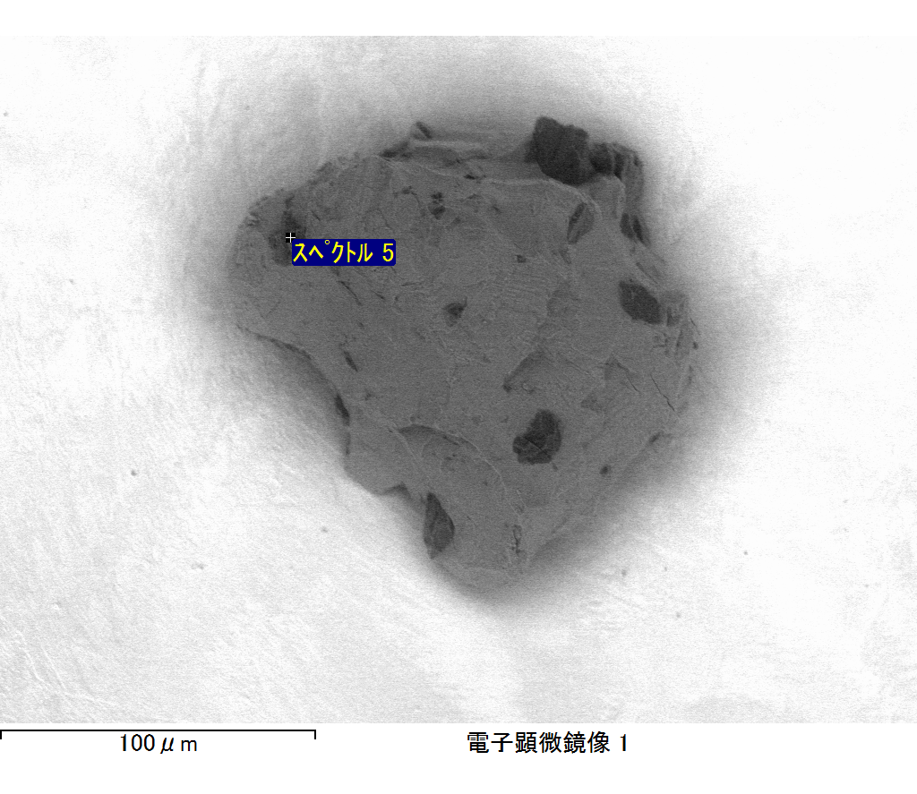

ｺﾒﾝﾄ :

2017/06/14 16:53:42

ﾌﾟﾛｼﾞｪｸﾄ 1

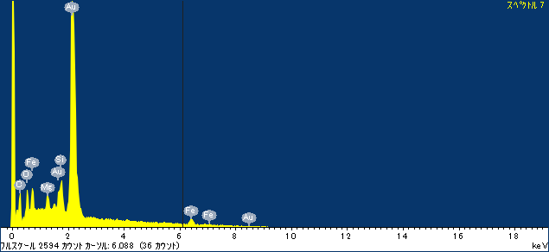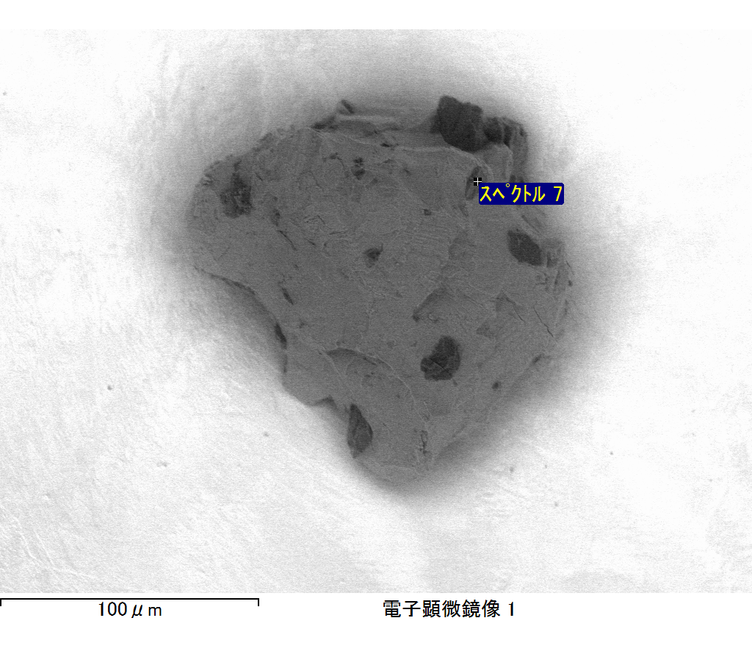

ｺﾒﾝﾄ :

2017/06/14 16:53:54

ﾌﾟﾛｼﾞｪｸﾄ 1

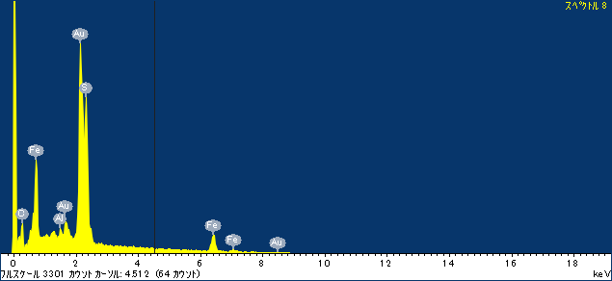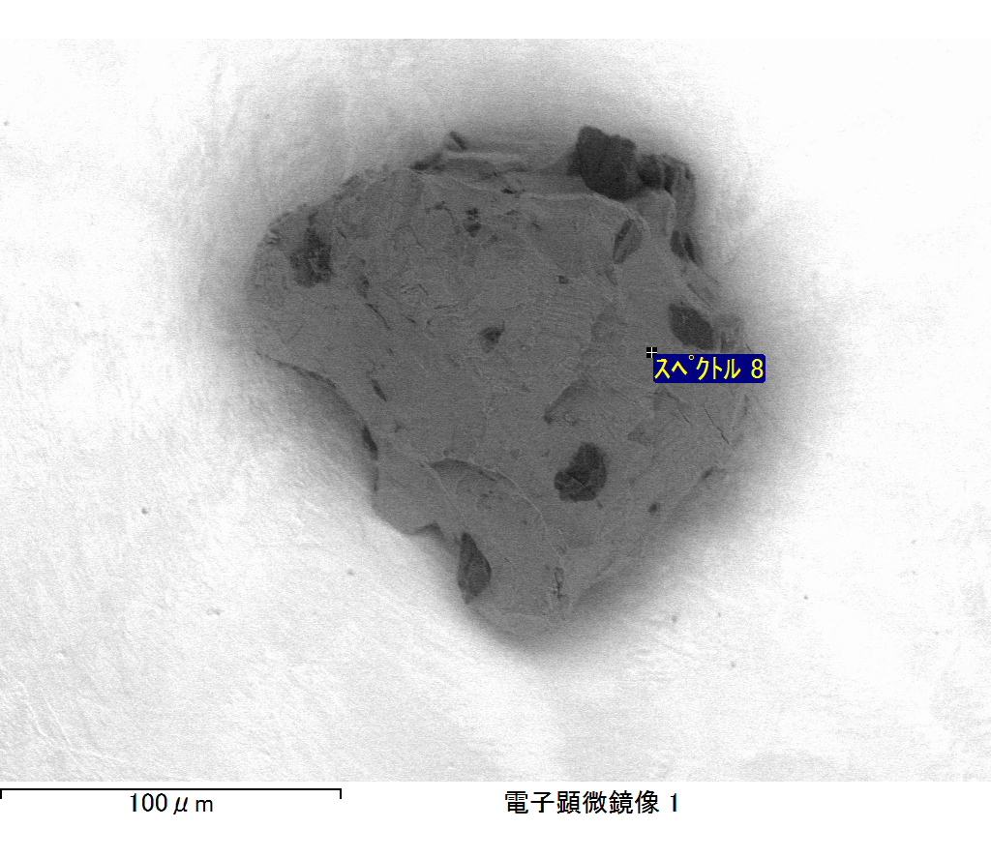

ｺﾒﾝﾄ :

2017/06/14 16:54:04

ﾌﾟﾛｼﾞｪｸﾄ 1

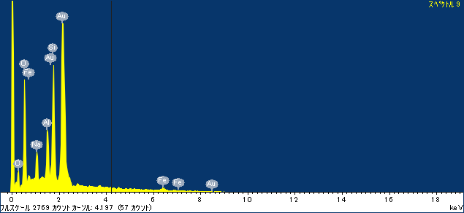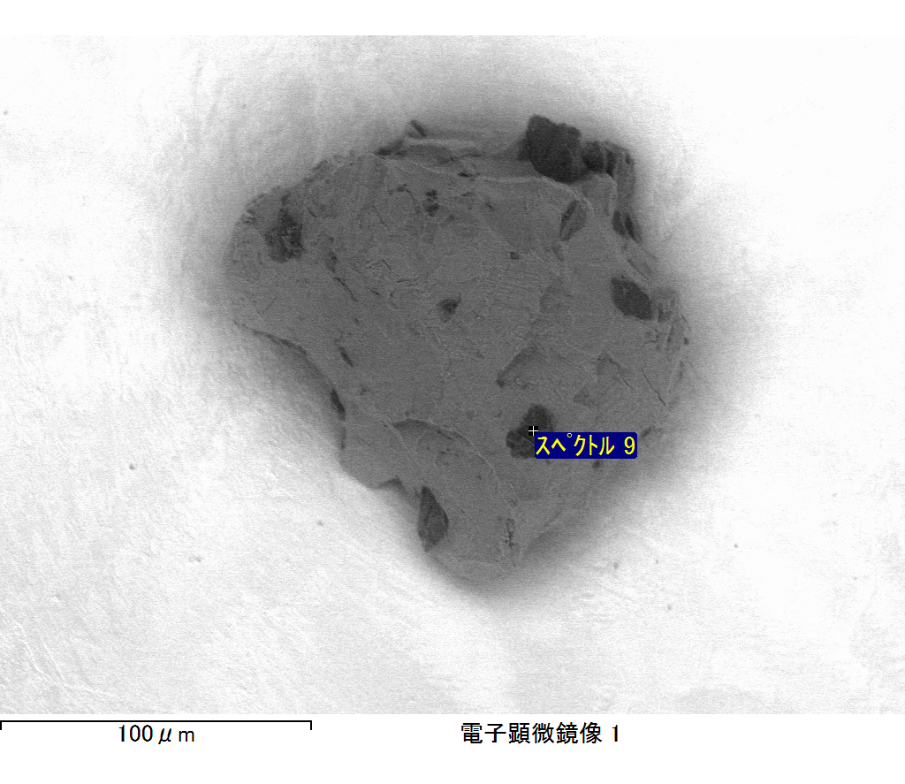

ｺﾒﾝﾄ :

2017/06/14 16:54:13

ﾌﾟﾛｼﾞｪｸﾄ 1