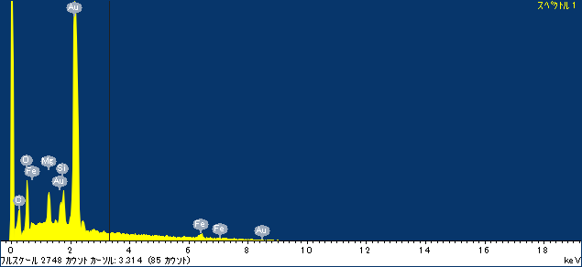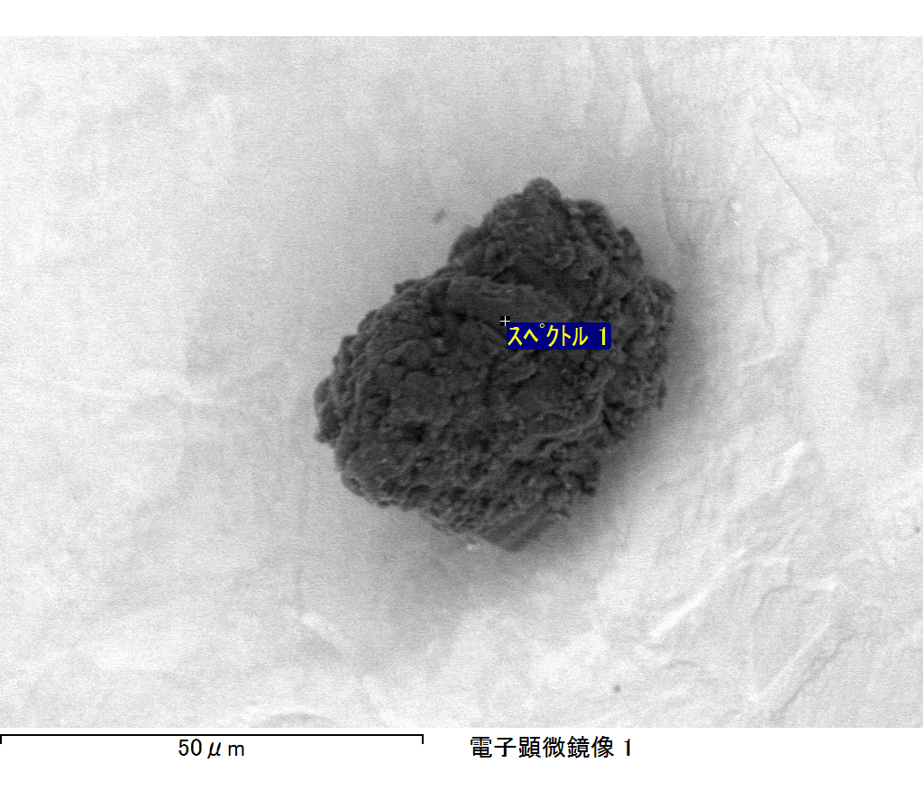

ｺﾒﾝﾄ :

2017/06/14 16:35:08

ﾌﾟﾛｼﾞｪｸﾄ 1

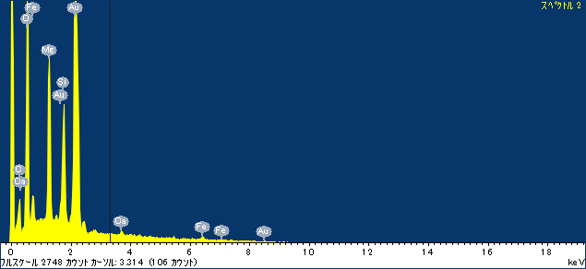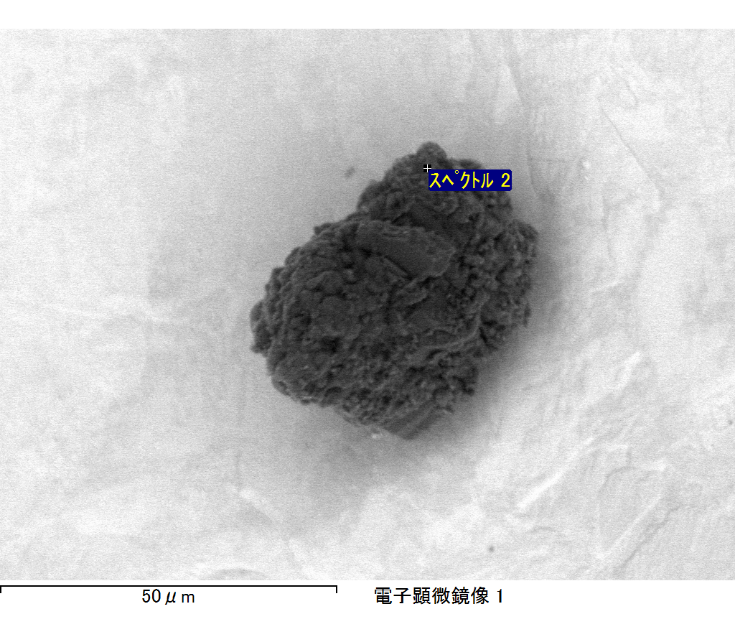

ｺﾒﾝﾄ :

2017/06/14 16:35:13

ﾌﾟﾛｼﾞｪｸﾄ 1

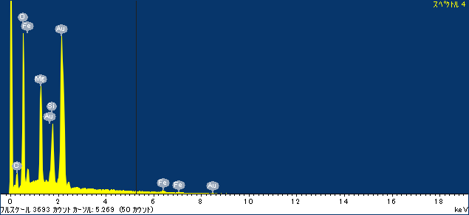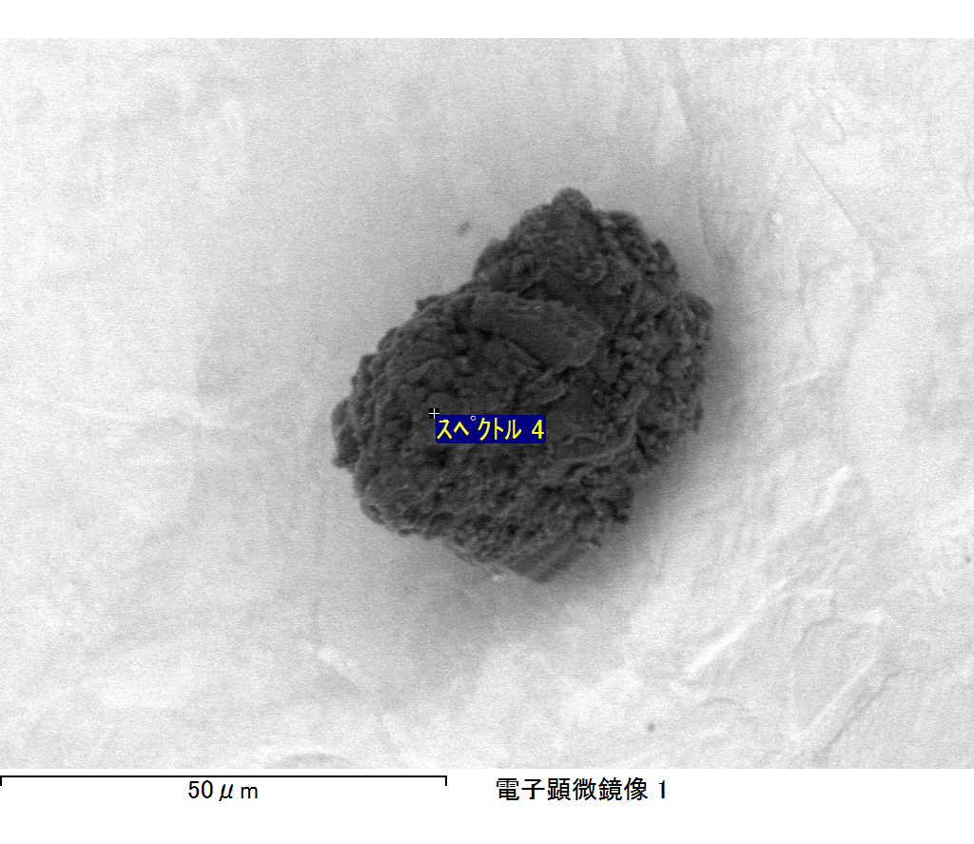

ｺﾒﾝﾄ :

2017/06/14 16:35:27

ﾌﾟﾛｼﾞｪｸﾄ 1

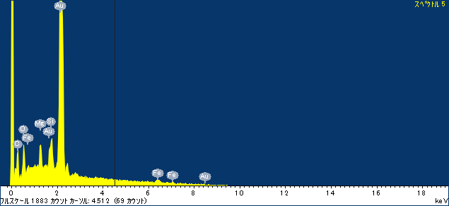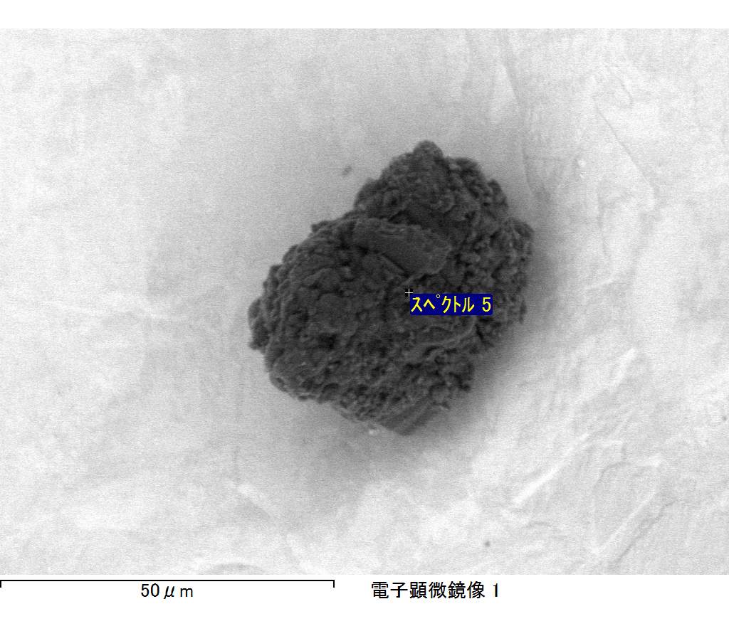

ｺﾒﾝﾄ :

2017/06/14 16:35:37

ﾌﾟﾛｼﾞｪｸﾄ 1

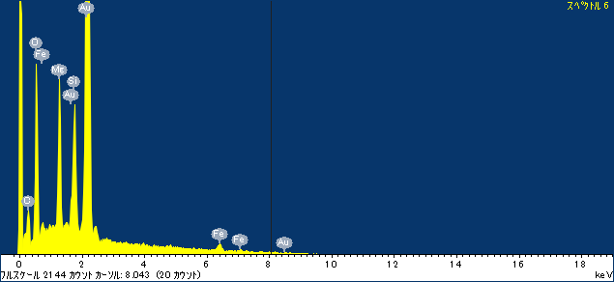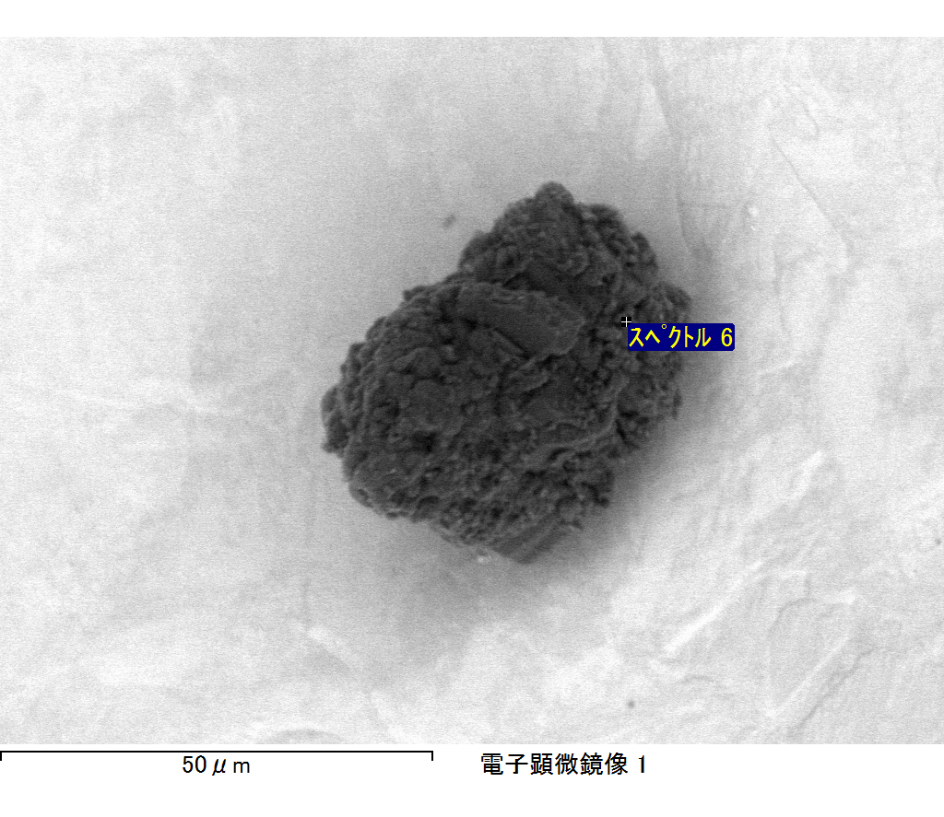

ｺﾒﾝﾄ :

2017/06/14 16:35:47

ﾌﾟﾛｼﾞｪｸﾄ 1