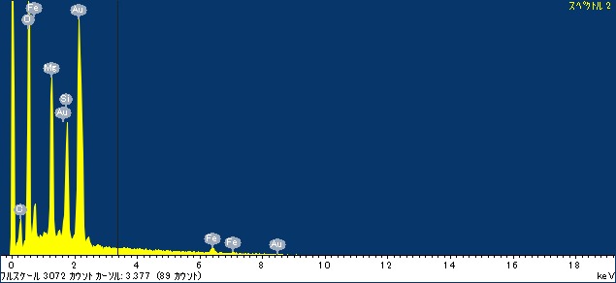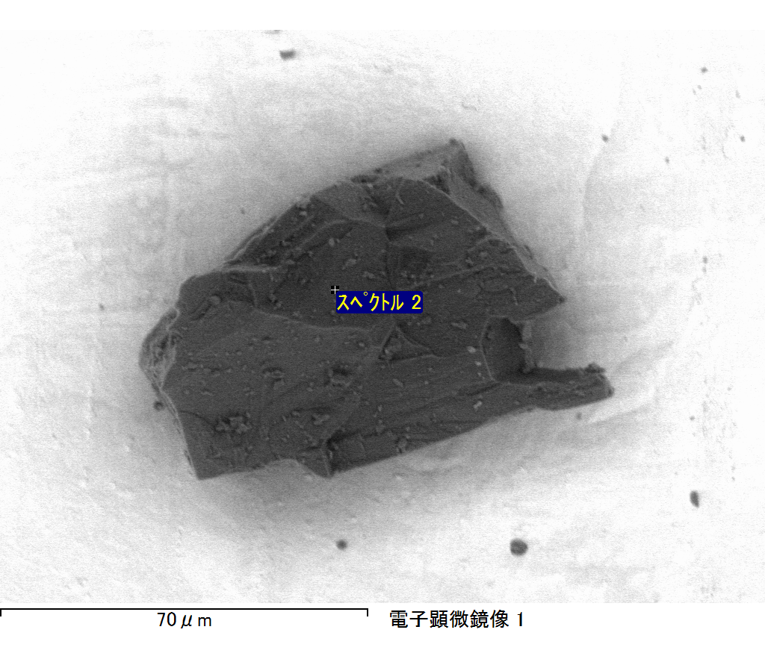

ｺﾒﾝﾄ :

2017/06/14 16:26:47

ﾌﾟﾛｼﾞｪｸﾄ 1

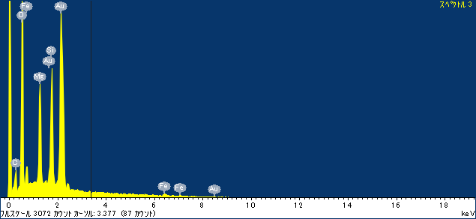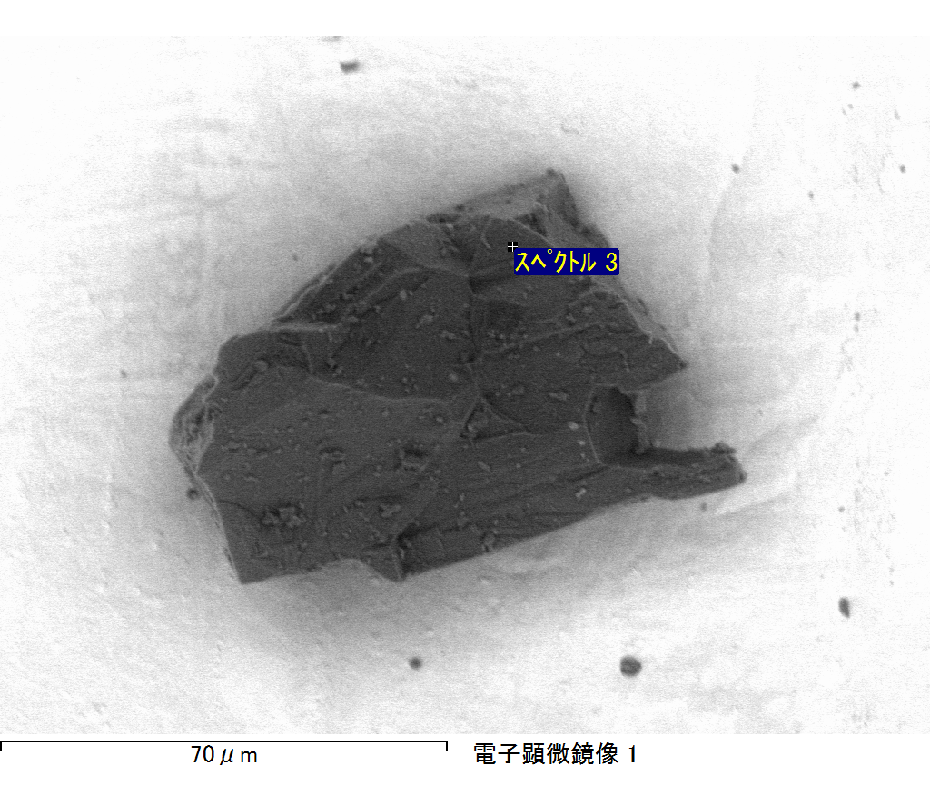

ｺﾒﾝﾄ :

2017/06/14 16:26:54

ﾌﾟﾛｼﾞｪｸﾄ 1

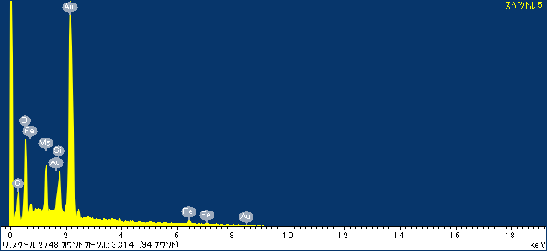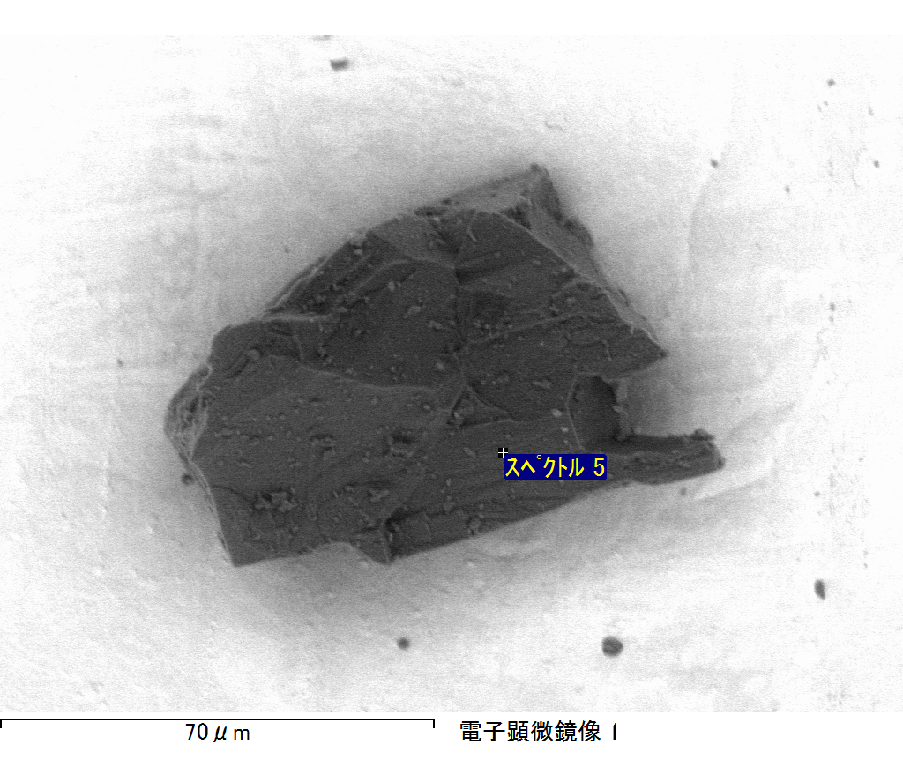

ｺﾒﾝﾄ :

2017/06/14 16:27:11

ﾌﾟﾛｼﾞｪｸﾄ 1

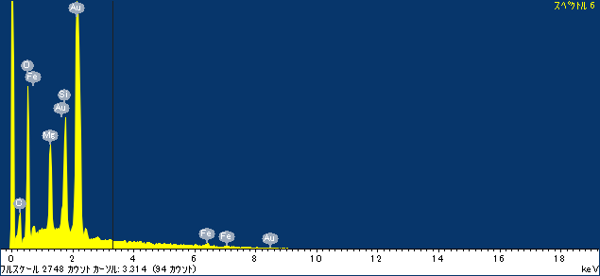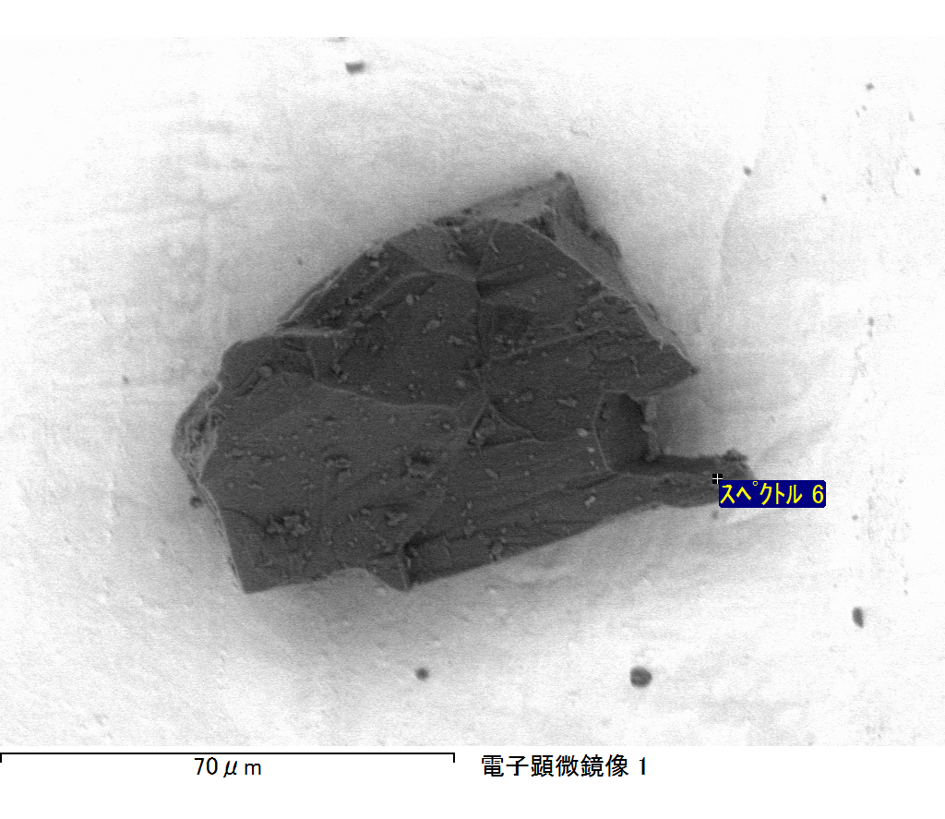

ｺﾒﾝﾄ :

2017/06/14 16:27:19

ﾌﾟﾛｼﾞｪｸﾄ 1

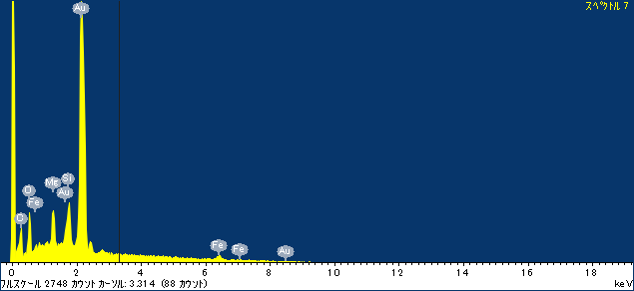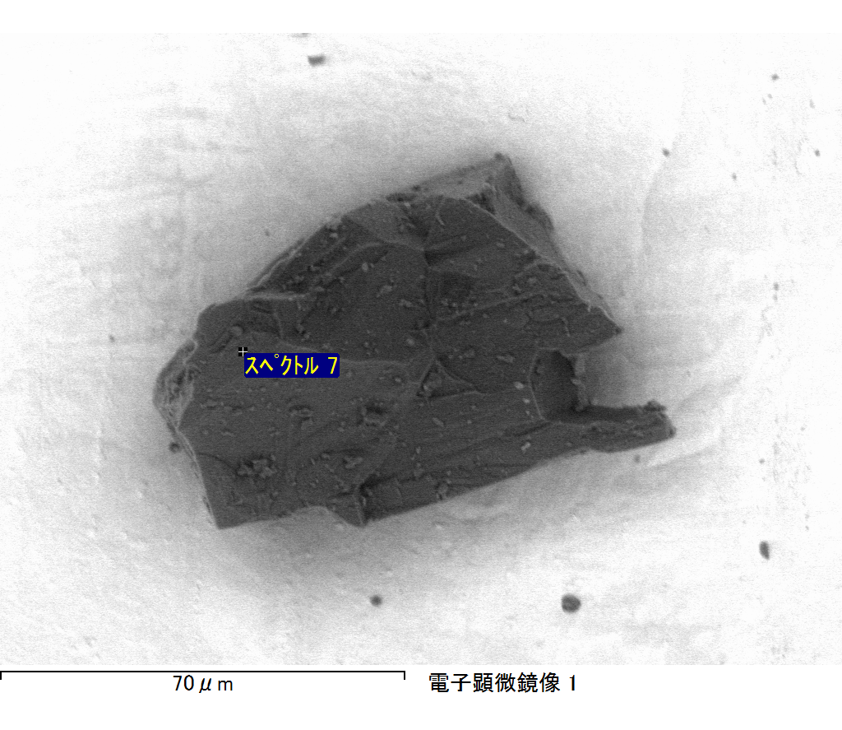

ｺﾒﾝﾄ :

2017/06/14 16:27:28

ﾌﾟﾛｼﾞｪｸﾄ 1

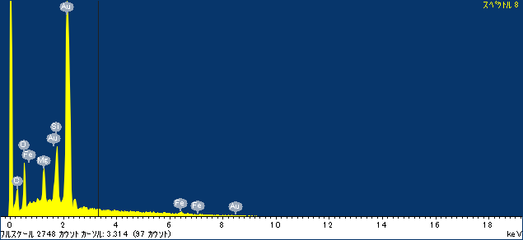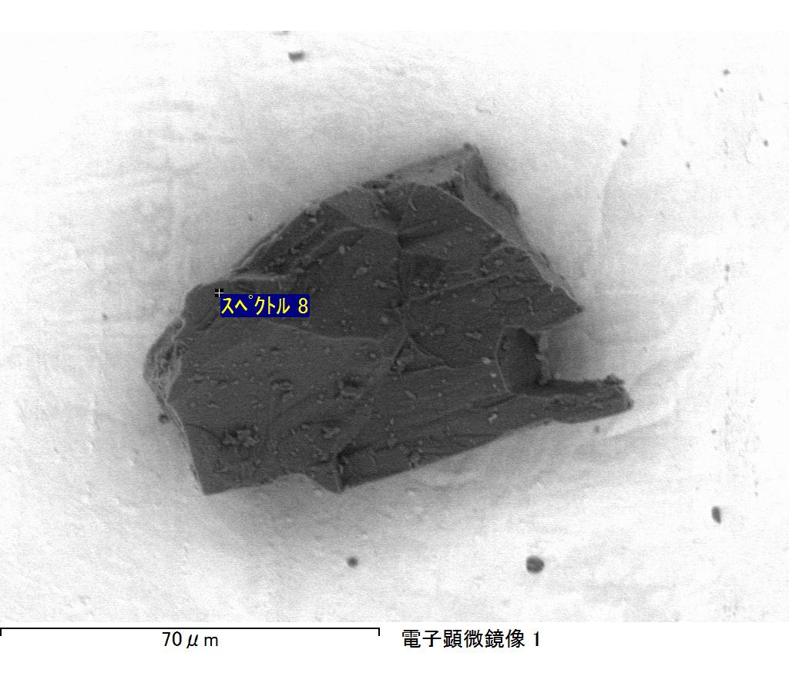

ｺﾒﾝﾄ :

2017/06/14 16:27:34

ﾌﾟﾛｼﾞｪｸﾄ 1