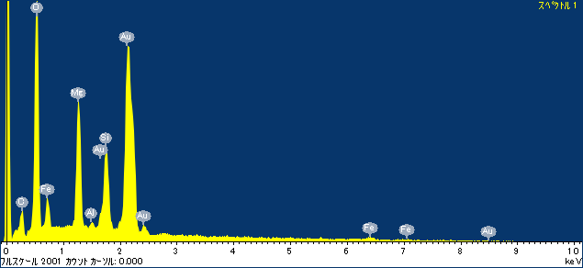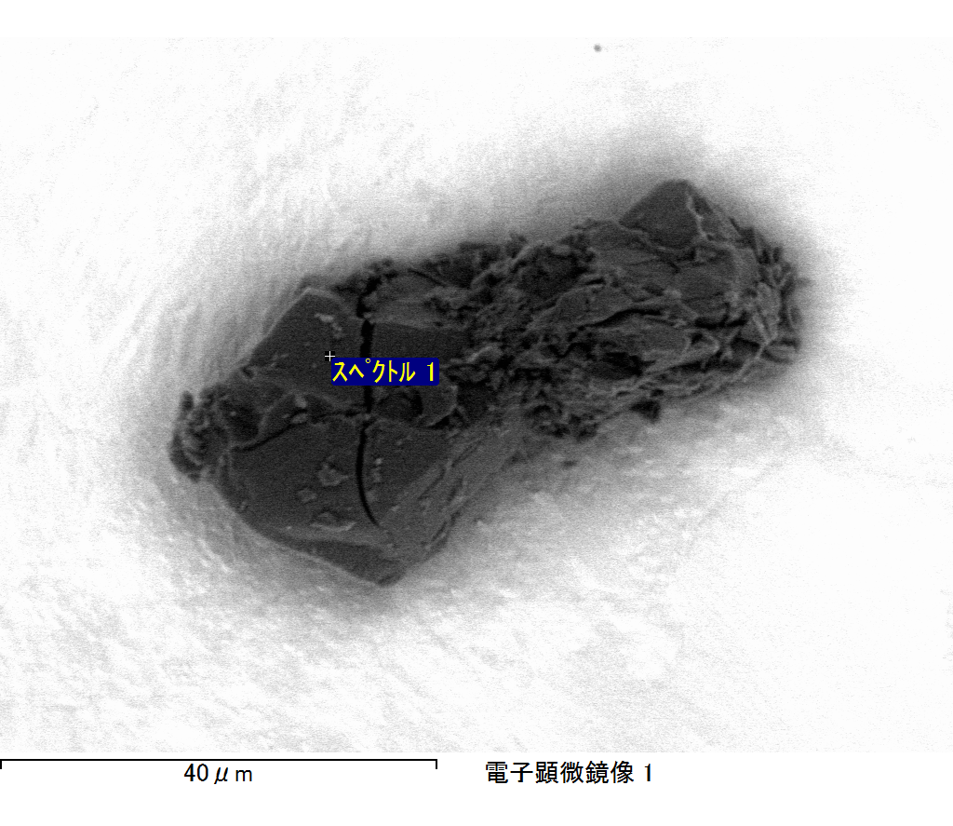

ｺﾒﾝﾄ :

2017/12/14 11:20:57

ﾌﾟﾛｼﾞｪｸﾄ 1

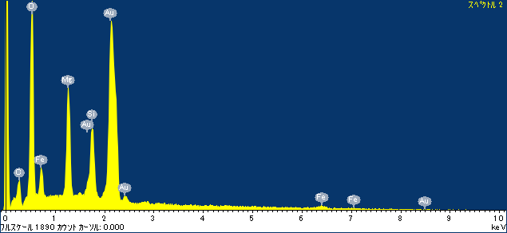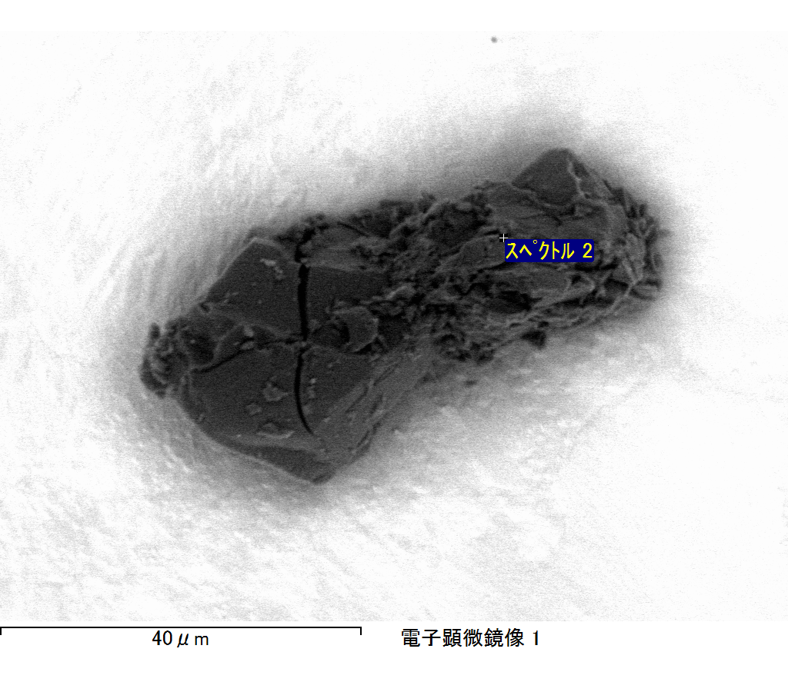

ｺﾒﾝﾄ :

2017/12/14 11:21:01

ﾌﾟﾛｼﾞｪｸﾄ 1

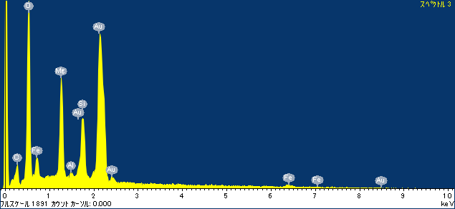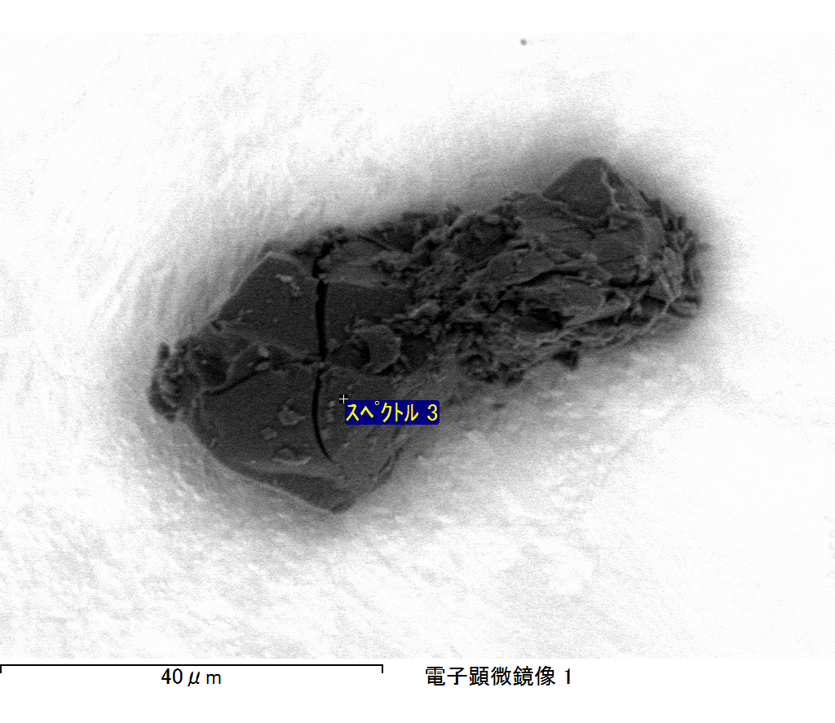

ｺﾒﾝﾄ :

2017/12/14 11:21:05

ﾌﾟﾛｼﾞｪｸﾄ 1

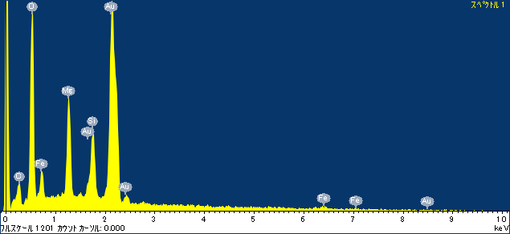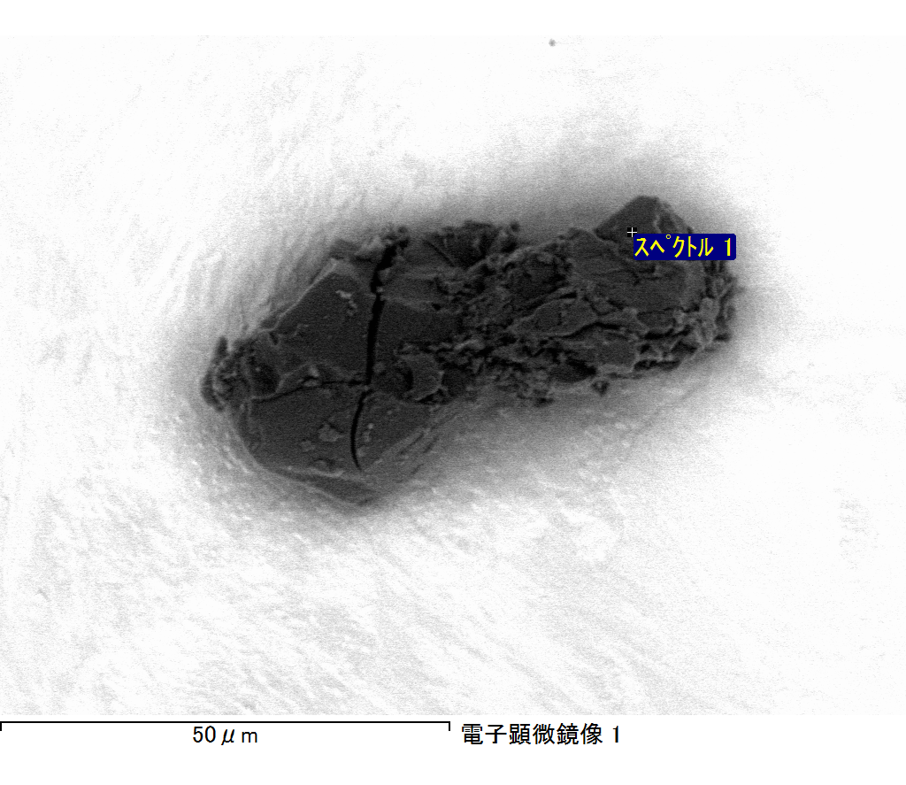

ｺﾒﾝﾄ :

2017/12/14 11:22:22

ﾌﾟﾛｼﾞｪｸﾄ 1

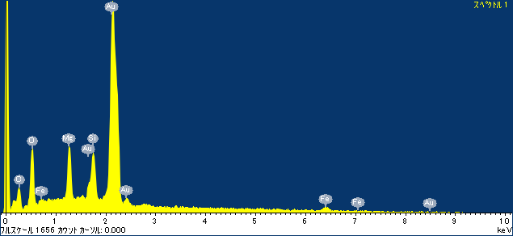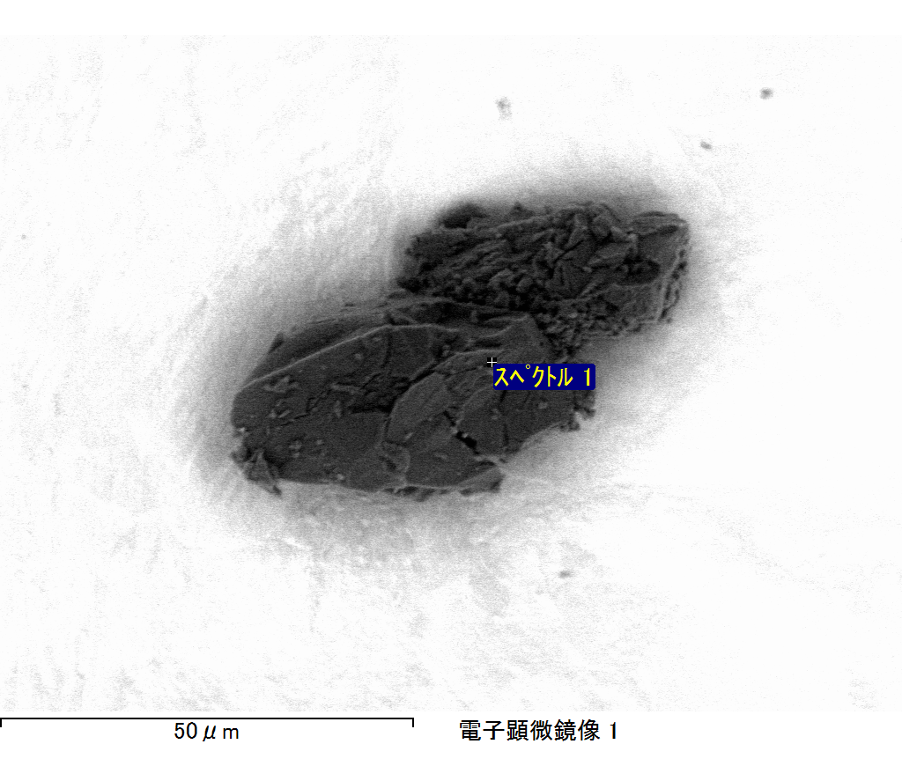

ｺﾒﾝﾄ :

2017/12/14 11:25:34

ﾌﾟﾛｼﾞｪｸﾄ 1

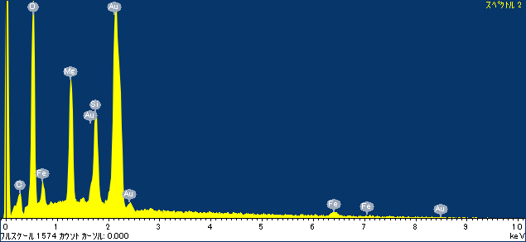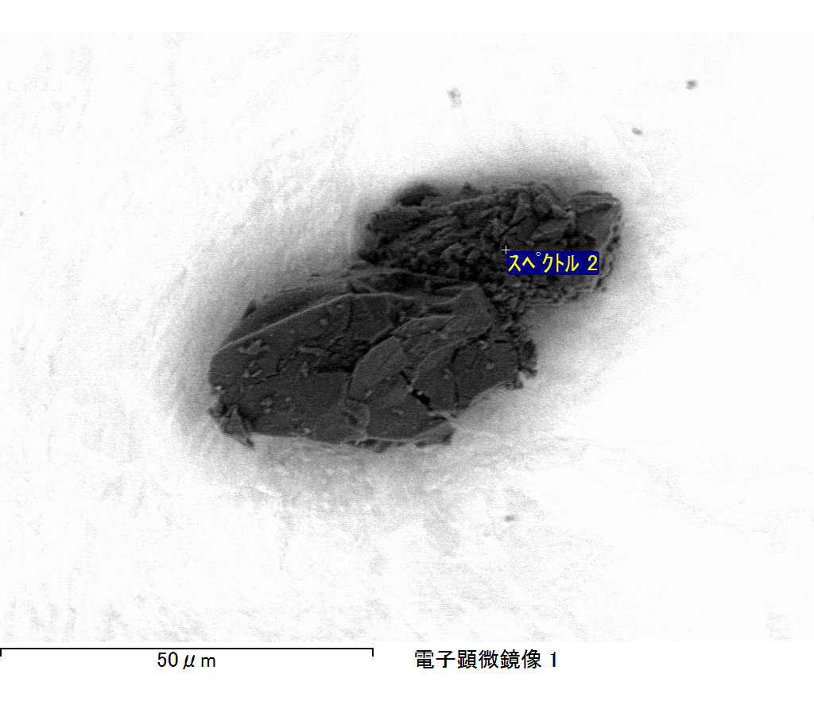

ｺﾒﾝﾄ :

2017/12/14 11:25:37

ﾌﾟﾛｼﾞｪｸﾄ 1