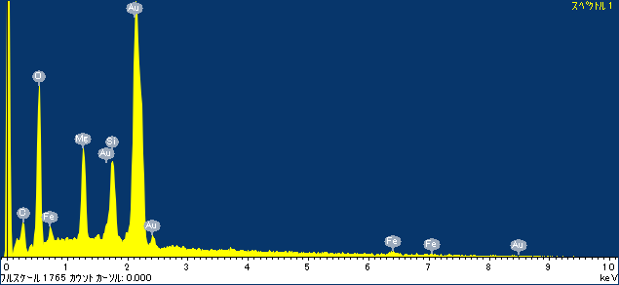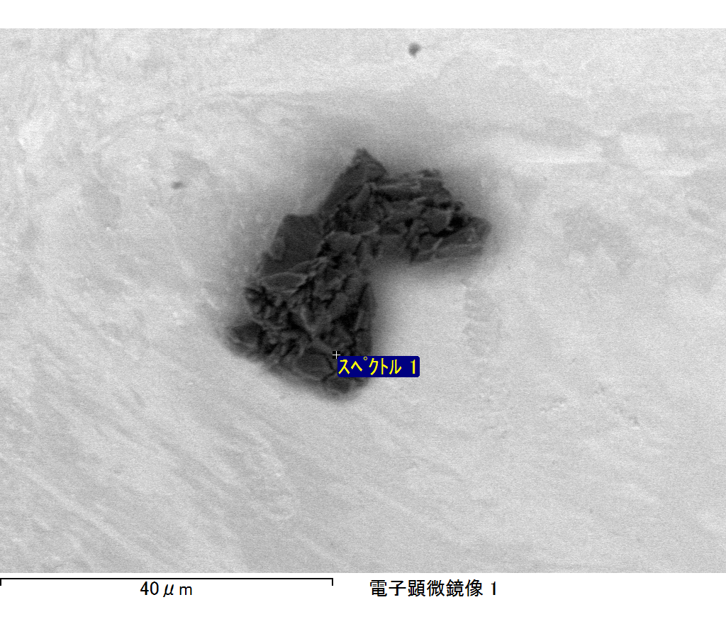

ｺﾒﾝﾄ :

2017/12/27 11:57:20

ﾌﾟﾛｼﾞｪｸﾄ 1

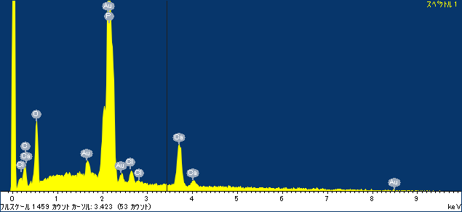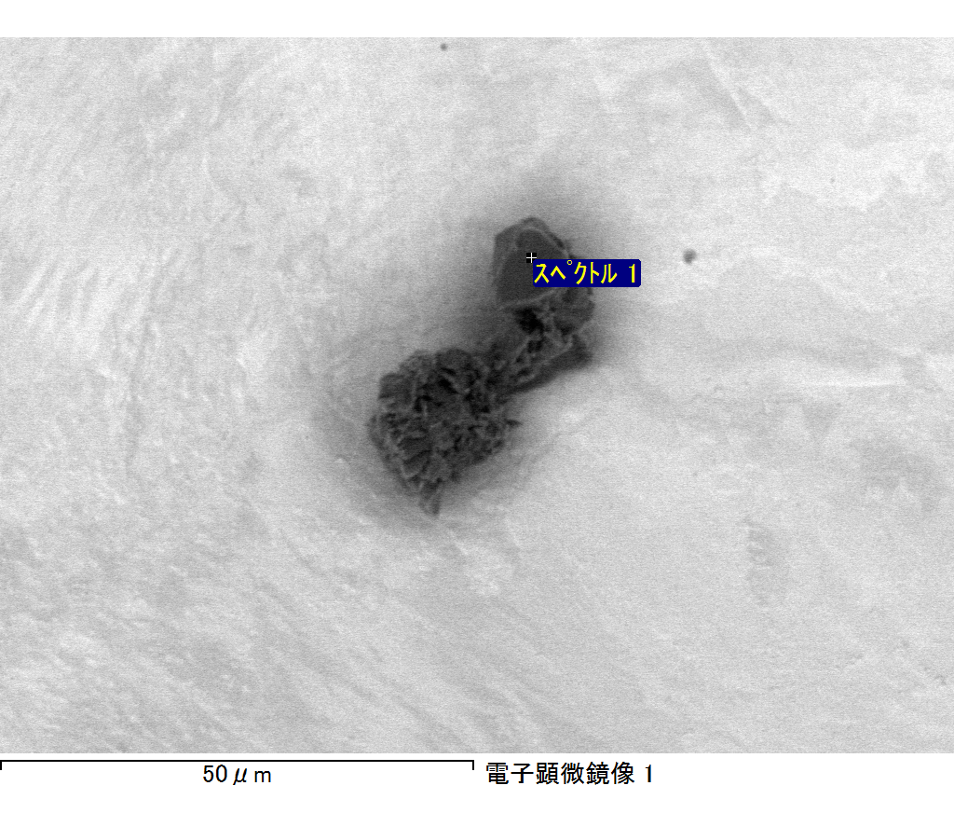

ｺﾒﾝﾄ :

2017/12/27 12:01:13

ﾌﾟﾛｼﾞｪｸﾄ 1

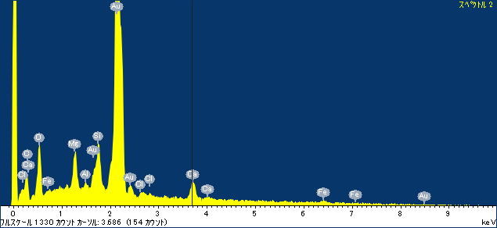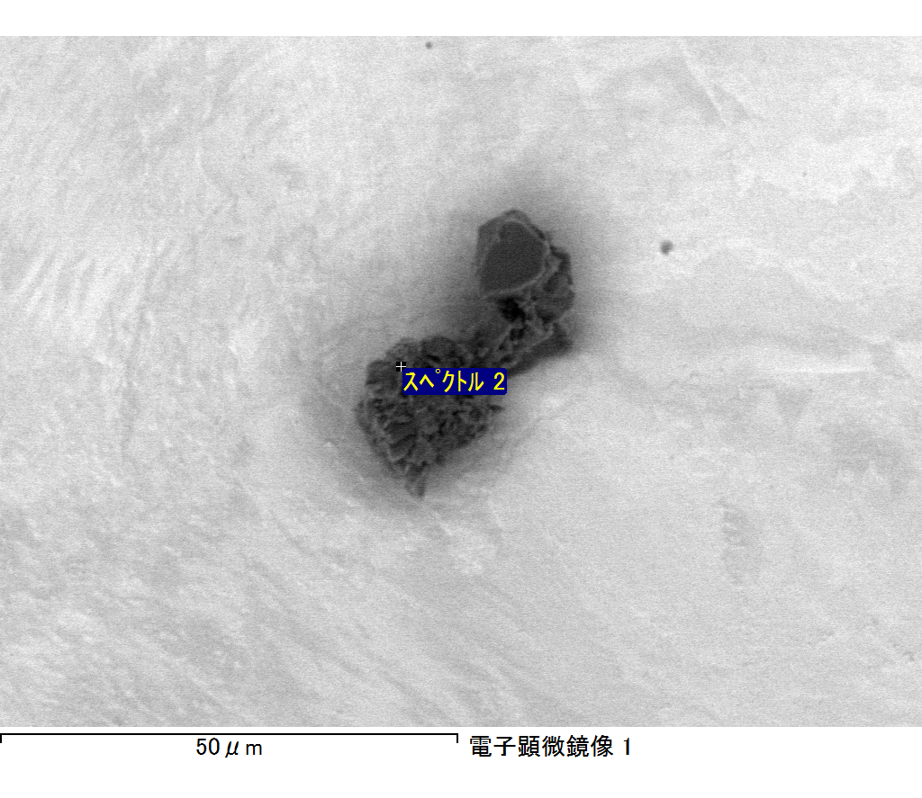

ｺﾒﾝﾄ :

2017/12/27 12:01:21

ﾌﾟﾛｼﾞｪｸﾄ 1

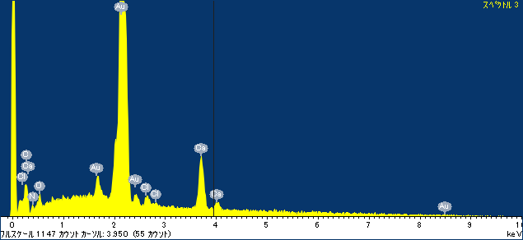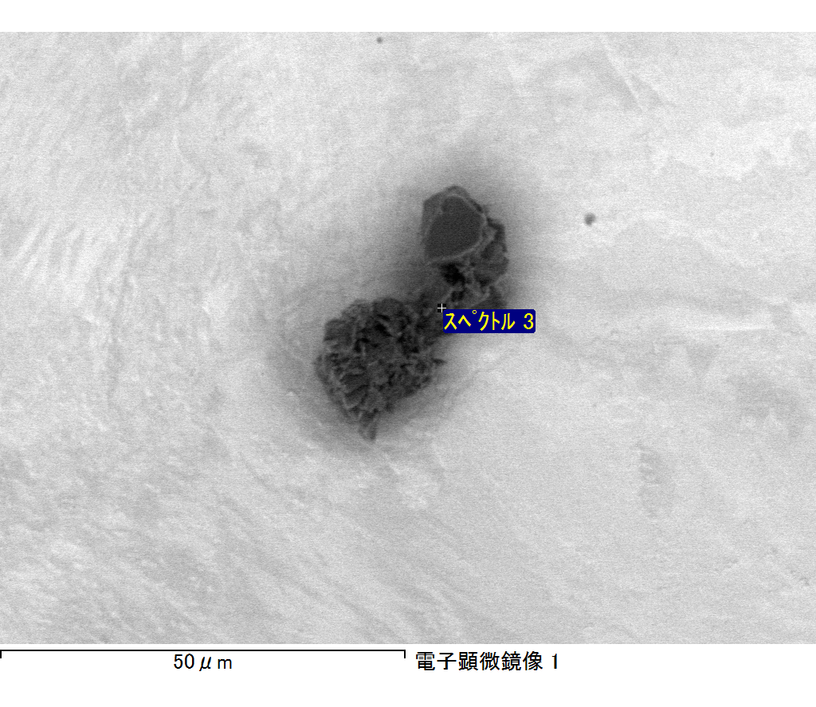

ｺﾒﾝﾄ :

2017/12/27 12:01:28

ﾌﾟﾛｼﾞｪｸﾄ 1

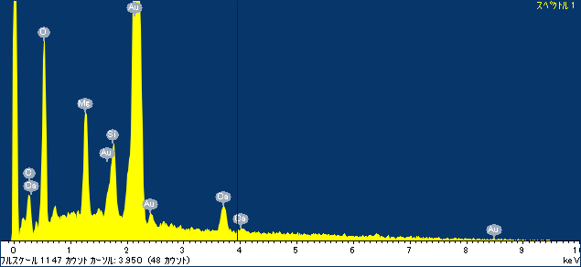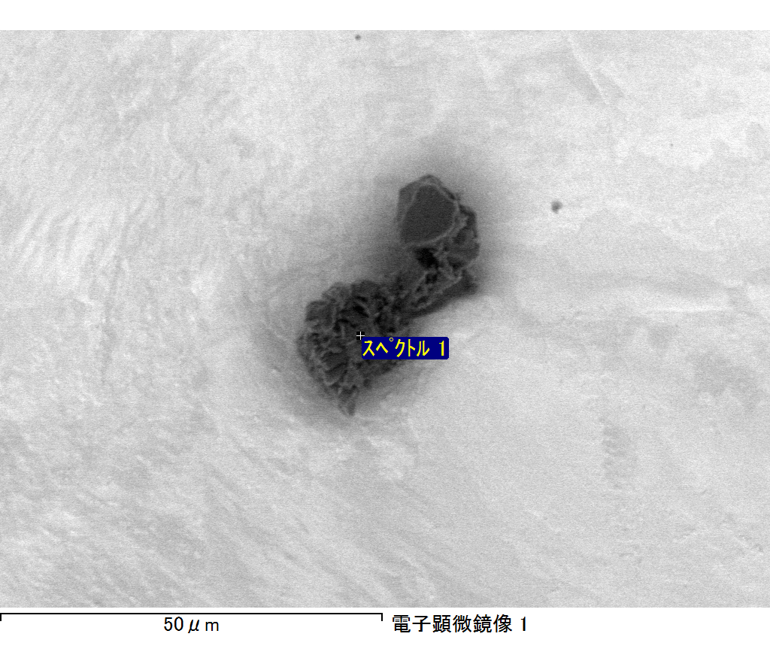

ｺﾒﾝﾄ :

2017/12/27 12:02:52

ﾌﾟﾛｼﾞｪｸﾄ 1