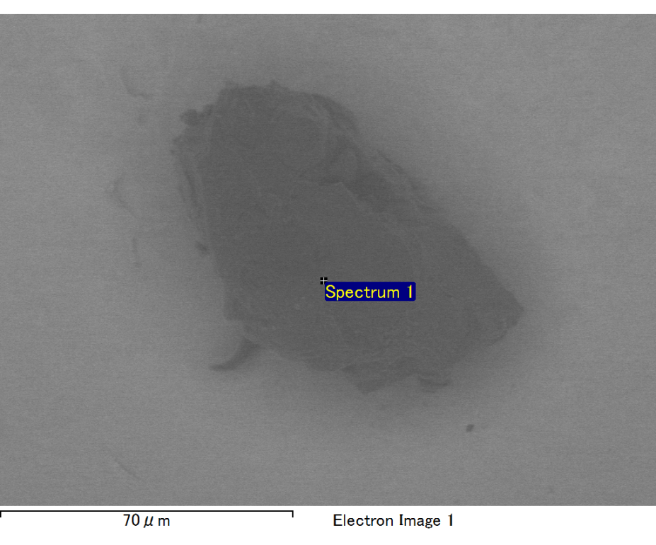

Spectrum processing :

Peak possibly omitted : 0.260 keV

Processing option : All elements analyzed (Normalised)

Number of iterations = 2

Standard :

O SiO2 1-Jun-1999 12:00 AM

Mg MgO 1-Jun-1999 12:00 AM

Si SiO2 1-Jun-1999 12:00 AM

Au Au 1-Jun-1999 12:00 AM

|  |  |  |  |
| --- | --- | --- | --- |
| Element | Weight% | Atomic% |  |
|  |  |  |  |
| O K | 30.63 | 71.05 |  |
| Mg K | 3.29 | 5.02 |  |
| Si K | 10.14 | 13.39 |  |
| Au M | 55.94 | 10.54 |  |
|  |  |  |  |
| Totals | 100.00 |  |  |

Spectrum Label: Spectrum 1

Livetime 30.0 s

Acquisition geometry ( degrees ):

Tilt = 10.0

Azimuth = 0.0

Elevation = 30.0

Accelerating voltage = 10.00 kV

Total spectrum counts = 17357

|  |  |  |  |
| --- | --- | --- | --- |
| Sample data : | Energy (eV) | Resn. (eV) | Area |
| Strobe : | 3.8 | 47.33 | 499795 |
|  |  |  |  |

No quant optimization performed

Sample: Sample 1

Type: Default

ID:

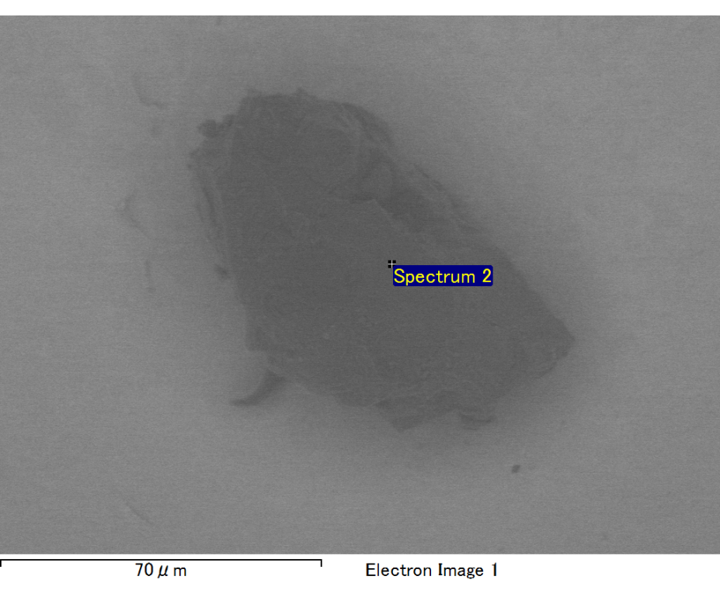

Spectrum processing :

No peaks omitted

Processing option : All elements analyzed (Normalised)

Number of iterations = 2

Standard :

O SiO2 1-Jun-1999 12:00 AM

Mg MgO 1-Jun-1999 12:00 AM

Si SiO2 1-Jun-1999 12:00 AM

Au Au 1-Jun-1999 12:00 AM

|  |  |  |  |
| --- | --- | --- | --- |
| Element | Weight% | Atomic% |  |
|  |  |  |  |
| O K | 24.69 | 64.53 |  |
| Mg K | 6.29 | 10.83 |  |
| Si K | 7.83 | 11.66 |  |
| Au M | 61.19 | 12.99 |  |
|  |  |  |  |
| Totals | 100.00 |  |  |

Spectrum Label: Spectrum 2

Livetime 30.0 s

Acquisition geometry ( degrees ):

Tilt = 10.0

Azimuth = 0.0

Elevation = 30.0

Accelerating voltage = 10.00 kV

Total spectrum counts = 16564

|  |  |  |  |
| --- | --- | --- | --- |
| Sample data : | Energy (eV) | Resn. (eV) | Area |
| Strobe : | 3.8 | 47.33 | 499737 |
|  |  |  |  |

No quant optimization performed

Sample: Sample 1

Type: Default

ID: