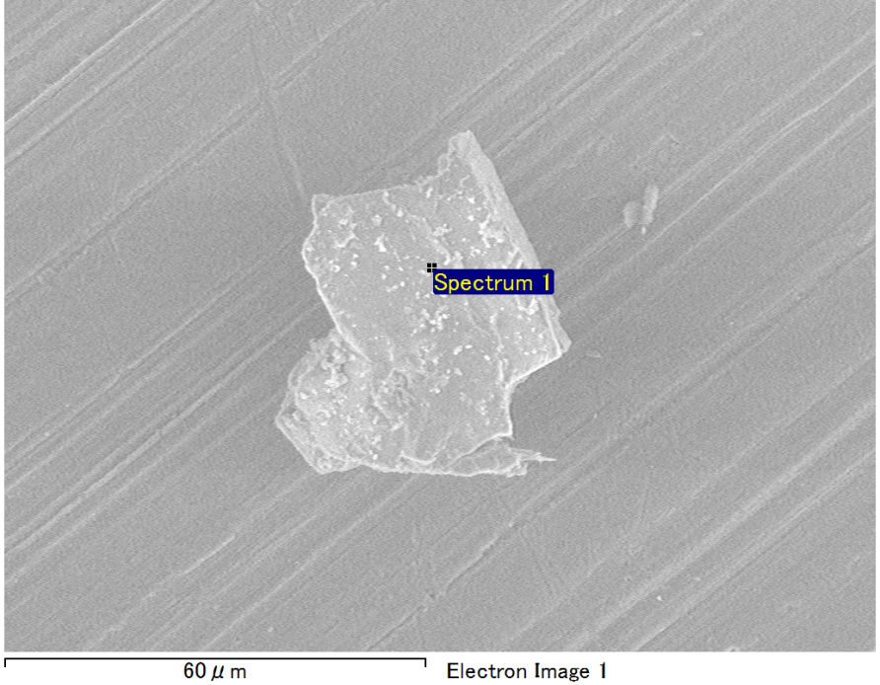

Spectrum Label: Spectrum 1

Livetime 90.0 s

Acquisition geometry ( degrees ):

Tilt = 0.0

Azimuth = 0.0

Elevation = 30.0

Accelerating voltage = 10.00 kV

Total spectrum counts = 66053

|  |  |  |  |
| --- | --- | --- | --- |
| Sample data : | Energy (eV) | Resn. (eV) | Area |
| Strobe : | 3.8 | 53.18 | 920511 |
|  |  |  |  |
| Optimization data : Manganese K series |  |  |  |
|  | Energy (eV) | Resn. (eV) | Area |
| Strobe : | .1 | 53.38 | 1150729 |
| Optimization element : | 5892.6 | 129.89 | 573533 |

Spectrum processing :

Peak possibly omitted : 0.705 keV

Processing option : Oxygen by stoichiometry (Normalised)

Number of iterations = 1

Standard :

Mg MgO 1-Jun-1999 12:00 AM

Al Al2O3 1-Jun-1999 12:00 AM

Si SiO2 1-Jun-1999 12:00 AM

|  |  |  |  |  |  |
| --- | --- | --- | --- | --- | --- |
| Element | Weight% | Atomic% | Compd% | Formula |  |
|  |  |  |  |  |  |
| Mg K | 5.73 | 4.79 | 9.50 | MgO |  |
| Al K | 41.00 | 30.88 | 77.46 | Al2O3 |  |
| Si K | 6.10 | 4.41 | 13.05 | SiO2 |  |
| O | 47.18 | 59.93 |  |  |  |
| Totals | 100.00 |  |  |  |  |

Project: Project 1

Owner: Operator

Site: Site of Interest 20

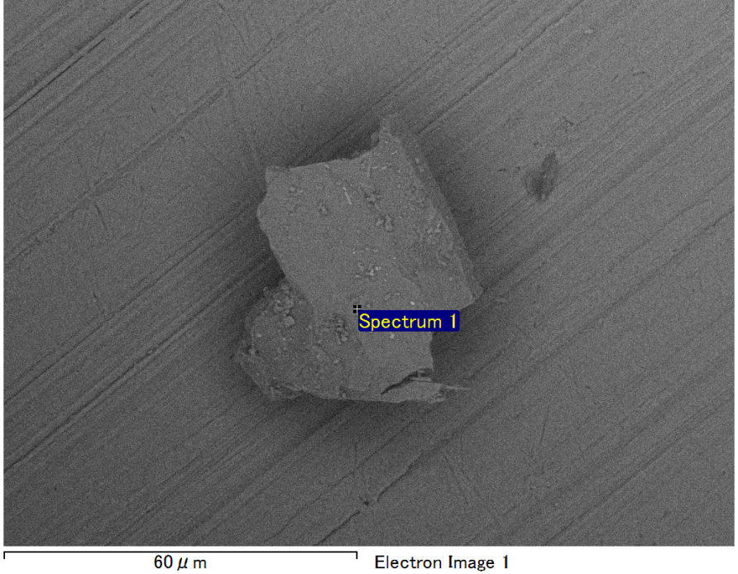

Spectrum Label: Spectrum 1

Livetime 90.0 s

Acquisition geometry ( degrees ):

Tilt = 0.0

Azimuth = 0.0

Elevation = 30.0

Accelerating voltage = 10.00 kV

Total spectrum counts = 63857

|  |  |  |  |
| --- | --- | --- | --- |
| Sample data : | Energy (eV) | Resn. (eV) | Area |
| Strobe : | 3.8 | 53.15 | 920247 |
|  |  |  |  |
| Optimization data : Manganese K series |  |  |  |
|  | Energy (eV) | Resn. (eV) | Area |
| Strobe : | .1 | 53.38 | 1150729 |
| Optimization element : | 5892.6 | 129.89 | 573533 |

Spectrum processing :

No peaks omitted

Processing option : Oxygen by stoichiometry (Normalised)

Number of iterations = 1

Standard :

Mg MgO 1-Jun-1999 12:00 AM

Al Al2O3 1-Jun-1999 12:00 AM

Si SiO2 1-Jun-1999 12:00 AM

|  |  |  |  |  |  |
| --- | --- | --- | --- | --- | --- |
| Element | Weight% | Atomic% | Compd% | Formula |  |
|  |  |  |  |  |  |
| Mg K | 4.87 | 4.08 | 8.08 | MgO |  |
| Al K | 43.85 | 33.05 | 82.85 | Al2O3 |  |
| Si K | 4.24 | 3.07 | 9.07 | SiO2 |  |
| O | 47.04 | 59.80 |  |  |  |
| Totals | 100.00 |  |  |  |  |

Project: Project 1

Owner: Operator

Site: Site of Interest 21

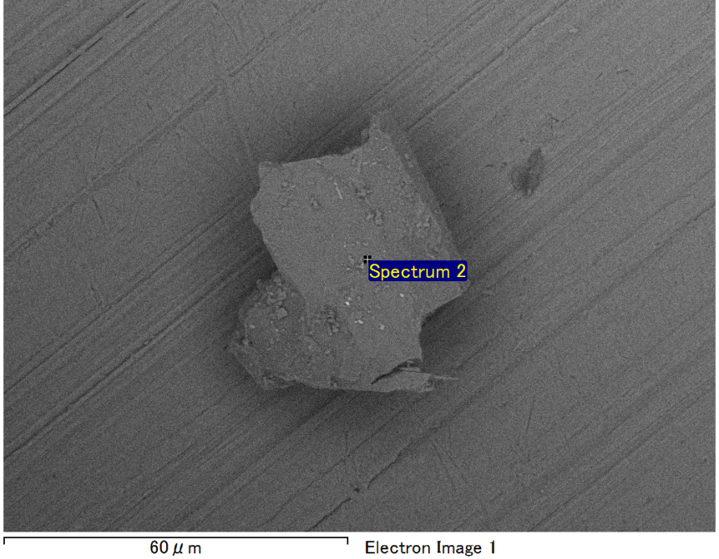

Spectrum Label: Spectrum 2

Livetime 90.0 s

Acquisition geometry ( degrees ):

Tilt = 0.0

Azimuth = 0.0

Elevation = 30.0

Accelerating voltage = 10.00 kV

Total spectrum counts = 63952

|  |  |  |  |
| --- | --- | --- | --- |
| Sample data : | Energy (eV) | Resn. (eV) | Area |
| Strobe : | 3.8 | 53.15 | 917915 |
|  |  |  |  |
| Optimization data : Manganese K series |  |  |  |
|  | Energy (eV) | Resn. (eV) | Area |
| Strobe : | .1 | 53.38 | 1150729 |
| Optimization element : | 5892.6 | 129.89 | 573533 |

Spectrum processing :

No peaks omitted

Processing option : Oxygen by stoichiometry (Normalised)

Number of iterations = 1

Standard :

Mg MgO 1-Jun-1999 12:00 AM

Al Al2O3 1-Jun-1999 12:00 AM

Si SiO2 1-Jun-1999 12:00 AM

Fe Fe 1-Jun-1999 12:00 AM

|  |  |  |  |  |  |
| --- | --- | --- | --- | --- | --- |
| Element | Weight% | Atomic% | Compd% | Formula |  |
|  |  |  |  |  |  |
| Mg K | 4.55 | 4.02 | 7.55 | MgO |  |
| Al K | 36.75 | 29.25 | 69.44 | Al2O3 |  |
| Si K | 5.02 | 3.83 | 10.73 | SiO2 |  |
| Fe L | 9.54 | 3.67 | 12.28 | FeO |  |
| O | 44.13 | 59.23 |  |  |  |
| Totals | 100.00 |  |  |  |  |

Project: Project 1

Owner: Operator

Site: Site of Interest 21

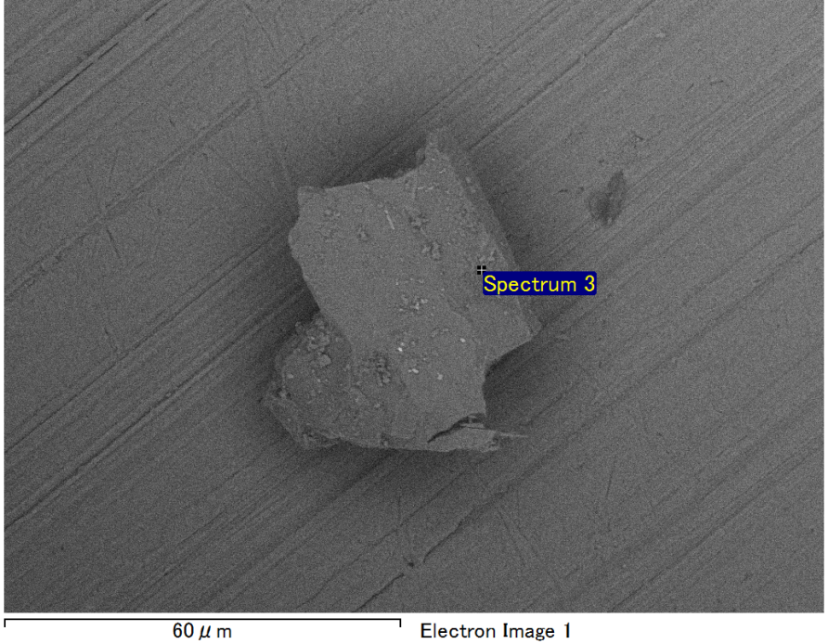

Spectrum Label: Spectrum 3

Livetime 90.0 s

Acquisition geometry ( degrees ):

Tilt = 0.0

Azimuth = 0.0

Elevation = 30.0

Accelerating voltage = 10.00 kV

Total spectrum counts = 64512

|  |  |  |  |
| --- | --- | --- | --- |
| Sample data : | Energy (eV) | Resn. (eV) | Area |
| Strobe : | 3.8 | 53.22 | 918396 |
|  |  |  |  |
| Optimization data : Manganese K series |  |  |  |
|  | Energy (eV) | Resn. (eV) | Area |
| Strobe : | .1 | 53.38 | 1150729 |
| Optimization element : | 5892.6 | 129.89 | 573533 |

Spectrum processing :

No peaks omitted

Processing option : Oxygen by stoichiometry (Normalised)

Number of iterations = 1

Standard :

Mg MgO 1-Jun-1999 12:00 AM

Al Al2O3 1-Jun-1999 12:00 AM

Si SiO2 1-Jun-1999 12:00 AM

|  |  |  |  |  |  |
| --- | --- | --- | --- | --- | --- |
| Element | Weight% | Atomic% | Compd% | Formula |  |
|  |  |  |  |  |  |
| Mg K | 3.30 | 2.76 | 5.47 | MgO |  |
| Al K | 40.77 | 30.70 | 77.04 | Al2O3 |  |
| Si K | 8.17 | 5.91 | 17.49 | SiO2 |  |
| O | 47.75 | 60.63 |  |  |  |
| Totals | 100.00 |  |  |  |  |

Project: Project 1

Owner: Operator

Site: Site of Interest 21

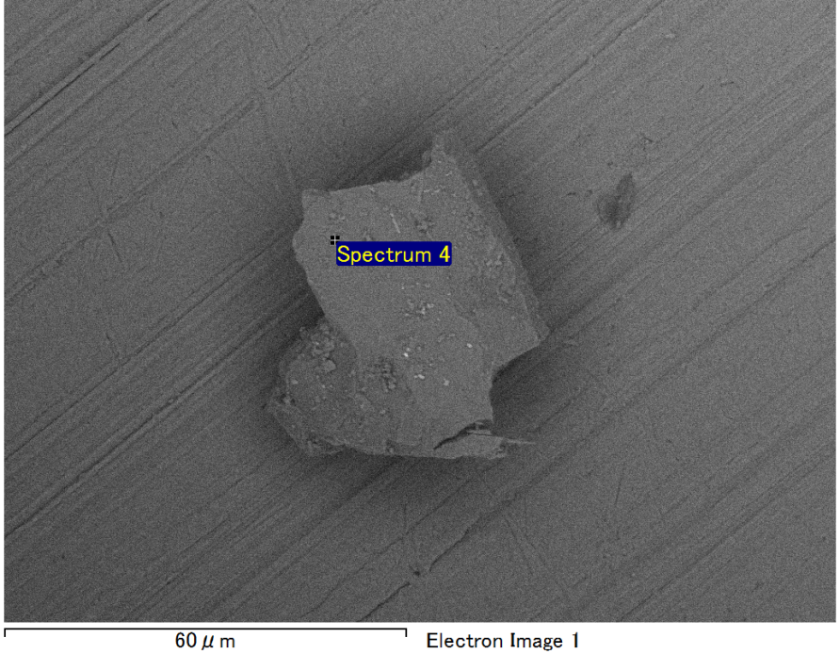

Spectrum Label: Spectrum 4

Livetime 90.0 s

Acquisition geometry ( degrees ):

Tilt = 0.0

Azimuth = 0.0

Elevation = 30.0

Accelerating voltage = 10.00 kV

Total spectrum counts = 64450

|  |  |  |  |
| --- | --- | --- | --- |
| Sample data : | Energy (eV) | Resn. (eV) | Area |
| Strobe : | 3.8 | 53.17 | 919399 |
|  |  |  |  |
| Optimization data : Manganese K series |  |  |  |
|  | Energy (eV) | Resn. (eV) | Area |
| Strobe : | .1 | 53.38 | 1150729 |
| Optimization element : | 5892.6 | 129.89 | 573533 |

Spectrum processing :

No peaks omitted

Processing option : Oxygen by stoichiometry (Normalised)

Number of iterations = 1

Standard :

Mg MgO 1-Jun-1999 12:00 AM

Al Al2O3 1-Jun-1999 12:00 AM

Si SiO2 1-Jun-1999 12:00 AM

|  |  |  |  |  |  |
| --- | --- | --- | --- | --- | --- |
| Element | Weight% | Atomic% | Compd% | Formula |  |
|  |  |  |  |  |  |
| Mg K | 3.43 | 2.87 | 5.69 | MgO |  |
| Al K | 42.67 | 32.15 | 80.62 | Al2O3 |  |
| Si K | 6.40 | 4.63 | 13.70 | SiO2 |  |
| O | 47.50 | 60.35 |  |  |  |
| Totals | 100.00 |  |  |  |  |

Project: Project 1

Owner: Operator

Site: Site of Interest 21