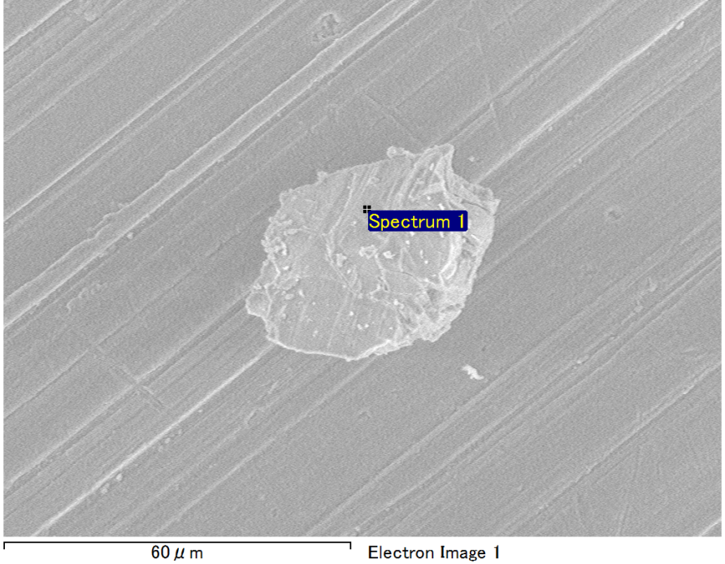

Spectrum Label: Spectrum 1

Livetime 90.0 s

Acquisition geometry ( degrees ):

Tilt = 0.0

Azimuth = 0.0

Elevation = 30.0

Accelerating voltage = 10.00 kV

Total spectrum counts = 65958

|  |  |  |  |
| --- | --- | --- | --- |
| Sample data : | Energy (eV) | Resn. (eV) | Area |
| Strobe : | 3.8 | 53.15 | 918629 |
|  |  |  |  |
| Optimization data : Manganese K series |  |  |  |
|  | Energy (eV) | Resn. (eV) | Area |
| Strobe : | .1 | 53.38 | 1150729 |
| Optimization element : | 5892.6 | 129.89 | 573533 |

Spectrum processing :

No peaks omitted

Processing option : Oxygen by stoichiometry (Normalised)

Number of iterations = 1

Standard :

Mg MgO 1-Jun-1999 12:00 AM

Al Al2O3 1-Jun-1999 12:00 AM

Si SiO2 1-Jun-1999 12:00 AM

Fe Fe 1-Jun-1999 12:00 AM

|  |  |  |  |  |  |
| --- | --- | --- | --- | --- | --- |
| Element | Weight% | Atomic% | Compd% | Formula |  |
|  |  |  |  |  |  |
| Mg K | 4.48 | 3.94 | 7.43 | MgO |  |
| Al K | 34.79 | 27.55 | 65.72 | Al2O3 |  |
| Si K | 7.20 | 5.48 | 15.41 | SiO2 |  |
| Fe L | 8.88 | 3.40 | 11.43 | FeO |  |
| O | 44.64 | 59.63 |  |  |  |
| Totals | 100.00 |  |  |  |  |

Project: Project 1

Owner: Operator

Site: Site of Interest 18

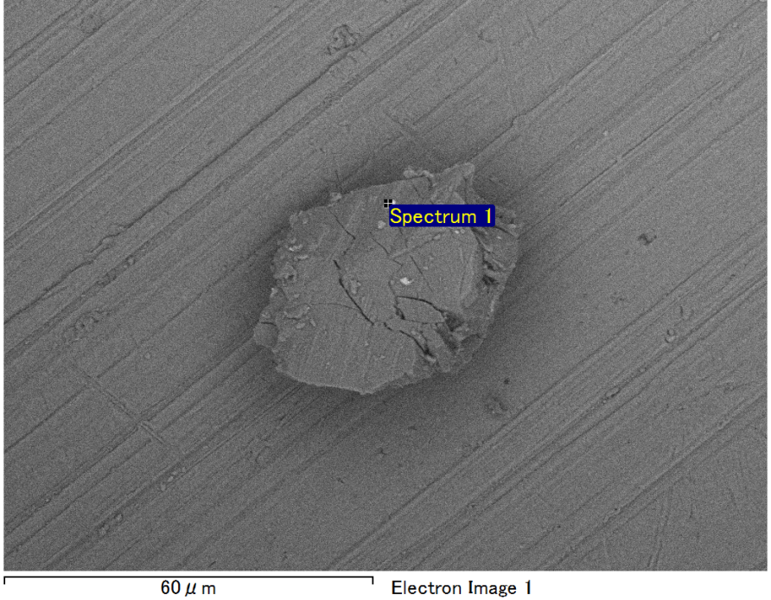

Spectrum Label: Spectrum 1

Livetime 90.0 s

Acquisition geometry ( degrees ):

Tilt = 0.0

Azimuth = 0.0

Elevation = 30.0

Accelerating voltage = 10.00 kV

Total spectrum counts = 65323

|  |  |  |  |
| --- | --- | --- | --- |
| Sample data : | Energy (eV) | Resn. (eV) | Area |
| Strobe : | 3.8 | 53.21 | 917692 |
|  |  |  |  |
| Optimization data : Manganese K series |  |  |  |
|  | Energy (eV) | Resn. (eV) | Area |
| Strobe : | .1 | 53.38 | 1150729 |
| Optimization element : | 5892.6 | 129.89 | 573533 |

Spectrum processing :

No peaks omitted

Processing option : Oxygen by stoichiometry (Normalised)

Number of iterations = 1

Standard :

Al Al2O3 1-Jun-1999 12:00 AM

S FeS2 1-Jun-1999 12:00 AM

Fe Fe 1-Jun-1999 12:00 AM

Ni Ni 1-Jun-1999 12:00 AM

|  |  |  |  |  |  |
| --- | --- | --- | --- | --- | --- |
| Element | Weight% | Atomic% | Compd% | Formula |  |
|  |  |  |  |  |  |
| Al K | 31.17 | 27.74 | 58.88 | Al2O3 |  |
| S K | 2.73 | 2.05 | 6.82 | SO3 |  |
| Fe L | 12.50 | 5.38 | 16.08 | FeO |  |
| Ni L | 14.31 | 5.86 | 18.21 | NiO |  |
| O | 39.29 | 58.98 |  |  |  |
| Totals | 100.00 |  |  |  |  |

Project: Project 1

Owner: Operator

Site: Site of Interest 19

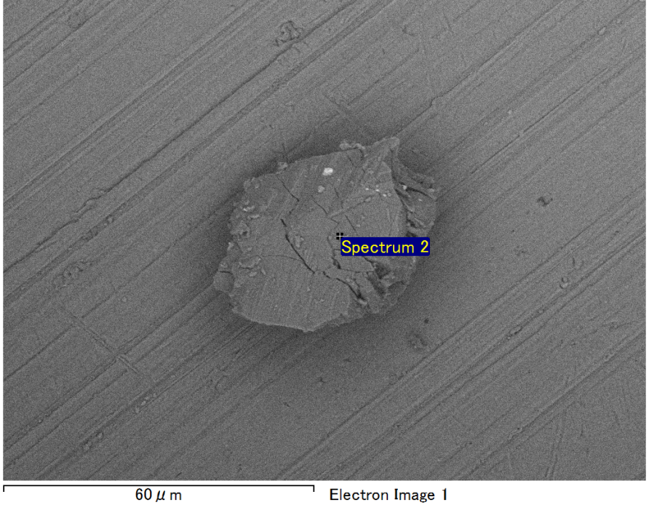

Spectrum Label: Spectrum 2

Livetime 90.0 s

Acquisition geometry ( degrees ):

Tilt = 0.0

Azimuth = 0.0

Elevation = 30.0

Accelerating voltage = 10.00 kV

Total spectrum counts = 64962

|  |  |  |  |
| --- | --- | --- | --- |
| Sample data : | Energy (eV) | Resn. (eV) | Area |
| Strobe : | 3.8 | 53.23 | 918054 |
|  |  |  |  |
| Optimization data : Manganese K series |  |  |  |
|  | Energy (eV) | Resn. (eV) | Area |
| Strobe : | .1 | 53.38 | 1150729 |
| Optimization element : | 5892.6 | 129.89 | 573533 |

Spectrum processing :

No peaks omitted

Processing option : Oxygen by stoichiometry (Normalised)

Number of iterations = 1

Standard :

Mg MgO 1-Jun-1999 12:00 AM

Al Al2O3 1-Jun-1999 12:00 AM

Si SiO2 1-Jun-1999 12:00 AM

S FeS2 1-Jun-1999 12:00 AM

Fe Fe 1-Jun-1999 12:00 AM

|  |  |  |  |  |  |
| --- | --- | --- | --- | --- | --- |
| Element | Weight% | Atomic% | Compd% | Formula |  |
|  |  |  |  |  |  |
| Mg K | 0.74 | 0.71 | 1.24 | MgO |  |
| Al K | 27.83 | 23.73 | 52.58 | Al2O3 |  |
| Si K | 0.95 | 0.78 | 2.03 | SiO2 |  |
| S K | 6.79 | 4.87 | 16.96 | SO3 |  |
| Fe L | 21.14 | 8.71 | 27.19 | FeO |  |
| O | 42.55 | 61.20 |  |  |  |
| Totals | 100.00 |  |  |  |  |

Project: Project 1

Owner: Operator

Site: Site of Interest 19

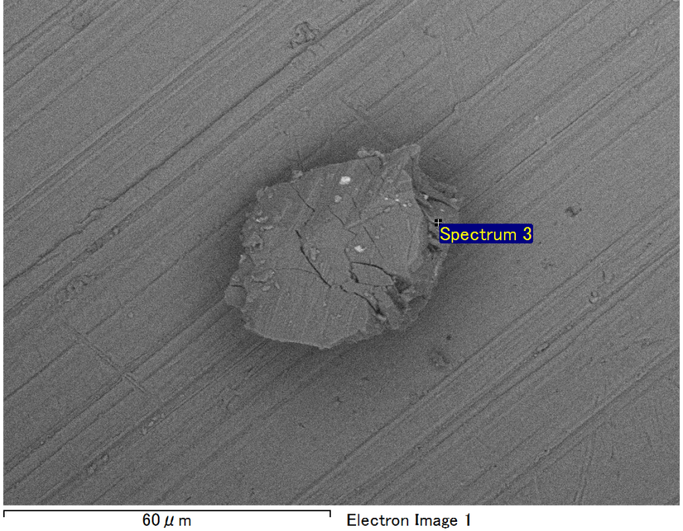

Spectrum Label: Spectrum 3

Livetime 90.0 s

Acquisition geometry ( degrees ):

Tilt = 0.0

Azimuth = 0.0

Elevation = 30.0

Accelerating voltage = 10.00 kV

Total spectrum counts = 65426

|  |  |  |  |
| --- | --- | --- | --- |
| Sample data : | Energy (eV) | Resn. (eV) | Area |
| Strobe : | 3.8 | 53.20 | 918464 |
|  |  |  |  |
| Optimization data : Manganese K series |  |  |  |
|  | Energy (eV) | Resn. (eV) | Area |
| Strobe : | .1 | 53.38 | 1150729 |
| Optimization element : | 5892.6 | 129.89 | 573533 |

Spectrum processing :

No peaks omitted

Processing option : Oxygen by stoichiometry (Normalised)

Number of iterations = 1

Standard :

Mg MgO 1-Jun-1999 12:00 AM

Al Al2O3 1-Jun-1999 12:00 AM

Si SiO2 1-Jun-1999 12:00 AM

Fe Fe 1-Jun-1999 12:00 AM

|  |  |  |  |  |  |
| --- | --- | --- | --- | --- | --- |
| Element | Weight% | Atomic% | Compd% | Formula |  |
|  |  |  |  |  |  |
| Mg K | 3.53 | 3.11 | 5.85 | MgO |  |
| Al K | 36.46 | 28.92 | 68.89 | Al2O3 |  |
| Si K | 6.36 | 4.85 | 13.62 | SiO2 |  |
| Fe L | 9.05 | 3.47 | 11.64 | FeO |  |
| O | 44.60 | 59.66 |  |  |  |
| Totals | 100.00 |  |  |  |  |

Project: Project 1

Owner: Operator

Site: Site of Interest 19

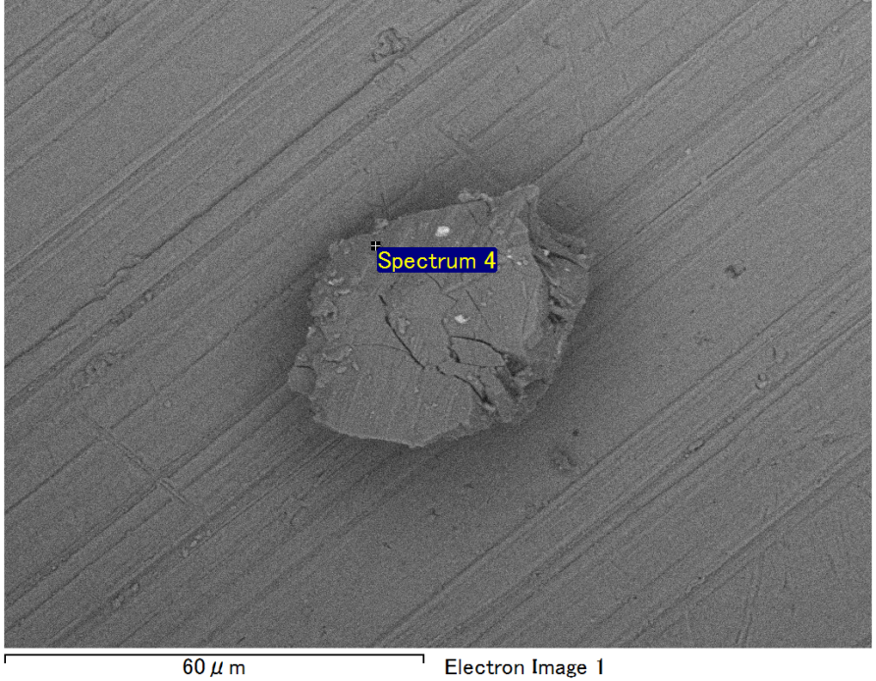

Spectrum Label: Spectrum 4

Livetime 90.0 s

Acquisition geometry ( degrees ):

Tilt = 0.0

Azimuth = 0.0

Elevation = 30.0

Accelerating voltage = 10.00 kV

Total spectrum counts = 66211

|  |  |  |  |
| --- | --- | --- | --- |
| Sample data : | Energy (eV) | Resn. (eV) | Area |
| Strobe : | 3.8 | 53.23 | 918334 |
|  |  |  |  |
| Optimization data : Manganese K series |  |  |  |
|  | Energy (eV) | Resn. (eV) | Area |
| Strobe : | .1 | 53.38 | 1150729 |
| Optimization element : | 5892.6 | 129.89 | 573533 |

Spectrum processing :

No peaks omitted

Processing option : Oxygen by stoichiometry (Normalised)

Number of iterations = 1

Standard :

Mg MgO 1-Jun-1999 12:00 AM

Al Al2O3 1-Jun-1999 12:00 AM

Si SiO2 1-Jun-1999 12:00 AM

Fe Fe 1-Jun-1999 12:00 AM

|  |  |  |  |  |  |
| --- | --- | --- | --- | --- | --- |
| Element | Weight% | Atomic% | Compd% | Formula |  |
|  |  |  |  |  |  |
| Mg K | 3.92 | 3.45 | 6.50 | MgO |  |
| Al K | 35.81 | 28.43 | 67.67 | Al2O3 |  |
| Si K | 6.53 | 4.98 | 13.97 | SiO2 |  |
| Fe L | 9.22 | 3.54 | 11.86 | FeO |  |
| O | 44.51 | 59.60 |  |  |  |
| Totals | 100.00 |  |  |  |  |

Project: Project 1

Owner: Operator

Site: Site of Interest 19