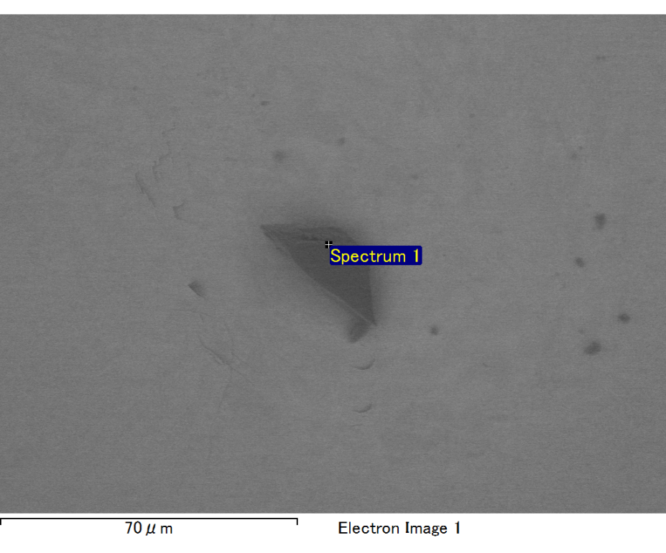

Spectrum processing :

No peaks omitted

Processing option : All elements analyzed (Normalised)

Number of iterations = 1

Standard :

O SiO2 1-Jun-1999 12:00 AM

Mg MgO 1-Jun-1999 12:00 AM

Si SiO2 1-Jun-1999 12:00 AM

Au Au 1-Jun-1999 12:00 AM

|  |  |  |  |
| --- | --- | --- | --- |
| Element | Weight% | Atomic% |  |
|  |  |  |  |
| O K | 26.72 | 70.37 |  |
| Mg K | 5.71 | 9.90 |  |
| Si K | 4.11 | 6.16 |  |
| Au M | 63.47 | 13.58 |  |
|  |  |  |  |
| Totals | 100.00 |  |  |

Spectrum Label: Spectrum 1

Livetime 30.0 s

Acquisition geometry ( degrees ):

Tilt = 0.0

Azimuth = 0.0

Elevation = 30.0

Accelerating voltage = 10.00 kV

Total spectrum counts = 17362

|  |  |  |  |
| --- | --- | --- | --- |
| Sample data : | Energy (eV) | Resn. (eV) | Area |
| Strobe : | 7.5 | 47.14 | 500249 |
|  |  |  |  |
| Optimization data : Cobalt K series |  |  |  |
|  | Energy (eV) | Resn. (eV) | Area |
| Strobe : | .0 | 49.17 | 497131 |
| Optimization element : | 6924.7 | 138.68 | 69233 |

Sample: Sample 1

Type: Default

ID: