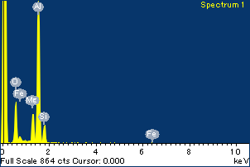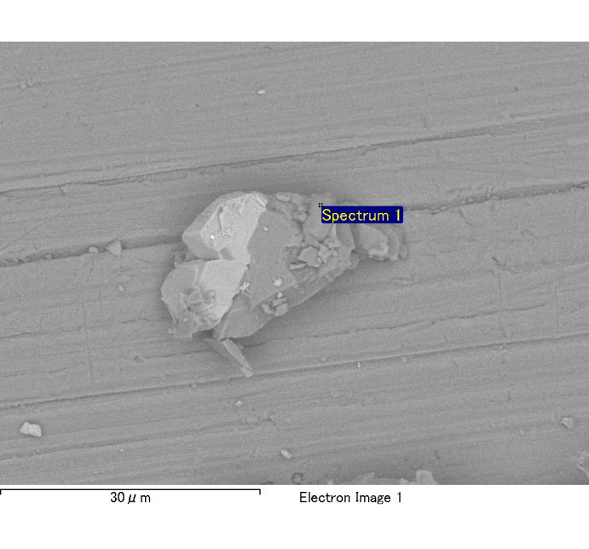

Spectrum Label: Spectrum 1

Livetime 120.0 s

Acquisition geometry ( degrees ):

Tilt = 0.0

Azimuth = 0.0

Elevation = 30.0

Accelerating voltage = 10.00 kV

Total spectrum counts = 121558

|  |  |  |  |
| --- | --- | --- | --- |
| Sample data : | Energy (eV) | Resn. (eV) | Area |
| Strobe : | 3.8 | 54.01 | 1206633 |
|  |  |  |  |
| Optimization data : Cobalt K series |  |  |  |
|  | Energy (eV) | Resn. (eV) | Area |
| Strobe : | .1 | 53.96 | 498142 |
| Optimization element : | 6926.7 | 142.17 | 16696 |

Spectrum processing :

No peaks omitted

Processing option : Oxygen by stoichiometry

Number of iterations = 2

Standard :

Na Albite 1-Jun-1999 12:00 AM

Mg MgO 1-Jun-1999 12:00 AM

Al Al2O3 1-Jun-1999 12:00 AM

Si SiO2 1-Jun-1999 12:00 AM

P GaP 1-Jun-1999 12:00 AM

S FeS2 1-Jun-1999 12:00 AM

K MAD-10 Feldspar 1-Jun-1999 12:00 AM

Ca Wollastonite 1-Jun-1999 12:00 AM

Cr Cr 1-Jun-1999 12:00 AM

Mn Mn 1-Jun-1999 12:00 AM

Fe Fe 1-Jun-1999 12:00 AM

Ni Ni 1-Jun-1999 12:00 AM

|  |  |  |  |  |  |
| --- | --- | --- | --- | --- | --- |
| Element | Weight% | Atomic% | Compd% | Formula |  |
|  |  |  |  |  |  |
| Na K | 0.00 | -0.04 | 0.00 | Na2O |  |
| Mg K | 0.15 | 5.84 | 0.25 | MgO |  |
| Al K | 0.84 | 29.50 | 1.59 | Al2O3 |  |
| Si K | 0.14 | 4.75 | 0.30 | SiO2 |  |
| P K | 0.00 | -0.06 | 0.00 | P2O5 |  |
| S K | 0.00 | 0.01 | 0.00 | SO3 |  |
| K K | 0.00 | 0.04 | 0.00 | K2O |  |
| Ca K | 0.00 | -0.01 | 0.00 | CaO |  |
| Cr K | -0.01 | -0.13 | -0.01 | Cr2O3 |  |
| Mn K | -0.02 | -0.32 | -0.02 | MnO |  |
| Fe K | 0.09 | 1.51 | 0.11 | FeO |  |
| Ni K | -0.05 | -0.76 | -0.06 | NiO |  |
| O | 1.01 | 59.68 |  |  |  |
| Totals | 2.15 |  |  |  |  |

Project: Project 1

Owner: Administrator

Site: Site of Interest 1

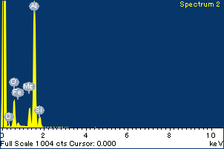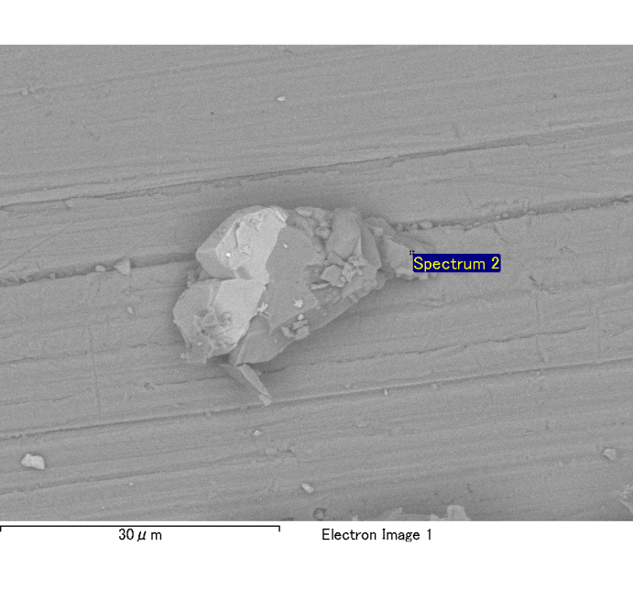

Spectrum Label: Spectrum 2

Livetime 120.0 s

Acquisition geometry ( degrees ):

Tilt = 0.0

Azimuth = 0.0

Elevation = 30.0

Accelerating voltage = 10.00 kV

Total spectrum counts = 122616

|  |  |  |  |
| --- | --- | --- | --- |
| Sample data : | Energy (eV) | Resn. (eV) | Area |
| Strobe : | 3.8 | 53.89 | 1208069 |
|  |  |  |  |
| Optimization data : Cobalt K series |  |  |  |
|  | Energy (eV) | Resn. (eV) | Area |
| Strobe : | .1 | 53.96 | 498142 |
| Optimization element : | 6926.7 | 142.17 | 16696 |

Spectrum processing :

No peaks omitted

Processing option : Oxygen by stoichiometry

Number of iterations = 2

Standard :

Na Albite 1-Jun-1999 12:00 AM

Mg MgO 1-Jun-1999 12:00 AM

Al Al2O3 1-Jun-1999 12:00 AM

Si SiO2 1-Jun-1999 12:00 AM

P GaP 1-Jun-1999 12:00 AM

S FeS2 1-Jun-1999 12:00 AM

K MAD-10 Feldspar 1-Jun-1999 12:00 AM

Ca Wollastonite 1-Jun-1999 12:00 AM

Cr Cr 1-Jun-1999 12:00 AM

Mn Mn 1-Jun-1999 12:00 AM

Fe Fe 1-Jun-1999 12:00 AM

Ni Ni 1-Jun-1999 12:00 AM

|  |  |  |  |  |  |
| --- | --- | --- | --- | --- | --- |
| Element | Weight% | Atomic% | Compd% | Formula |  |
|  |  |  |  |  |  |
| Na K | 0.00 | 0.01 | 0.00 | Na2O |  |
| Mg K | 0.13 | 4.89 | 0.21 | MgO |  |
| Al K | 0.94 | 32.66 | 1.78 | Al2O3 |  |
| Si K | 0.10 | 3.42 | 0.22 | SiO2 |  |
| P K | 0.00 | 0.06 | 0.00 | P2O5 |  |
| S K | 0.00 | 0.02 | 0.00 | SO3 |  |
| K K | 0.00 | 0.11 | 0.01 | K2O |  |
| Ca K | 0.00 | 0.07 | 0.00 | CaO |  |
| Cr K | 0.00 | 0.06 | 0.00 | Cr2O3 |  |
| Mn K | -0.03 | -0.44 | -0.03 | MnO |  |
| Fe K | 0.03 | 0.58 | 0.04 | FeO |  |
| Ni K | -0.09 | -1.36 | -0.11 | NiO |  |
| O | 1.03 | 59.93 |  |  |  |
| Totals | 2.14 |  |  |  |  |

Project: Project 1

Owner: Administrator

Site: Site of Interest 1

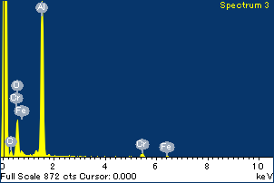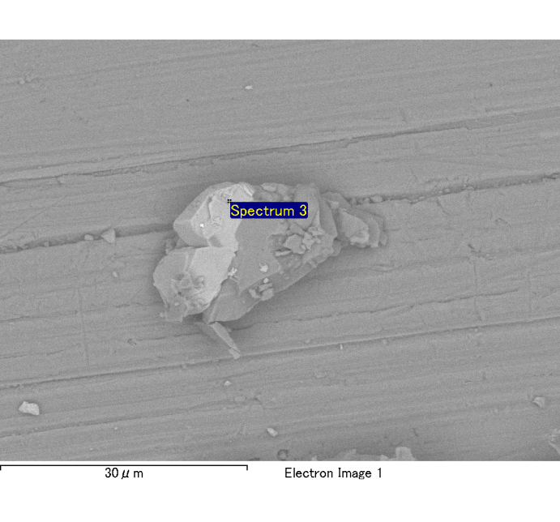

Spectrum Label: Spectrum 3

Livetime 120.0 s

Acquisition geometry ( degrees ):

Tilt = 0.0

Azimuth = 0.0

Elevation = 30.0

Accelerating voltage = 10.00 kV

Total spectrum counts = 120196

|  |  |  |  |
| --- | --- | --- | --- |
| Sample data : | Energy (eV) | Resn. (eV) | Area |
| Strobe : | 3.8 | 54.00 | 1206912 |
|  |  |  |  |
| Optimization data : Cobalt K series |  |  |  |
|  | Energy (eV) | Resn. (eV) | Area |
| Strobe : | .1 | 53.96 | 498142 |
| Optimization element : | 6926.7 | 142.17 | 16696 |

Spectrum processing :

No peaks omitted

Processing option : Oxygen by stoichiometry

Number of iterations = 2

Standard :

Na Albite 1-Jun-1999 12:00 AM

Mg MgO 1-Jun-1999 12:00 AM

Al Al2O3 1-Jun-1999 12:00 AM

Si SiO2 1-Jun-1999 12:00 AM

P GaP 1-Jun-1999 12:00 AM

S FeS2 1-Jun-1999 12:00 AM

K MAD-10 Feldspar 1-Jun-1999 12:00 AM

Ca Wollastonite 1-Jun-1999 12:00 AM

Cr Cr 1-Jun-1999 12:00 AM

Mn Mn 1-Jun-1999 12:00 AM

Fe Fe 1-Jun-1999 12:00 AM

Ni Ni 1-Jun-1999 12:00 AM

|  |  |  |  |  |  |
| --- | --- | --- | --- | --- | --- |
| Element | Weight% | Atomic% | Compd% | Formula |  |
|  |  |  |  |  |  |
| Na K | 0.00 | 0.23 | 0.01 | Na2O |  |
| Mg K | 0.01 | 0.63 | 0.02 | MgO |  |
| Al K | 0.82 | 32.04 | 1.55 | Al2O3 |  |
| Si K | 0.01 | 0.37 | 0.02 | SiO2 |  |
| P K | 0.00 | 0.12 | 0.01 | P2O5 |  |
| S K | 0.00 | -0.11 | -0.01 | SO3 |  |
| K K | 0.00 | -0.09 | 0.00 | K2O |  |
| Ca K | 0.00 | 0.02 | 0.00 | CaO |  |
| Cr K | 0.23 | 4.78 | 0.34 | Cr2O3 |  |
| Mn K | -0.03 | -0.54 | -0.04 | MnO |  |
| Fe K | 0.16 | 3.06 | 0.21 | FeO |  |
| Ni K | 0.01 | 0.17 | 0.01 | NiO |  |
| O | 0.90 | 59.33 |  |  |  |
| Totals | 2.12 |  |  |  |  |

Project: Project 1

Owner: Administrator

Site: Site of Interest 1

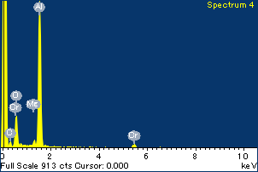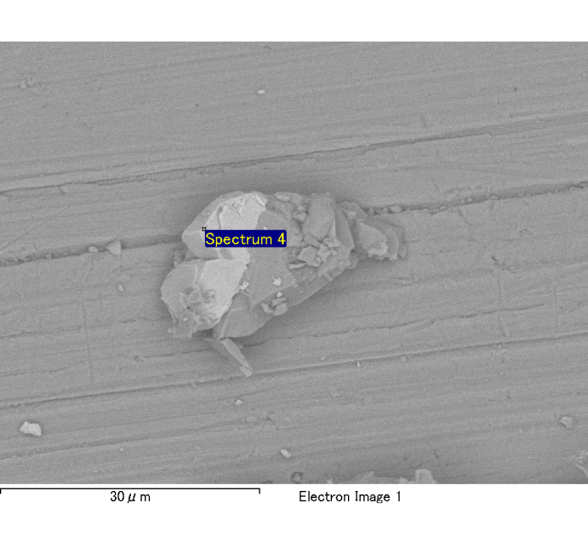

Spectrum Label: Spectrum 4

Livetime 120.0 s

Acquisition geometry ( degrees ):

Tilt = 0.0

Azimuth = 0.0

Elevation = 30.0

Accelerating voltage = 10.00 kV

Total spectrum counts = 119942

|  |  |  |  |
| --- | --- | --- | --- |
| Sample data : | Energy (eV) | Resn. (eV) | Area |
| Strobe : | 3.8 | 53.97 | 1209362 |
|  |  |  |  |
| Optimization data : Cobalt K series |  |  |  |
|  | Energy (eV) | Resn. (eV) | Area |
| Strobe : | .1 | 53.96 | 498142 |
| Optimization element : | 6926.7 | 142.17 | 16696 |

Spectrum processing :

No peaks omitted

Processing option : Oxygen by stoichiometry

Number of iterations = 2

Standard :

Na Albite 1-Jun-1999 12:00 AM

Mg MgO 1-Jun-1999 12:00 AM

Al Al2O3 1-Jun-1999 12:00 AM

Si SiO2 1-Jun-1999 12:00 AM

P GaP 1-Jun-1999 12:00 AM

S FeS2 1-Jun-1999 12:00 AM

K MAD-10 Feldspar 1-Jun-1999 12:00 AM

Ca Wollastonite 1-Jun-1999 12:00 AM

Cr Cr 1-Jun-1999 12:00 AM

Mn Mn 1-Jun-1999 12:00 AM

Fe Fe 1-Jun-1999 12:00 AM

Ni Ni 1-Jun-1999 12:00 AM

|  |  |  |  |  |  |
| --- | --- | --- | --- | --- | --- |
| Element | Weight% | Atomic% | Compd% | Formula |  |
|  |  |  |  |  |  |
| Na K | 0.00 | 0.00 | 0.00 | Na2O |  |
| Mg K | 0.02 | 0.96 | 0.04 | MgO |  |
| Al K | 0.83 | 33.64 | 1.57 | Al2O3 |  |
| Si K | 0.01 | 0.38 | 0.02 | SiO2 |  |
| P K | 0.00 | -0.05 | 0.00 | P2O5 |  |
| S K | 0.00 | 0.01 | 0.00 | SO3 |  |
| K K | 0.00 | 0.06 | 0.00 | K2O |  |
| Ca K | 0.00 | -0.04 | 0.00 | CaO |  |
| Cr K | 0.23 | 4.83 | 0.34 | Cr2O3 |  |
| Mn K | 0.02 | 0.30 | 0.02 | MnO |  |
| Fe K | 0.06 | 1.11 | 0.07 | FeO |  |
| Ni K | -0.05 | -0.98 | -0.07 | NiO |  |
| O | 0.87 | 59.77 |  |  |  |
| Totals | 1.98 |  |  |  |  |

Project: Project 1

Owner: Administrator

Site: Site of Interest 1

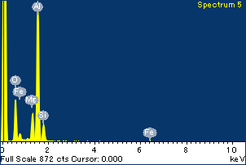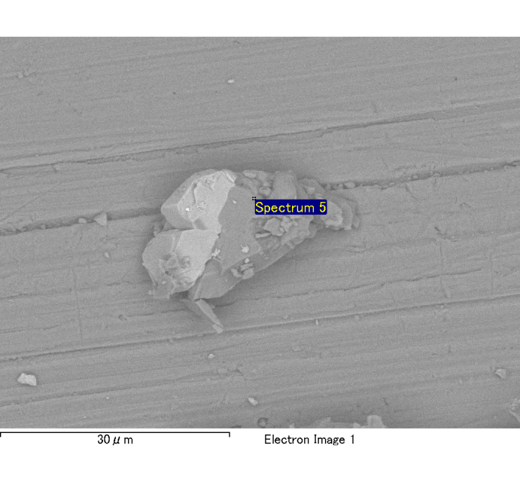

Spectrum Label: Spectrum 5

Livetime 120.0 s

Acquisition geometry ( degrees ):

Tilt = 0.0

Azimuth = 0.0

Elevation = 30.0

Accelerating voltage = 10.00 kV

Total spectrum counts = 122121

|  |  |  |  |
| --- | --- | --- | --- |
| Sample data : | Energy (eV) | Resn. (eV) | Area |
| Strobe : | 3.8 | 53.96 | 1207841 |
|  |  |  |  |
| Optimization data : Cobalt K series |  |  |  |
|  | Energy (eV) | Resn. (eV) | Area |
| Strobe : | .1 | 53.96 | 498142 |
| Optimization element : | 6926.7 | 142.17 | 16696 |

Spectrum processing :

No peaks omitted

Processing option : Oxygen by stoichiometry

Number of iterations = 2

Standard :

Na Albite 1-Jun-1999 12:00 AM

Mg MgO 1-Jun-1999 12:00 AM

Al Al2O3 1-Jun-1999 12:00 AM

Si SiO2 1-Jun-1999 12:00 AM

P GaP 1-Jun-1999 12:00 AM

S FeS2 1-Jun-1999 12:00 AM

K MAD-10 Feldspar 1-Jun-1999 12:00 AM

Ca Wollastonite 1-Jun-1999 12:00 AM

Cr Cr 1-Jun-1999 12:00 AM

Mn Mn 1-Jun-1999 12:00 AM

Fe Fe 1-Jun-1999 12:00 AM

Ni Ni 1-Jun-1999 12:00 AM

|  |  |  |  |  |  |
| --- | --- | --- | --- | --- | --- |
| Element | Weight% | Atomic% | Compd% | Formula |  |
|  |  |  |  |  |  |
| Na K | 0.00 | 0.17 | 0.01 | Na2O |  |
| Mg K | 0.15 | 5.93 | 0.25 | MgO |  |
| Al K | 0.84 | 29.12 | 1.58 | Al2O3 |  |
| Si K | 0.14 | 4.57 | 0.29 | SiO2 |  |
| P K | 0.00 | -0.04 | 0.00 | P2O5 |  |
| S K | 0.00 | -0.05 | 0.00 | SO3 |  |
| K K | 0.00 | 0.02 | 0.00 | K2O |  |
| Ca K | 0.00 | 0.05 | 0.00 | CaO |  |
| Cr K | 0.00 | -0.05 | 0.00 | Cr2O3 |  |
| Mn K | -0.02 | -0.33 | -0.02 | MnO |  |
| Fe K | 0.07 | 1.10 | 0.08 | FeO |  |
| Ni K | 0.01 | 0.10 | 0.01 | NiO |  |
| O | 1.01 | 59.43 |  |  |  |
| Totals | 2.19 |  |  |  |  |

Project: Project 1

Owner: Administrator

Site: Site of Interest 1

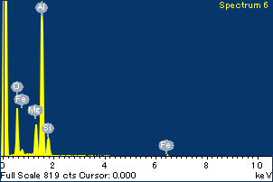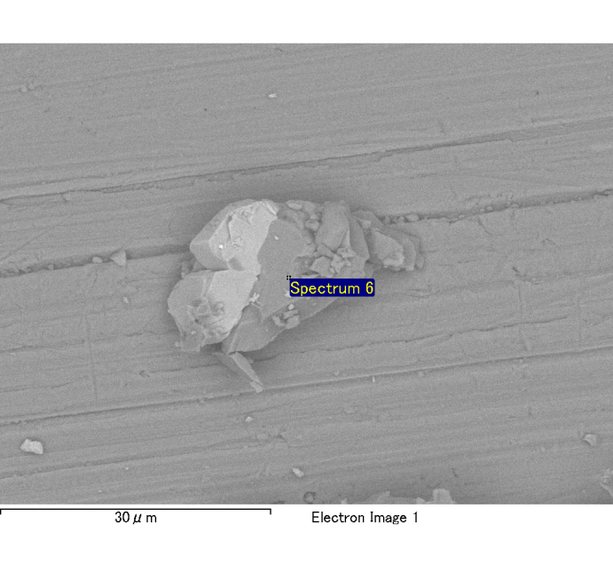

Spectrum Label: Spectrum 6

Livetime 120.0 s

Acquisition geometry ( degrees ):

Tilt = 0.0

Azimuth = 0.0

Elevation = 30.0

Accelerating voltage = 10.00 kV

Total spectrum counts = 120945

|  |  |  |  |
| --- | --- | --- | --- |
| Sample data : | Energy (eV) | Resn. (eV) | Area |
| Strobe : | 3.8 | 53.97 | 1208406 |
|  |  |  |  |
| Optimization data : Cobalt K series |  |  |  |
|  | Energy (eV) | Resn. (eV) | Area |
| Strobe : | .1 | 53.96 | 498142 |
| Optimization element : | 6926.7 | 142.17 | 16696 |

Spectrum processing :

No peaks omitted

Processing option : Oxygen by stoichiometry

Number of iterations = 2

Standard :

Na Albite 1-Jun-1999 12:00 AM

Mg MgO 1-Jun-1999 12:00 AM

Al Al2O3 1-Jun-1999 12:00 AM

Si SiO2 1-Jun-1999 12:00 AM

P GaP 1-Jun-1999 12:00 AM

S FeS2 1-Jun-1999 12:00 AM

K MAD-10 Feldspar 1-Jun-1999 12:00 AM

Ca Wollastonite 1-Jun-1999 12:00 AM

Cr Cr 1-Jun-1999 12:00 AM

Mn Mn 1-Jun-1999 12:00 AM

Fe Fe 1-Jun-1999 12:00 AM

Ni Ni 1-Jun-1999 12:00 AM

|  |  |  |  |  |  |
| --- | --- | --- | --- | --- | --- |
| Element | Weight% | Atomic% | Compd% | Formula |  |
|  |  |  |  |  |  |
| Na K | 0.00 | 0.12 | 0.00 | Na2O |  |
| Mg K | 0.15 | 5.85 | 0.25 | MgO |  |
| Al K | 0.80 | 28.45 | 1.51 | Al2O3 |  |
| Si K | 0.13 | 4.47 | 0.28 | SiO2 |  |
| P K | 0.00 | -0.03 | 0.00 | P2O5 |  |
| S K | 0.00 | 0.12 | 0.01 | SO3 |  |
| K K | 0.00 | -0.08 | 0.00 | K2O |  |
| Ca K | 0.00 | 0.04 | 0.00 | CaO |  |
| Cr K | 0.00 | 0.01 | 0.00 | Cr2O3 |  |
| Mn K | -0.01 | -0.21 | -0.02 | MnO |  |
| Fe K | 0.14 | 2.45 | 0.18 | FeO |  |
| Ni K | -0.04 | -0.62 | -0.05 | NiO |  |
| O | 0.99 | 59.43 |  |  |  |
| Totals | 2.16 |  |  |  |  |

Project: Project 1

Owner: Administrator

Site: Site of Interest 1

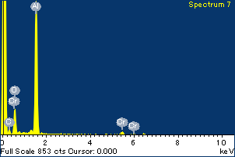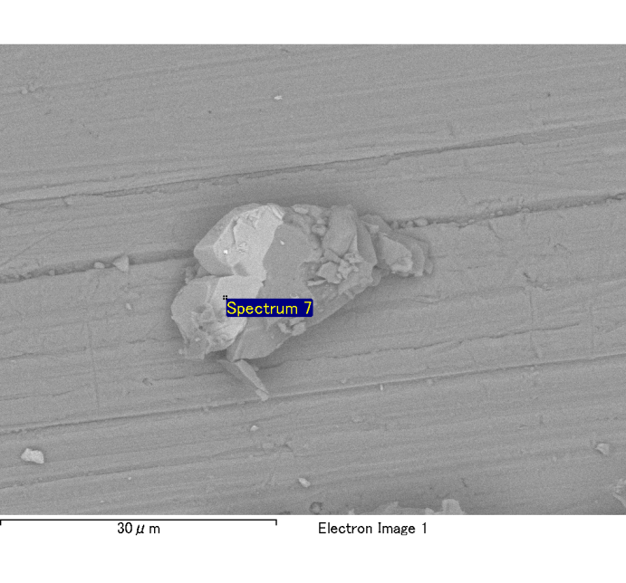

Spectrum Label: Spectrum 7

Livetime 120.0 s

Acquisition geometry ( degrees ):

Tilt = 0.0

Azimuth = 0.0

Elevation = 30.0

Accelerating voltage = 10.00 kV

Total spectrum counts = 118646

|  |  |  |  |
| --- | --- | --- | --- |
| Sample data : | Energy (eV) | Resn. (eV) | Area |
| Strobe : | 3.8 | 54.08 | 1208032 |
|  |  |  |  |
| Optimization data : Cobalt K series |  |  |  |
|  | Energy (eV) | Resn. (eV) | Area |
| Strobe : | .1 | 53.96 | 498142 |
| Optimization element : | 6926.7 | 142.17 | 16696 |

Spectrum processing :

No peaks omitted

Processing option : Oxygen by stoichiometry

Number of iterations = 2

Standard :

Na Albite 1-Jun-1999 12:00 AM

Mg MgO 1-Jun-1999 12:00 AM

Al Al2O3 1-Jun-1999 12:00 AM

Si SiO2 1-Jun-1999 12:00 AM

P GaP 1-Jun-1999 12:00 AM

S FeS2 1-Jun-1999 12:00 AM

K MAD-10 Feldspar 1-Jun-1999 12:00 AM

Ca Wollastonite 1-Jun-1999 12:00 AM

Cr Cr 1-Jun-1999 12:00 AM

Mn Mn 1-Jun-1999 12:00 AM

Fe Fe 1-Jun-1999 12:00 AM

Ni Ni 1-Jun-1999 12:00 AM

|  |  |  |  |  |  |
| --- | --- | --- | --- | --- | --- |
| Element | Weight% | Atomic% | Compd% | Formula |  |
|  |  |  |  |  |  |
| Na K | 0.00 | -0.18 | -0.01 | Na2O |  |
| Mg K | 0.02 | 0.69 | 0.03 | MgO |  |
| Al K | 0.81 | 31.66 | 1.52 | Al2O3 |  |
| Si K | 0.01 | 0.33 | 0.02 | SiO2 |  |
| P K | -0.01 | -0.18 | -0.01 | P2O5 |  |
| S K | 0.00 | 0.05 | 0.00 | SO3 |  |
| K K | 0.01 | 0.15 | 0.01 | K2O |  |
| Ca K | 0.00 | 0.06 | 0.00 | CaO |  |
| Cr K | 0.22 | 4.57 | 0.33 | Cr2O3 |  |
| Mn K | 0.00 | 0.05 | 0.00 | MnO |  |
| Fe K | 0.14 | 2.59 | 0.18 | FeO |  |
| Ni K | 0.06 | 1.06 | 0.07 | NiO |  |
| O | 0.89 | 59.14 |  |  |  |
| Totals | 2.14 |  |  |  |  |

Project: Project 1

Owner: Administrator

Site: Site of Interest 1

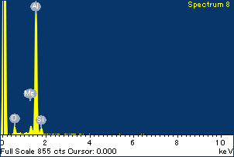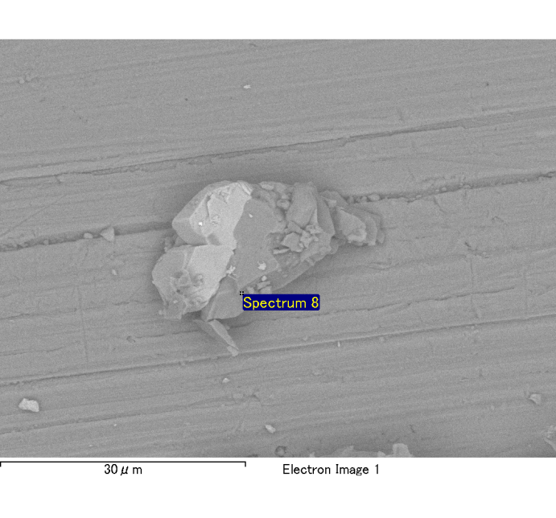

Spectrum Label: Spectrum 8

Livetime 120.0 s

Acquisition geometry ( degrees ):

Tilt = 0.0

Azimuth = 0.0

Elevation = 30.0

Accelerating voltage = 10.00 kV

Total spectrum counts = 117672

|  |  |  |  |
| --- | --- | --- | --- |
| Sample data : | Energy (eV) | Resn. (eV) | Area |
| Strobe : | 3.8 | 54.06 | 1207884 |
|  |  |  |  |
| Optimization data : Cobalt K series |  |  |  |
|  | Energy (eV) | Resn. (eV) | Area |
| Strobe : | .1 | 53.96 | 498142 |
| Optimization element : | 6926.7 | 142.17 | 16696 |

Spectrum processing :

No peaks omitted

Processing option : Oxygen by stoichiometry

Number of iterations = 2

Standard :

Na Albite 1-Jun-1999 12:00 AM

Mg MgO 1-Jun-1999 12:00 AM

Al Al2O3 1-Jun-1999 12:00 AM

Si SiO2 1-Jun-1999 12:00 AM

P GaP 1-Jun-1999 12:00 AM

S FeS2 1-Jun-1999 12:00 AM

K MAD-10 Feldspar 1-Jun-1999 12:00 AM

Ca Wollastonite 1-Jun-1999 12:00 AM

Cr Cr 1-Jun-1999 12:00 AM

Mn Mn 1-Jun-1999 12:00 AM

Fe Fe 1-Jun-1999 12:00 AM

Ni Ni 1-Jun-1999 12:00 AM

|  |  |  |  |  |  |
| --- | --- | --- | --- | --- | --- |
| Element | Weight% | Atomic% | Compd% | Formula |  |
|  |  |  |  |  |  |
| Na K | 0.00 | 0.22 | 0.01 | Na2O |  |
| Mg K | 0.04 | 1.98 | 0.07 | MgO |  |
| Al K | 0.80 | 34.10 | 1.51 | Al2O3 |  |
| Si K | 0.05 | 2.09 | 0.11 | SiO2 |  |
| P K | 0.00 | 0.12 | 0.01 | P2O5 |  |
| S K | 0.00 | 0.05 | 0.00 | SO3 |  |
| K K | 0.00 | -0.01 | 0.00 | K2O |  |
| Ca K | 0.00 | 0.03 | 0.00 | CaO |  |
| Cr K | 0.01 | 0.21 | 0.01 | Cr2O3 |  |
| Mn K | -0.01 | -0.12 | -0.01 | MnO |  |
| Fe K | 0.13 | 2.63 | 0.16 | FeO |  |
| Ni K | -0.05 | -1.01 | -0.07 | NiO |  |
| O | 0.83 | 59.71 |  |  |  |
| Totals | 1.82 |  |  |  |  |

Project: Project 1

Owner: Administrator

Site: Site of Interest 1