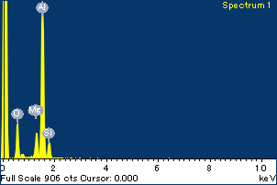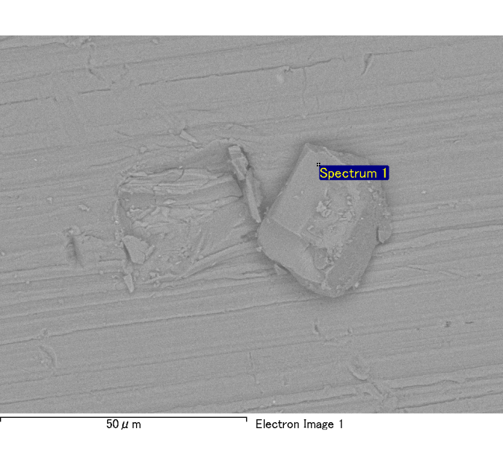

Spectrum Label: Spectrum 1

Livetime 120.0 s

Acquisition geometry ( degrees ):

Tilt = 0.0

Azimuth = 0.0

Elevation = 30.0

Accelerating voltage = 10.00 kV

Total spectrum counts = 120287

|  |  |  |  |
| --- | --- | --- | --- |
| Sample data : | Energy (eV) | Resn. (eV) | Area |
| Strobe : | 3.8 | 54.01 | 1207835 |
|  |  |  |  |
| Optimization data : Cobalt K series |  |  |  |
|  | Energy (eV) | Resn. (eV) | Area |
| Strobe : | .1 | 53.96 | 498142 |
| Optimization element : | 6926.7 | 142.17 | 16696 |

Spectrum processing :

No peaks omitted

Processing option : Oxygen by stoichiometry

Number of iterations = 2

Standard :

Na Albite 1-Jun-1999 12:00 AM

Mg MgO 1-Jun-1999 12:00 AM

Al Al2O3 1-Jun-1999 12:00 AM

Si SiO2 1-Jun-1999 12:00 AM

P GaP 1-Jun-1999 12:00 AM

S FeS2 1-Jun-1999 12:00 AM

K MAD-10 Feldspar 1-Jun-1999 12:00 AM

Ca Wollastonite 1-Jun-1999 12:00 AM

Cr Cr 1-Jun-1999 12:00 AM

Mn Mn 1-Jun-1999 12:00 AM

Fe Fe 1-Jun-1999 12:00 AM

Ni Ni 1-Jun-1999 12:00 AM

|  |  |  |  |  |  |
| --- | --- | --- | --- | --- | --- |
| Element | Weight% | Atomic% | Compd% | Formula |  |
|  |  |  |  |  |  |
| Na K | 0.00 | 0.03 | 0.00 | Na2O |  |
| Mg K | 0.12 | 4.70 | 0.20 | MgO |  |
| Al K | 0.85 | 30.27 | 1.61 | Al2O3 |  |
| Si K | 0.12 | 4.05 | 0.25 | SiO2 |  |
| P K | 0.00 | 0.06 | 0.00 | P2O5 |  |
| S K | 0.00 | -0.08 | -0.01 | SO3 |  |
| K K | 0.00 | 0.03 | 0.00 | K2O |  |
| Ca K | 0.00 | 0.01 | 0.00 | CaO |  |
| Cr K | -0.01 | -0.12 | -0.01 | Cr2O3 |  |
| Mn K | 0.02 | 0.34 | 0.02 | MnO |  |
| Fe K | 0.11 | 1.85 | 0.14 | FeO |  |
| Ni K | -0.04 | -0.64 | -0.05 | NiO |  |
| O | 0.99 | 59.51 |  |  |  |
| Totals | 2.16 |  |  |  |  |

Project: Project 1

Owner: Administrator

Site: Site of Interest 5

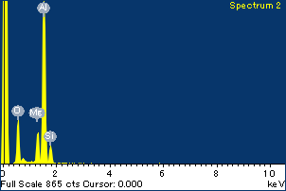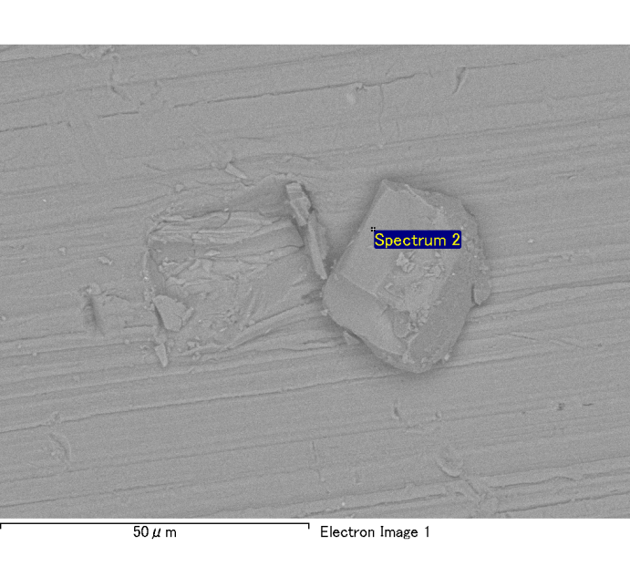

Spectrum Label: Spectrum 2

Livetime 120.0 s

Acquisition geometry ( degrees ):

Tilt = 0.0

Azimuth = 0.0

Elevation = 30.0

Accelerating voltage = 10.00 kV

Total spectrum counts = 119960

|  |  |  |  |
| --- | --- | --- | --- |
| Sample data : | Energy (eV) | Resn. (eV) | Area |
| Strobe : | 3.8 | 53.94 | 1208842 |
|  |  |  |  |
| Optimization data : Cobalt K series |  |  |  |
|  | Energy (eV) | Resn. (eV) | Area |
| Strobe : | .1 | 53.96 | 498142 |
| Optimization element : | 6926.7 | 142.17 | 16696 |

Spectrum processing :

No peaks omitted

Processing option : Oxygen by stoichiometry

Number of iterations = 2

Standard :

Na Albite 1-Jun-1999 12:00 AM

Mg MgO 1-Jun-1999 12:00 AM

Al Al2O3 1-Jun-1999 12:00 AM

Si SiO2 1-Jun-1999 12:00 AM

P GaP 1-Jun-1999 12:00 AM

S FeS2 1-Jun-1999 12:00 AM

K MAD-10 Feldspar 1-Jun-1999 12:00 AM

Ca Wollastonite 1-Jun-1999 12:00 AM

Cr Cr 1-Jun-1999 12:00 AM

Mn Mn 1-Jun-1999 12:00 AM

Fe Fe 1-Jun-1999 12:00 AM

Ni Ni 1-Jun-1999 12:00 AM

|  |  |  |  |  |  |
| --- | --- | --- | --- | --- | --- |
| Element | Weight% | Atomic% | Compd% | Formula |  |
|  |  |  |  |  |  |
| Na K | 0.00 | 0.10 | 0.00 | Na2O |  |
| Mg K | 0.13 | 5.15 | 0.21 | MgO |  |
| Al K | 0.83 | 30.12 | 1.56 | Al2O3 |  |
| Si K | 0.12 | 4.33 | 0.27 | SiO2 |  |
| P K | 0.00 | -0.11 | -0.01 | P2O5 |  |
| S K | 0.00 | 0.11 | 0.01 | SO3 |  |
| K K | 0.00 | -0.08 | 0.00 | K2O |  |
| Ca K | 0.00 | -0.06 | 0.00 | CaO |  |
| Cr K | -0.01 | -0.11 | -0.01 | Cr2O3 |  |
| Mn K | 0.01 | 0.12 | 0.01 | MnO |  |
| Fe K | 0.07 | 1.22 | 0.09 | FeO |  |
| Ni K | -0.03 | -0.48 | -0.04 | NiO |  |
| O | 0.97 | 59.69 |  |  |  |
| Totals | 2.09 |  |  |  |  |

Project: Project 1

Owner: Administrator

Site: Site of Interest 5

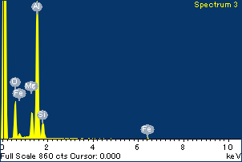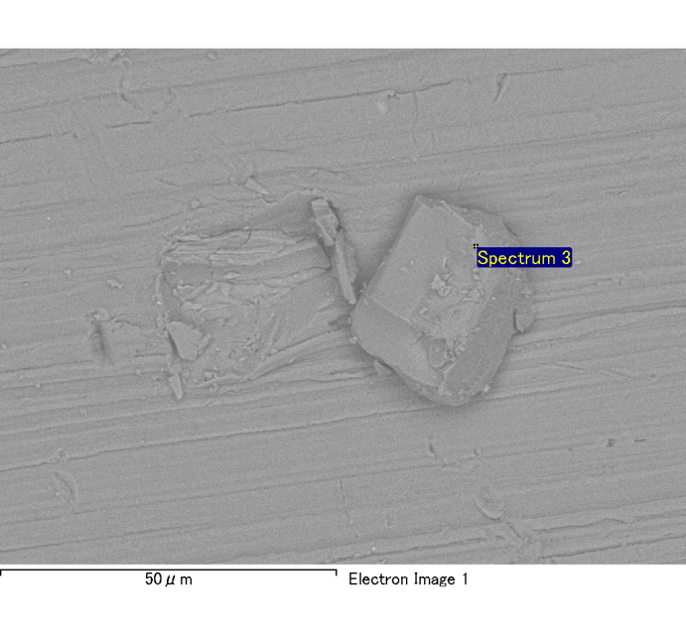

Spectrum Label: Spectrum 3

Livetime 120.0 s

Acquisition geometry ( degrees ):

Tilt = 0.0

Azimuth = 0.0

Elevation = 30.0

Accelerating voltage = 10.00 kV

Total spectrum counts = 120348

|  |  |  |  |
| --- | --- | --- | --- |
| Sample data : | Energy (eV) | Resn. (eV) | Area |
| Strobe : | 3.8 | 53.97 | 1209017 |
|  |  |  |  |
| Optimization data : Cobalt K series |  |  |  |
|  | Energy (eV) | Resn. (eV) | Area |
| Strobe : | .1 | 53.96 | 498142 |
| Optimization element : | 6926.7 | 142.17 | 16696 |

Spectrum processing :

No peaks omitted

Processing option : Oxygen by stoichiometry

Number of iterations = 2

Standard :

Na Albite 1-Jun-1999 12:00 AM

Mg MgO 1-Jun-1999 12:00 AM

Al Al2O3 1-Jun-1999 12:00 AM

Si SiO2 1-Jun-1999 12:00 AM

P GaP 1-Jun-1999 12:00 AM

S FeS2 1-Jun-1999 12:00 AM

K MAD-10 Feldspar 1-Jun-1999 12:00 AM

Ca Wollastonite 1-Jun-1999 12:00 AM

Cr Cr 1-Jun-1999 12:00 AM

Mn Mn 1-Jun-1999 12:00 AM

Fe Fe 1-Jun-1999 12:00 AM

Ni Ni 1-Jun-1999 12:00 AM

|  |  |  |  |  |  |
| --- | --- | --- | --- | --- | --- |
| Element | Weight% | Atomic% | Compd% | Formula |  |
|  |  |  |  |  |  |
| Na K | 0.00 | 0.02 | 0.00 | Na2O |  |
| Mg K | 0.14 | 5.37 | 0.23 | MgO |  |
| Al K | 0.84 | 29.00 | 1.58 | Al2O3 |  |
| Si K | 0.13 | 4.38 | 0.28 | SiO2 |  |
| P K | 0.00 | 0.14 | 0.01 | P2O5 |  |
| S K | 0.00 | -0.05 | 0.00 | SO3 |  |
| K K | 0.00 | 0.00 | 0.00 | K2O |  |
| Ca K | 0.00 | -0.01 | 0.00 | CaO |  |
| Cr K | 0.00 | 0.04 | 0.00 | Cr2O3 |  |
| Mn K | 0.00 | 0.05 | 0.00 | MnO |  |
| Fe K | 0.15 | 2.57 | 0.20 | FeO |  |
| Ni K | -0.06 | -1.00 | -0.08 | NiO |  |
| O | 1.02 | 59.50 |  |  |  |
| Totals | 2.22 |  |  |  |  |

Project: Project 1

Owner: Administrator

Site: Site of Interest 5

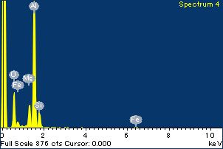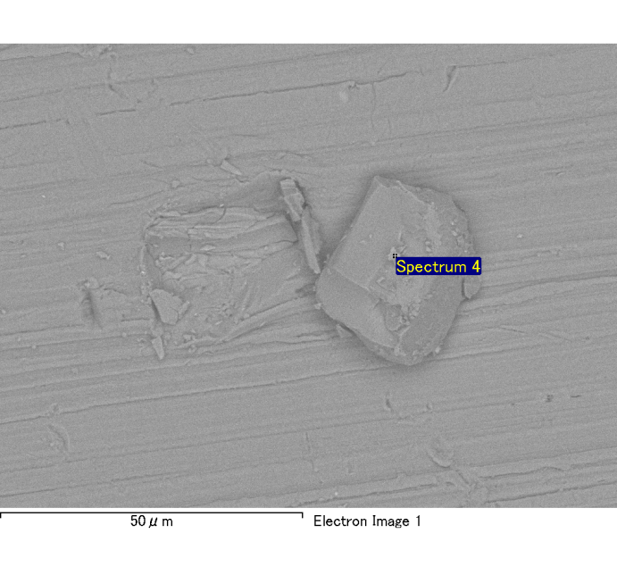

Spectrum Label: Spectrum 4

Livetime 120.0 s

Acquisition geometry ( degrees ):

Tilt = 0.0

Azimuth = 0.0

Elevation = 30.0

Accelerating voltage = 10.00 kV

Total spectrum counts = 120731

|  |  |  |  |
| --- | --- | --- | --- |
| Sample data : | Energy (eV) | Resn. (eV) | Area |
| Strobe : | 3.8 | 54.03 | 1207790 |
|  |  |  |  |
| Optimization data : Cobalt K series |  |  |  |
|  | Energy (eV) | Resn. (eV) | Area |
| Strobe : | .1 | 53.96 | 498142 |
| Optimization element : | 6926.7 | 142.17 | 16696 |

Spectrum processing :

No peaks omitted

Processing option : Oxygen by stoichiometry

Number of iterations = 2

Standard :

Na Albite 1-Jun-1999 12:00 AM

Mg MgO 1-Jun-1999 12:00 AM

Al Al2O3 1-Jun-1999 12:00 AM

Si SiO2 1-Jun-1999 12:00 AM

P GaP 1-Jun-1999 12:00 AM

S FeS2 1-Jun-1999 12:00 AM

K MAD-10 Feldspar 1-Jun-1999 12:00 AM

Ca Wollastonite 1-Jun-1999 12:00 AM

Cr Cr 1-Jun-1999 12:00 AM

Mn Mn 1-Jun-1999 12:00 AM

Fe Fe 1-Jun-1999 12:00 AM

Ni Ni 1-Jun-1999 12:00 AM

|  |  |  |  |  |  |
| --- | --- | --- | --- | --- | --- |
| Element | Weight% | Atomic% | Compd% | Formula |  |
|  |  |  |  |  |  |
| Na K | 0.00 | 0.07 | 0.00 | Na2O |  |
| Mg K | 0.14 | 5.02 | 0.23 | MgO |  |
| Al K | 0.86 | 27.68 | 1.62 | Al2O3 |  |
| Si K | 0.13 | 4.13 | 0.28 | SiO2 |  |
| P K | 0.01 | 0.20 | 0.02 | P2O5 |  |
| S K | 0.00 | 0.08 | 0.01 | SO3 |  |
| K K | 0.00 | -0.10 | -0.01 | K2O |  |
| Ca K | 0.00 | 0.03 | 0.00 | CaO |  |
| Cr K | -0.01 | -0.20 | -0.02 | Cr2O3 |  |
| Mn K | 0.00 | 0.07 | 0.01 | MnO |  |
| Fe K | 0.15 | 2.41 | 0.20 | FeO |  |
| Ni K | 0.10 | 1.44 | 0.12 | NiO |  |
| O | 1.08 | 59.17 |  |  |  |
| Totals | 2.47 |  |  |  |  |

Project: Project 1

Owner: Administrator

Site: Site of Interest 5

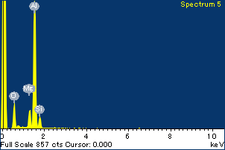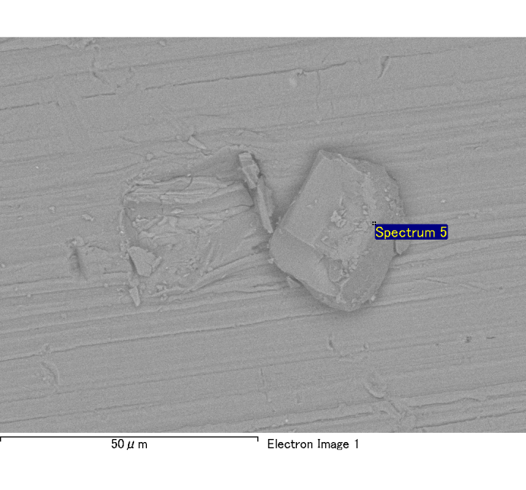

Spectrum Label: Spectrum 5

Livetime 120.0 s

Acquisition geometry ( degrees ):

Tilt = 0.0

Azimuth = 0.0

Elevation = 30.0

Accelerating voltage = 10.00 kV

Total spectrum counts = 119202

|  |  |  |  |
| --- | --- | --- | --- |
| Sample data : | Energy (eV) | Resn. (eV) | Area |
| Strobe : | 3.8 | 54.00 | 1208757 |
|  |  |  |  |
| Optimization data : Cobalt K series |  |  |  |
|  | Energy (eV) | Resn. (eV) | Area |
| Strobe : | .1 | 53.96 | 498142 |
| Optimization element : | 6926.7 | 142.17 | 16696 |

Spectrum processing :

No peaks omitted

Processing option : Oxygen by stoichiometry

Number of iterations = 2

Standard :

Na Albite 1-Jun-1999 12:00 AM

Mg MgO 1-Jun-1999 12:00 AM

Al Al2O3 1-Jun-1999 12:00 AM

Si SiO2 1-Jun-1999 12:00 AM

P GaP 1-Jun-1999 12:00 AM

S FeS2 1-Jun-1999 12:00 AM

K MAD-10 Feldspar 1-Jun-1999 12:00 AM

Ca Wollastonite 1-Jun-1999 12:00 AM

Cr Cr 1-Jun-1999 12:00 AM

Mn Mn 1-Jun-1999 12:00 AM

Fe Fe 1-Jun-1999 12:00 AM

Ni Ni 1-Jun-1999 12:00 AM

|  |  |  |  |  |  |
| --- | --- | --- | --- | --- | --- |
| Element | Weight% | Atomic% | Compd% | Formula |  |
|  |  |  |  |  |  |
| Na K | 0.00 | 0.08 | 0.00 | Na2O |  |
| Mg K | 0.10 | 4.20 | 0.17 | MgO |  |
| Al K | 0.82 | 30.59 | 1.55 | Al2O3 |  |
| Si K | 0.10 | 3.58 | 0.21 | SiO2 |  |
| P K | 0.00 | 0.03 | 0.00 | P2O5 |  |
| S K | 0.00 | 0.00 | 0.00 | SO3 |  |
| K K | 0.00 | -0.05 | 0.00 | K2O |  |
| Ca K | 0.00 | -0.05 | 0.00 | CaO |  |
| Cr K | 0.00 | 0.04 | 0.00 | Cr2O3 |  |
| Mn K | 0.02 | 0.38 | 0.03 | MnO |  |
| Fe K | 0.07 | 1.20 | 0.09 | FeO |  |
| Ni K | 0.03 | 0.53 | 0.04 | NiO |  |
| O | 0.95 | 59.47 |  |  |  |
| Totals | 2.09 |  |  |  |  |

Project: Project 1

Owner: Administrator

Site: Site of Interest 5

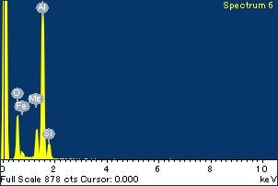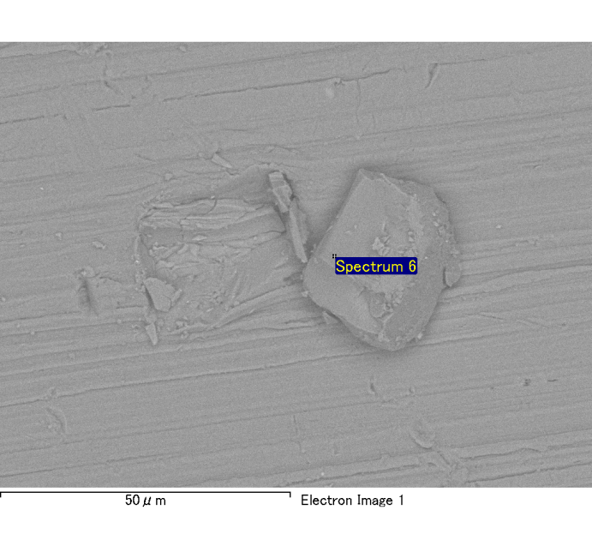

Spectrum Label: Spectrum 6

Livetime 120.0 s

Acquisition geometry ( degrees ):

Tilt = 0.0

Azimuth = 0.0

Elevation = 30.0

Accelerating voltage = 10.00 kV

Total spectrum counts = 120919

|  |  |  |  |
| --- | --- | --- | --- |
| Sample data : | Energy (eV) | Resn. (eV) | Area |
| Strobe : | 3.8 | 54.02 | 1207853 |
|  |  |  |  |
| Optimization data : Cobalt K series |  |  |  |
|  | Energy (eV) | Resn. (eV) | Area |
| Strobe : | .1 | 53.96 | 498142 |
| Optimization element : | 6926.7 | 142.17 | 16696 |

Spectrum processing :

No peaks omitted

Processing option : Oxygen by stoichiometry

Number of iterations = 2

Standard :

Na Albite 1-Jun-1999 12:00 AM

Mg MgO 1-Jun-1999 12:00 AM

Al Al2O3 1-Jun-1999 12:00 AM

Si SiO2 1-Jun-1999 12:00 AM

P GaP 1-Jun-1999 12:00 AM

S FeS2 1-Jun-1999 12:00 AM

K MAD-10 Feldspar 1-Jun-1999 12:00 AM

Ca Wollastonite 1-Jun-1999 12:00 AM

Cr Cr 1-Jun-1999 12:00 AM

Mn Mn 1-Jun-1999 12:00 AM

Fe Fe 1-Jun-1999 12:00 AM

Ni Ni 1-Jun-1999 12:00 AM

|  |  |  |  |  |  |
| --- | --- | --- | --- | --- | --- |
| Element | Weight% | Atomic% | Compd% | Formula |  |
|  |  |  |  |  |  |
| Na K | 0.00 | 0.02 | 0.00 | Na2O |  |
| Mg K | 0.14 | 5.55 | 0.23 | MgO |  |
| Al K | 0.84 | 30.27 | 1.59 | Al2O3 |  |
| Si K | 0.12 | 4.09 | 0.25 | SiO2 |  |
| P K | 0.00 | -0.01 | 0.00 | P2O5 |  |
| S K | 0.00 | -0.02 | 0.00 | SO3 |  |
| K K | 0.00 | 0.12 | 0.01 | K2O |  |
| Ca K | 0.00 | 0.01 | 0.00 | CaO |  |
| Cr K | 0.00 | -0.04 | 0.00 | Cr2O3 |  |
| Mn K | 0.00 | -0.03 | 0.00 | MnO |  |
| Fe K | 0.10 | 1.69 | 0.12 | FeO |  |
| Ni K | -0.07 | -1.20 | -0.09 | NiO |  |
| O | 0.98 | 59.55 |  |  |  |
| Totals | 2.10 |  |  |  |  |

Project: Project 1

Owner: Administrator

Site: Site of Interest 5

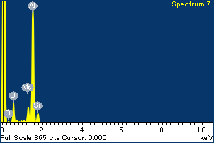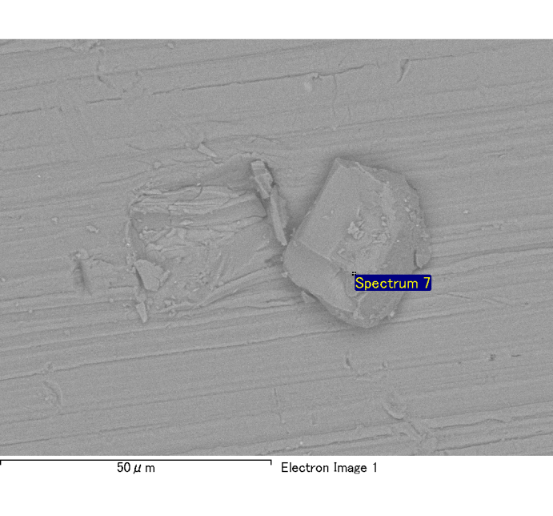

Spectrum Label: Spectrum 7

Livetime 120.0 s

Acquisition geometry ( degrees ):

Tilt = 0.0

Azimuth = 0.0

Elevation = 30.0

Accelerating voltage = 10.00 kV

Total spectrum counts = 118460

|  |  |  |  |
| --- | --- | --- | --- |
| Sample data : | Energy (eV) | Resn. (eV) | Area |
| Strobe : | 3.8 | 53.92 | 1207854 |
|  |  |  |  |
| Optimization data : Cobalt K series |  |  |  |
|  | Energy (eV) | Resn. (eV) | Area |
| Strobe : | .1 | 53.96 | 498142 |
| Optimization element : | 6926.7 | 142.17 | 16696 |

Spectrum processing :

No peaks omitted

Processing option : Oxygen by stoichiometry

Number of iterations = 2

Standard :

Na Albite 1-Jun-1999 12:00 AM

Mg MgO 1-Jun-1999 12:00 AM

Al Al2O3 1-Jun-1999 12:00 AM

Si SiO2 1-Jun-1999 12:00 AM

P GaP 1-Jun-1999 12:00 AM

S FeS2 1-Jun-1999 12:00 AM

K MAD-10 Feldspar 1-Jun-1999 12:00 AM

Ca Wollastonite 1-Jun-1999 12:00 AM

Cr Cr 1-Jun-1999 12:00 AM

Mn Mn 1-Jun-1999 12:00 AM

Fe Fe 1-Jun-1999 12:00 AM

Ni Ni 1-Jun-1999 12:00 AM

|  |  |  |  |  |  |
| --- | --- | --- | --- | --- | --- |
| Element | Weight% | Atomic% | Compd% | Formula |  |
|  |  |  |  |  |  |
| Na K | 0.00 | 0.12 | 0.00 | Na2O |  |
| Mg K | 0.09 | 3.79 | 0.15 | MgO |  |
| Al K | 0.83 | 30.87 | 1.57 | Al2O3 |  |
| Si K | 0.09 | 3.26 | 0.20 | SiO2 |  |
| P K | 0.00 | -0.06 | 0.00 | P2O5 |  |
| S K | 0.01 | 0.25 | 0.02 | SO3 |  |
| K K | 0.00 | 0.00 | 0.00 | K2O |  |
| Ca K | 0.00 | 0.05 | 0.00 | CaO |  |
| Cr K | -0.01 | -0.23 | -0.02 | Cr2O3 |  |
| Mn K | 0.04 | 0.65 | 0.05 | MnO |  |
| Fe K | 0.07 | 1.31 | 0.09 | FeO |  |
| Ni K | 0.03 | 0.53 | 0.04 | NiO |  |
| O | 0.95 | 59.46 |  |  |  |
| Totals | 2.10 |  |  |  |  |

Project: Project 1

Owner: Administrator

Site: Site of Interest 5

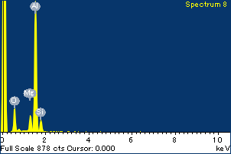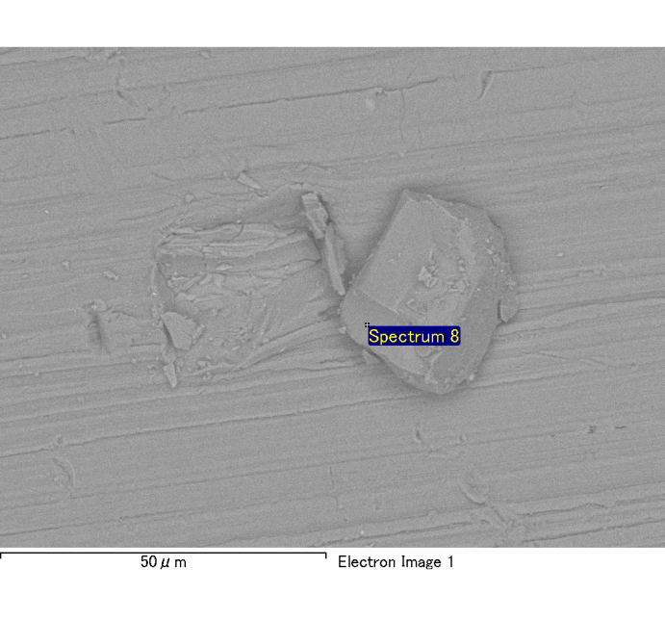

Spectrum Label: Spectrum 8

Livetime 120.0 s

Acquisition geometry ( degrees ):

Tilt = 0.0

Azimuth = 0.0

Elevation = 30.0

Accelerating voltage = 10.00 kV

Total spectrum counts = 118744

|  |  |  |  |
| --- | --- | --- | --- |
| Sample data : | Energy (eV) | Resn. (eV) | Area |
| Strobe : | 3.8 | 54.04 | 1209239 |
|  |  |  |  |
| Optimization data : Cobalt K series |  |  |  |
|  | Energy (eV) | Resn. (eV) | Area |
| Strobe : | .1 | 53.96 | 498142 |
| Optimization element : | 6926.7 | 142.17 | 16696 |

Spectrum processing :

No peaks omitted

Processing option : Oxygen by stoichiometry

Number of iterations = 2

Standard :

Na Albite 1-Jun-1999 12:00 AM

Mg MgO 1-Jun-1999 12:00 AM

Al Al2O3 1-Jun-1999 12:00 AM

Si SiO2 1-Jun-1999 12:00 AM

P GaP 1-Jun-1999 12:00 AM

S FeS2 1-Jun-1999 12:00 AM

K MAD-10 Feldspar 1-Jun-1999 12:00 AM

Ca Wollastonite 1-Jun-1999 12:00 AM

Cr Cr 1-Jun-1999 12:00 AM

Mn Mn 1-Jun-1999 12:00 AM

Fe Fe 1-Jun-1999 12:00 AM

Ni Ni 1-Jun-1999 12:00 AM

|  |  |  |  |  |  |
| --- | --- | --- | --- | --- | --- |
| Element | Weight% | Atomic% | Compd% | Formula |  |
|  |  |  |  |  |  |
| Na K | 0.00 | -0.09 | 0.00 | Na2O |  |
| Mg K | 0.09 | 4.03 | 0.15 | MgO |  |
| Al K | 0.81 | 31.74 | 1.54 | Al2O3 |  |
| Si K | 0.10 | 3.88 | 0.22 | SiO2 |  |
| P K | 0.00 | 0.07 | 0.00 | P2O5 |  |
| S K | 0.00 | 0.06 | 0.00 | SO3 |  |
| K K | 0.01 | 0.19 | 0.01 | K2O |  |
| Ca K | 0.00 | 0.04 | 0.00 | CaO |  |
| Cr K | 0.00 | -0.03 | 0.00 | Cr2O3 |  |
| Mn K | 0.00 | 0.07 | 0.00 | MnO |  |
| Fe K | 0.06 | 1.08 | 0.07 | FeO |  |
| Ni K | -0.05 | -0.98 | -0.07 | NiO |  |
| O | 0.91 | 59.95 |  |  |  |
| Totals | 1.94 |  |  |  |  |

Project: Project 1

Owner: Administrator

Site: Site of Interest 5