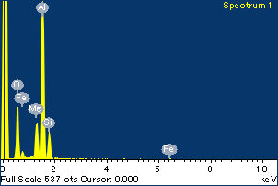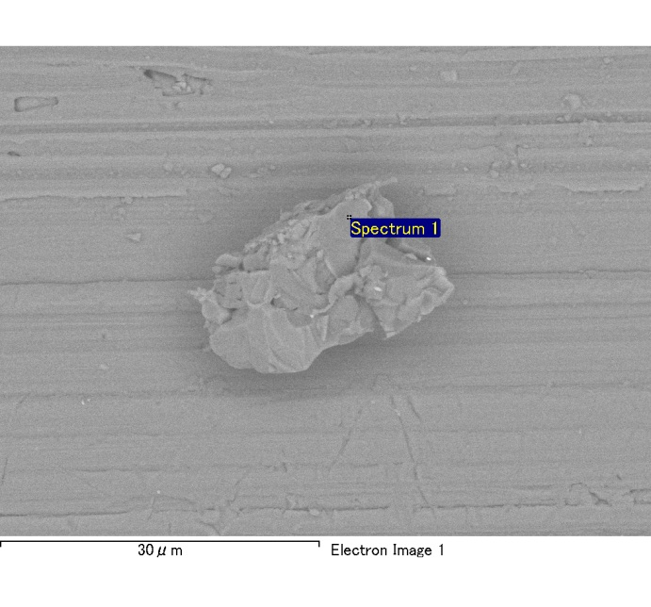

Spectrum Label: Spectrum 1

Livetime 120.0 s

Acquisition geometry ( degrees ):

Tilt = 0.0

Azimuth = 0.0

Elevation = 30.0

Accelerating voltage = 10.00 kV

Total spectrum counts = 115508

|  |  |  |  |
| --- | --- | --- | --- |
| Sample data : | Energy (eV) | Resn. (eV) | Area |
| Strobe : | 3.8 | 53.96 | 1207603 |
|  |  |  |  |
| Optimization data : Cobalt K series |  |  |  |
|  | Energy (eV) | Resn. (eV) | Area |
| Strobe : | .1 | 53.96 | 498142 |
| Optimization element : | 6926.7 | 142.17 | 16696 |

Spectrum processing :

No peaks omitted

Processing option : Oxygen by stoichiometry

Number of iterations = 2

Standard :

Na Albite 1-Jun-1999 12:00 AM

Mg MgO 1-Jun-1999 12:00 AM

Al Al2O3 1-Jun-1999 12:00 AM

Si SiO2 1-Jun-1999 12:00 AM

P GaP 1-Jun-1999 12:00 AM

S FeS2 1-Jun-1999 12:00 AM

K MAD-10 Feldspar 1-Jun-1999 12:00 AM

Ca Wollastonite 1-Jun-1999 12:00 AM

Cr Cr 1-Jun-1999 12:00 AM

Mn Mn 1-Jun-1999 12:00 AM

Fe Fe 1-Jun-1999 12:00 AM

Ni Ni 1-Jun-1999 12:00 AM

|  |  |  |  |  |  |
| --- | --- | --- | --- | --- | --- |
| Element | Weight% | Atomic% | Compd% | Formula |  |
|  |  |  |  |  |  |
| Na K | 0.00 | 0.21 | 0.00 | Na2O |  |
| Mg K | 0.10 | 5.90 | 0.17 | MgO |  |
| Al K | 0.53 | 27.71 | 1.00 | Al2O3 |  |
| Si K | 0.11 | 5.33 | 0.23 | SiO2 |  |
| P K | 0.00 | 0.12 | 0.01 | P2O5 |  |
| S K | 0.00 | -0.02 | 0.00 | SO3 |  |
| K K | 0.00 | -0.11 | 0.00 | K2O |  |
| Ca K | 0.00 | -0.04 | 0.00 | CaO |  |
| Cr K | 0.00 | 0.07 | 0.00 | Cr2O3 |  |
| Mn K | 0.00 | -0.13 | -0.01 | MnO |  |
| Fe K | 0.09 | 2.29 | 0.12 | FeO |  |
| Ni K | -0.04 | -0.98 | -0.05 | NiO |  |
| O | 0.68 | 59.66 |  |  |  |
| Totals | 1.46 |  |  |  |  |

Project: Project 1

Owner: Administrator

Site: Site of Interest 6

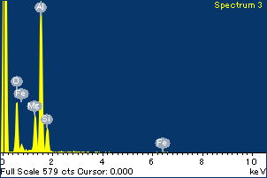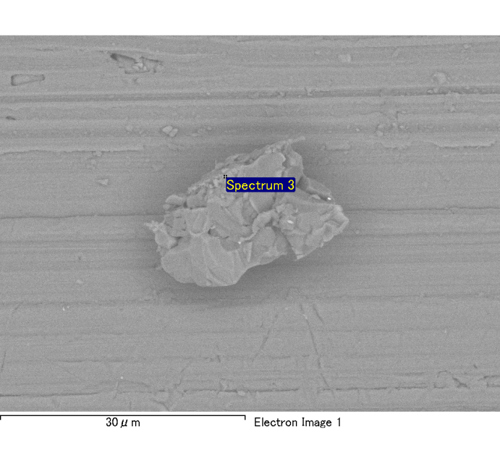

Spectrum Label: Spectrum 3

Livetime 120.0 s

Acquisition geometry ( degrees ):

Tilt = 0.0

Azimuth = 0.0

Elevation = 30.0

Accelerating voltage = 10.00 kV

Total spectrum counts = 116401

|  |  |  |  |
| --- | --- | --- | --- |
| Sample data : | Energy (eV) | Resn. (eV) | Area |
| Strobe : | 3.8 | 54.03 | 1208421 |
|  |  |  |  |
| Optimization data : Cobalt K series |  |  |  |
|  | Energy (eV) | Resn. (eV) | Area |
| Strobe : | .1 | 53.96 | 498142 |
| Optimization element : | 6926.7 | 142.17 | 16696 |

Spectrum processing :

No peaks omitted

Processing option : Oxygen by stoichiometry

Number of iterations = 2

Standard :

Na Albite 1-Jun-1999 12:00 AM

Mg MgO 1-Jun-1999 12:00 AM

Al Al2O3 1-Jun-1999 12:00 AM

Si SiO2 1-Jun-1999 12:00 AM

P GaP 1-Jun-1999 12:00 AM

S FeS2 1-Jun-1999 12:00 AM

K MAD-10 Feldspar 1-Jun-1999 12:00 AM

Ca Wollastonite 1-Jun-1999 12:00 AM

Cr Cr 1-Jun-1999 12:00 AM

Mn Mn 1-Jun-1999 12:00 AM

Fe Fe 1-Jun-1999 12:00 AM

Ni Ni 1-Jun-1999 12:00 AM

|  |  |  |  |  |  |
| --- | --- | --- | --- | --- | --- |
| Element | Weight% | Atomic% | Compd% | Formula |  |
|  |  |  |  |  |  |
| Na K | 0.00 | 0.03 | 0.00 | Na2O |  |
| Mg K | 0.13 | 6.85 | 0.21 | MgO |  |
| Al K | 0.54 | 26.30 | 1.01 | Al2O3 |  |
| Si K | 0.12 | 5.72 | 0.26 | SiO2 |  |
| P K | 0.00 | -0.15 | -0.01 | P2O5 |  |
| S K | 0.00 | 0.06 | 0.00 | SO3 |  |
| K K | 0.00 | 0.08 | 0.00 | K2O |  |
| Ca K | 0.00 | 0.15 | 0.01 | CaO |  |
| Cr K | -0.02 | -0.46 | -0.03 | Cr2O3 |  |
| Mn K | -0.01 | -0.14 | -0.01 | MnO |  |
| Fe K | 0.08 | 1.90 | 0.10 | FeO |  |
| Ni K | 0.02 | 0.42 | 0.02 | NiO |  |
| O | 0.71 | 59.24 |  |  |  |
| Totals | 1.58 |  |  |  |  |

Project: Project 1

Owner: Administrator

Site: Site of Interest 6



Spectrum Label: Spectrum 3

Livetime 120.0 s

Acquisition geometry ( degrees ):

Tilt = 0.0

Azimuth = 0.0

Elevation = 30.0

Accelerating voltage = 10.00 kV

Total spectrum counts = 116401

|  |  |  |  |
| --- | --- | --- | --- |
| Sample data : | Energy (eV) | Resn. (eV) | Area |
| Strobe : | 3.8 | 54.03 | 1208421 |
|  |  |  |  |
| Optimization data : Cobalt K series |  |  |  |
|  | Energy (eV) | Resn. (eV) | Area |
| Strobe : | .1 | 53.96 | 498142 |
| Optimization element : | 6926.7 | 142.17 | 16696 |

Spectrum processing :

No peaks omitted

Processing option : Oxygen by stoichiometry

Number of iterations = 2

Standard :

Na Albite 1-Jun-1999 12:00 AM

Mg MgO 1-Jun-1999 12:00 AM

Al Al2O3 1-Jun-1999 12:00 AM

Si SiO2 1-Jun-1999 12:00 AM

P GaP 1-Jun-1999 12:00 AM

S FeS2 1-Jun-1999 12:00 AM

K MAD-10 Feldspar 1-Jun-1999 12:00 AM

Ca Wollastonite 1-Jun-1999 12:00 AM

Cr Cr 1-Jun-1999 12:00 AM

Mn Mn 1-Jun-1999 12:00 AM

Fe Fe 1-Jun-1999 12:00 AM

Ni Ni 1-Jun-1999 12:00 AM

|  |  |  |  |  |  |
| --- | --- | --- | --- | --- | --- |
| Element | Weight% | Atomic% | Compd% | Formula |  |
|  |  |  |  |  |  |
| Na K | 0.00 | 0.03 | 0.00 | Na2O |  |
| Mg K | 0.13 | 6.85 | 0.21 | MgO |  |
| Al K | 0.54 | 26.30 | 1.01 | Al2O3 |  |
| Si K | 0.12 | 5.72 | 0.26 | SiO2 |  |
| P K | 0.00 | -0.15 | -0.01 | P2O5 |  |
| S K | 0.00 | 0.06 | 0.00 | SO3 |  |
| K K | 0.00 | 0.08 | 0.00 | K2O |  |
| Ca K | 0.00 | 0.15 | 0.01 | CaO |  |
| Cr K | -0.02 | -0.46 | -0.03 | Cr2O3 |  |
| Mn K | -0.01 | -0.14 | -0.01 | MnO |  |
| Fe K | 0.08 | 1.90 | 0.10 | FeO |  |
| Ni K | 0.02 | 0.42 | 0.02 | NiO |  |
| O | 0.71 | 59.24 |  |  |  |
| Totals | 1.58 |  |  |  |  |

Project: Project 1

Owner: Administrator

Site: Site of Interest 6

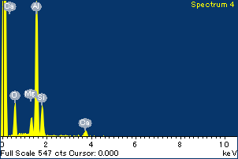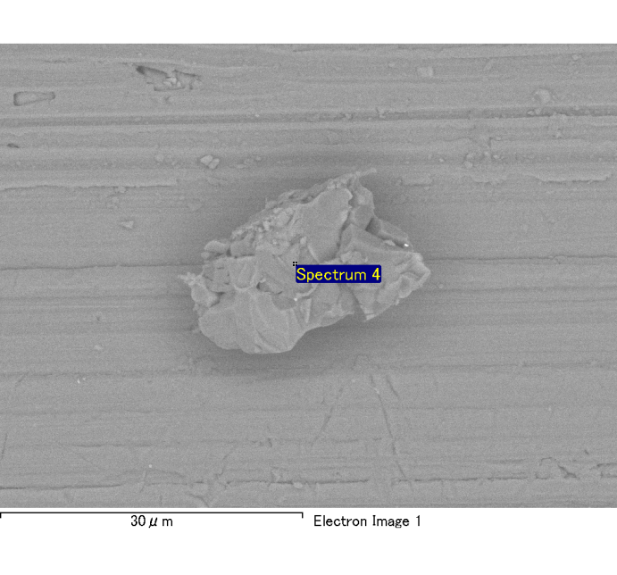

Spectrum Label: Spectrum 4

Livetime 120.0 s

Acquisition geometry ( degrees ):

Tilt = 0.0

Azimuth = 0.0

Elevation = 30.0

Accelerating voltage = 10.00 kV

Total spectrum counts = 116432

|  |  |  |  |
| --- | --- | --- | --- |
| Sample data : | Energy (eV) | Resn. (eV) | Area |
| Strobe : | 3.8 | 53.98 | 1207825 |
|  |  |  |  |
| Optimization data : Cobalt K series |  |  |  |
|  | Energy (eV) | Resn. (eV) | Area |
| Strobe : | .1 | 53.96 | 498142 |
| Optimization element : | 6926.7 | 142.17 | 16696 |

Spectrum processing :

No peaks omitted

Processing option : Oxygen by stoichiometry

Number of iterations = 2

Standard :

Na Albite 1-Jun-1999 12:00 AM

Mg MgO 1-Jun-1999 12:00 AM

Al Al2O3 1-Jun-1999 12:00 AM

Si SiO2 1-Jun-1999 12:00 AM

P GaP 1-Jun-1999 12:00 AM

S FeS2 1-Jun-1999 12:00 AM

K MAD-10 Feldspar 1-Jun-1999 12:00 AM

Ca Wollastonite 1-Jun-1999 12:00 AM

Cr Cr 1-Jun-1999 12:00 AM

Mn Mn 1-Jun-1999 12:00 AM

Fe Fe 1-Jun-1999 12:00 AM

Ni Ni 1-Jun-1999 12:00 AM

|  |  |  |  |  |  |
| --- | --- | --- | --- | --- | --- |
| Element | Weight% | Atomic% | Compd% | Formula |  |
|  |  |  |  |  |  |
| Na K | 0.00 | 0.14 | 0.00 | Na2O |  |
| Mg K | 0.06 | 3.17 | 0.10 | MgO |  |
| Al K | 0.54 | 25.32 | 1.01 | Al2O3 |  |
| Si K | 0.15 | 6.75 | 0.32 | SiO2 |  |
| P K | 0.00 | 0.07 | 0.00 | P2O5 |  |
| S K | 0.00 | 0.03 | 0.00 | SO3 |  |
| K K | 0.00 | -0.02 | 0.00 | K2O |  |
| Ca K | 0.08 | 2.41 | 0.11 | CaO |  |
| Cr K | 0.01 | 0.23 | 0.01 | Cr2O3 |  |
| Mn K | 0.00 | 0.08 | 0.00 | MnO |  |
| Fe K | 0.03 | 0.75 | 0.04 | FeO |  |
| Ni K | 0.06 | 1.26 | 0.07 | NiO |  |
| O | 0.75 | 59.81 |  |  |  |
| Totals | 1.68 |  |  |  |  |

Project: Project 1

Owner: Administrator

Site: Site of Interest 6

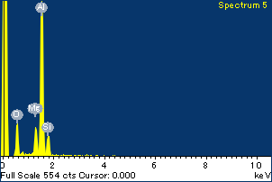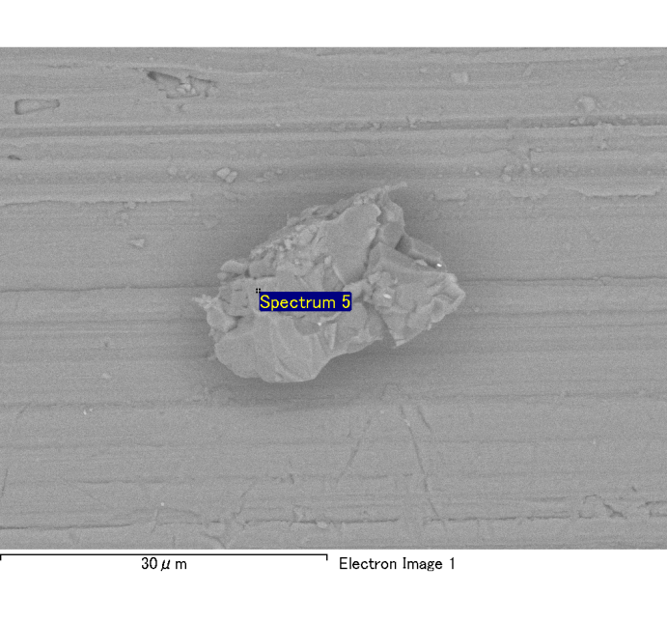

Spectrum Label: Spectrum 5

Livetime 120.0 s

Acquisition geometry ( degrees ):

Tilt = 0.0

Azimuth = 0.0

Elevation = 30.0

Accelerating voltage = 10.00 kV

Total spectrum counts = 115663

|  |  |  |  |
| --- | --- | --- | --- |
| Sample data : | Energy (eV) | Resn. (eV) | Area |
| Strobe : | 3.8 | 53.94 | 1210179 |
|  |  |  |  |
| Optimization data : Cobalt K series |  |  |  |
|  | Energy (eV) | Resn. (eV) | Area |
| Strobe : | .1 | 53.96 | 498142 |
| Optimization element : | 6926.7 | 142.17 | 16696 |

Spectrum processing :

No peaks omitted

Processing option : Oxygen by stoichiometry

Number of iterations = 2

Standard :

Na Albite 1-Jun-1999 12:00 AM

Mg MgO 1-Jun-1999 12:00 AM

Al Al2O3 1-Jun-1999 12:00 AM

Si SiO2 1-Jun-1999 12:00 AM

P GaP 1-Jun-1999 12:00 AM

S FeS2 1-Jun-1999 12:00 AM

K MAD-10 Feldspar 1-Jun-1999 12:00 AM

Ca Wollastonite 1-Jun-1999 12:00 AM

Cr Cr 1-Jun-1999 12:00 AM

Mn Mn 1-Jun-1999 12:00 AM

Fe Fe 1-Jun-1999 12:00 AM

Ni Ni 1-Jun-1999 12:00 AM

|  |  |  |  |  |  |
| --- | --- | --- | --- | --- | --- |
| Element | Weight% | Atomic% | Compd% | Formula |  |
|  |  |  |  |  |  |
| Na K | 0.00 | -0.11 | 0.00 | Na2O |  |
| Mg K | 0.08 | 4.80 | 0.13 | MgO |  |
| Al K | 0.55 | 29.79 | 1.05 | Al2O3 |  |
| Si K | 0.09 | 4.79 | 0.20 | SiO2 |  |
| P K | 0.00 | -0.11 | -0.01 | P2O5 |  |
| S K | 0.00 | 0.01 | 0.00 | SO3 |  |
| K K | 0.00 | -0.14 | 0.00 | K2O |  |
| Ca K | 0.01 | 0.19 | 0.01 | CaO |  |
| Cr K | 0.00 | 0.09 | 0.00 | Cr2O3 |  |
| Mn K | -0.01 | -0.19 | -0.01 | MnO |  |
| Fe K | 0.04 | 0.94 | 0.05 | FeO |  |
| Ni K | 0.00 | 0.11 | 0.01 | NiO |  |
| O | 0.66 | 59.85 |  |  |  |
| Totals | 1.42 |  |  |  |  |

Project: Project 1

Owner: Administrator

Site: Site of Interest 6

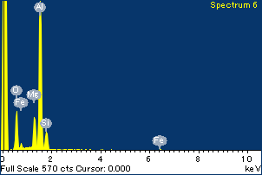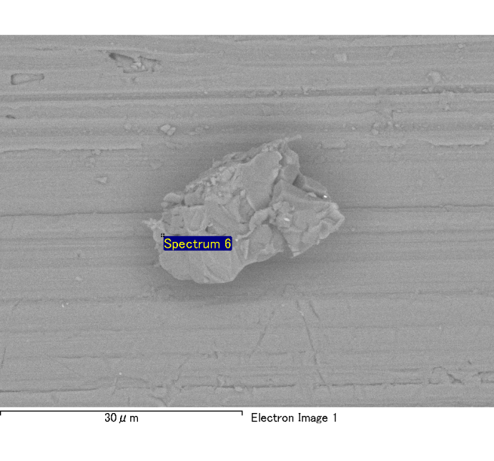

Spectrum Label: Spectrum 6

Livetime 120.0 s

Acquisition geometry ( degrees ):

Tilt = 0.0

Azimuth = 0.0

Elevation = 30.0

Accelerating voltage = 10.00 kV

Total spectrum counts = 115987

|  |  |  |  |
| --- | --- | --- | --- |
| Sample data : | Energy (eV) | Resn. (eV) | Area |
| Strobe : | 3.8 | 54.00 | 1207725 |
|  |  |  |  |
| Optimization data : Cobalt K series |  |  |  |
|  | Energy (eV) | Resn. (eV) | Area |
| Strobe : | .1 | 53.96 | 498142 |
| Optimization element : | 6926.7 | 142.17 | 16696 |

Spectrum processing :

No peaks omitted

Processing option : Oxygen by stoichiometry

Number of iterations = 2

Standard :

Na Albite 1-Jun-1999 12:00 AM

Mg MgO 1-Jun-1999 12:00 AM

Al Al2O3 1-Jun-1999 12:00 AM

Si SiO2 1-Jun-1999 12:00 AM

P GaP 1-Jun-1999 12:00 AM

S FeS2 1-Jun-1999 12:00 AM

K MAD-10 Feldspar 1-Jun-1999 12:00 AM

Ca Wollastonite 1-Jun-1999 12:00 AM

Cr Cr 1-Jun-1999 12:00 AM

Mn Mn 1-Jun-1999 12:00 AM

Fe Fe 1-Jun-1999 12:00 AM

Ni Ni 1-Jun-1999 12:00 AM

|  |  |  |  |  |  |
| --- | --- | --- | --- | --- | --- |
| Element | Weight% | Atomic% | Compd% | Formula |  |
|  |  |  |  |  |  |
| Na K | 0.00 | 0.09 | 0.00 | Na2O |  |
| Mg K | 0.10 | 5.68 | 0.17 | MgO |  |
| Al K | 0.56 | 27.94 | 1.07 | Al2O3 |  |
| Si K | 0.09 | 4.28 | 0.19 | SiO2 |  |
| P K | 0.00 | -0.04 | 0.00 | P2O5 |  |
| S K | 0.00 | 0.04 | 0.00 | SO3 |  |
| K K | 0.00 | 0.08 | 0.00 | K2O |  |
| Ca K | 0.00 | 0.06 | 0.00 | CaO |  |
| Cr K | 0.00 | 0.07 | 0.00 | Cr2O3 |  |
| Mn K | 0.01 | 0.22 | 0.01 | MnO |  |
| Fe K | 0.07 | 1.65 | 0.09 | FeO |  |
| Ni K | 0.04 | 0.80 | 0.04 | NiO |  |
| O | 0.71 | 59.12 |  |  |  |
| Totals | 1.59 |  |  |  |  |

Project: Project 1

Owner: Administrator

Site: Site of Interest 6

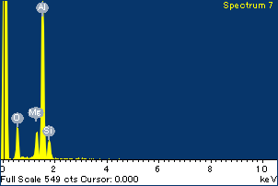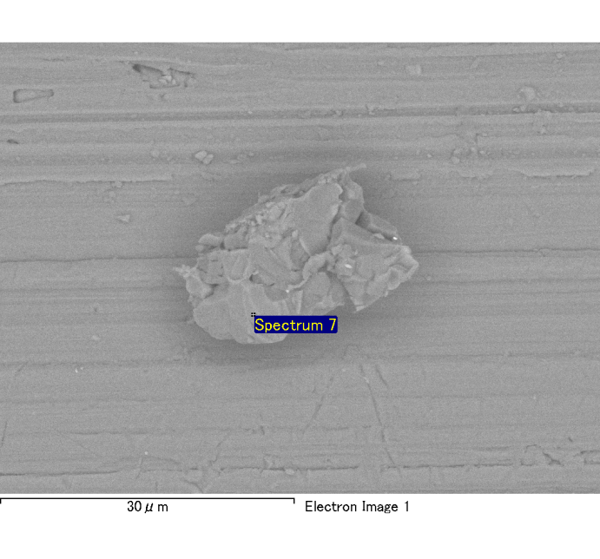

Spectrum Label: Spectrum 7

Livetime 120.0 s

Acquisition geometry ( degrees ):

Tilt = 0.0

Azimuth = 0.0

Elevation = 30.0

Accelerating voltage = 10.00 kV

Total spectrum counts = 114027

|  |  |  |  |
| --- | --- | --- | --- |
| Sample data : | Energy (eV) | Resn. (eV) | Area |
| Strobe : | 3.8 | 53.95 | 1208630 |
|  |  |  |  |
| Optimization data : Cobalt K series |  |  |  |
|  | Energy (eV) | Resn. (eV) | Area |
| Strobe : | .1 | 53.96 | 498142 |
| Optimization element : | 6926.7 | 142.17 | 16696 |

Spectrum processing :

No peaks omitted

Processing option : Oxygen by stoichiometry

Number of iterations = 2

Standard :

Na Albite 1-Jun-1999 12:00 AM

Mg MgO 1-Jun-1999 12:00 AM

Al Al2O3 1-Jun-1999 12:00 AM

Si SiO2 1-Jun-1999 12:00 AM

P GaP 1-Jun-1999 12:00 AM

S FeS2 1-Jun-1999 12:00 AM

K MAD-10 Feldspar 1-Jun-1999 12:00 AM

Ca Wollastonite 1-Jun-1999 12:00 AM

Cr Cr 1-Jun-1999 12:00 AM

Mn Mn 1-Jun-1999 12:00 AM

Fe Fe 1-Jun-1999 12:00 AM

Ni Ni 1-Jun-1999 12:00 AM

|  |  |  |  |  |  |
| --- | --- | --- | --- | --- | --- |
| Element | Weight% | Atomic% | Compd% | Formula |  |
|  |  |  |  |  |  |
| Na K | 0.00 | 0.12 | 0.00 | Na2O |  |
| Mg K | 0.08 | 4.74 | 0.13 | MgO |  |
| Al K | 0.53 | 30.20 | 1.01 | Al2O3 |  |
| Si K | 0.09 | 4.66 | 0.18 | SiO2 |  |
| P K | 0.00 | 0.16 | 0.01 | P2O5 |  |
| S K | 0.00 | -0.10 | -0.01 | SO3 |  |
| K K | 0.00 | -0.04 | 0.00 | K2O |  |
| Ca K | 0.00 | 0.00 | 0.00 | CaO |  |
| Cr K | 0.00 | -0.08 | 0.00 | Cr2O3 |  |
| Mn K | 0.01 | 0.24 | 0.01 | MnO |  |
| Fe K | 0.02 | 0.52 | 0.02 | FeO |  |
| Ni K | -0.01 | -0.26 | -0.01 | NiO |  |
| O | 0.63 | 59.85 |  |  |  |
| Totals | 1.34 |  |  |  |  |

Project: Project 1

Owner: Administrator

Site: Site of Interest 6

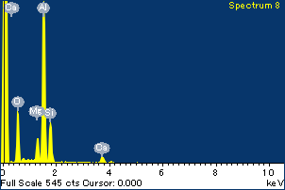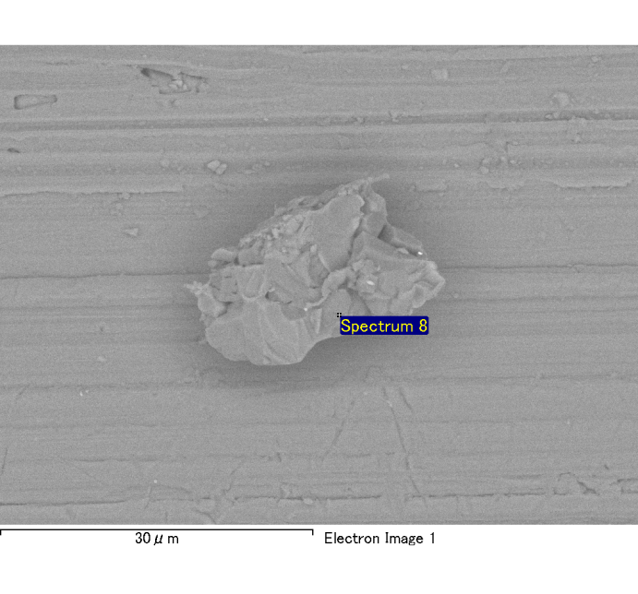

Spectrum Label: Spectrum 8

Livetime 120.0 s

Acquisition geometry ( degrees ):

Tilt = 0.0

Azimuth = 0.0

Elevation = 30.0

Accelerating voltage = 10.00 kV

Total spectrum counts = 116246

|  |  |  |  |
| --- | --- | --- | --- |
| Sample data : | Energy (eV) | Resn. (eV) | Area |
| Strobe : | 3.8 | 54.01 | 1208838 |
|  |  |  |  |
| Optimization data : Cobalt K series |  |  |  |
|  | Energy (eV) | Resn. (eV) | Area |
| Strobe : | .1 | 53.96 | 498142 |
| Optimization element : | 6926.7 | 142.17 | 16696 |

Spectrum processing :

No peaks omitted

Processing option : Oxygen by stoichiometry

Number of iterations = 2

Standard :

Na Albite 1-Jun-1999 12:00 AM

Mg MgO 1-Jun-1999 12:00 AM

Al Al2O3 1-Jun-1999 12:00 AM

Si SiO2 1-Jun-1999 12:00 AM

P GaP 1-Jun-1999 12:00 AM

S FeS2 1-Jun-1999 12:00 AM

K MAD-10 Feldspar 1-Jun-1999 12:00 AM

Ca Wollastonite 1-Jun-1999 12:00 AM

Cr Cr 1-Jun-1999 12:00 AM

Mn Mn 1-Jun-1999 12:00 AM

Fe Fe 1-Jun-1999 12:00 AM

Ni Ni 1-Jun-1999 12:00 AM

|  |  |  |  |  |  |
| --- | --- | --- | --- | --- | --- |
| Element | Weight% | Atomic% | Compd% | Formula |  |
|  |  |  |  |  |  |
| Na K | 0.00 | 0.14 | 0.00 | Na2O |  |
| Mg K | 0.07 | 3.34 | 0.11 | MgO |  |
| Al K | 0.54 | 24.93 | 1.03 | Al2O3 |  |
| Si K | 0.17 | 7.61 | 0.37 | SiO2 |  |
| P K | 0.00 | -0.05 | 0.00 | P2O5 |  |
| S K | 0.00 | 0.08 | 0.01 | SO3 |  |
| K K | 0.00 | -0.05 | 0.00 | K2O |  |
| Ca K | 0.08 | 2.32 | 0.11 | CaO |  |
| Cr K | 0.01 | 0.28 | 0.02 | Cr2O3 |  |
| Mn K | 0.00 | -0.10 | -0.01 | MnO |  |
| Fe K | 0.00 | -0.04 | 0.00 | FeO |  |
| Ni K | 0.07 | 1.40 | 0.08 | NiO |  |
| O | 0.78 | 60.13 |  |  |  |
| Totals | 1.71 |  |  |  |  |

Project: Project 1

Owner: Administrator

Site: Site of Interest 6