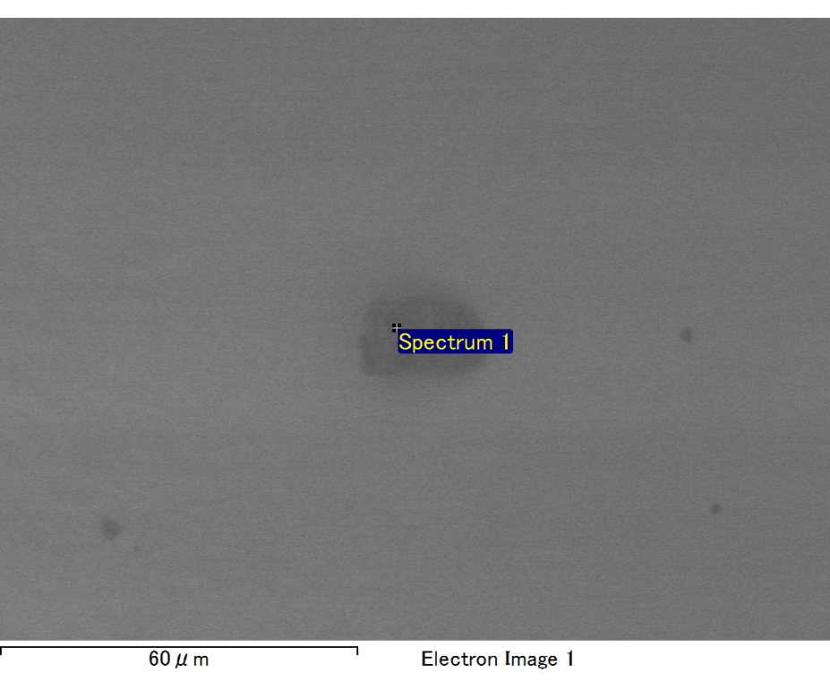

Spectrum processing :

No peaks omitted

Processing option : All elements analyzed (Normalised)

Number of iterations = 2

Standard :

O SiO2 1-Jun-1999 12:00 AM

Al Al2O3 1-Jun-1999 12:00 AM

Si SiO2 1-Jun-1999 12:00 AM

Au Au 1-Jun-1999 12:00 AM

|  |  |  |  |
| --- | --- | --- | --- |
| Element | Weight% | Atomic% |  |
|  |  |  |  |
| O K | 18.85 | 60.26 |  |
| Al K | 3.00 | 5.69 |  |
| Si K | 8.81 | 16.04 |  |
| Au M | 69.34 | 18.01 |  |
|  |  |  |  |
| Totals | 100.00 |  |  |

Spectrum Label: Spectrum 1

Livetime 60.0 s

Acquisition geometry ( degrees ):

Tilt = 10.0

Azimuth = 0.0

Elevation = 30.0

Accelerating voltage = 10.00 kV

Total spectrum counts = 31179

|  |  |  |  |
| --- | --- | --- | --- |
| Sample data : | Energy (eV) | Resn. (eV) | Area |
| Strobe : | 3.8 | 47.35 | 1000370 |
|  |  |  |  |

No quant optimization performed

Sample: Sample 1

Type: Default

ID:



Spectrum processing :

No peaks omitted

Processing option : All elements analyzed (Normalised)

Number of iterations = 2

Standard :

O SiO2 1-Jun-1999 12:00 AM

Al Al2O3 1-Jun-1999 12:00 AM

Si SiO2 1-Jun-1999 12:00 AM

Au Au 1-Jun-1999 12:00 AM

|  |  |  |  |
| --- | --- | --- | --- |
| Element | Weight% | Atomic% |  |
|  |  |  |  |
| O K | 18.85 | 60.26 |  |
| Al K | 3.00 | 5.69 |  |
| Si K | 8.81 | 16.04 |  |
| Au M | 69.34 | 18.01 |  |
|  |  |  |  |
| Totals | 100.00 |  |  |

Spectrum Label: Spectrum 1

Livetime 60.0 s

Acquisition geometry ( degrees ):

Tilt = 10.0

Azimuth = 0.0

Elevation = 30.0

Accelerating voltage = 10.00 kV

Total spectrum counts = 31179

|  |  |  |  |
| --- | --- | --- | --- |
| Sample data : | Energy (eV) | Resn. (eV) | Area |
| Strobe : | 3.8 | 47.35 | 1000370 |
|  |  |  |  |

No quant optimization performed

Sample: Sample 1

Type: Default

ID:

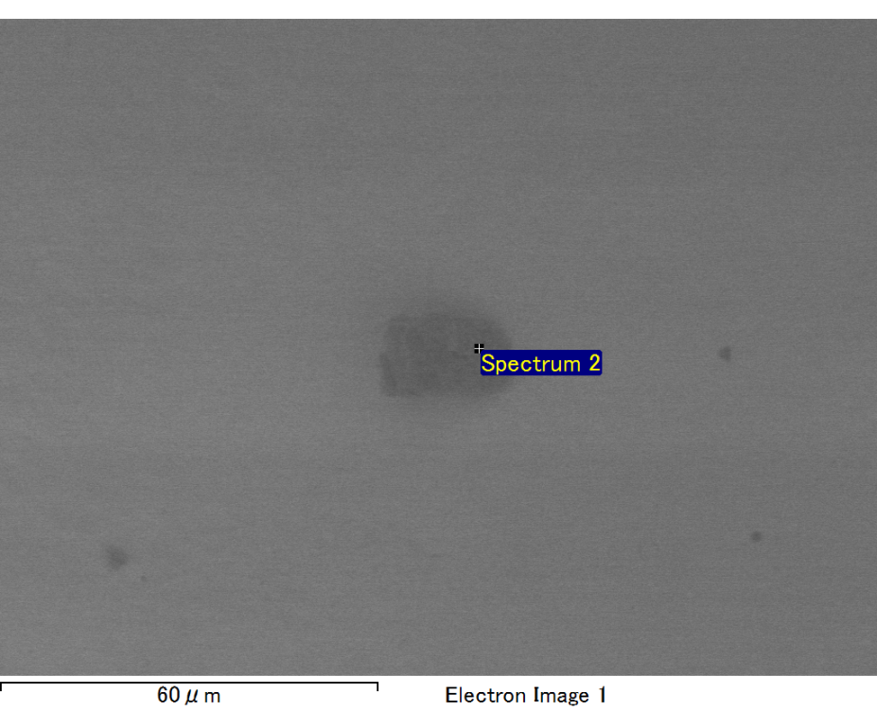

Spectrum processing :

No peaks omitted

Processing option : All elements analyzed (Normalised)

Number of iterations = 2

Standard :

O SiO2 1-Jun-1999 12:00 AM

Na Albite 1-Jun-1999 12:00 AM

Mg MgO 1-Jun-1999 12:00 AM

Al Al2O3 1-Jun-1999 12:00 AM

Si SiO2 1-Jun-1999 12:00 AM

Au Au 1-Jun-1999 12:00 AM

|  |  |  |  |
| --- | --- | --- | --- |
| Element | Weight% | Atomic% |  |
|  |  |  |  |
| O K | 24.25 | 64.44 |  |
| Na K | 2.05 | 3.79 |  |
| Mg K | 1.32 | 2.31 |  |
| Al K | 2.88 | 4.54 |  |
| Si K | 7.64 | 11.56 |  |
| Au M | 61.86 | 13.35 |  |
|  |  |  |  |
| Totals | 100.00 |  |  |

Spectrum Label: Spectrum 2

Livetime 60.0 s

Acquisition geometry ( degrees ):

Tilt = 10.0

Azimuth = 0.0

Elevation = 30.0

Accelerating voltage = 10.00 kV

Total spectrum counts = 32205

|  |  |  |  |
| --- | --- | --- | --- |
| Sample data : | Energy (eV) | Resn. (eV) | Area |
| Strobe : | 3.8 | 47.22 | 999234 |
|  |  |  |  |

No quant optimization performed

Sample: Sample 1

Type: Default

ID:

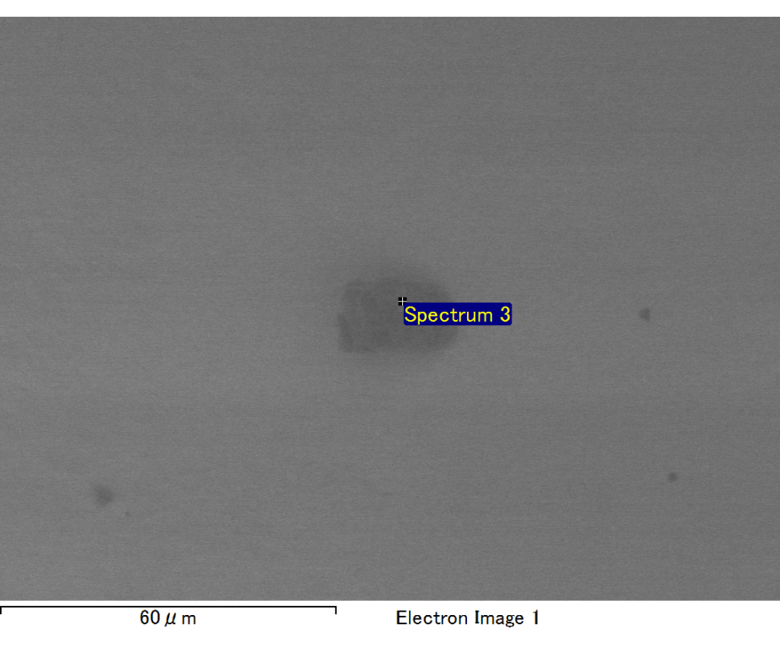

Spectrum processing :

No peaks omitted

Processing option : All elements analyzed (Normalised)

Number of iterations = 2

Standard :

C CaCO3 1-Jun-1999 12:00 AM

O SiO2 1-Jun-1999 12:00 AM

S FeS2 1-Jun-1999 12:00 AM

Fe Fe 1-Jun-1999 12:00 AM

Au Au 1-Jun-1999 12:00 AM

|  |  |  |  |
| --- | --- | --- | --- |
| Element | Weight% | Atomic% |  |
|  |  |  |  |
| C K | 4.51 | 22.90 |  |
| O K | 4.63 | 17.66 |  |
| S K | 10.06 | 19.13 |  |
| Fe L | 19.54 | 21.34 |  |
| Au M | 61.26 | 18.97 |  |
|  |  |  |  |
| Totals | 100.00 |  |  |

Spectrum Label: Spectrum 3

Livetime 60.0 s

Acquisition geometry ( degrees ):

Tilt = 10.0

Azimuth = 0.0

Elevation = 30.0

Accelerating voltage = 10.00 kV

Total spectrum counts = 31331

|  |  |  |  |
| --- | --- | --- | --- |
| Sample data : | Energy (eV) | Resn. (eV) | Area |
| Strobe : | 3.8 | 47.39 | 1000585 |
|  |  |  |  |

No quant optimization performed

Sample: Sample 1

Type: Default

ID: