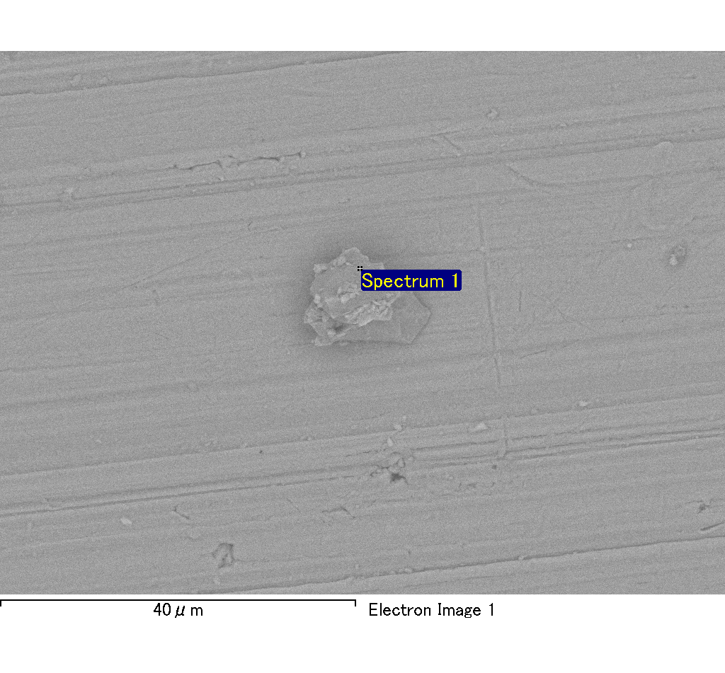
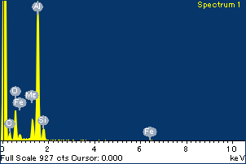
Project: Project 1
Owner: Administrator
Site: Site of Interest 8
Spectrum processing :
No peaks omitted

Processing option : Oxygen by stoichiometry
Number of iterations = 2

Standard :
Na Albite 1-Jun-1999 12:00 AM
Mg MgO 1-Jun-1999 12:00 AM
Al Al2O3 1-Jun-1999 12:00 AM
Si SiO2 1-Jun-1999 12:00 AM
P GaP 1-Jun-1999 12:00 AM
S FeS2 1-Jun-1999 12:00 AM
K MAD-10 Feldspar 1-Jun-1999 12:00 AM
Ca Wollastonite 1-Jun-1999 12:00 AM
Cr Cr 1-Jun-1999 12:00 AM
Mn Mn 1-Jun-1999 12:00 AM
Fe Fe 1-Jun-1999 12:00 AM
Ni Ni 1-Jun-1999 12:00 AM

Element | Weight% | Atomic% | Compd% | Formula
Na K | 0.00 | -0.09 | 0.00 | Na2O
Mg K | 0.12 | 4.54 | 0.20 | MgO
Al K | 0.89 | 30.59 | 1.68 | Al2O3
Si K | 0.11 | 3.62 | 0.23 | SiO2
P K | 0.00 | -0.13 | -0.01 | P2O5
S K | 0.00 | -0.10 | -0.01 | SO3
K K | 0.00 | -0.03 | 0.00 | K2O
Ca K | 0.00 | -0.10 | -0.01 | CaO
Cr K | -0.01 | -0.11 | -0.01 | Cr2O3
Mn K | 0.00 | -0.01 | 0.00 | MnO
Fe K | 0.10 | 1.65 | 0.13 | FeO
Ni K | 0.06 | 0.92 | 0.07 | NiO
O | 1.02 | 59.26
Totals | 2.28

Spectrum Label: Spectrum 1

Livetime 120.0 s

Acquisition geometry ( degrees ):
Tilt = 0.0
Azimuth = 0.0
Elevation = 30.0

Accelerating voltage = 10.00 kV

Total spectrum counts = 120976

Sample data : | Energy (eV) | Resn. (eV) | Area
Strobe : | 3.8 | 53.98 | 1207197
Optimization data : Cobalt K series
 | Energy (eV) | Resn. (eV) | Area
Strobe : | .1 | 53.96 | 498142
Optimization element : | 6926.7 | 142.17 | 16696

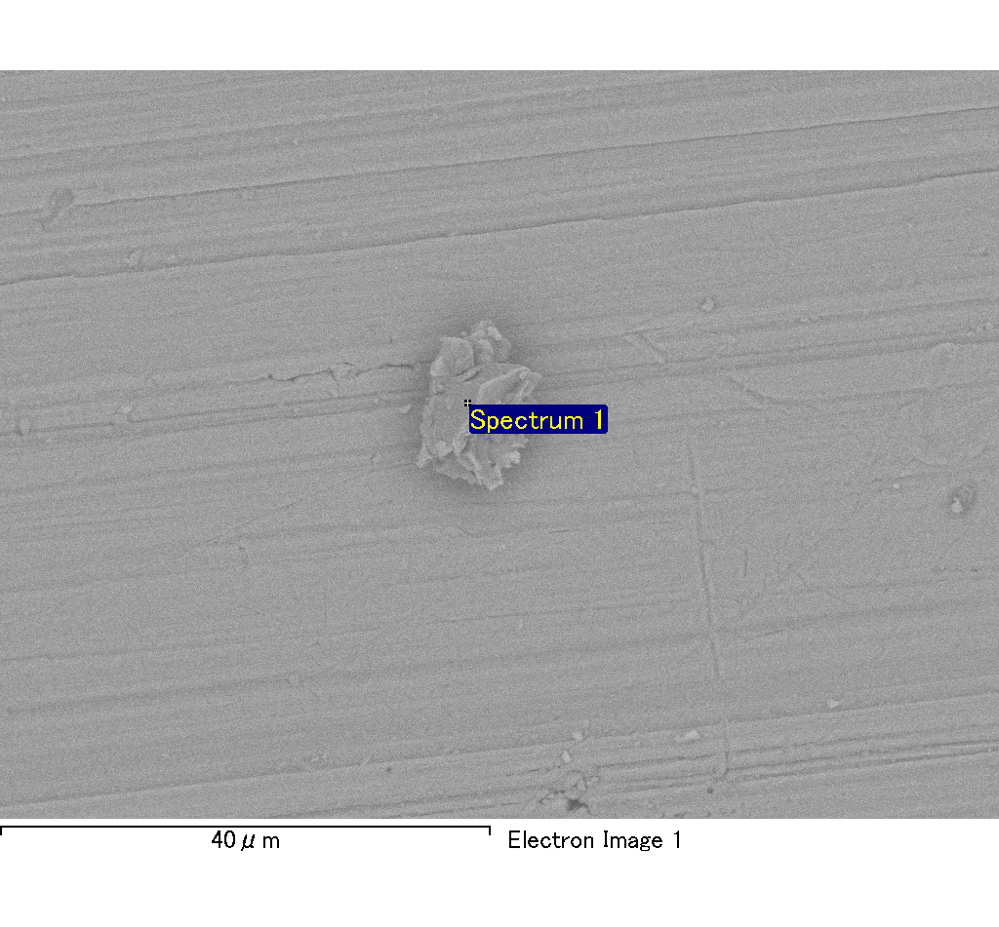
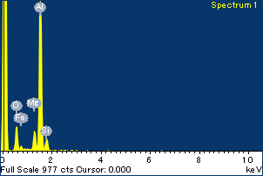
Project: Project 1
Owner: Administrator
Site: Site of Interest 9
Spectrum processing :
No peaks omitted

Processing option : Oxygen by stoichiometry
Number of iterations = 2

Standard :
Na Albite 1-Jun-1999 12:00 AM
Mg MgO 1-Jun-1999 12:00 AM
Al Al2O3 1-Jun-1999 12:00 AM
Si SiO2 1-Jun-1999 12:00 AM
P GaP 1-Jun-1999 12:00 AM
S FeS2 1-Jun-1999 12:00 AM
K MAD-10 Feldspar 1-Jun-1999 12:00 AM
Ca Wollastonite 1-Jun-1999 12:00 AM
Cr Cr 1-Jun-1999 12:00 AM
Mn Mn 1-Jun-1999 12:00 AM
Fe Fe 1-Jun-1999 12:00 AM
Ni Ni 1-Jun-1999 12:00 AM

Element | Weight% | Atomic% | Compd% | Formula
Na K | 0.00 | 0.02 | 0.00 | Na2O
Mg K | 0.10 | 3.72 | 0.17 | MgO
Al K | 0.96 | 31.90 | 1.81 | Al2O3
Si K | 0.09 | 2.81 | 0.19 | SiO2
P K | 0.00 | 0.06 | 0.00 | P2O5
S K | 0.00 | 0.08 | 0.01 | SO3
K K | 0.00 | -0.03 | 0.00 | K2O
Ca K | 0.00 | 0.08 | 0.01 | CaO
Cr K | 0.01 | 0.09 | 0.01 | Cr2O3
Mn K | 0.00 | -0.08 | -0.01 | MnO
Fe K | 0.10 | 1.59 | 0.13 | FeO
Ni K | 0.01 | 0.23 | 0.02 | NiO
O | 1.06 | 59.53
Totals | 2.33

Spectrum Label: Spectrum 1

Livetime 120.0 s

Acquisition geometry ( degrees ):
Tilt = 0.0
Azimuth = 0.0
Elevation = 30.0

Accelerating voltage = 10.00 kV

Total spectrum counts = 121072

Sample data : | Energy (eV) | Resn. (eV) | Area
Strobe : | 3.8 | 53.97 | 1207351
Optimization data : Cobalt K series
 | Energy (eV) | Resn. (eV) | Area
Strobe : | .1 | 53.96 | 498142
Optimization element : | 6926.7 | 142.17 | 16696

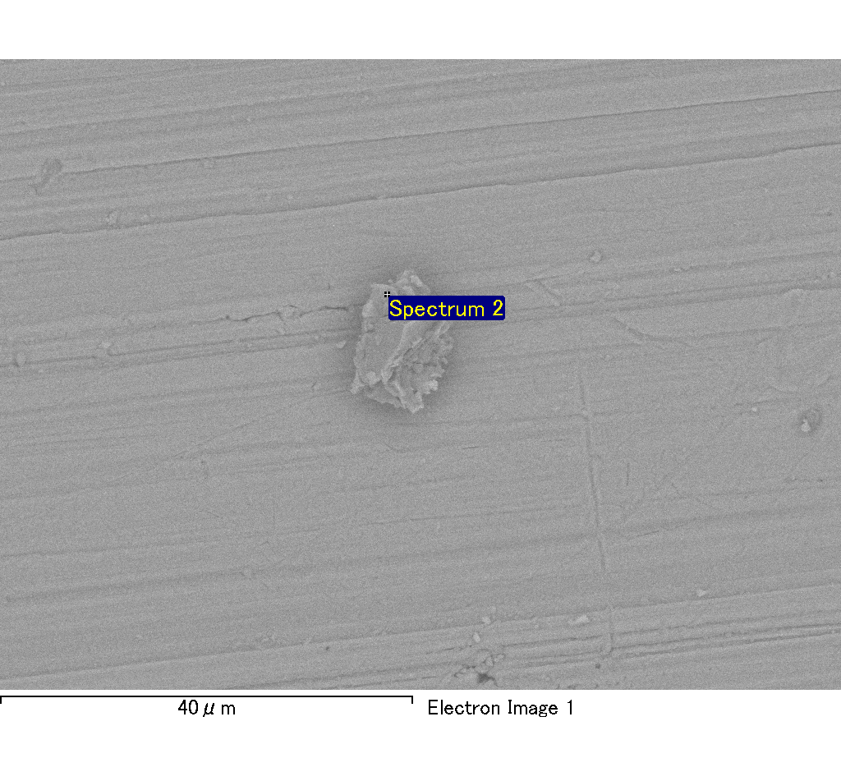
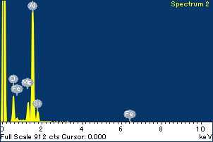
Project: Project 1
Owner: Administrator
Site: Site of Interest 9
Spectrum processing :
No peaks omitted

Processing option : Oxygen by stoichiometry
Number of iterations = 2

Standard :
Na Albite 1-Jun-1999 12:00 AM
Mg MgO 1-Jun-1999 12:00 AM
Al Al2O3 1-Jun-1999 12:00 AM
Si SiO2 1-Jun-1999 12:00 AM
P GaP 1-Jun-1999 12:00 AM
S FeS2 1-Jun-1999 12:00 AM
K MAD-10 Feldspar 1-Jun-1999 12:00 AM
Ca Wollastonite 1-Jun-1999 12:00 AM
Cr Cr 1-Jun-1999 12:00 AM
Mn Mn 1-Jun-1999 12:00 AM
Fe Fe 1-Jun-1999 12:00 AM
Ni Ni 1-Jun-1999 12:00 AM

Element | Weight% | Atomic% | Compd% | Formula
Na K | 0.00 | 0.05 | 0.00 | Na2O
Mg K | 0.12 | 4.71 | 0.20 | MgO
Al K | 0.87 | 30.28 | 1.64 | Al2O3
Si K | 0.11 | 3.70 | 0.24 | SiO2
P K | 0.00 | 0.00 | 0.00 | P2O5
S K | 0.01 | 0.20 | 0.02 | SO3
K K | 0.00 | -0.01 | 0.00 | K2O
Ca K | 0.00 | 0.04 | 0.00 | CaO
Cr K | -0.01 | -0.10 | -0.01 | Cr2O3
Mn K | 0.00 | -0.06 | 0.00 | MnO
Fe K | 0.11 | 1.81 | 0.14 | FeO
Ni K | -0.01 | -0.21 | -0.02 | NiO
O | 1.01 | 59.58
Totals | 2.21

Spectrum Label: Spectrum 2

Livetime 120.0 s

Acquisition geometry ( degrees ):
Tilt = 0.0
Azimuth = 0.0
Elevation = 30.0

Accelerating voltage = 10.00 kV

Total spectrum counts = 120585

Sample data : | Energy (eV) | Resn. (eV) | Area
Strobe : | 3.8 | 54.01 | 1207719
Optimization data : Cobalt K series
 | Energy (eV) | Resn. (eV) | Area
Strobe : | .1 | 53.96 | 498142
Optimization element : | 6926.7 | 142.17 | 16696

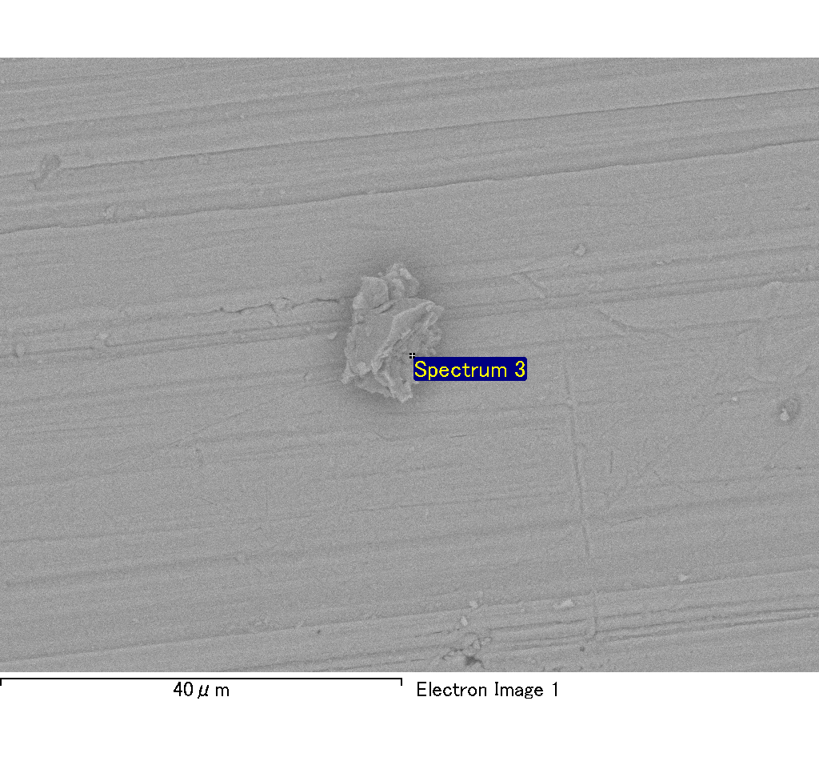
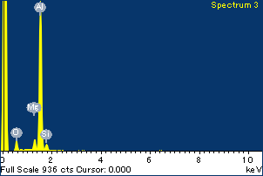
Project: Project 1
Owner: Administrator
Site: Site of Interest 9
Spectrum processing :
No peaks omitted

Processing option : Oxygen by stoichiometry
Number of iterations = 2

Standard :
Na Albite 1-Jun-1999 12:00 AM
Mg MgO 1-Jun-1999 12:00 AM
Al Al2O3 1-Jun-1999 12:00 AM
Si SiO2 1-Jun-1999 12:00 AM
P GaP 1-Jun-1999 12:00 AM
S FeS2 1-Jun-1999 12:00 AM
K MAD-10 Feldspar 1-Jun-1999 12:00 AM
Ca Wollastonite 1-Jun-1999 12:00 AM
Cr Cr 1-Jun-1999 12:00 AM
Mn Mn 1-Jun-1999 12:00 AM
Fe Fe 1-Jun-1999 12:00 AM
Ni Ni 1-Jun-1999 12:00 AM

Element | Weight% | Atomic% | Compd% | Formula
Na K | 0.00 | 0.20 | 0.01 | Na2O
Mg K | 0.06 | 2.41 | 0.09 | MgO
Al K | 0.86 | 33.58 | 1.63 | Al2O3
Si K | 0.06 | 2.06 | 0.12 | SiO2
P K | 0.00 | -0.04 | 0.00 | P2O5
S K | 0.00 | 0.04 | 0.00 | SO3
K K | 0.00 | -0.04 | 0.00 | K2O
Ca K | 0.00 | -0.01 | 0.00 | CaO
Cr K | 0.01 | 0.19 | 0.01 | Cr2O3
Mn K | 0.00 | 0.00 | 0.00 | MnO
Fe K | 0.13 | 2.39 | 0.16 | FeO
Ni K | -0.01 | -0.22 | -0.02 | NiO
O | 0.91 | 59.44
Totals | 2.00

Spectrum Label: Spectrum 3

Livetime 120.0 s

Acquisition geometry ( degrees ):
Tilt = 0.0
Azimuth = 0.0
Elevation = 30.0

Accelerating voltage = 10.00 kV

Total spectrum counts = 117783

Sample data : | Energy (eV) | Resn. (eV) | Area
Strobe : | 3.8 | 53.99 | 1208181
Optimization data : Cobalt K series
 | Energy (eV) | Resn. (eV) | Area
Strobe : | .1 | 53.96 | 498142
Optimization element : | 6926.7 | 142.17 | 16696

