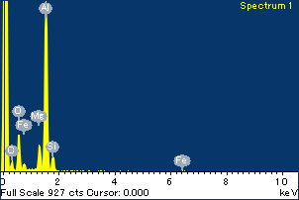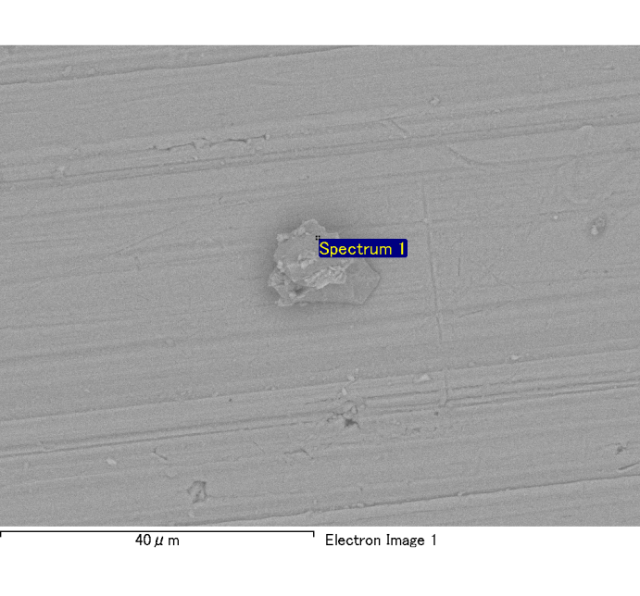

Spectrum Label: Spectrum 1

Livetime 120.0 s

Acquisition geometry ( degrees ):

Tilt = 0.0

Azimuth = 0.0

Elevation = 30.0

Accelerating voltage = 10.00 kV

Total spectrum counts = 120976

|  |  |  |  |
| --- | --- | --- | --- |
| Sample data : | Energy (eV) | Resn. (eV) | Area |
| Strobe : | 3.8 | 53.98 | 1207197 |
|  |  |  |  |
| Optimization data : Cobalt K series |  |  |  |
|  | Energy (eV) | Resn. (eV) | Area |
| Strobe : | .1 | 53.96 | 498142 |
| Optimization element : | 6926.7 | 142.17 | 16696 |

Spectrum processing :

No peaks omitted

Processing option : Oxygen by stoichiometry

Number of iterations = 2

Standard :

Na Albite 1-Jun-1999 12:00 AM

Mg MgO 1-Jun-1999 12:00 AM

Al Al2O3 1-Jun-1999 12:00 AM

Si SiO2 1-Jun-1999 12:00 AM

P GaP 1-Jun-1999 12:00 AM

S FeS2 1-Jun-1999 12:00 AM

K MAD-10 Feldspar 1-Jun-1999 12:00 AM

Ca Wollastonite 1-Jun-1999 12:00 AM

Cr Cr 1-Jun-1999 12:00 AM

Mn Mn 1-Jun-1999 12:00 AM

Fe Fe 1-Jun-1999 12:00 AM

Ni Ni 1-Jun-1999 12:00 AM

|  |  |  |  |  |  |
| --- | --- | --- | --- | --- | --- |
| Element | Weight% | Atomic% | Compd% | Formula |  |
|  |  |  |  |  |  |
| Na K | 0.00 | -0.09 | 0.00 | Na2O |  |
| Mg K | 0.12 | 4.54 | 0.20 | MgO |  |
| Al K | 0.89 | 30.59 | 1.68 | Al2O3 |  |
| Si K | 0.11 | 3.62 | 0.23 | SiO2 |  |
| P K | 0.00 | -0.13 | -0.01 | P2O5 |  |
| S K | 0.00 | -0.10 | -0.01 | SO3 |  |
| K K | 0.00 | -0.03 | 0.00 | K2O |  |
| Ca K | 0.00 | -0.10 | -0.01 | CaO |  |
| Cr K | -0.01 | -0.11 | -0.01 | Cr2O3 |  |
| Mn K | 0.00 | -0.01 | 0.00 | MnO |  |
| Fe K | 0.10 | 1.65 | 0.13 | FeO |  |
| Ni K | 0.06 | 0.92 | 0.07 | NiO |  |
| O | 1.02 | 59.26 |  |  |  |
| Totals | 2.28 |  |  |  |  |

Project: Project 1

Owner: Administrator

Site: Site of Interest 8

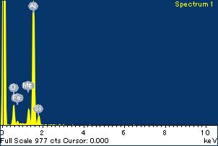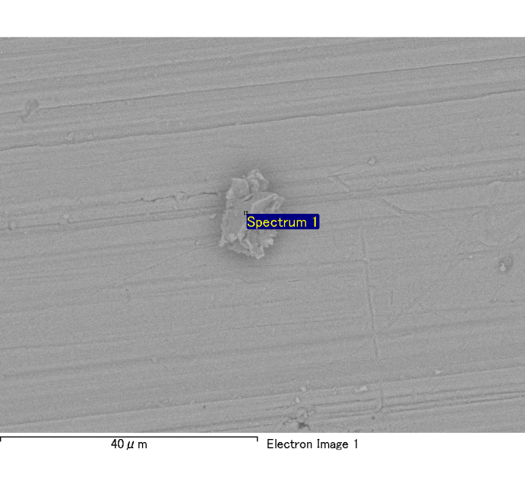

Spectrum Label: Spectrum 1

Livetime 120.0 s

Acquisition geometry ( degrees ):

Tilt = 0.0

Azimuth = 0.0

Elevation = 30.0

Accelerating voltage = 10.00 kV

Total spectrum counts = 121072

|  |  |  |  |
| --- | --- | --- | --- |
| Sample data : | Energy (eV) | Resn. (eV) | Area |
| Strobe : | 3.8 | 53.97 | 1207351 |
|  |  |  |  |
| Optimization data : Cobalt K series |  |  |  |
|  | Energy (eV) | Resn. (eV) | Area |
| Strobe : | .1 | 53.96 | 498142 |
| Optimization element : | 6926.7 | 142.17 | 16696 |

Spectrum processing :

No peaks omitted

Processing option : Oxygen by stoichiometry

Number of iterations = 2

Standard :

Na Albite 1-Jun-1999 12:00 AM

Mg MgO 1-Jun-1999 12:00 AM

Al Al2O3 1-Jun-1999 12:00 AM

Si SiO2 1-Jun-1999 12:00 AM

P GaP 1-Jun-1999 12:00 AM

S FeS2 1-Jun-1999 12:00 AM

K MAD-10 Feldspar 1-Jun-1999 12:00 AM

Ca Wollastonite 1-Jun-1999 12:00 AM

Cr Cr 1-Jun-1999 12:00 AM

Mn Mn 1-Jun-1999 12:00 AM

Fe Fe 1-Jun-1999 12:00 AM

Ni Ni 1-Jun-1999 12:00 AM

|  |  |  |  |  |  |
| --- | --- | --- | --- | --- | --- |
| Element | Weight% | Atomic% | Compd% | Formula |  |
|  |  |  |  |  |  |
| Na K | 0.00 | 0.02 | 0.00 | Na2O |  |
| Mg K | 0.10 | 3.72 | 0.17 | MgO |  |
| Al K | 0.96 | 31.90 | 1.81 | Al2O3 |  |
| Si K | 0.09 | 2.81 | 0.19 | SiO2 |  |
| P K | 0.00 | 0.06 | 0.00 | P2O5 |  |
| S K | 0.00 | 0.08 | 0.01 | SO3 |  |
| K K | 0.00 | -0.03 | 0.00 | K2O |  |
| Ca K | 0.00 | 0.08 | 0.01 | CaO |  |
| Cr K | 0.01 | 0.09 | 0.01 | Cr2O3 |  |
| Mn K | 0.00 | -0.08 | -0.01 | MnO |  |
| Fe K | 0.10 | 1.59 | 0.13 | FeO |  |
| Ni K | 0.01 | 0.23 | 0.02 | NiO |  |
| O | 1.06 | 59.53 |  |  |  |
| Totals | 2.33 |  |  |  |  |

Project: Project 1

Owner: Administrator

Site: Site of Interest 9

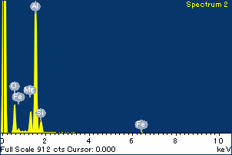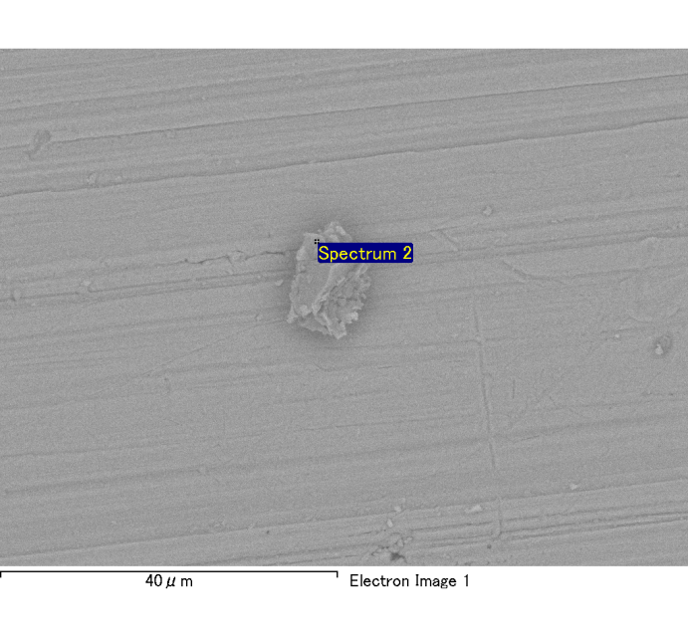

Spectrum Label: Spectrum 2

Livetime 120.0 s

Acquisition geometry ( degrees ):

Tilt = 0.0

Azimuth = 0.0

Elevation = 30.0

Accelerating voltage = 10.00 kV

Total spectrum counts = 120585

|  |  |  |  |
| --- | --- | --- | --- |
| Sample data : | Energy (eV) | Resn. (eV) | Area |
| Strobe : | 3.8 | 54.01 | 1207719 |
|  |  |  |  |
| Optimization data : Cobalt K series |  |  |  |
|  | Energy (eV) | Resn. (eV) | Area |
| Strobe : | .1 | 53.96 | 498142 |
| Optimization element : | 6926.7 | 142.17 | 16696 |

Spectrum processing :

No peaks omitted

Processing option : Oxygen by stoichiometry

Number of iterations = 2

Standard :

Na Albite 1-Jun-1999 12:00 AM

Mg MgO 1-Jun-1999 12:00 AM

Al Al2O3 1-Jun-1999 12:00 AM

Si SiO2 1-Jun-1999 12:00 AM

P GaP 1-Jun-1999 12:00 AM

S FeS2 1-Jun-1999 12:00 AM

K MAD-10 Feldspar 1-Jun-1999 12:00 AM

Ca Wollastonite 1-Jun-1999 12:00 AM

Cr Cr 1-Jun-1999 12:00 AM

Mn Mn 1-Jun-1999 12:00 AM

Fe Fe 1-Jun-1999 12:00 AM

Ni Ni 1-Jun-1999 12:00 AM

|  |  |  |  |  |  |
| --- | --- | --- | --- | --- | --- |
| Element | Weight% | Atomic% | Compd% | Formula |  |
|  |  |  |  |  |  |
| Na K | 0.00 | 0.05 | 0.00 | Na2O |  |
| Mg K | 0.12 | 4.71 | 0.20 | MgO |  |
| Al K | 0.87 | 30.28 | 1.64 | Al2O3 |  |
| Si K | 0.11 | 3.70 | 0.24 | SiO2 |  |
| P K | 0.00 | 0.00 | 0.00 | P2O5 |  |
| S K | 0.01 | 0.20 | 0.02 | SO3 |  |
| K K | 0.00 | -0.01 | 0.00 | K2O |  |
| Ca K | 0.00 | 0.04 | 0.00 | CaO |  |
| Cr K | -0.01 | -0.10 | -0.01 | Cr2O3 |  |
| Mn K | 0.00 | -0.06 | 0.00 | MnO |  |
| Fe K | 0.11 | 1.81 | 0.14 | FeO |  |
| Ni K | -0.01 | -0.21 | -0.02 | NiO |  |
| O | 1.01 | 59.58 |  |  |  |
| Totals | 2.21 |  |  |  |  |

Project: Project 1

Owner: Administrator

Site: Site of Interest 9

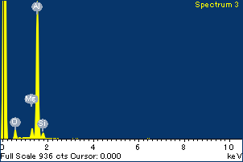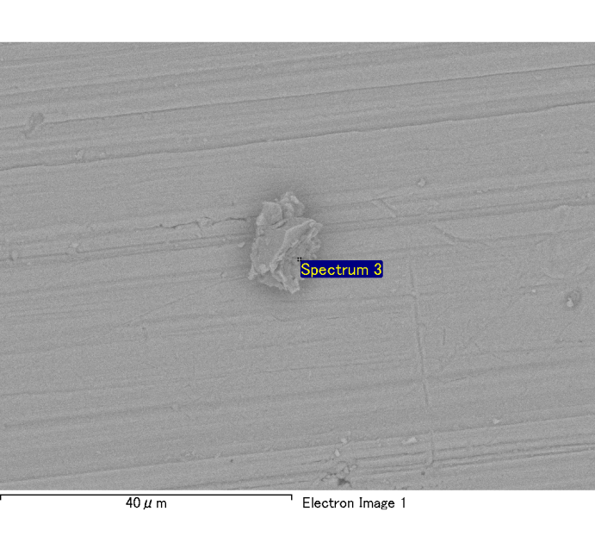

Spectrum Label: Spectrum 3

Livetime 120.0 s

Acquisition geometry ( degrees ):

Tilt = 0.0

Azimuth = 0.0

Elevation = 30.0

Accelerating voltage = 10.00 kV

Total spectrum counts = 117783

|  |  |  |  |
| --- | --- | --- | --- |
| Sample data : | Energy (eV) | Resn. (eV) | Area |
| Strobe : | 3.8 | 53.99 | 1208181 |
|  |  |  |  |
| Optimization data : Cobalt K series |  |  |  |
|  | Energy (eV) | Resn. (eV) | Area |
| Strobe : | .1 | 53.96 | 498142 |
| Optimization element : | 6926.7 | 142.17 | 16696 |

Spectrum processing :

No peaks omitted

Processing option : Oxygen by stoichiometry

Number of iterations = 2

Standard :

Na Albite 1-Jun-1999 12:00 AM

Mg MgO 1-Jun-1999 12:00 AM

Al Al2O3 1-Jun-1999 12:00 AM

Si SiO2 1-Jun-1999 12:00 AM

P GaP 1-Jun-1999 12:00 AM

S FeS2 1-Jun-1999 12:00 AM

K MAD-10 Feldspar 1-Jun-1999 12:00 AM

Ca Wollastonite 1-Jun-1999 12:00 AM

Cr Cr 1-Jun-1999 12:00 AM

Mn Mn 1-Jun-1999 12:00 AM

Fe Fe 1-Jun-1999 12:00 AM

Ni Ni 1-Jun-1999 12:00 AM

|  |  |  |  |  |  |
| --- | --- | --- | --- | --- | --- |
| Element | Weight% | Atomic% | Compd% | Formula |  |
|  |  |  |  |  |  |
| Na K | 0.00 | 0.20 | 0.01 | Na2O |  |
| Mg K | 0.06 | 2.41 | 0.09 | MgO |  |
| Al K | 0.86 | 33.58 | 1.63 | Al2O3 |  |
| Si K | 0.06 | 2.06 | 0.12 | SiO2 |  |
| P K | 0.00 | -0.04 | 0.00 | P2O5 |  |
| S K | 0.00 | 0.04 | 0.00 | SO3 |  |
| K K | 0.00 | -0.04 | 0.00 | K2O |  |
| Ca K | 0.00 | -0.01 | 0.00 | CaO |  |
| Cr K | 0.01 | 0.19 | 0.01 | Cr2O3 |  |
| Mn K | 0.00 | 0.00 | 0.00 | MnO |  |
| Fe K | 0.13 | 2.39 | 0.16 | FeO |  |
| Ni K | -0.01 | -0.22 | -0.02 | NiO |  |
| O | 0.91 | 59.44 |  |  |  |
| Totals | 2.00 |  |  |  |  |

Project: Project 1

Owner: Administrator

Site: Site of Interest 9