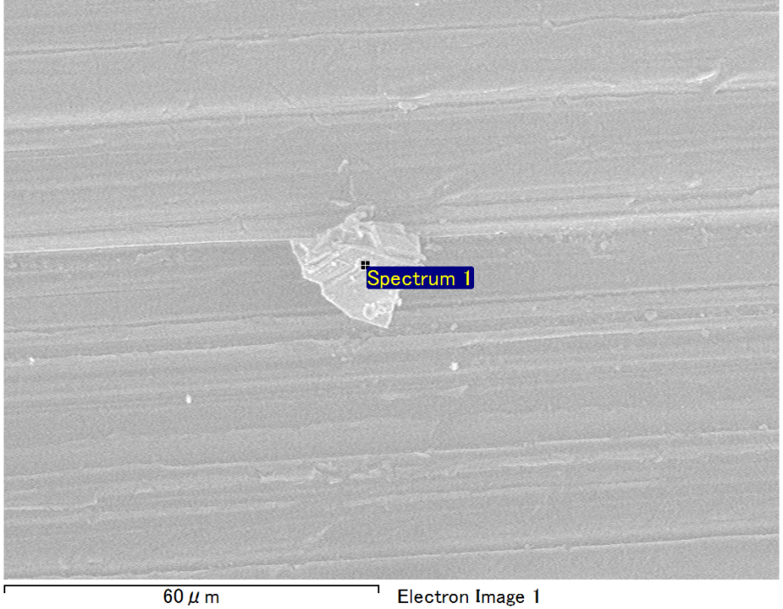

Spectrum Label: Spectrum 1

Livetime 90.0 s

Acquisition geometry ( degrees ):

Tilt = 0.0

Azimuth = 0.0

Elevation = 30.0

Accelerating voltage = 10.00 kV

Total spectrum counts = 65720

|  |  |  |  |
| --- | --- | --- | --- |
| Sample data : | Energy (eV) | Resn. (eV) | Area |
| Strobe : | 3.8 | 53.20 | 919180 |
|  |  |  |  |
| Optimization data : Manganese K series |  |  |  |
|  | Energy (eV) | Resn. (eV) | Area |
| Strobe : | .1 | 53.38 | 1150729 |
| Optimization element : | 5892.6 | 129.89 | 573533 |

Spectrum processing :

No peaks omitted

Processing option : Oxygen by stoichiometry (Normalised)

Number of iterations = 1

Standard :

Mg MgO 1-Jun-1999 12:00 AM

Al Al2O3 1-Jun-1999 12:00 AM

Si SiO2 1-Jun-1999 12:00 AM

|  |  |  |  |  |  |
| --- | --- | --- | --- | --- | --- |
| Element | Weight% | Atomic% | Compd% | Formula |  |
|  |  |  |  |  |  |
| Mg K | 2.74 | 2.29 | 4.54 | MgO |  |
| Al K | 45.45 | 34.27 | 85.87 | Al2O3 |  |
| Si K | 4.48 | 3.25 | 9.59 | SiO2 |  |
| O | 47.33 | 60.19 |  |  |  |
| Totals | 100.00 |  |  |  |  |

Project: Project 1

Owner: Operator

Site: Site of Interest 1

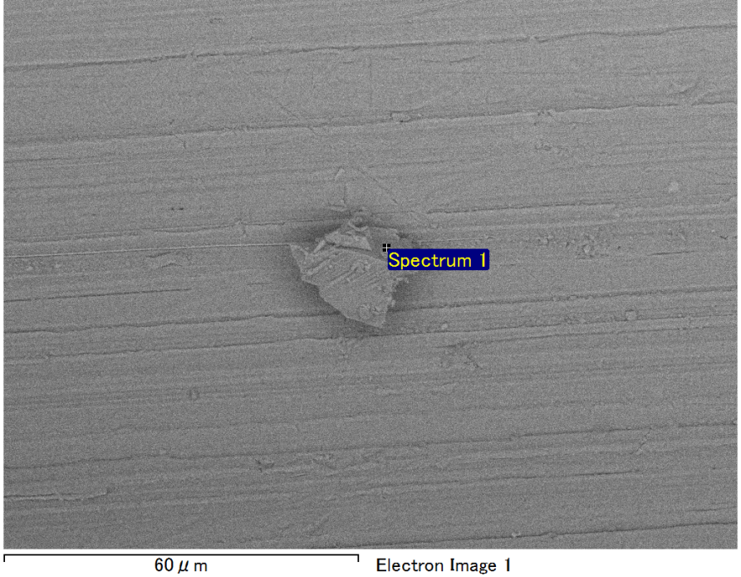

Spectrum Label: Spectrum 1

Livetime 90.0 s

Acquisition geometry ( degrees ):

Tilt = 0.0

Azimuth = 0.0

Elevation = 30.0

Accelerating voltage = 10.00 kV

Total spectrum counts = 67150

|  |  |  |  |
| --- | --- | --- | --- |
| Sample data : | Energy (eV) | Resn. (eV) | Area |
| Strobe : | 3.8 | 53.21 | 916708 |
|  |  |  |  |
| Optimization data : Manganese K series |  |  |  |
|  | Energy (eV) | Resn. (eV) | Area |
| Strobe : | .1 | 53.38 | 1150729 |
| Optimization element : | 5892.6 | 129.89 | 573533 |

Spectrum processing :

No peaks omitted

Processing option : Oxygen by stoichiometry (Normalised)

Number of iterations = 1

Standard :

Mg MgO 1-Jun-1999 12:00 AM

Al Al2O3 1-Jun-1999 12:00 AM

Si SiO2 1-Jun-1999 12:00 AM

|  |  |  |  |  |  |
| --- | --- | --- | --- | --- | --- |
| Element | Weight% | Atomic% | Compd% | Formula |  |
|  |  |  |  |  |  |
| Mg K | 3.26 | 2.73 | 5.41 | MgO |  |
| Al K | 43.38 | 32.69 | 81.96 | Al2O3 |  |
| Si K | 5.91 | 4.28 | 12.64 | SiO2 |  |
| O | 47.46 | 60.31 |  |  |  |
| Totals | 100.00 |  |  |  |  |

Project: Project 1

Owner: Operator

Site: Site of Interest 2

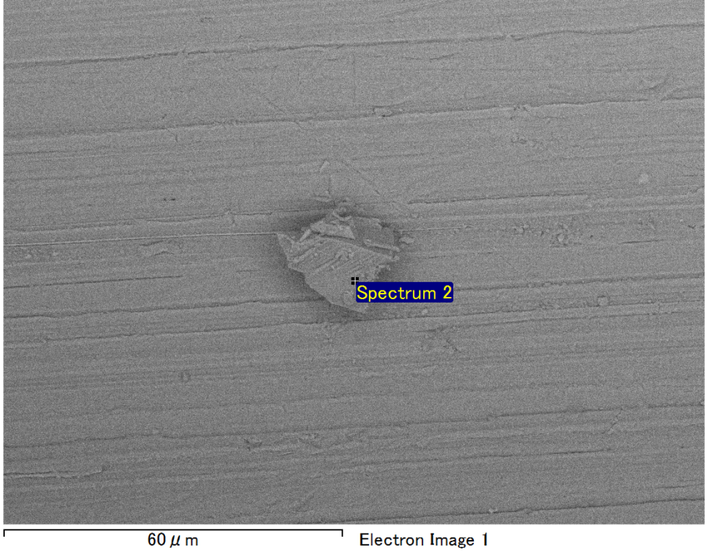

Spectrum Label: Spectrum 2

Livetime 90.0 s

Acquisition geometry ( degrees ):

Tilt = 0.0

Azimuth = 0.0

Elevation = 30.0

Accelerating voltage = 10.00 kV

Total spectrum counts = 65291

|  |  |  |  |
| --- | --- | --- | --- |
| Sample data : | Energy (eV) | Resn. (eV) | Area |
| Strobe : | 3.8 | 53.17 | 919169 |
|  |  |  |  |
| Optimization data : Manganese K series |  |  |  |
|  | Energy (eV) | Resn. (eV) | Area |
| Strobe : | .1 | 53.38 | 1150729 |
| Optimization element : | 5892.6 | 129.89 | 573533 |

Spectrum processing :

No peaks omitted

Processing option : Oxygen by stoichiometry (Normalised)

Number of iterations = 1

Standard :

Mg MgO 1-Jun-1999 12:00 AM

Al Al2O3 1-Jun-1999 12:00 AM

Si SiO2 1-Jun-1999 12:00 AM

|  |  |  |  |  |  |
| --- | --- | --- | --- | --- | --- |
| Element | Weight% | Atomic% | Compd% | Formula |  |
|  |  |  |  |  |  |
| Mg K | 2.49 | 2.08 | 4.13 | MgO |  |
| Al K | 45.11 | 34.01 | 85.23 | Al2O3 |  |
| Si K | 4.97 | 3.60 | 10.64 | SiO2 |  |
| O | 47.43 | 60.30 |  |  |  |
| Totals | 100.00 |  |  |  |  |

Project: Project 1

Owner: Operator

Site: Site of Interest 2

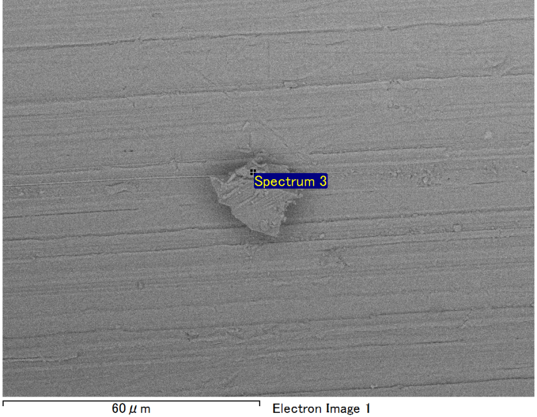

Spectrum Label: Spectrum 3

Livetime 90.0 s

Acquisition geometry ( degrees ):

Tilt = 0.0

Azimuth = 0.0

Elevation = 30.0

Accelerating voltage = 10.00 kV

Total spectrum counts = 67080

|  |  |  |  |
| --- | --- | --- | --- |
| Sample data : | Energy (eV) | Resn. (eV) | Area |
| Strobe : | 3.8 | 53.16 | 920476 |
|  |  |  |  |
| Optimization data : Manganese K series |  |  |  |
|  | Energy (eV) | Resn. (eV) | Area |
| Strobe : | .1 | 53.38 | 1150729 |
| Optimization element : | 5892.6 | 129.89 | 573533 |

Spectrum processing :

Peak possibly omitted : 0.705 keV

Processing option : Oxygen by stoichiometry (Normalised)

Number of iterations = 1

Standard :

Mg MgO 1-Jun-1999 12:00 AM

Al Al2O3 1-Jun-1999 12:00 AM

Si SiO2 1-Jun-1999 12:00 AM

|  |  |  |  |  |  |
| --- | --- | --- | --- | --- | --- |
| Element | Weight% | Atomic% | Compd% | Formula |  |
|  |  |  |  |  |  |
| Mg K | 4.37 | 3.65 | 7.24 | MgO |  |
| Al K | 41.46 | 31.23 | 78.34 | Al2O3 |  |
| Si K | 6.74 | 4.88 | 14.42 | SiO2 |  |
| O | 47.43 | 60.25 |  |  |  |
| Totals | 100.00 |  |  |  |  |

Project: Project 1

Owner: Operator

Site: Site of Interest 2

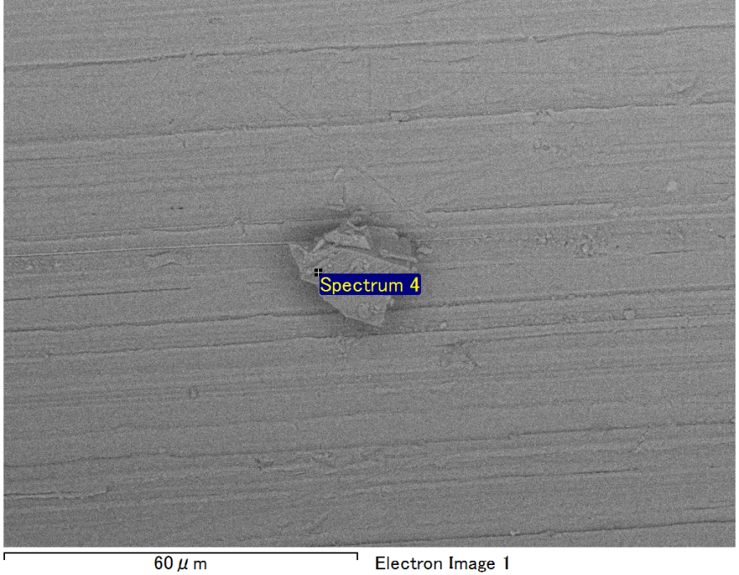

Spectrum Label: Spectrum 4

Livetime 90.0 s

Acquisition geometry ( degrees ):

Tilt = 0.0

Azimuth = 0.0

Elevation = 30.0

Accelerating voltage = 10.00 kV

Total spectrum counts = 64028

|  |  |  |  |
| --- | --- | --- | --- |
| Sample data : | Energy (eV) | Resn. (eV) | Area |
| Strobe : | 3.8 | 53.25 | 918853 |
|  |  |  |  |
| Optimization data : Manganese K series |  |  |  |
|  | Energy (eV) | Resn. (eV) | Area |
| Strobe : | .1 | 53.38 | 1150729 |
| Optimization element : | 5892.6 | 129.89 | 573533 |

Spectrum processing :

No peaks omitted

Processing option : Oxygen by stoichiometry (Normalised)

Number of iterations = 1

Standard :

Mg MgO 1-Jun-1999 12:00 AM

Al Al2O3 1-Jun-1999 12:00 AM

Si SiO2 1-Jun-1999 12:00 AM

|  |  |  |  |  |  |
| --- | --- | --- | --- | --- | --- |
| Element | Weight% | Atomic% | Compd% | Formula |  |
|  |  |  |  |  |  |
| Mg K | 1.04 | 0.87 | 1.72 | MgO |  |
| Al K | 50.40 | 38.06 | 95.23 | Al2O3 |  |
| Si K | 1.43 | 1.04 | 3.05 | SiO2 |  |
| O | 47.14 | 60.03 |  |  |  |
| Totals | 100.00 |  |  |  |  |

Project: Project 1

Owner: Operator

Site: Site of Interest 2