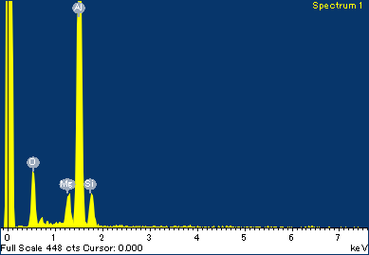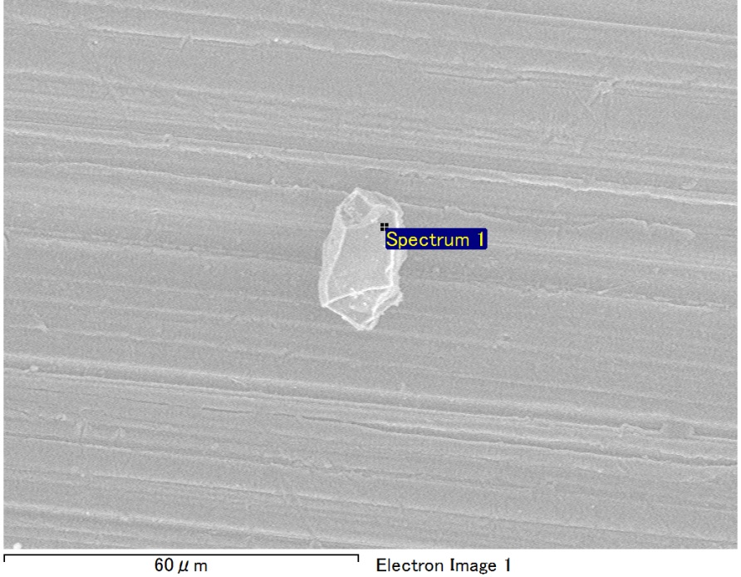

Spectrum Label: Spectrum 1

Livetime 90.0 s

Acquisition geometry ( degrees ):

Tilt = 0.0

Azimuth = 0.0

Elevation = 30.0

Accelerating voltage = 10.00 kV

Total spectrum counts = 65812

|  |  |  |  |
| --- | --- | --- | --- |
| Sample data : | Energy (eV) | Resn. (eV) | Area |
| Strobe : | 3.8 | 53.14 | 919011 |
|  |  |  |  |
| Optimization data : Manganese K series |  |  |  |
|  | Energy (eV) | Resn. (eV) | Area |
| Strobe : | .1 | 53.38 | 1150729 |
| Optimization element : | 5892.6 | 129.89 | 573533 |

Spectrum processing :

No peaks omitted

Processing option : Oxygen by stoichiometry (Normalised)

Number of iterations = 1

Standard :

Mg MgO 1-Jun-1999 12:00 AM

Al Al2O3 1-Jun-1999 12:00 AM

Si SiO2 1-Jun-1999 12:00 AM

|  |  |  |  |  |  |
| --- | --- | --- | --- | --- | --- |
| Element | Weight% | Atomic% | Compd% | Formula |  |
|  |  |  |  |  |  |
| Mg K | 3.28 | 2.74 | 5.44 | MgO |  |
| Al K | 43.82 | 33.02 | 82.79 | Al2O3 |  |
| Si K | 5.50 | 3.98 | 11.77 | SiO2 |  |
| O | 47.40 | 60.25 |  |  |  |
| Totals | 100.00 |  |  |  |  |

Project: Project 1

Owner: Operator

Site: Site of Interest 10

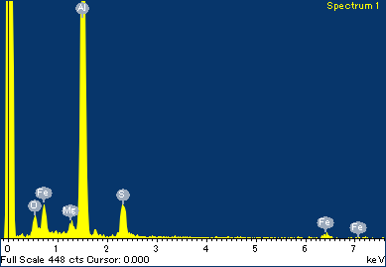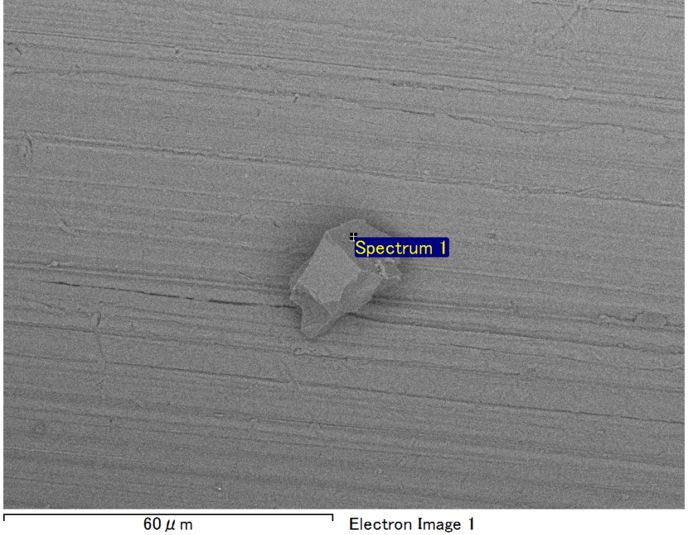

Spectrum Label: Spectrum 1

Livetime 90.0 s

Acquisition geometry ( degrees ):

Tilt = 0.0

Azimuth = 0.0

Elevation = 30.0

Accelerating voltage = 10.00 kV

Total spectrum counts = 66141

|  |  |  |  |
| --- | --- | --- | --- |
| Sample data : | Energy (eV) | Resn. (eV) | Area |
| Strobe : | 3.8 | 53.20 | 918188 |
|  |  |  |  |
| Optimization data : Manganese K series |  |  |  |
|  | Energy (eV) | Resn. (eV) | Area |
| Strobe : | .1 | 53.38 | 1150729 |
| Optimization element : | 5892.6 | 129.89 | 573533 |

Spectrum processing :

No peaks omitted

Processing option : Oxygen by stoichiometry (Normalised)

Number of iterations = 1

Standard :

Mg MgO 1-Jun-1999 12:00 AM

Al Al2O3 1-Jun-1999 12:00 AM

S FeS2 1-Jun-1999 12:00 AM

Fe Fe 1-Jun-1999 12:00 AM

|  |  |  |  |  |  |
| --- | --- | --- | --- | --- | --- |
| Element | Weight% | Atomic% | Compd% | Formula |  |
|  |  |  |  |  |  |
| Mg K | 0.70 | 0.66 | 1.16 | MgO |  |
| Al K | 32.57 | 27.65 | 61.53 | Al2O3 |  |
| S K | 4.55 | 3.25 | 11.35 | SO3 |  |
| Fe L | 20.18 | 8.28 | 25.96 | FeO |  |
| O | 42.01 | 60.16 |  |  |  |
| Totals | 100.00 |  |  |  |  |

Project: Project 1

Owner: Operator

Site: Site of Interest 12

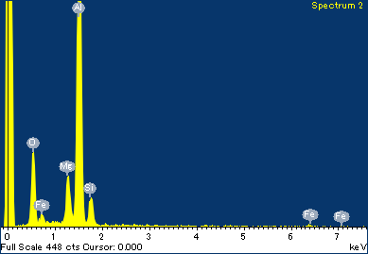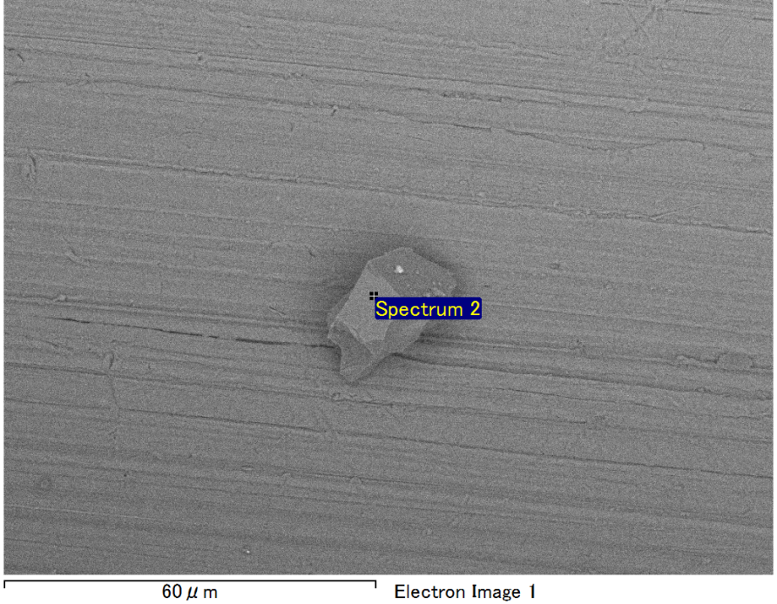

Spectrum Label: Spectrum 2

Livetime 90.0 s

Acquisition geometry ( degrees ):

Tilt = 0.0

Azimuth = 0.0

Elevation = 30.0

Accelerating voltage = 10.00 kV

Total spectrum counts = 66446

|  |  |  |  |
| --- | --- | --- | --- |
| Sample data : | Energy (eV) | Resn. (eV) | Area |
| Strobe : | 3.8 | 53.15 | 919372 |
|  |  |  |  |
| Optimization data : Manganese K series |  |  |  |
|  | Energy (eV) | Resn. (eV) | Area |
| Strobe : | .1 | 53.38 | 1150729 |
| Optimization element : | 5892.6 | 129.89 | 573533 |

Spectrum processing :

No peaks omitted

Processing option : Oxygen by stoichiometry (Normalised)

Number of iterations = 1

Standard :

Mg MgO 1-Jun-1999 12:00 AM

Al Al2O3 1-Jun-1999 12:00 AM

Si SiO2 1-Jun-1999 12:00 AM

Fe Fe 1-Jun-1999 12:00 AM

|  |  |  |  |  |  |
| --- | --- | --- | --- | --- | --- |
| Element | Weight% | Atomic% | Compd% | Formula |  |
|  |  |  |  |  |  |
| Mg K | 4.22 | 3.72 | 7.00 | MgO |  |
| Al K | 38.75 | 30.71 | 73.21 | Al2O3 |  |
| Si K | 3.98 | 3.03 | 8.51 | SiO2 |  |
| Fe L | 8.77 | 3.36 | 11.28 | FeO |  |
| O | 44.29 | 59.19 |  |  |  |
| Totals | 100.00 |  |  |  |  |

Project: Project 1

Owner: Operator

Site: Site of Interest 12

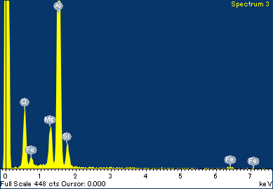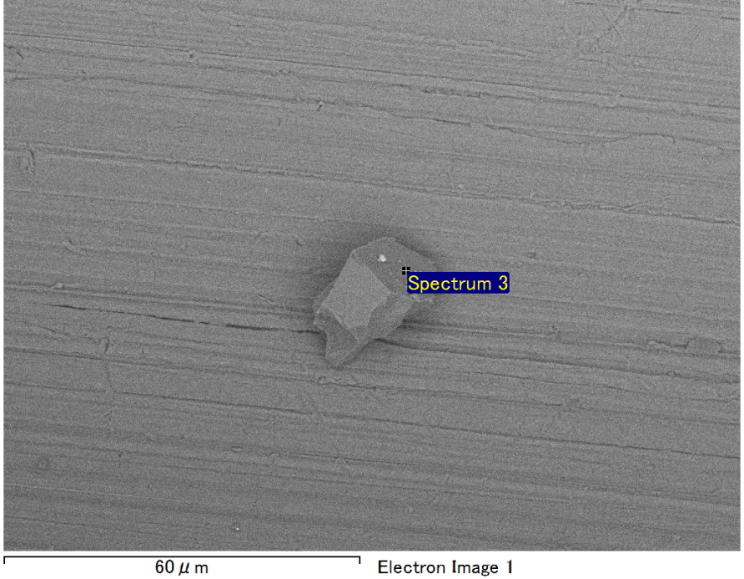

Spectrum Label: Spectrum 3

Livetime 90.0 s

Acquisition geometry ( degrees ):

Tilt = 0.0

Azimuth = 0.0

Elevation = 30.0

Accelerating voltage = 10.00 kV

Total spectrum counts = 66542

|  |  |  |  |
| --- | --- | --- | --- |
| Sample data : | Energy (eV) | Resn. (eV) | Area |
| Strobe : | 3.8 | 53.22 | 917434 |
|  |  |  |  |
| Optimization data : Manganese K series |  |  |  |
|  | Energy (eV) | Resn. (eV) | Area |
| Strobe : | .1 | 53.38 | 1150729 |
| Optimization element : | 5892.6 | 129.89 | 573533 |

Spectrum processing :

No peaks omitted

Processing option : Oxygen by stoichiometry (Normalised)

Number of iterations = 1

Standard :

Mg MgO 1-Jun-1999 12:00 AM

Al Al2O3 1-Jun-1999 12:00 AM

Si SiO2 1-Jun-1999 12:00 AM

Fe Fe 1-Jun-1999 12:00 AM

|  |  |  |  |  |  |
| --- | --- | --- | --- | --- | --- |
| Element | Weight% | Atomic% | Compd% | Formula |  |
|  |  |  |  |  |  |
| Mg K | 4.73 | 4.20 | 7.84 | MgO |  |
| Al K | 37.54 | 30.07 | 70.92 | Al2O3 |  |
| Si K | 3.57 | 2.75 | 7.64 | SiO2 |  |
| Fe L | 10.57 | 4.09 | 13.60 | FeO |  |
| O | 43.59 | 58.89 |  |  |  |
| Totals | 100.00 |  |  |  |  |

Project: Project 1

Owner: Operator

Site: Site of Interest 12

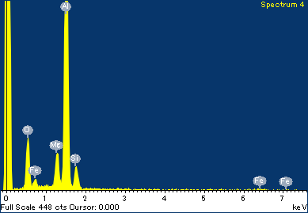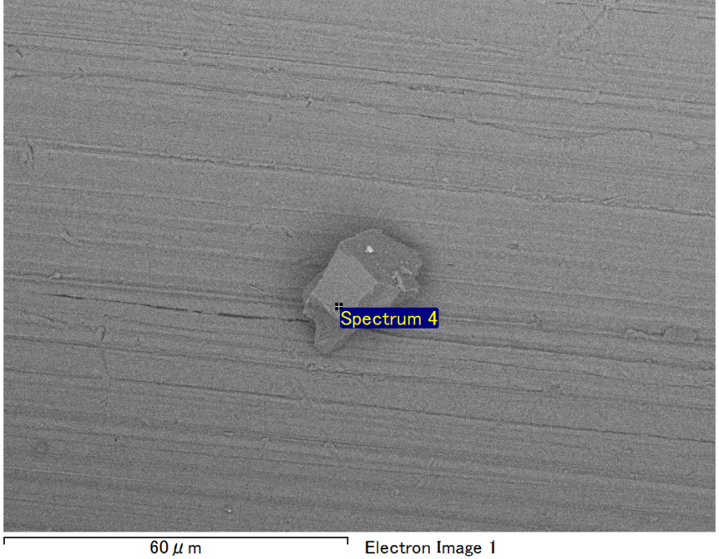

Spectrum Label: Spectrum 4

Livetime 90.0 s

Acquisition geometry ( degrees ):

Tilt = 0.0

Azimuth = 0.0

Elevation = 30.0

Accelerating voltage = 10.00 kV

Total spectrum counts = 65785

|  |  |  |  |
| --- | --- | --- | --- |
| Sample data : | Energy (eV) | Resn. (eV) | Area |
| Strobe : | 3.8 | 53.13 | 919316 |
|  |  |  |  |
| Optimization data : Manganese K series |  |  |  |
|  | Energy (eV) | Resn. (eV) | Area |
| Strobe : | .1 | 53.38 | 1150729 |
| Optimization element : | 5892.6 | 129.89 | 573533 |

Spectrum processing :

No peaks omitted

Processing option : Oxygen by stoichiometry (Normalised)

Number of iterations = 1

Standard :

Mg MgO 1-Jun-1999 12:00 AM

Al Al2O3 1-Jun-1999 12:00 AM

Si SiO2 1-Jun-1999 12:00 AM

Fe Fe 1-Jun-1999 12:00 AM

|  |  |  |  |  |  |
| --- | --- | --- | --- | --- | --- |
| Element | Weight% | Atomic% | Compd% | Formula |  |
|  |  |  |  |  |  |
| Mg K | 3.82 | 3.39 | 6.34 | MgO |  |
| Al K | 38.37 | 30.67 | 72.50 | Al2O3 |  |
| Si K | 3.75 | 2.88 | 8.02 | SiO2 |  |
| Fe L | 10.21 | 3.94 | 13.14 | FeO |  |
| O | 43.84 | 59.11 |  |  |  |
| Totals | 100.00 |  |  |  |  |

Project: Project 1

Owner: Operator

Site: Site of Interest 12