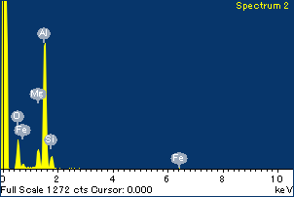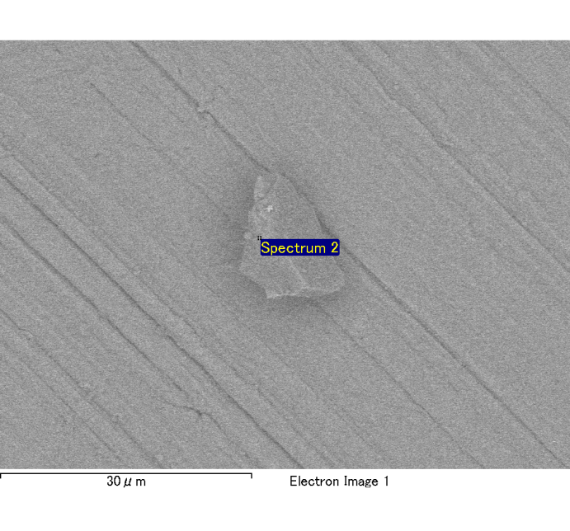

Spectrum Label: Spectrum 2

Livetime 120.0 s

Acquisition geometry ( degrees ):

Tilt = 0.0

Azimuth = 0.0

Elevation = 30.0

Accelerating voltage = 10.00 kV

Total spectrum counts = 120489

|  |  |  |  |
| --- | --- | --- | --- |
| Sample data : | Energy (eV) | Resn. (eV) | Area |
| Strobe : | 3.8 | 54.00 | 1207571 |
|  |  |  |  |
| Optimization data : Cobalt K series |  |  |  |
|  | Energy (eV) | Resn. (eV) | Area |
| Strobe : | .1 | 53.96 | 498142 |
| Optimization element : | 6926.7 | 142.17 | 16696 |

Spectrum processing :

No peaks omitted

Processing option : Oxygen by stoichiometry

Number of iterations = 2

Standard :

Na Albite 1-Jun-1999 12:00 AM

Mg MgO 1-Jun-1999 12:00 AM

Al Al2O3 1-Jun-1999 12:00 AM

Si SiO2 1-Jun-1999 12:00 AM

P GaP 1-Jun-1999 12:00 AM

S FeS2 1-Jun-1999 12:00 AM

K MAD-10 Feldspar 1-Jun-1999 12:00 AM

Ca Wollastonite 1-Jun-1999 12:00 AM

Cr Cr 1-Jun-1999 12:00 AM

Mn Mn 1-Jun-1999 12:00 AM

Fe Fe 1-Jun-1999 12:00 AM

Ni Ni 1-Jun-1999 12:00 AM

|  |  |  |  |  |  |
| --- | --- | --- | --- | --- | --- |
| Element | Weight% | Atomic% | Compd% | Formula |  |
|  |  |  |  |  |  |
| Na K | 0.00 | 0.04 | 0.00 | Na2O |  |
| Mg K | 0.12 | 4.48 | 0.21 | MgO |  |
| Al K | 0.91 | 29.80 | 1.73 | Al2O3 |  |
| Si K | 0.12 | 3.83 | 0.26 | SiO2 |  |
| P K | 0.00 | -0.01 | 0.00 | P2O5 |  |
| S K | 0.00 | -0.12 | -0.01 | SO3 |  |
| K K | 0.00 | -0.05 | 0.00 | K2O |  |
| Ca K | 0.00 | 0.02 | 0.00 | CaO |  |
| Cr K | 0.02 | 0.26 | 0.02 | Cr2O3 |  |
| Mn K | 0.00 | 0.02 | 0.00 | MnO |  |
| Fe K | 0.14 | 2.13 | 0.17 | FeO |  |
| Ni K | 0.02 | 0.30 | 0.03 | NiO |  |
| O | 1.08 | 59.30 |  |  |  |
| Totals | 2.40 |  |  |  |  |

Project: Project 1

Owner: Administrator

Site: Site of Interest 1

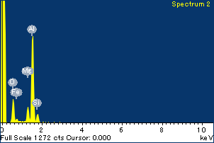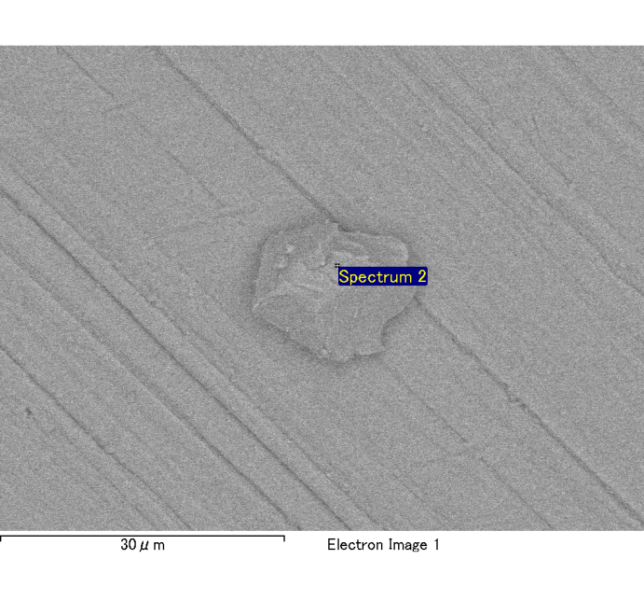

Spectrum Label: Spectrum 2

Livetime 120.0 s

Acquisition geometry ( degrees ):

Tilt = 0.0

Azimuth = 0.0

Elevation = 30.0

Accelerating voltage = 10.00 kV

Total spectrum counts = 119900

|  |  |  |  |
| --- | --- | --- | --- |
| Sample data : | Energy (eV) | Resn. (eV) | Area |
| Strobe : | 3.8 | 53.96 | 1207563 |
|  |  |  |  |
| Optimization data : Cobalt K series |  |  |  |
|  | Energy (eV) | Resn. (eV) | Area |
| Strobe : | .1 | 53.96 | 498142 |
| Optimization element : | 6926.7 | 142.17 | 16696 |

Spectrum processing :

No peaks omitted

Processing option : Oxygen by stoichiometry

Number of iterations = 2

Standard :

Na Albite 1-Jun-1999 12:00 AM

Mg MgO 1-Jun-1999 12:00 AM

Al Al2O3 1-Jun-1999 12:00 AM

Si SiO2 1-Jun-1999 12:00 AM

P GaP 1-Jun-1999 12:00 AM

S FeS2 1-Jun-1999 12:00 AM

K MAD-10 Feldspar 1-Jun-1999 12:00 AM

Ca Wollastonite 1-Jun-1999 12:00 AM

Cr Cr 1-Jun-1999 12:00 AM

Mn Mn 1-Jun-1999 12:00 AM

Fe Fe 1-Jun-1999 12:00 AM

Ni Ni 1-Jun-1999 12:00 AM

|  |  |  |  |  |  |
| --- | --- | --- | --- | --- | --- |
| Element | Weight% | Atomic% | Compd% | Formula |  |
|  |  |  |  |  |  |
| Na K | 0.00 | -0.06 | 0.00 | Na2O |  |
| Mg K | 0.12 | 4.94 | 0.21 | MgO |  |
| Al K | 0.86 | 30.82 | 1.62 | Al2O3 |  |
| Si K | 0.11 | 3.88 | 0.24 | SiO2 |  |
| P K | 0.00 | 0.11 | 0.01 | P2O5 |  |
| S K | 0.00 | 0.01 | 0.00 | SO3 |  |
| K K | 0.00 | 0.05 | 0.00 | K2O |  |
| Ca K | 0.01 | 0.14 | 0.01 | CaO |  |
| Cr K | 0.01 | 0.14 | 0.01 | Cr2O3 |  |
| Mn K | -0.02 | -0.32 | -0.02 | MnO |  |
| Fe K | 0.05 | 0.82 | 0.06 | FeO |  |
| Ni K | -0.02 | -0.32 | -0.03 | NiO |  |
| O | 0.99 | 59.78 |  |  |  |
| Totals | 2.11 |  |  |  |  |

Project: Project 1

Owner: Administrator

Site: Site of Interest 2

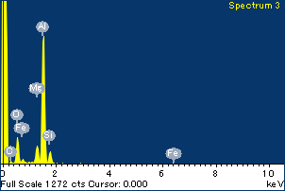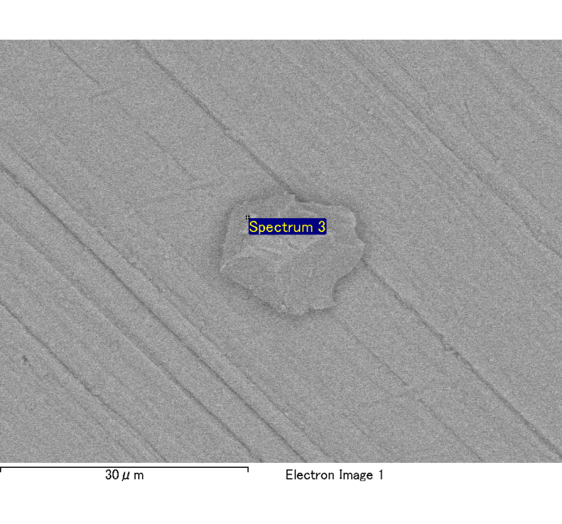

Spectrum Label: Spectrum 3

Livetime 120.0 s

Acquisition geometry ( degrees ):

Tilt = 0.0

Azimuth = 0.0

Elevation = 30.0

Accelerating voltage = 10.00 kV

Total spectrum counts = 121615

|  |  |  |  |
| --- | --- | --- | --- |
| Sample data : | Energy (eV) | Resn. (eV) | Area |
| Strobe : | 3.8 | 54.01 | 1207242 |
|  |  |  |  |
| Optimization data : Cobalt K series |  |  |  |
|  | Energy (eV) | Resn. (eV) | Area |
| Strobe : | .1 | 53.96 | 498142 |
| Optimization element : | 6926.7 | 142.17 | 16696 |

Spectrum processing :

No peaks omitted

Processing option : Oxygen by stoichiometry

Number of iterations = 2

Standard :

Na Albite 1-Jun-1999 12:00 AM

Mg MgO 1-Jun-1999 12:00 AM

Al Al2O3 1-Jun-1999 12:00 AM

Si SiO2 1-Jun-1999 12:00 AM

P GaP 1-Jun-1999 12:00 AM

S FeS2 1-Jun-1999 12:00 AM

K MAD-10 Feldspar 1-Jun-1999 12:00 AM

Ca Wollastonite 1-Jun-1999 12:00 AM

Cr Cr 1-Jun-1999 12:00 AM

Mn Mn 1-Jun-1999 12:00 AM

Fe Fe 1-Jun-1999 12:00 AM

Ni Ni 1-Jun-1999 12:00 AM

|  |  |  |  |  |  |
| --- | --- | --- | --- | --- | --- |
| Element | Weight% | Atomic% | Compd% | Formula |  |
|  |  |  |  |  |  |
| Na K | 0.00 | -0.02 | 0.00 | Na2O |  |
| Mg K | 0.12 | 4.19 | 0.19 | MgO |  |
| Al K | 0.95 | 30.63 | 1.79 | Al2O3 |  |
| Si K | 0.12 | 3.61 | 0.25 | SiO2 |  |
| P K | 0.00 | -0.01 | 0.00 | P2O5 |  |
| S K | 0.00 | 0.01 | 0.00 | SO3 |  |
| K K | 0.00 | -0.01 | 0.00 | K2O |  |
| Ca K | 0.00 | -0.05 | 0.00 | CaO |  |
| Cr K | 0.00 | 0.07 | 0.01 | Cr2O3 |  |
| Mn K | -0.01 | -0.23 | -0.02 | MnO |  |
| Fe K | 0.16 | 2.53 | 0.21 | FeO |  |
| Ni K | -0.01 | -0.21 | -0.02 | NiO |  |
| O | 1.09 | 59.50 |  |  |  |
| Totals | 2.41 |  |  |  |  |

Project: Project 1

Owner: Administrator

Site: Site of Interest 2

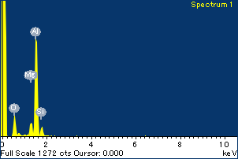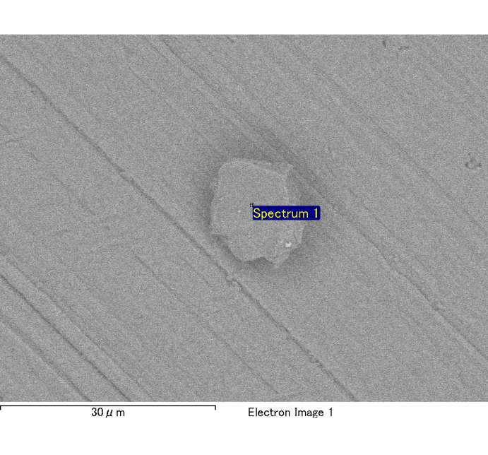

Spectrum Label: Spectrum 1

Livetime 120.0 s

Acquisition geometry ( degrees ):

Tilt = 0.0

Azimuth = 0.0

Elevation = 30.0

Accelerating voltage = 10.00 kV

Total spectrum counts = 119830

|  |  |  |  |
| --- | --- | --- | --- |
| Sample data : | Energy (eV) | Resn. (eV) | Area |
| Strobe : | 3.8 | 53.99 | 1208824 |
|  |  |  |  |
| Optimization data : Cobalt K series |  |  |  |
|  | Energy (eV) | Resn. (eV) | Area |
| Strobe : | .1 | 53.96 | 498142 |
| Optimization element : | 6926.7 | 142.17 | 16696 |

Spectrum processing :

No peaks omitted

Processing option : Oxygen by stoichiometry

Number of iterations = 2

Standard :

Na Albite 1-Jun-1999 12:00 AM

Mg MgO 1-Jun-1999 12:00 AM

Al Al2O3 1-Jun-1999 12:00 AM

Si SiO2 1-Jun-1999 12:00 AM

P GaP 1-Jun-1999 12:00 AM

S FeS2 1-Jun-1999 12:00 AM

K MAD-10 Feldspar 1-Jun-1999 12:00 AM

Ca Wollastonite 1-Jun-1999 12:00 AM

Cr Cr 1-Jun-1999 12:00 AM

Mn Mn 1-Jun-1999 12:00 AM

Fe Fe 1-Jun-1999 12:00 AM

Ni Ni 1-Jun-1999 12:00 AM

|  |  |  |  |  |  |
| --- | --- | --- | --- | --- | --- |
| Element | Weight% | Atomic% | Compd% | Formula |  |
|  |  |  |  |  |  |
| Na K | 0.00 | -0.11 | 0.00 | Na2O |  |
| Mg K | 0.11 | 4.18 | 0.18 | MgO |  |
| Al K | 0.87 | 30.60 | 1.64 | Al2O3 |  |
| Si K | 0.11 | 3.74 | 0.24 | SiO2 |  |
| P K | 0.00 | 0.00 | 0.00 | P2O5 |  |
| S K | 0.00 | 0.07 | 0.01 | SO3 |  |
| K K | 0.00 | 0.08 | 0.00 | K2O |  |
| Ca K | 0.00 | 0.01 | 0.00 | CaO |  |
| Cr K | 0.00 | 0.07 | 0.01 | Cr2O3 |  |
| Mn K | 0.01 | 0.17 | 0.01 | MnO |  |
| Fe K | 0.15 | 2.55 | 0.19 | FeO |  |
| Ni K | -0.06 | -0.98 | -0.08 | NiO |  |
| O | 1.00 | 59.62 |  |  |  |
| Totals | 2.20 |  |  |  |  |

Project: Project 1

Owner: Administrator

Site: Site of Interest 3

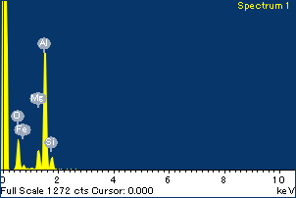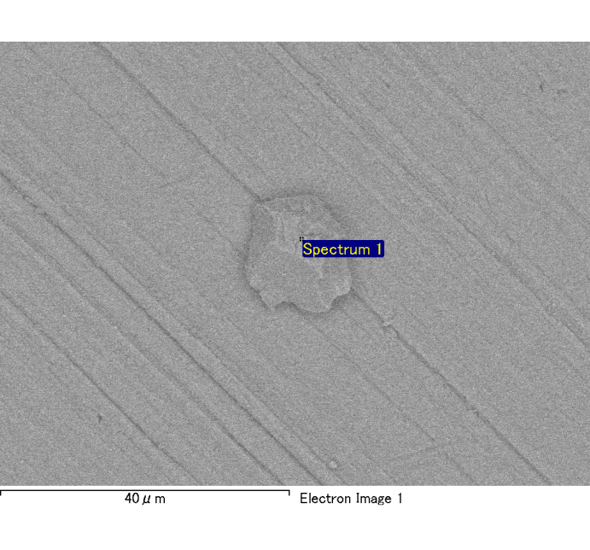

Spectrum Label: Spectrum 1

Livetime 120.0 s

Acquisition geometry ( degrees ):

Tilt = 0.0

Azimuth = 0.0

Elevation = 30.0

Accelerating voltage = 10.00 kV

Total spectrum counts = 120280

|  |  |  |  |
| --- | --- | --- | --- |
| Sample data : | Energy (eV) | Resn. (eV) | Area |
| Strobe : | 3.8 | 53.94 | 1207518 |
|  |  |  |  |
| Optimization data : Cobalt K series |  |  |  |
|  | Energy (eV) | Resn. (eV) | Area |
| Strobe : | .1 | 53.96 | 498142 |
| Optimization element : | 6926.7 | 142.17 | 16696 |

Spectrum processing :

No peaks omitted

Processing option : Oxygen by stoichiometry

Number of iterations = 2

Standard :

Na Albite 1-Jun-1999 12:00 AM

Mg MgO 1-Jun-1999 12:00 AM

Al Al2O3 1-Jun-1999 12:00 AM

Si SiO2 1-Jun-1999 12:00 AM

P GaP 1-Jun-1999 12:00 AM

S FeS2 1-Jun-1999 12:00 AM

K MAD-10 Feldspar 1-Jun-1999 12:00 AM

Ca Wollastonite 1-Jun-1999 12:00 AM

Cr Cr 1-Jun-1999 12:00 AM

Mn Mn 1-Jun-1999 12:00 AM

Fe Fe 1-Jun-1999 12:00 AM

Ni Ni 1-Jun-1999 12:00 AM

|  |  |  |  |  |  |
| --- | --- | --- | --- | --- | --- |
| Element | Weight% | Atomic% | Compd% | Formula |  |
|  |  |  |  |  |  |
| Na K | 0.00 | 0.10 | 0.00 | Na2O |  |
| Mg K | 0.13 | 5.05 | 0.21 | MgO |  |
| Al K | 0.85 | 30.29 | 1.60 | Al2O3 |  |
| Si K | 0.12 | 4.21 | 0.26 | SiO2 |  |
| P K | 0.00 | -0.10 | -0.01 | P2O5 |  |
| S K | 0.00 | -0.02 | 0.00 | SO3 |  |
| K K | 0.00 | -0.01 | 0.00 | K2O |  |
| Ca K | 0.00 | 0.07 | 0.00 | CaO |  |
| Cr K | 0.00 | 0.01 | 0.00 | Cr2O3 |  |
| Mn K | -0.02 | -0.28 | -0.02 | MnO |  |
| Fe K | 0.06 | 1.06 | 0.08 | FeO |  |
| Ni K | 0.00 | 0.07 | 0.01 | NiO |  |
| O | 0.99 | 59.56 |  |  |  |
| Totals | 2.14 |  |  |  |  |

Project: Project 1

Owner: Administrator

Site: Site of Interest 4

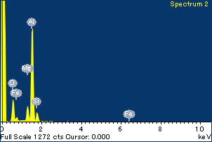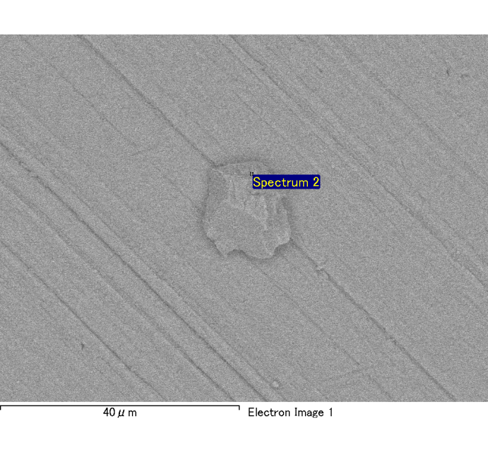

Spectrum Label: Spectrum 2

Livetime 120.0 s

Acquisition geometry ( degrees ):

Tilt = 0.0

Azimuth = 0.0

Elevation = 30.0

Accelerating voltage = 10.00 kV

Total spectrum counts = 121203

|  |  |  |  |
| --- | --- | --- | --- |
| Sample data : | Energy (eV) | Resn. (eV) | Area |
| Strobe : | 3.8 | 53.96 | 1209468 |
|  |  |  |  |
| Optimization data : Cobalt K series |  |  |  |
|  | Energy (eV) | Resn. (eV) | Area |
| Strobe : | .1 | 53.96 | 498142 |
| Optimization element : | 6926.7 | 142.17 | 16696 |

Spectrum processing :

No peaks omitted

Processing option : Oxygen by stoichiometry

Number of iterations = 2

Standard :

Na Albite 1-Jun-1999 12:00 AM

Mg MgO 1-Jun-1999 12:00 AM

Al Al2O3 1-Jun-1999 12:00 AM

Si SiO2 1-Jun-1999 12:00 AM

P GaP 1-Jun-1999 12:00 AM

S FeS2 1-Jun-1999 12:00 AM

K MAD-10 Feldspar 1-Jun-1999 12:00 AM

Ca Wollastonite 1-Jun-1999 12:00 AM

Cr Cr 1-Jun-1999 12:00 AM

Mn Mn 1-Jun-1999 12:00 AM

Fe Fe 1-Jun-1999 12:00 AM

Ni Ni 1-Jun-1999 12:00 AM

|  |  |  |  |  |  |
| --- | --- | --- | --- | --- | --- |
| Element | Weight% | Atomic% | Compd% | Formula |  |
|  |  |  |  |  |  |
| Na K | 0.00 | -0.03 | 0.00 | Na2O |  |
| Mg K | 0.13 | 4.54 | 0.21 | MgO |  |
| Al K | 0.93 | 30.26 | 1.77 | Al2O3 |  |
| Si K | 0.11 | 3.55 | 0.24 | SiO2 |  |
| P K | 0.00 | 0.01 | 0.00 | P2O5 |  |
| S K | 0.00 | -0.12 | -0.01 | SO3 |  |
| K K | 0.00 | -0.04 | 0.00 | K2O |  |
| Ca K | -0.01 | -0.15 | -0.01 | CaO |  |
| Cr K | 0.01 | 0.16 | 0.01 | Cr2O3 |  |
| Mn K | 0.03 | 0.41 | 0.03 | MnO |  |
| Fe K | 0.14 | 2.18 | 0.18 | FeO |  |
| Ni K | 0.00 | -0.06 | 0.00 | NiO |  |
| O | 1.09 | 59.28 |  |  |  |
| Totals | 2.42 |  |  |  |  |

Project: Project 1

Owner: Administrator

Site: Site of Interest 4

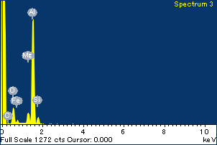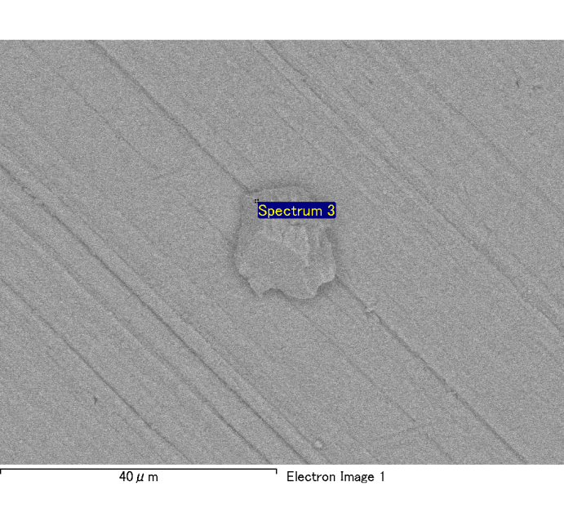

Spectrum Label: Spectrum 3

Livetime 120.0 s

Acquisition geometry ( degrees ):

Tilt = 0.0

Azimuth = 0.0

Elevation = 30.0

Accelerating voltage = 10.00 kV

Total spectrum counts = 122170

|  |  |  |  |
| --- | --- | --- | --- |
| Sample data : | Energy (eV) | Resn. (eV) | Area |
| Strobe : | 3.8 | 53.98 | 1207856 |
|  |  |  |  |
| Optimization data : Cobalt K series |  |  |  |
|  | Energy (eV) | Resn. (eV) | Area |
| Strobe : | .1 | 53.96 | 498142 |
| Optimization element : | 6926.7 | 142.17 | 16696 |

Spectrum processing :

No peaks omitted

Processing option : Oxygen by stoichiometry

Number of iterations = 2

Standard :

Na Albite 1-Jun-1999 12:00 AM

Mg MgO 1-Jun-1999 12:00 AM

Al Al2O3 1-Jun-1999 12:00 AM

Si SiO2 1-Jun-1999 12:00 AM

P GaP 1-Jun-1999 12:00 AM

S FeS2 1-Jun-1999 12:00 AM

K MAD-10 Feldspar 1-Jun-1999 12:00 AM

Ca Wollastonite 1-Jun-1999 12:00 AM

Cr Cr 1-Jun-1999 12:00 AM

Mn Mn 1-Jun-1999 12:00 AM

Fe Fe 1-Jun-1999 12:00 AM

Ni Ni 1-Jun-1999 12:00 AM

|  |  |  |  |  |  |
| --- | --- | --- | --- | --- | --- |
| Element | Weight% | Atomic% | Compd% | Formula |  |
|  |  |  |  |  |  |
| Na K | 0.00 | -0.03 | 0.00 | Na2O |  |
| Mg K | 0.10 | 3.51 | 0.17 | MgO |  |
| Al K | 1.06 | 33.37 | 2.00 | Al2O3 |  |
| Si K | 0.10 | 2.94 | 0.21 | SiO2 |  |
| P K | 0.00 | 0.09 | 0.01 | P2O5 |  |
| S K | 0.00 | 0.04 | 0.00 | SO3 |  |
| K K | 0.00 | 0.04 | 0.00 | K2O |  |
| Ca K | 0.00 | -0.05 | 0.00 | CaO |  |
| Cr K | -0.01 | -0.23 | -0.02 | Cr2O3 |  |
| Mn K | 0.00 | -0.08 | -0.01 | MnO |  |
| Fe K | 0.06 | 0.90 | 0.08 | FeO |  |
| Ni K | -0.03 | -0.37 | -0.03 | NiO |  |
| O | 1.13 | 59.86 |  |  |  |
| Totals | 2.40 |  |  |  |  |

Project: Project 1

Owner: Administrator

Site: Site of Interest 4

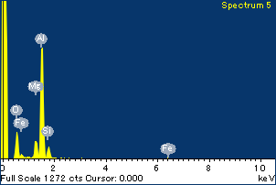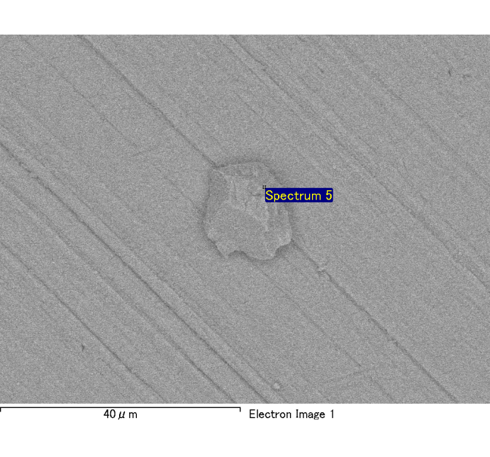

Spectrum Label: Spectrum 5

Livetime 120.0 s

Acquisition geometry ( degrees ):

Tilt = 0.0

Azimuth = 0.0

Elevation = 30.0

Accelerating voltage = 10.00 kV

Total spectrum counts = 120072

|  |  |  |  |
| --- | --- | --- | --- |
| Sample data : | Energy (eV) | Resn. (eV) | Area |
| Strobe : | 3.8 | 53.97 | 1208055 |
|  |  |  |  |
| Optimization data : Cobalt K series |  |  |  |
|  | Energy (eV) | Resn. (eV) | Area |
| Strobe : | .1 | 53.96 | 498142 |
| Optimization element : | 6926.7 | 142.17 | 16696 |

Spectrum processing :

No peaks omitted

Processing option : Oxygen by stoichiometry

Number of iterations = 2

Standard :

Na Albite 1-Jun-1999 12:00 AM

Mg MgO 1-Jun-1999 12:00 AM

Al Al2O3 1-Jun-1999 12:00 AM

Si SiO2 1-Jun-1999 12:00 AM

P GaP 1-Jun-1999 12:00 AM

S FeS2 1-Jun-1999 12:00 AM

K MAD-10 Feldspar 1-Jun-1999 12:00 AM

Ca Wollastonite 1-Jun-1999 12:00 AM

Cr Cr 1-Jun-1999 12:00 AM

Mn Mn 1-Jun-1999 12:00 AM

Fe Fe 1-Jun-1999 12:00 AM

Ni Ni 1-Jun-1999 12:00 AM

|  |  |  |  |  |  |
| --- | --- | --- | --- | --- | --- |
| Element | Weight% | Atomic% | Compd% | Formula |  |
|  |  |  |  |  |  |
| Na K | 0.00 | -0.14 | 0.00 | Na2O |  |
| Mg K | 0.12 | 4.54 | 0.20 | MgO |  |
| Al K | 0.88 | 29.80 | 1.67 | Al2O3 |  |
| Si K | 0.12 | 3.75 | 0.25 | SiO2 |  |
| P K | 0.00 | 0.08 | 0.01 | P2O5 |  |
| S K | 0.00 | -0.08 | -0.01 | SO3 |  |
| K K | 0.00 | 0.04 | 0.00 | K2O |  |
| Ca K | 0.00 | 0.08 | 0.00 | CaO |  |
| Cr K | 0.00 | -0.02 | 0.00 | Cr2O3 |  |
| Mn K | 0.00 | 0.02 | 0.00 | MnO |  |
| Fe K | 0.15 | 2.48 | 0.20 | FeO |  |
| Ni K | 0.01 | 0.13 | 0.01 | NiO |  |
| O | 1.04 | 59.32 |  |  |  |
| Totals | 2.32 |  |  |  |  |

Project: Project 1

Owner: Administrator

Site: Site of Interest 4