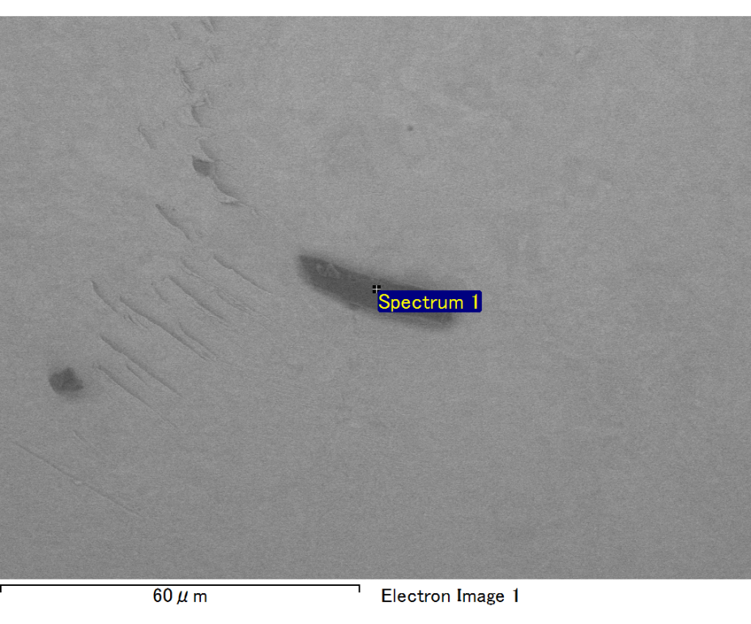

Spectrum processing :

No peaks omitted

Processing option : All elements analyzed (Normalised)

Number of iterations = 2

Standard :

C CaCO3 1-Jun-1999 12:00 AM

O SiO2 1-Jun-1999 12:00 AM

Mg MgO 1-Jun-1999 12:00 AM

Si SiO2 1-Jun-1999 12:00 AM

Ca Wollastonite 1-Jun-1999 12:00 AM

Au Au 1-Jun-1999 12:00 AM

|  |  |  |  |
| --- | --- | --- | --- |
| Element | Weight% | Atomic% |  |
|  |  |  |  |
| C K | 2.99 | 10.38 |  |
| O K | 23.27 | 60.62 |  |
| Mg K | 2.77 | 4.75 |  |
| Si K | 5.57 | 8.27 |  |
| Ca K | 2.58 | 2.68 |  |
| Au M | 62.82 | 13.29 |  |
|  |  |  |  |
| Totals | 100.00 |  |  |

Spectrum Label: Spectrum 1

Livetime 60.0 s

Acquisition geometry ( degrees ):

Tilt = 10.0

Azimuth = 0.0

Elevation = 30.0

Accelerating voltage = 10.00 kV

Total spectrum counts = 43885

|  |  |  |  |
| --- | --- | --- | --- |
| Sample data : | Energy (eV) | Resn. (eV) | Area |
| Strobe : | 3.8 | 47.33 | 999865 |
|  |  |  |  |

No quant optimization performed

Sample: Sample 1

Type: Default

ID:

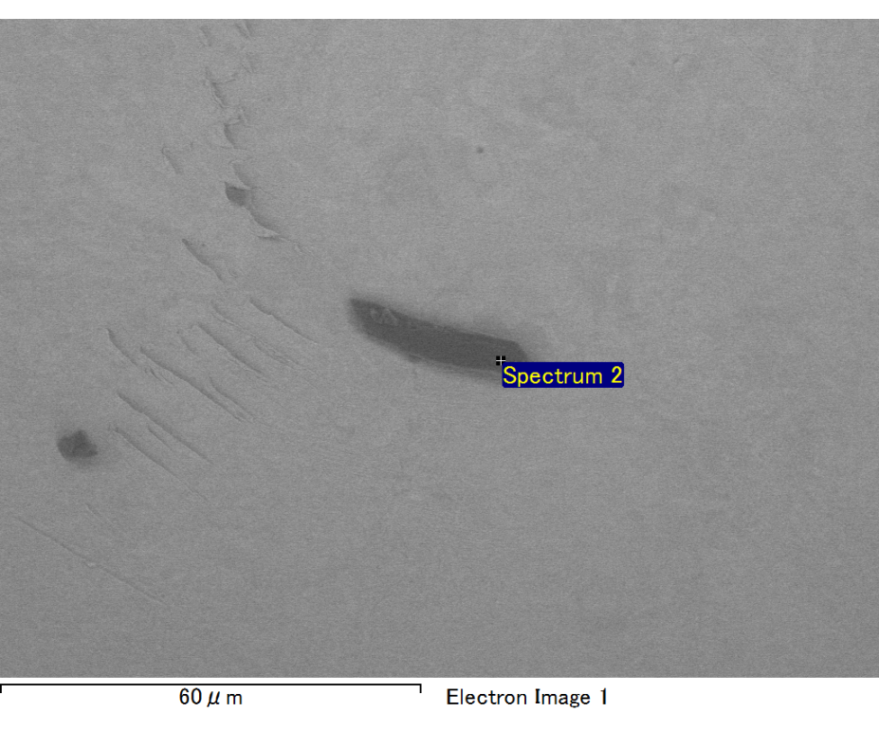

Spectrum processing :

Peak possibly omitted : 0.720 keV

Processing option : All elements analyzed (Normalised)

Number of iterations = 2

Standard :

C CaCO3 1-Jun-1999 12:00 AM

O SiO2 1-Jun-1999 12:00 AM

Mg MgO 1-Jun-1999 12:00 AM

Si SiO2 1-Jun-1999 12:00 AM

Au Au 1-Jun-1999 12:00 AM

|  |  |  |  |
| --- | --- | --- | --- |
| Element | Weight% | Atomic% |  |
|  |  |  |  |
| C K | 2.82 | 10.33 |  |
| O K | 21.19 | 58.38 |  |
| Mg K | 3.88 | 7.04 |  |
| Si K | 6.03 | 9.46 |  |
| Au M | 66.08 | 14.79 |  |
|  |  |  |  |
| Totals | 100.00 |  |  |

Spectrum Label: Spectrum 2

Livetime 60.0 s

Acquisition geometry ( degrees ):

Tilt = 10.0

Azimuth = 0.0

Elevation = 30.0

Accelerating voltage = 10.00 kV

Total spectrum counts = 41864

|  |  |  |  |
| --- | --- | --- | --- |
| Sample data : | Energy (eV) | Resn. (eV) | Area |
| Strobe : | 3.8 | 47.38 | 1000332 |
|  |  |  |  |

No quant optimization performed

Sample: Sample 1

Type: Default

ID: